Diabetes & Obesity 2020
Asian Diabetes conferences
Asian Obesity conferences
Asia Obesity meetings
Asia Diabetes meetings
Sydney Diabetes & Obesity Conference
Sydney Diabetes & Obesity Meetings
Diabetes & Obesity Conferences | Diabetes & Obesity Research Conferences | World Diabetes & Obesity Conferences | Diabetes & Obesity Congress 2020 | Diabetes & Obesity Conferences | Global Diabetes & Obesity conference 2020 | Diabetes & Obesity Conferences | Diabetes conference Sydney | Diabetes & Obesity 2020 Australia
Theme: “Reunite and Raise hands against metabolic disorders”
Diabetes & Obesity 2020: Annual congress on Diabetes, Metabolism and Obesity scheduled to be held during July 06-07, 2020 at Sydney, Australia. The conference invites all the participants across the globe to attend and share their insights and convey recent developments in the field of Diabetes & Endocrinology, Obesity.
Scientific Sessions : Diabetes Mellitus | Obesity | Human Metabolism | Genetics of Obesity | Obesity Health Effects | Advanced Technologies & Treatments for Diabetes | Advanced Treatments for Obesity | Metabolism Syndrome Treatments | Diet for Diabetes | Control of Obesity | Role of Anaesthesiologists in obesity | Diet and Nutrition | Nutrition and Food Healthcare | Diabetes Research | Diabetic Kidney disease or Diabetic Nephropathy | Diabetic Eye disease or Diabetic Retinopathy | Diabetic Gastro Paresis
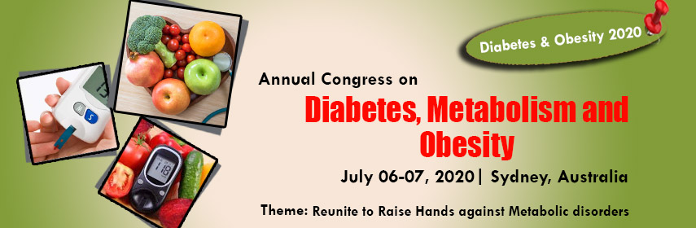
Image URL: https://d2cax41o7ahm5l.cloudfront.net/cs/upload-images/diabetesobesity-2020-45397.jpg
Subject name: Diabetes & Endocrinology
Annual congress on Diabetes, Metabolism and Obesity
Date & Venue: July 06-07, 2020 | Sydney, Australia
Conference Short name: Diabetes & Obesity 2020
Conference URL : https://diabetesobesity.diabetesexpo.com/

