Rosette Forming Glioneuronal Tumor
Jae Koo Lee, M.D., Seung Won Choi, M.D., Young Sin Ra, PhD, Asan Medical Center, Seoul, Korea, University of Ulsan, College of Medicine
Rosette forming glioneuronal tumor (RGNT) is a rare variant of glioneuronal tumor. It is described as an infratentorial form of dysembryoplastic neuroepithelial tumor (DNT). However, its clinico-pathologic findings are distinct from that of DNT. RGNT, classified as WHO Grade I tumor, usually shows indolent clinical course and rarely recurs even after subtotal resection. We report two cases of RGNT. One case had a recurrence at 5 years after the initial subtotal resection.
Case I.
A healthy middle-aged man presented with sudden onset dizziness. He didn’t show any neurological deficit at the time of diagnosis. We performed gross total resection and the patient recovered without any specific event. There has been no evidence of recurrence during 4 year follow-up.
Case II.
A 8-year girl presented with GTC-type seizure and ill-defined temporal lesion was found on her MRI (Fig 3-A). She showed no focal neurological deficit. Parents denied to have surgical management at that time, however, her seizure became intractable 2 years after the initial diagnosis and she underwent subtotal resection (Fig 3-B). Postoperative MRI showed cystic cavity along with residual solid component near to the medial temporal lobe (Fig 3-C) and this cyst became slowly enlarged in size (Fig 3-D). 4.5 years after the first operation, she came to ER complaining of severe headache and vomit. Tumor became significantly enlarge in both cystic and solid component (Fig 3-E). We inserted an Ommaya catheter into the cystic cavity to relieve the pressure (Fig 3-F).
RGNT is a rare tumor which was first described as dysembryoplastic neuroepithelial tumor (DNT) of the cerebellum.1 Komori et. al defined RGNT as a specific disease, in the characteristic location specifically in association with the fourth ventricle. 2 RGNT arises in the fourth ventricle in 59% of the cases, and tend to have variable involvement of the CNS as shown in Table 1.3,4 Supratentorial form of RGNT has not been reported yet. In our second case, we first report the supratentorial hemispheric RGNT.
RGNT was assigned grade one by The World Health Organization, and given its benign clinical behavior, a complete resection of the tumor and cure may be possible. Among the previously reported cases, no evidence of recurrence in GTR or tumor growth in STR was seen in 34/37 (92%) of patient. 4 However, a few cases of recurrence after subtotal resection has been reported and our second case showed a fatal recurrence 4 years after the first operation. 3,4 In this matter, vigilant follow up is recommended after subtotal resection and adjuvant treatment might be beneficial in such cases.
RGNT is known as a benign tumor and surgical resection has been advocated as a mainstay treatment. However, in many cases, gross total resection is not feasible and poses significant post-surgical complications. And because of its rarity, clinical course after surgical resection is not well demonstrated yet. In our second case, we experienced a fatal recurrence after subtotal resection, and are planning radiation therapy. Some reports reviewed recurrent cases of RGNT after gross total resection. We report a supratentorial hemispheric form of RGNT which recurred after surgical resection. Further studies are necessary to demonstrate the optimal treatment for this disease entity.

Image
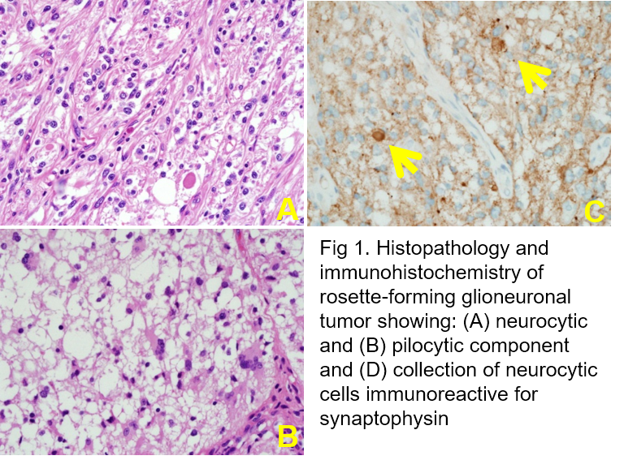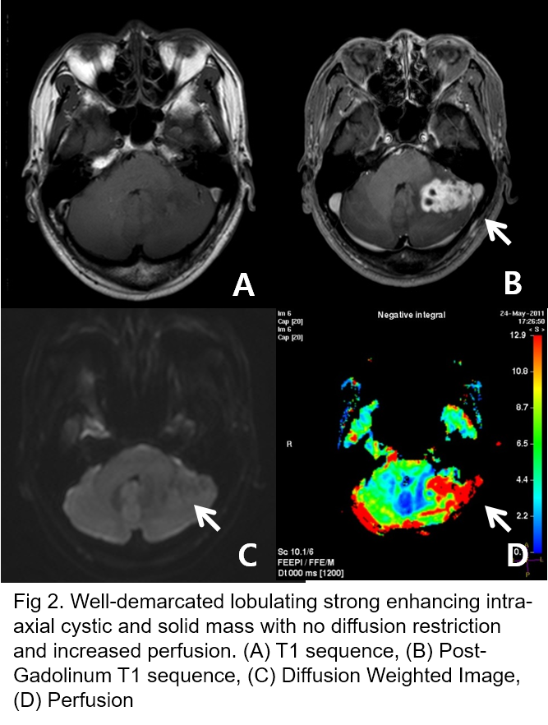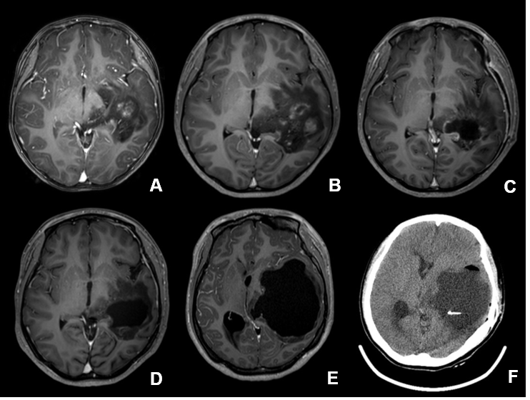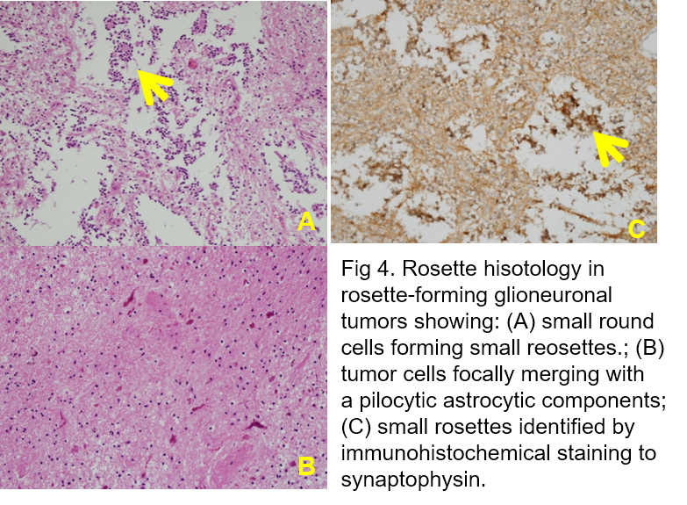
Recent publications
1. Kuchelmeister et. al, 1995, Pathologica
2. Komori T, et. al, 2002, American Journal of Surgical Patholology
3. Zhang J, et. al, 2013, Journal of Clinical Neuroscience
4. Hsu et. al, 2012, British Journal of Neurosurgery

