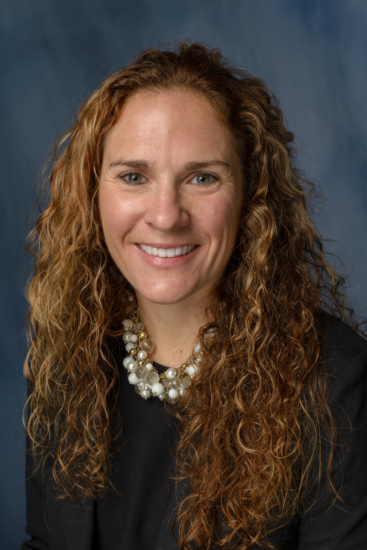
Title: Mass media health promotion interventions for increasing stroke awareness
in young people: a systematic review of the literature

Kelly Flowers, MA, MAIB, MBA, Doctoral Student
University of Florida, College of Journalism and Mass Communication

Background: One of the greatest public health challenges is developing mass media health behavior change programs and interventions to improve the health and reduce the burden of chronic disease. Approximately 10-20% of all diagnosed strokes occur in young adults (18-45 years old) each year. This population is not typically targeted for stroke mass media campaigns, therefore some barriers exist requiring tailored health promotion interventions, whose effectiveness remains uncertain.
Objective: A systematic review aimed to identify relevant published evidence, synthesize the main study components and identify evidence of the effectiveness of the interventions for mass media campaigns targeting the awareness of the Warning Signs (WS) and Risk Factors (RF) for stroke in young people. Supplementary factors of message repetition and need to call 9-1-1 at first sign of stroke symptoms were also examined.
Method - Data Sources: PubMed, MEDLINE, and PsycINFO were searched for journal articles on health promotion interventions for increasing stroke awareness of warning signs in young people, published in English between 2005 and 2015.
Results: Twenty-six studies investigating mass media stroke campaigns were included, reporting only two studies that targeted young adults.
With a majority of stroke communication studies not employing theories it is difficult to determine the relationship among variables and thus provide an explanation regarding their relationship. Out of 26 studies reviewed only one study utilized a theory and no studies used theory to study stroke in young adults.
The mass media interventions in these studies varied in widely target populations, settings, delivery methods, contents and messaging involved. Twenty-four of the study designs were quantitative, and the emerging evidence of effectiveness was inconclusive. None of the studies included variables or messaging on the severity of having a stroke and the need to call 9-1-1 immediately upon witnessing WS. Additionally, no studies included variables that measured repetition of messaging and the increase of stroke WS and RF.
Conclusions: Further investigation is needed in mass media stroke education targeting young adults. Since no studies targeting young adults have been conducted using a theory, measuring the effects of message repetition, and utilizing educational messaging to ensure immediate transport to a hospital upon first stroke WS further research is needed.

Biography

Kelly Flowers is also a doctoral student at the University of Florida. Kelly graduated with a B.A. and a M.A. in Mass Communication from Michigan State University, competing all four undergraduate years as a member of the varsity swim team. While pursuing her Ph.D. in Mass Communication, she graduated with a Masters in International Business (MAIB) and a MBA from the University of Florida. As a graduate student, Kelly taught Television and American Society at the University of Florida and Introduction to Public Speaking and Interpersonal Communication and Santa Fe College.

Presenting author details
Full name: Kelly Flowers
Contact number: 1.352.258.4079

