The Development of ErbB2-targeted Therapy for Alzheimer’s Disease
Yung-Feng Liao, PhD, Bo-Jeng Wang, PhD, Yun-Wen Chen, MS, and Pei-Yi Wu, PhD, Institute of Cellular and Organismic Biology, Academia Sinica, Taipei 11529, TAIWAN.

Abstract (300 word limit)
γSecretase-catalyzed production of amyloid-β (Aβ) underlies the pathogenesis of Alzheimer’s disease (AD). To identify genetic modifiers that can selectively affect γ-secretase cleavage of APP while sparing Notch cleavage, we generated cell-based assays employing bioluminescence resonance energy transfer (BRET) technology to monitor the protein-protein interactions between PS1 and two γ-secretase substrates, APP C-terminal fragment (C99), and extracellular domain truncated Notch (N∆E). An RNAi screen identified 14 candidate genes whose downregulation resulted in a selective decrease in the interaction between PS1 and C99. Among those 14 candidate genes, an ErbB2-centered interaction network was found to preferentially govern the proteostasis of APP-C99. We further demonstrated that overexpression of ErbB2 upregulates the levels of C99 and AICD effectively. The knockdown of ErbB2 selectively decreased the protein levels of C99, AICD, and secreted Aβ40, but not those of N∆E and NICD. Selective suppression of ErbB2 expression by CL-387,785, an ErbB1/2-selective irreversible tyrosine kinase inhibitor, can preferentially attenuate the levels of C99 and AICD, resulting in a significant reduction in Aβ production. Down-regulation of ErbB2 by CL-387,785 also resulted in a significant decrease in the levels of C99 and secreted Aβ in both zebrafish and mouse models of AD, through the activation of autophagy. Oral administration of CL-387,785 for 3 wk significantly improves the cognitive functions of APP/presenilin-1 (PS1) transgenic mice. These findings unveil a noncanonical function of ErbB2 in modulating autophagy and establishe ErbB2 as a novel therapeutic target for AD.

Image
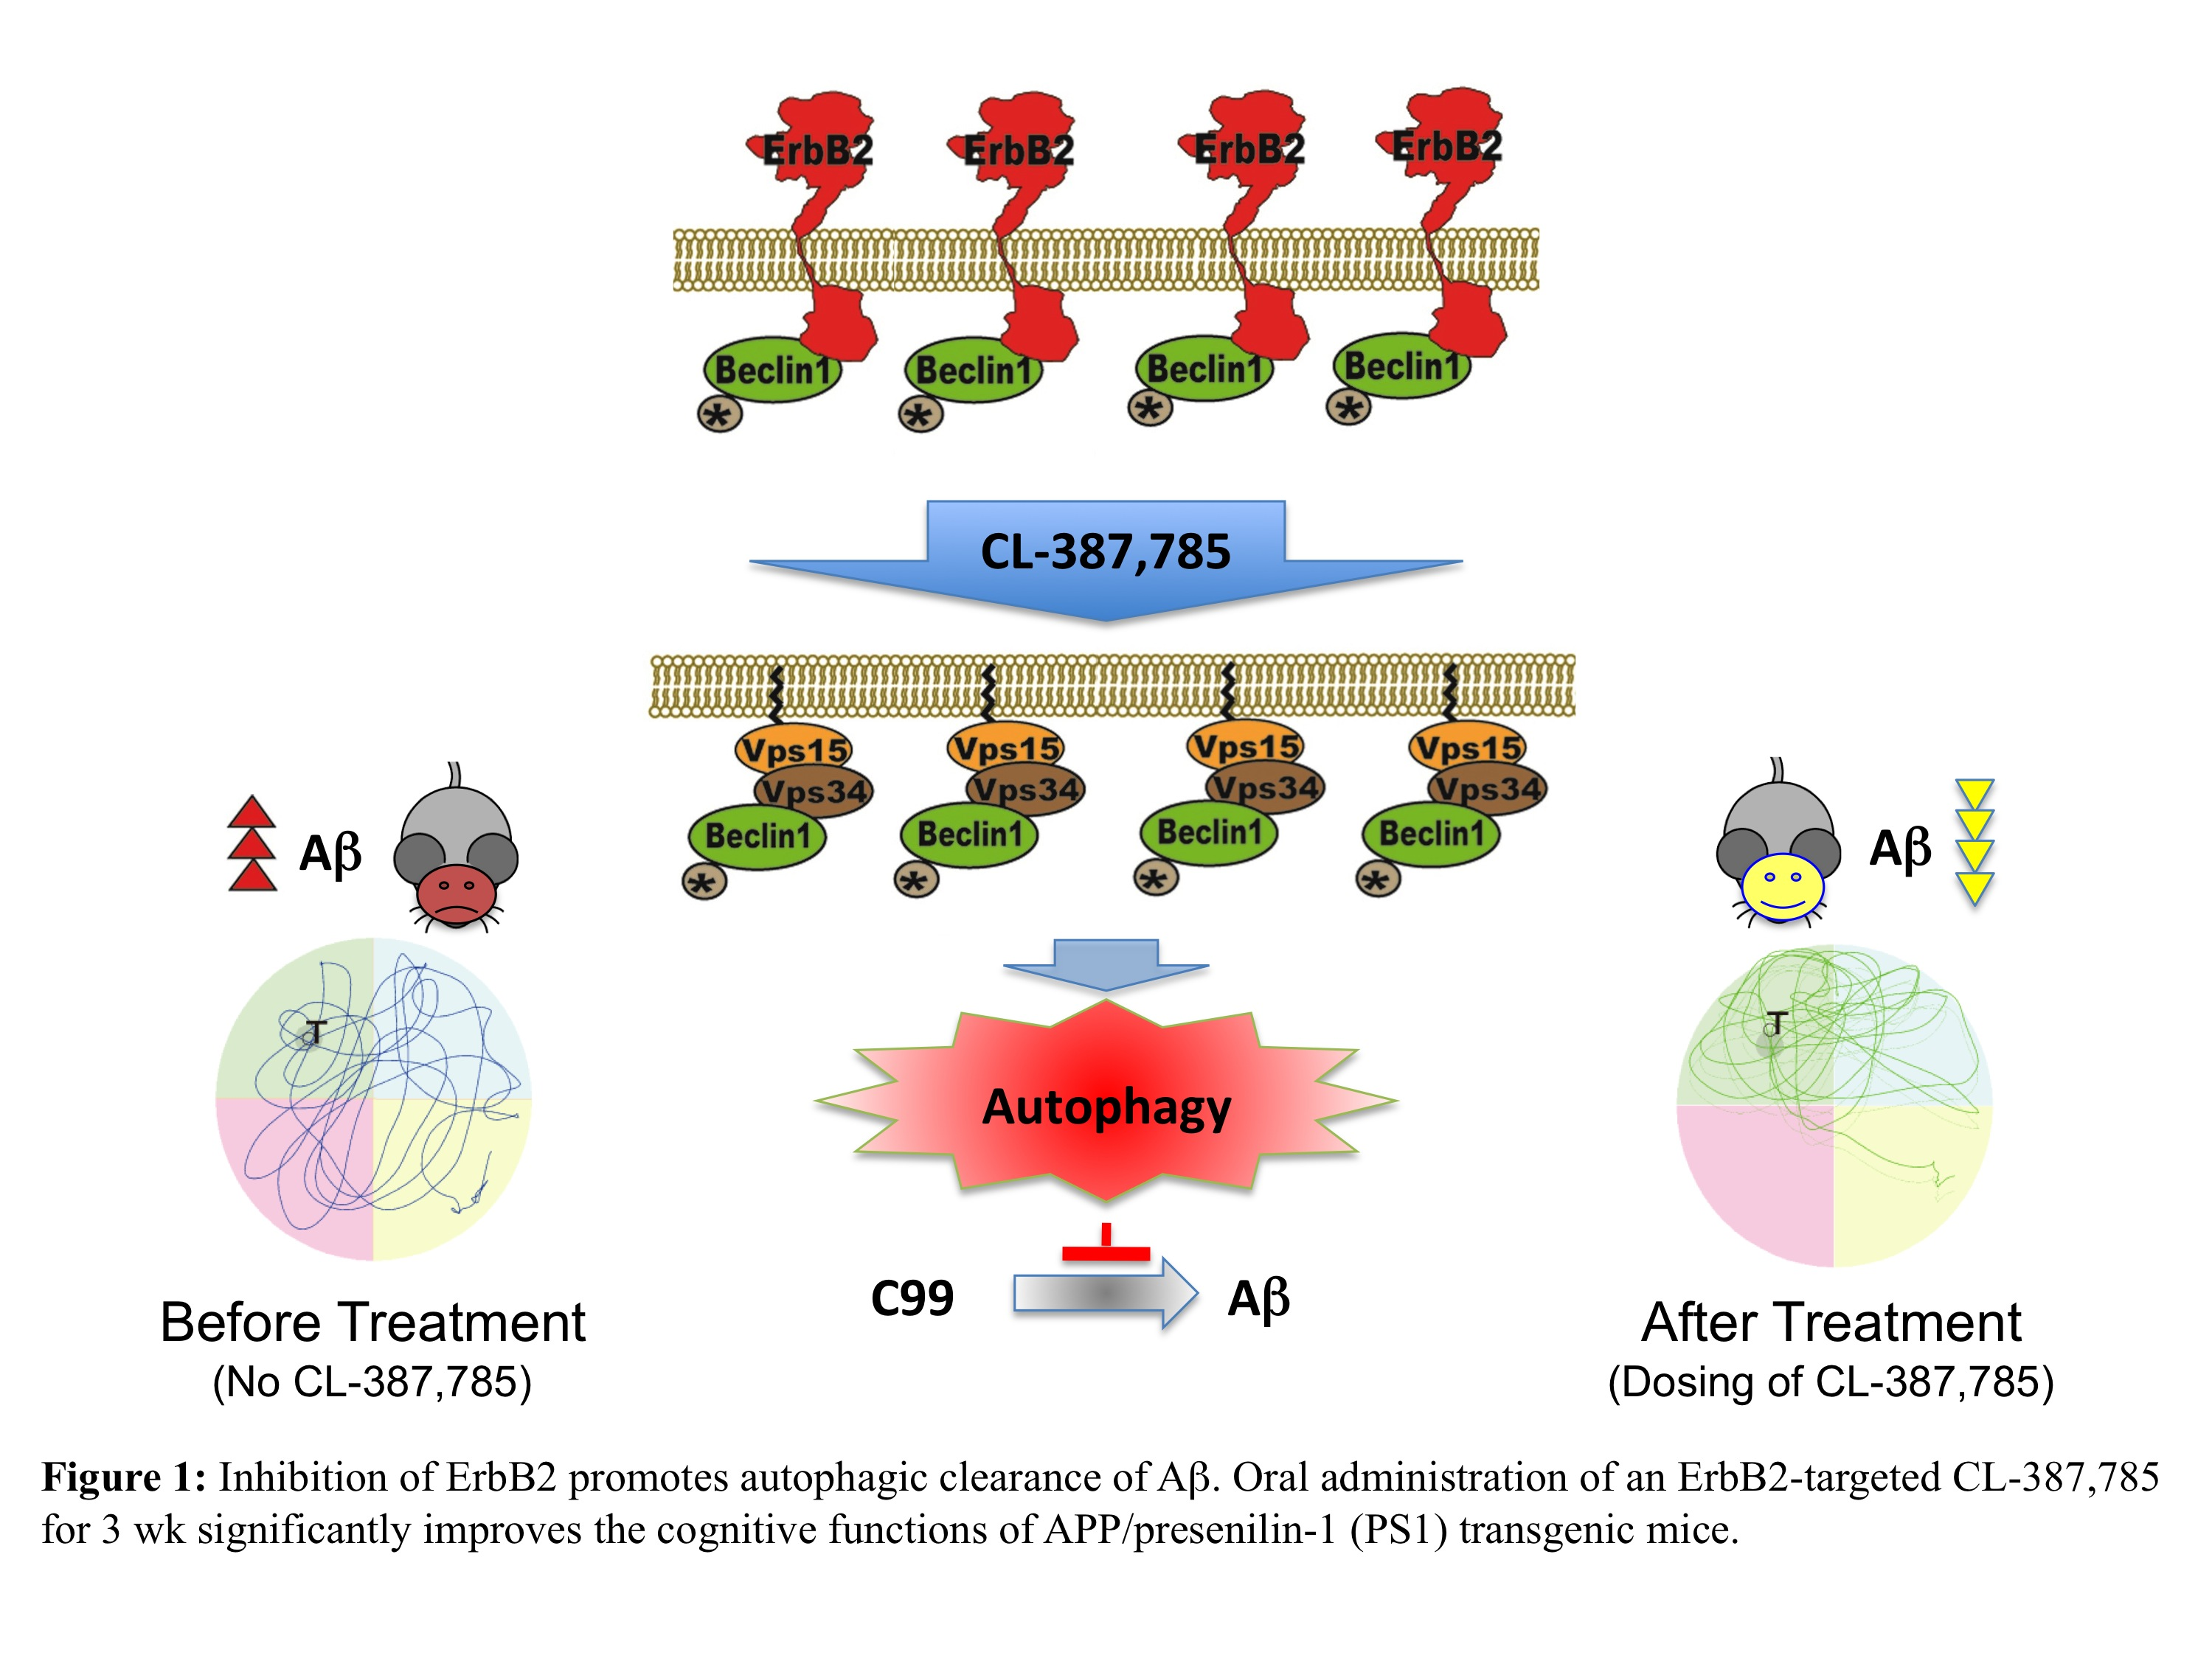
Recent Publications (minimum 5)
- Liao, Y.-F.*, Wang, B.-J., Cheng, H.-T., Kuo, L.-H., Wolfe, M. S. (2004) TNF-α, IL-1β, and IFN-γ stimulate γ-secretase-mediated cleavage of amyloid precursor protein through a JNK-dependent MAPK pathway. J. Biol. Chem. 279, 49523-49532.
- Liao, Y.-F.*, Wang, B.-J., Hsu, W.-M., Lee, H., Liao, C.-Y., Wu, S.-Y., Cheng, H.-T., and Hu, M.-K. (2007) Unnatural amino acid-substituted (hydroxyethyl)urea peptidomimetics inhibit gamma-secretase and promote the neuronal differentiation of neuroblastoma cells. Mol. Pharmacol., 71, 588-601.
- W.-M. Hsu, H. Lee, H.-F. Juan, Y.-Y. Shih, B.-J. Wang, C.-Y. Pan, Y.-M. Jeng, H.-H. Chang, M.-Y. Lu, K.-H. Lin, H.-S. Lai, W.-J. Chen, Y.-G. Tsay*, Y.-F. Liao*, and F.-J. Hsieh* (2008) Identification of GRP75 as an Independent Favorable Prognostic Marker of Neuroblastoma by a Proteomics Analysis. Clin. Cancer Res., 14, 6237-6245.
- L.-H. Kuo, M.-K. Hu, W.-M. Hsu, Y.-T. Tung, B.-J. Wang, W.-W. Tsai, C.-T. Yen, and Y.-F. Liao* (2008) TNF-α-elicited stimulation of γ-secretase is mediated by JNK-dependent phosphorylation of presenilin and nicastrin. Mol. Biol. Cell, 19, 4201-4212.
- A. Kapoor, W.-M. Hsu, B.-J. Wang, G.-H. Wu, T.-Y. Lin, S.-J. Lee, C.-T. Yen, S.-M. Liang*, Y.-F. Liao*. (2010) Caveolin-1 regulates γ-secretase-mediated APP processing by modulating spatial distribution of γ-secretase in membrane. J. Alzheimers Dis., 22: 423-442.
- H.-H. Chang, H. Lee, M.-K. Hu, P.-N. Tsao, H.-F. Juan, M.-C. Huang, Y.-Y. Shih, B.-J. Wang, Y.-M. Jeng, C. L. Chang, S.-F. Huang, Y.-G. Tsay, F.-J. Hsieh, K.-H. Lin*, W.-M. Hsu*, and Y.-F. Liao*. (2010) Notch1 expression predicts an unfavorable prognosis and serves as a therapeutic target of patients with neuroblastoma. Clin. Cancer Res., 16: 4411–4420.
- A. Kapoor, B.-J. Wang, W.-M. Hsu, M.-Y. Chang, S.-M. Liang*, Y.-F. Liao*. (2013) Retinoic acid-elicited RARα/RXRα signaling attenuates Aβ production by directly inhibiting γ-secretase-mediated cleavage of amyloid precursor protein. ACS Chem. Neurosci., 4: 1093-1100.
- Y.-T. Tung, B.-J. Wang, W.-M. Hsu, M.-K. Hu, G. M. Her, W.-P. Huang*, Y.-F. Liao*. (2014) Presenilin-1 regulates the expression of p62 to govern p62-dependent Tau degradation. Mol. Neurobiol., 49: 10-27.
- W.-B. Lai, B.-J. Wang, M.-K. Hu, W.-M. Hsu, Y.-F. Liao*. (2014) The activation of EphA4 signaling regulates the proteolysis of amyloid precursor protein through a Lyn-mediated pathway. Mol. Neurobiol., 49: 1055-1068.
- B.-J. Wang, G. M. Her, M.-K. Hu, Y.-W. Chen, Y.-T. Tung, P.-Y. Wu, W.-M. Hsu, H. Lee, L.-W. Jin, S.-P. L. Hwang, R. P.-Y. Chen, C.-J. Huang, and Y.-F. Liao*. (2017) ErbB2 regulates autophagic flux to modulate the proteostasis of APP-CTFs in Alzheimer's disease. Proc. Natl. Acad. Sci. U.S.A., 114: E3129-E3138.

Biography (150 word limit)
Yung-Feng Liao has completed his PhD in Biochemistry and Molecular Biology from University of Georgia (Athens, Georgia, USA) and postdoctoral studies from Harvard Medical School/Massachusetts General Hospital/Brigham and Women’s Hospital (Boston, Massachusetts, USA). He is the principal investigator of the Laboratory of Molecular Neurobiology in the Institute of Cellular and Organismic Biology, Academia Sinica, a premier research institution in Taiwan. He has published more than 50 papers in reputed journals and has been serving either as an editorial board member or as a peer reviewer of prestigious journals.

Email: yliao@sinica.edu.tw

Notes/Comments:

