The Detrimental Roles of Neutrophil Gelatinase-Associated Lipocalin in Ischemic Stroke
Yi-Chinn Weng, PhD, Guona Wang, PhD, Yu-Chieh Wu, MSc, Wen-Hai Chou, PhD, Center for Neuropsychiatric Research, National Health Research Institutes, Taiwan

Abstract (300 word limit)
Ischemic stroke is a major cause of death and long-term disability worldwide. Tissue plasminogen activator (tPA) is the only drug approved for pharmacological intervention to reverse acute ischemic stroke, but reestablishment of circulation may paradoxically initiate reperfusion injury. Activated immune cells (neutrophils, macrophages) infiltrate into ischemic brain tissue, release free radicals, proinflammatory cytokines and proteins, thus causing brain edema, disruption of blood-brain barrier (BBB) and neuronal cell death. Therefore, treatments that can inactivate these immune cells and limit stroke-reperfusion injuries are urgently needed. Our recent results demonstrate that neutrophil gelatinase-associated lipocalin (NGAL) was acutely induced in mice and humans after ischemic stroke and is an important mediator of stroke-reperfusion injury. Increased levels of NGAL were observed in mouse serum as early as 1 hour after transient middle cerebral artery occlusion (tMCAo), reaching peak levels at 23 hours. NGAL was also detected in neutrophils infiltrating into the ipsilateral hemisphere, as well as a subset of astrocytes after tMCAo, but not in neurons and microglia. Cerebral infarction, neurological deficits, infiltration of immune cells, proinflammatory molecules and BBB permeability after tMCAo were significantly reduced in NGAL null mice. The plasma concentration of NGAL was markedly elevated in patients with ischemic stroke. During a four-year follow-up, patients with higher levels of NGAL had higher mortality rates. These results demonstrate that NGAL is a neurotoxic factor secreted rapidly in response to cerebral ischemia, suggesting its potential usage as an early stroke biomarker and a novel therapeutic target to reduce stroke-reperfusion injury.

Image
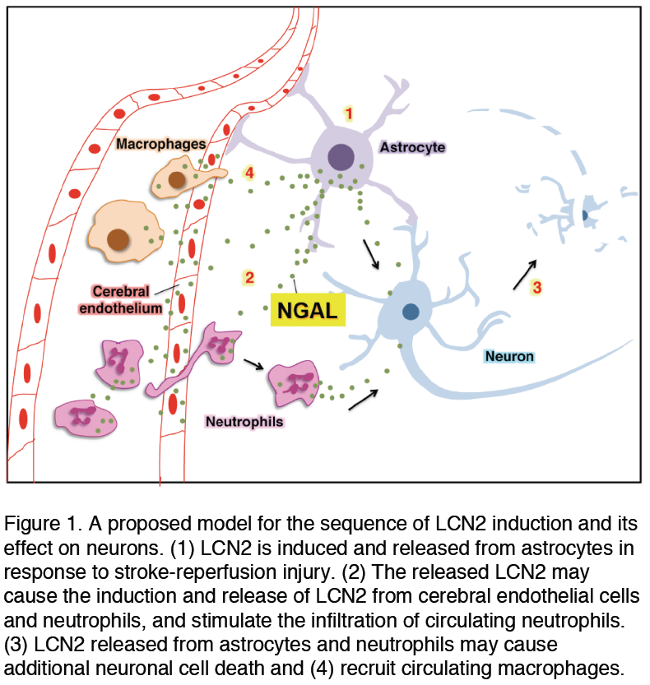
Recent Publications (minimum 5)
- *Kumar, V., *Weng, Y.-C., Geldenhuys, W.J., Wang, D., Han, X., Messing, R.O., Chou, W.-H. (2015) Generation and Characterization of ATP Analog-specific Protein Kinas C delta. Journal of Biological Chemistry. 290(4):1936–51. (*co-first author)
- Wang, G., Weng, Y.-C., Han, X., Whaley, J.D., McCrae, K.R., Chou, W.-H. (2015) Lipocalin-2 released in response to cerebral ischemia mediates reperfusion injury in mice. Journal of Cellular and Molecular Medicine. 19(7):1637-45.
- Weng, Y.-C., Wang, G., Messing, R.O., Chou, W.-H. (2015) Identification of lipocalin-2 as a PKC delta phosphorylation substrate in neutrophils. Journal of Biomedical Science. 22:21
- Weng Y.-C., Chou W.-H. (2015) Neutrophil Gelatinase-Associated Lipocalin and Matrix Metalloproteinase-9 as Potential Biomarkers for Stroke: A Pilot Study. J Neurol Neurophysiol April, 6:2
- Weng Y.-C., Sonni A, Labelle-Dumais C, de Leau M, Kauffman WB, Jeanne M, Biffi A, Greenberg SM, Rosand J, Gould DB. (2012) COL4A1 mutations in patients with sporadic late-onset intracerebral hemorrhage. Ann Neurol. 71(4):470-7.

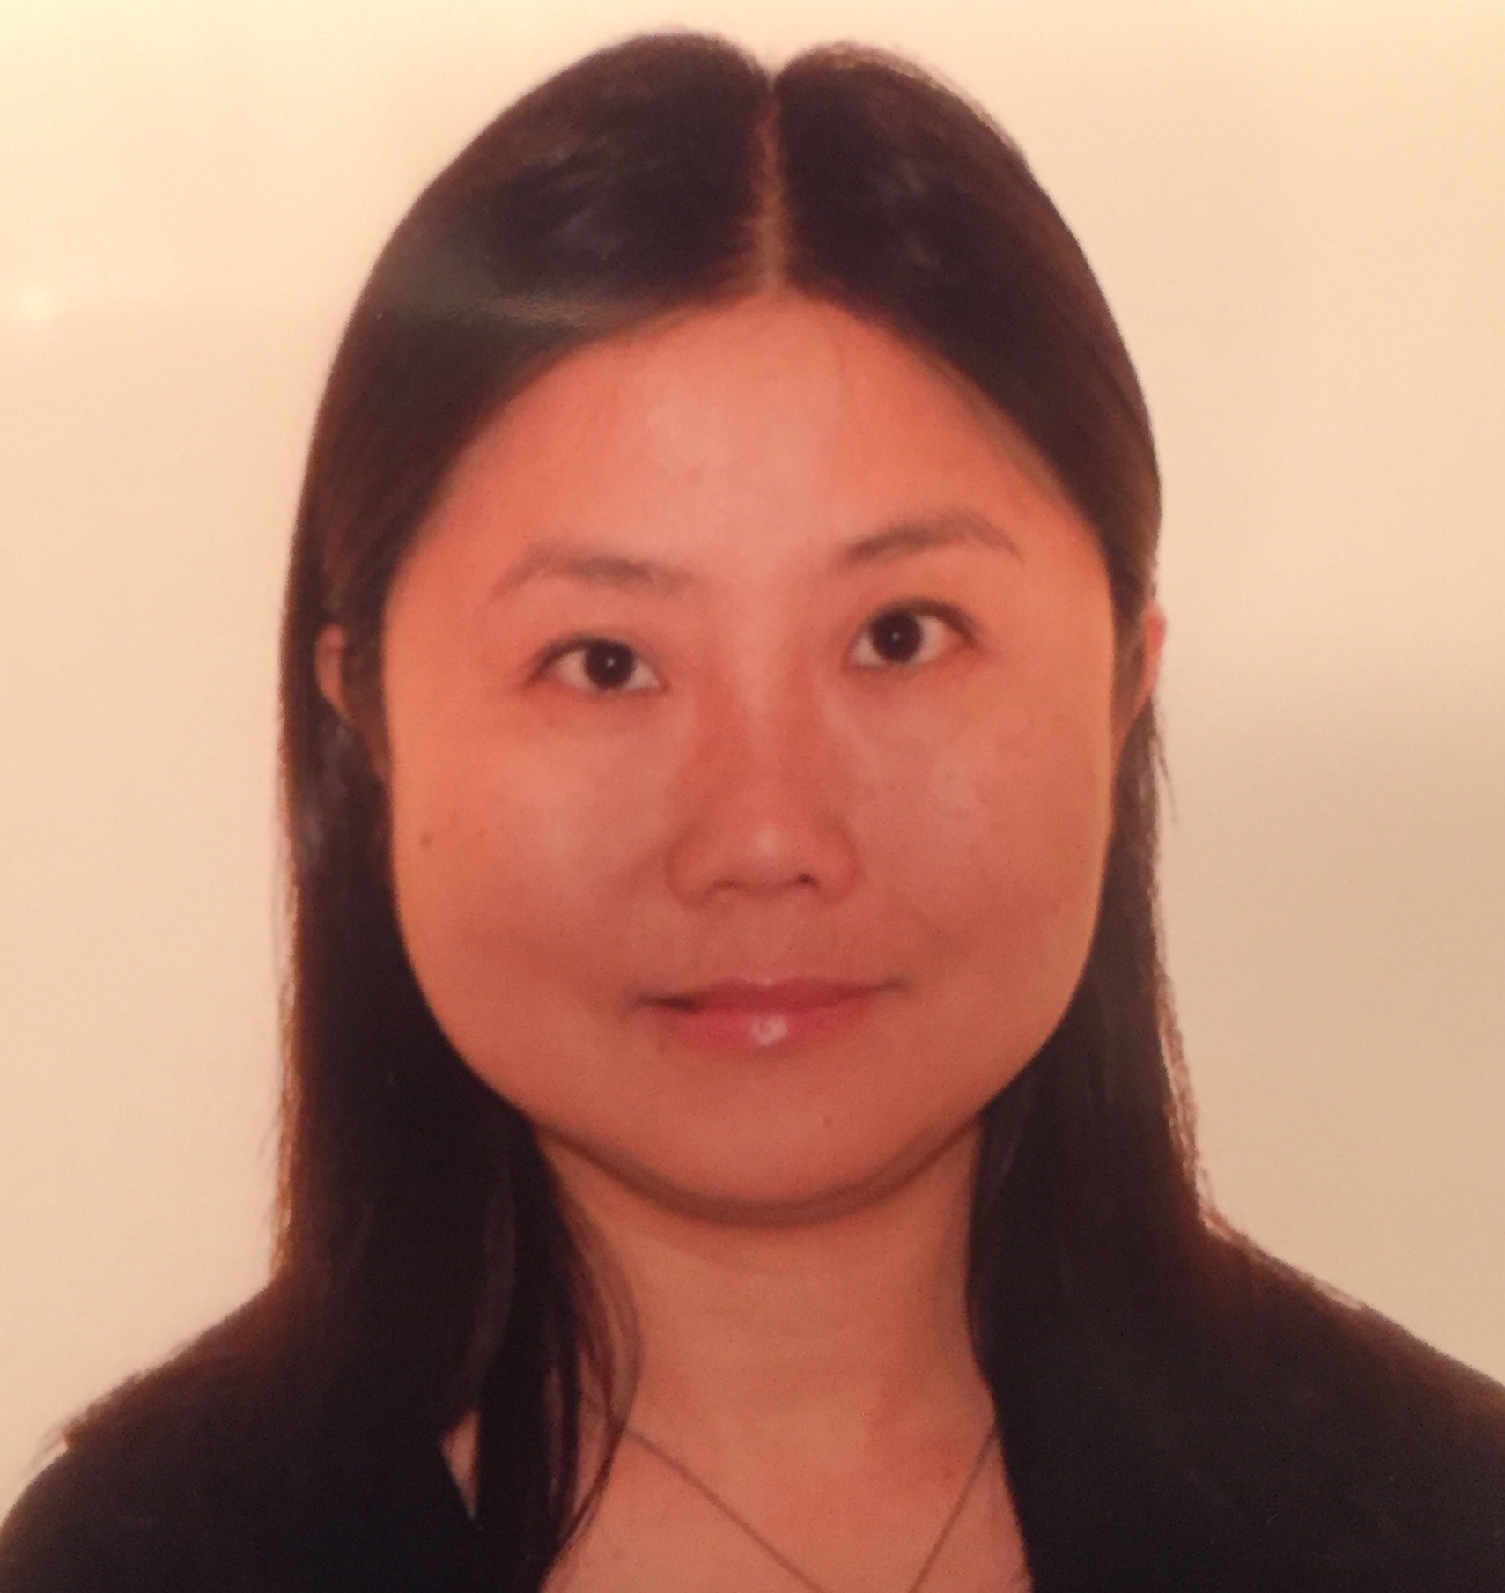 Biography (150 word limit)
Dr. Yi-Chinn Weng received her PhD from Department of Molecular Medicine, University of Texas Health Science Center, San Antonio, and postdoctoral studies from University of California, San Francisco. She has published several research papers in reputed journals including Nature, Proceedings of the National Academy of Sciences, Annals of Neurology, and Journal of Biological Chemistry.
Email: wengyc050706@nhri.org.tw

Notes/Comments:

