Preparation nano emulsions containing rosemary and examination of it effect on nerve cells of the CA1 hippocampus male rat following transient pervasive ischemic/ reperfusion
Evaluation the protective effect of nano emulsions containing rosemary on CA1 hippocampus neurons ischemic/ reperfusion injury

Abstract:
Background: Stroke is an important cause of mortality and morbidity worldwide but effective therapeutic strategy for the prevention of brain injury in patients with cerebral ischemia is lacking. Regard to know the mechanism of injury, the use of plant medicine can help, rosemary is a plant that is accessible and unexpansive that have strong antioxidant and anti-inflammatory effects, that may be helpful.
Material and method: This study had two main parts: in vivo and in vitro. In in vivo part, we divided wistar rats into 8 groups (control, ischemia/reperfusion, 3 dose of alcoholic extracts of rosemary and 3 dose of aqueous extracts of rosemary), after 21 days of rosemary administration the ischemia and reperfusion was done, finally apoptosis gene and neurons death were assayed in hippocampus and in in vitro part we cultured hippocampus neurons (in 7 groups: control, 3 dose of aqueous extracts of rosemary and 3 dose of alcoholic aqueous extracts of rosemary) and then cell viability was assayed.
Results: We demonstrated that 200 mg/kg aqueous extracts of rosemary decrease the apoptosis gene expression and increase the anti-apoptosis gene expression in compare to ischemia (p<0.05) and decrease the neuron death in CA1 region in hippocampus (p<0.05). The neurons viability in culture group with 200 mg/ml alcoholic aqueous extracts of rosemary had no significant difference with control.
Conclusion: Present study demonstrated that cerebral ischemic tolerance induced by rosemary extracts pretreatment, the alcoholic aqueous extracts of rosemary in 200 mg/kg dose was more effective to protect of hippocampus.
Key world: Rosemary, Hippocampus, Ischemia /Reperfusion

Introduction
Stroke is a common and serious disease, that has critical outcome to human health and induce the third common cause of disability among other diseases (1, 2), based on World Health Organization (WHO) report, annually near to 15 million people experience the stroke in the whole world, that Mortality rate is about 5 million and morbidity rate is near to 5 million after stroke (3) for example 30% of patient cannot walk without help, 19% have had associated aphasia and 35% suffer from depression (4) that they impose large burden on healthcare and social service in most countries (5). Stroke can occur because of ischemia or hemorrhagic, that prevalence and morbidity of ischemia stroke is more than hemorrhagic stroke (6).
Critical practice for the treatment of unexpected cerebral ischemic incidents is rapid reperfusion but sometimes post perfusion lesions occur and intensify the brain injury that is called ischemia/Reperfusion (I/R) injury (7) inflammation, oxidative stress and apoptosis are the major factors that induce injury after I/R (8).
As we know one of the major pathway to induce cell death in I/R is apoptosis (9) oxidative stress that occur in I/R, lead the outer membrane of mitochondria to more permeable (10), BAX come to mitochondria from cytosol and cytochrome c release from mitochondria (11), generally, this movements control by Bcl-2 (12), when cytochrome c release into cytosol the apoptosis reaction happen and the last even is activated the caspase 3, so active caspase-3 leads to DNA fragmentation (13). Brain has different part with different function that any injury in each part can disturb the brain function, hippocampus is a part of brain with important roles, especially in learning and memory, including recognition memory and spatial processing/navigation (14), so any damage on hippocampus can disturb the learning and memory. One of the most sensitive part of brain in stroke is neurons in CA1 region in hippocampus (15).
Rosmarinus officinalis L. (Rosemary) is a domestic plant that grown in many parts of the world. rosemary has polyphenols with strong antioxidant activity, the most important and strong antioxidant component are carnosic acid, caffeic acid and its derivatives such as rosmarinic acid. the leaf of rosemary is known therapeutic potential agents against several diseases, so the use of rosemary is suggested as a good human dietary factors (16) and the rosemary component can use for Alzheimer’s disease treatment (17). Phenolic compounds have antioxidant and hypocholesterolemic activities (18), the main natural antioxidant of rosemary is polyphenolic compounds that the essential source of them is leaves of rosemary. Stems, roots and flowers have little content of polyphenols, flower of rosemary in spring is a good source for carnosic acid (19).
The size of drugs is an important factor to their effects, the small size of drug increase the surface area per mass unit of drugs so enhance the stability and solubility in foods, this event occur in nano emulsions that defined as oil droplets which their sizes is in the range of 20–100 nm and dispersed in aqueous media (20, 21).
As we know the I/R impose many financial burden in healthcare systems because one third of patients suffer from disability forever, so it is an emergency position in medicine, on the other hand, some medicinal plants are well known and their side effects are less than some chemical drugs, in addition, they can be used routinely in people's diets. In present study we tried to exam the protective effect of nano emulsions containing rosemary on nerve cells of the CA1 hippocampus male rat against ischemic/ reperfusion.

Materials & Method:
Study design:
This study had two main part: in vivo study and in vitro study.
For in vitro study 48 male wistar rates (between 250-300 g) were purchased from Royan Iran company, randomly divided into 8 groups (n=6). The rats kept in standard condition (12-hour lighting and 12 hours of darkness, in 22-24 °C.), with free access to sufficient amounts of water and food.
The experimental groups were:
- Control group: The rats just anesthetized, without treatment or surgery
- Ischemic/Reperfusion group: After anesthesia, the carotid arteries were closed for 20 minutes and reperfusion was performed.
- Experimental group 1: IP (intraperitoneal) injection 50 mg / kg of rosemary alcoholic extract, 21 days later, after anesthesia ischemia was done for 20 minutes followed by reperfusion.
- Experimental group 2: IP (intraperitoneal) injection 100 mg / kg of rosemary alcoholic extract, 21 days later, after anesthesia ischemia was done for 20 minutes followed by reperfusion.
- Experimental group 3: IP (intraperitoneal) injection 200 mg / kg of rosemary alcoholic extract, 21 days later, after anesthesia ischemia was done for 20 minutes followed by reperfusion.
- Experimental group 4: IP (intraperitoneal) injection 50 mg / kg of rosemary aqueous extracts, 21 days later, after anesthesia ischemia was done for 20 minutes followed by reperfusion.
- Experimental group 5: IP (intraperitoneal) injection 100 mg / kg of rosemary aqueous extracts, 21 days later, after anesthesia ischemia was done for 20 minutes followed by reperfusion.
- Experimental group6: IP (intraperitoneal) injection 200 mg/kg of rosemary aqueous extracts, 21 days later, after anesthesia ischemia was done for 20 minutes followed by reperfusion.
We used pentobarbital sodium (40 mg/kg) to anesthetize in all groups, I/R injury was done by closing the carotid arteries for 20 minutes and reperfusion. 72 hours after I/R we anesthetized the rats again and sacrificed them, after craniotomy the brain was immediately placed on a cold dish to remove the hippocampus from the cortex. Half of it fixed in fixator (formalin 10%) for more than 3 days to do histology assay and another half was frozen and kept at -80°C to do real time PCR.
For in vitro part of study we need to culture the hippocampus cell and evaluated the effect of two extract in different dose on them, at first to extract the hippocampus cells, hippocampus tissue was suspended in high glucose DMEM medium (Gibco, USA) and then we added collagenase (Sigma-Aldrich, USA) and incubated in 37 °C and 5% CO2 for 30 minutes and pipetted them every 15 minutes, then the cells washed and culture in 75 cm² culture flasks (SPL, South Korea) with high glucose DMEM supplemented by 10% FBS (Fetal Bovine Serum, Gibco, USA) and 100 IU/ml penicillin and 100 mg/ml streptomycin (Sigma-Aldrich, USA), when the cell line confluence of rat hippocampal reached to 80%, cells moved and cultured in 96 well culture plate and divided into 7 groups:
1) control group, without any extract
2) 50 mg/ml aqueous extracts of rosemary
3) 100 mg/ml aqueous extracts of rosemary
4) 200 mg/ml aqueous extracts of rosemary
5) 50 mg/ml alcoholic aqueous extracts of rosemary
6) 100 mg/ml alcoholic aqueous extracts of rosemary
7) 200 mg/ml alcoholic aqueous extracts of rosemary
Preparation of Nano emulsion containing rosemary:
The preparation of rosemary nano emulsion was done by the method that was described by AlMotwaa et all in 2020, with some modification. At first 5.5% of tween 80 and Span 20 in a ratio of 2 to 1 was mixed, then 1.8% of rosemary extract and 92.7% water added, mixed and reached to 70°C until the white emulsion converted to transparent solution (22).
Characterization of Nano emulsion containing rosemary
After preparation of nano emulsion containing rosemary finished, we examined them by DLS (Dynamic light scattering) to evaluate the hydrodynamic diameter of nano emulsion containing rosemary, measured the zeta potential as marker to investigate the surface charge of nano emulsion and TEM to check the direct shape and size of nano emulsion.
To check the stability of the nano in the environment, we kept the solution at four different temperatures for one and three months, and then the DLS was performed again.
Nissl Staining:
After fixation time, tissue dehydrated by alcohol in different degree, cleared and embedded in paraffin and sectioned with a microtome (Leitz 1512, Germany) at 10 μm thickness and mounted on a glass slide, before staining the glass slide kept in oven at 37 °C. Based on standard histology protocols, the glass slide was hydrated and then immersed in Cresyl violet acetate 0.1% solution in distilled water and then washed with distilled water, dehydrated by ethanol, and cleared in xylene and finally mounted (23, 24).
To evaluated the glass slide we used the light microscope and X400 magnification, neurons with clear nuclei and nucleus were considered as healthy neurons.
MTT assay:
100 microliters of MTT solution (Sigma-Aldrich, USA) added to each well and the plate was incubated for 4 hours in 37 °C incubator with 5% CO₂, then 100 microliters of DMSO (as solvent for formases) were added to each well after removed the MTT solution. The absorption was read by the ELISA reader at 570 nm (25). The formula of cell viability that we used is:
Cell viability = (Sample OD/ Blank* OD) × 100
* DMSO was blank
Flow cytometry:
To evaluate the apoptosis and necrosis, Propidium iodide and Annexin V-FITC were used. the cells were incubated with Annexin V-FITC 5 mg/ml and propidium iodide 6 mg/ml in 6 well culture plate for 20 minutes in room temperature to identify the dead cells, then the cells were moved to tubes and samples were analyzed by flow cytometry on a FACS vantage (Becton Dickinson). Finally, the results were analyzed by FlowJo version 7.6.1 software (26).
Real rime PCR:
To investigate the genes expression, the primers were designed (Table 1) and custom. First step was the extraction of whole RNA in the tissue (parstous kit, Iran) and the absorbance values of RNA at OD 260 and OD 280 were detected (260/280=1.8-2 was acceptable), then the cDNA was synthesized (yekta tajhiz azma kite, Iran).
To do real time PCR we mixed the forward and reverse primers, cDNA and cyber green master mix and reach their volume to 20ul and put the strips in stratagene mx3000p instrument, to evaluate the gene expression the CTs (cycle threshold) were analyzed by REST software (27).
Statistical analysis:
All statistical analysis was performed by Prism Ver.3 statistical software using nonlinear regression method and comparison of data with ANOVA and T-test (posttest: Tukey) analysis method.
Result:
Characterization of Nano emulsion containing rosemary:
Based on DLS result the hydrodynamic diameter of aqueous extracts of rosemary was near to 10 nm and alcoholic aqueous extracts of rosemary was near to 700 nm (figure1, a and b), this diameter is important because we need to use this nano emulsion in water and by this test we demonstrated the diameter of them in water. The zeta potential of aqueous extracts of rosemary was near to -30 mV and in alcoholic aqueous extracts of rosemary was near to 0 mV (figure1, c and d), the more negative surface charge of aqueous extracts of rosemary show the more stability of it in compare to alcoholic aqueous extracts of rosemary (28). Based on TEM images the diameter of aqueous extracts of rosemary was 50 nm and alcoholic aqueous extracts of rosemary was 100 nm (figure1, e and f).
After one and three months we evaluated the nano emulsion by DLS again, the DLS reports demonstrated that nano emulsion was stable in all four temperatures, even room temperature.
Nissl Staining:
In nissl staining image we evaluated the health pyramidal neurons in CA1 region of hippocampus (figure 2 a-h), the number of normal neurons in control group was more than all groups and the degenerated neurons was increased in I/R group and we compared the mean of the health neurons between all groups (figure 2 i), there was no significant different between treatment groups and all of them could increase the health neurons in compared to I/R group, but the health neurons in 200 mg/kg aqueous extracts of rosemary (Experimental group 6) was more than another treatment groups.
MTT assay:
To evaluate the cell viability rate in different groups on in vivo part of study we used MTT assay, generally alcoholic aqueous extracts of rosemary was better than aqueous extracts of rosemary (Figure 3 a), in aqueous extracts of rosemary, 200 mg/ml was better than 100 mg/ml and 50mg/ml (Figure 3 b) and in alcoholic aqueous extracts of rosemary 100 mg/ml had better cell viability in compare to another doses (Figure 3 c).
Flow cytometry:
The live cells were assayed by Flow cytometry, generally alcoholic aqueous extracts of rosemary were better than aqueous extracts of rosemary (Figure 4), and in aqueous extracts of rosemary, 200 mg/ml was better than 100 mg/ml and 50mg/ml (Figure 4 a) and in alcoholic aqueous extracts of rosemary 200 mg/ml had better cell viability in compare to another doses (Figure 4 b).
Real rime PCR:
BCL2 gene expression as anti-apoptotic gene in I/R group significantly decreased and in alcoholic aqueous extracts of rosemary 200 mg/kg the expression of BCL2 increased in compared to I/R (P<0.05) and had no significant difference with control group (Figure 5 a).
The BAX gene expression as apoptotic gene decreased in control group and increased in I/R group, pretreatment with alcoholic aqueous extracts of rosemary 200 mg/kg decrease the expression of BCL2 in compared to I/R group (P<0.05) and had no significant difference with control group (Figure 5 b). Another apoptotic gene that was evaluated was Caspase 3 gene, in control group the expression was decreased and in I/R increased, treatment with alcoholic aqueous extracts of rosemary in all doses decreased this expression in compared to I/R and had no different with control group (Figure 5 c).
Discussion:
The stroke is an even that occur with high prevalence, significant number of stroke victims die and some of them become disabled for the rest of their lives, so it imposes a lot of financial burden on the health care systems (3, 5). Damage to blood–brain barrier (BBB), and then brain edema are the main pathogenesis of brain stroke that lead to cell death (29), the last event in brain I/R damage is apoptosis from different pathway such as oxidative stress, inflammation and etc. (8), one of the most important mechanism of I/R injuries that disrupt the BBB and subsequently cell death is oxidative stress (30). In our study we confirmed this issue, nissle staining image demonstrated that health neurons decreased in I/R group. Anti-apoptotic gene, BCL2 expression decreased and BAX and caspase 3 gene as apoptosis gene increased in I/R group that indicate the rate of apoptosis in I/R increase. Bcl-2 is the key cell apoptosis inhibitory protein. Its regulatory effect depends on its expression, although the Bcl-2-Bax ratio is also considered a key factor. When the Bcl-2-Bax ratio increases, cell apoptosis is decrease and when the ratio is decreased, apoptosis is increase (31).
The increase of interest in traditional and herbal medicines can be explained by the low efficacy and lack of widely applicable pharmacological treatments (32), as well known the aqueous and alcoholic extracts of the leaves of rosemary have many different pharmacological properties, such as anti-bacterial, anti-thrombotic, anti-ulceogenic, diuretic, anti-diabetic, anti-noceptive, anti-depressant activities, hepatoprotective, antioxidant and anti-inﬂammatory (33). The rosemary extract can decrease the reactive oxygen species production and inﬂammatory response (34) so reduce lipid peroxidation in heart and brain (cortex and hippocampus) (35) subsequently decrees the cell death. The clinical administration the combination of rosemary with rho iso-alpha acids from hops, and oleanolic acid (named NG440) could effect on inflammatory cytokines and PGE2 (Prostaglandin E₂) production and decreased pain by 50% in patients with osteoarthritis (as inflammatory disease) (36).
Based on nissl staining we demonstrated that the pretreatment with extract of rosemary could decrease the CA1 region neuronal death in compared to I/R group and had no significant different with control group and in in vivo part of our study the rosemary extract could increase the cell viability in MTT and flow cytometry, but between the two extract the alcoholic aqueous extracts of rosemary had more protective effect. Pretreatment with rosemary extract could increase the BCL2 and decrease the BAX and caspase 3, 200 mg/kg of alcoholic aqueous extracts of rosemary was more effective to protect CA1 region to apoptosis and could reach their expression to control group. The same study indicated that alcoholic aqueous extracts of rosemary decline lipid peroxidation and hydroxyl anion radical and hydrogen peroxide activities in rat serum, liver, kidney, heart, and brain tissues (29), Furthermore, alcoholic aqueous extracts of rosemary administration could be useful for cerebral infarction, and neurological scores, and significant decrease the permeability of BBB subsequently decrease the brain edema (37), so reduce the damage of I/R in brain.
Conclusion:
In conclusion, the present study demonstrated that cerebral ischemic tolerance induced by rosemary extracts pretreatment, it could decrease the oxidative stress and subsequently apoptosis that induced by ischemia and reperfusion in CA1 region. The alcoholic aqueous extracts of rosemary in 200 mg/kg dose was more effective to protect the CA1 and therefore, could improve stroke outcome. Since the stroke impose many a lot of financial and human burden to the health system and rosemary is unexpansive and accessible plant, it may be reasonable to recommend use routinely.

References:
1. Tang Q, Han R, Xiao H, Shen J, Luo Q, Li J. Neuroprotective effects of tanshinone IIA and/or tetramethylpyrazine in cerebral ischemic injury in vivo and in vitro. Brain research. 2012;1488:81-91.
2. Urban PP, Wolf T, Uebele M, Marx JrJ, Vogt T, Stoeter P, et al. Occurence and clinical predictors of spasticity after ischemic stroke. Stroke. 2010;41(9):2016-20.
3. Organization WH. The world health report 2002: reducing risks, promoting healthy life: World Health Organization; 2002.
4. Kelly-Hayes M, Beiser A, Kase CS, Scaramucci A, D’Agostino RB, Wolf PA. The influence of gender and age on disability following ischemic stroke: the Framingham study. Journal of Stroke and Cerebrovascular Diseases. 2003;12(3):119-26.
5. Feigin VL, Lawes CM, Bennett DA, Anderson CS. Stroke epidemiology: a review of population-based studies of incidence, prevalence, and case-fatality in the late 20th century. The Lancet Neurology. 2003;2(1):43-53.
6. Hosseini AA, Sobhani-Rad D, Ghandehari K, Benamer HT. Frequency and clinical patterns of stroke in Iran-Systematic and critical review. BMC neurology. 2010;10(1):72.
7. Eltzschig HK, Eckle T. Ischemia and reperfusion—from mechanism to translation. Nature medicine. 2011;17(11):1391.
8. Abdel-Aleem GA, Khaleel EF, Mostafa DG, Elberier LK. Neuroprotective effect of resveratrol against brain ischemia reperfusion injury in rats entails reduction of DJ-1 protein expression and activation of PI3K/Akt/GSK3b survival pathway. Archives of physiology and biochemistry. 2016;122(4):200-13.
9. Mattson M, Duan W, Pedersen W, Culmsee C. Neurodegenerative disorders and ischemic brain diseases. Apoptosis. 2001;6(1-2):69-81.
10. Kowaltowski AJ, Castilho RF, Vercesi AE. Mitochondrial permeability transition and oxidative stress. FEBS letters. 2001;495(1-2):12-5.
11. Kroemer G. Mitochondrial control of apoptosis: an introduction. Biochemical and biophysical research communications. 2003;304(3):433-5.
12. Kuwana T, Mackey MR, Perkins G, Ellisman MH, Latterich M, Schneiter R, et al. Bid, Bax, and lipids cooperate to form supramolecular openings in the outer mitochondrial membrane. Cell. 2002;111(3):331-42.
13. Yuan Y, Guo Q, Ye Z, Pingping X, Wang N, Song Z. Ischemic postconditioning protects brain from ischemia/reperfusion injury by attenuating endoplasmic reticulum stress-induced apoptosis through PI3K-Akt pathway. Brain research. 2011;1367:85-93.
14. Mira RG, Lira M, Tapia-Rojas C, Rebolledo DL, Quintanilla RA, Cerpa W. Effect of alcohol on hippocampal-dependent plasticity and behavior: Role of glutamatergic synaptic transmission. Frontiers in Behavioral Neuroscience. 2019;13:288.
15. Morioka T, Kalehua A, Streit W. Progressive expression of immunomolecules on microglial cells in rat dorsal hippocampus following transient forebrain ischemia. Acta neuropathologica. 1992;83(2):149-57.
16. Al-Sereiti M, Abu-Amer K, Sena P. Pharmacology of rosemary (Rosmarinus officinalis Linn.) and its therapeutic potentials. 1999.
17. Ono K, Hasegawa K, Naiki H, Yamada M. Curcumin has potent anti‐amyloidogenic effects for Alzheimer's β‐amyloid fibrils in vitro. Journal of neuroscience research. 2004;75(6):742-50.
18. Afonso MS, de O Silva AM, Carvalho EB, Rivelli DP, Barros SB, Rogero MM, et al. Phenolic compounds from Rosemary (Rosmarinus officinalis L.) attenuate oxidative stress and reduce blood cholesterol concentrations in diet-induced hypercholesterolemic rats. Nutrition & metabolism. 2013;10(1):19.
19. Del Bano MJ, Lorente J, Castillo J, Benavente-García O, Del Rio JA, Ortuño A, et al. Phenolic diterpenes, flavones, and rosmarinic acid distribution during the development of leaves, flowers, stems, and roots of Rosmarinus officinalis. Antioxidant activity. Journal of agricultural and food chemistry. 2003;51(15):4247-53.
20. Mason TG, Wilking JN, Meleson K, Chang CB, Graves SM. Nanoemulsions: formation, structure, and physical properties. Journal of Physics: Condensed Matter. 2006;18(41):R635.
21. Odriozola-Serrano I, Oms-Oliu G, Martín-Belloso O. Nanoemulsion-based delivery systems to improve functionality of lipophilic components. Frontiers in nutrition. 2014;1:24.
22. AlMotwaa SM, Alkhatib MH, Alkreathy HM. Incorporating ifosfamide into salvia oil-based nanoemulsion diminishes its nephrotoxicity in mice inoculated with tumor. Advanced Pharmaceutical Bulletin. 2020;10(1).
23. Kolijn K, van Leenders GJ. Comparison of RNA extraction kits and histological stains for laser capture microdissected prostate tissue. BMC research notes. 2016;9(1):17.
24. Sadeghi A, Bideskan AE, Alipour F, Fazel A, Haghir H. The effect of ascorbic acid and garlic administration on lead-induced neural damage in rat offspring’s hippocampus. Iranian journal of basic medical sciences. 2013;16(2):157.
25. Kumar P, Nagarajan A, Uchil PD. Analysis of cell viability by the MTT assay. Cold Spring Harbor Protocols. 2018;2018(6):pdb. prot095505.
26. Macey MG, Macey MG. Flow cytometry: Springer; 2007.
27. Yuan JS, Reed A, Chen F, Stewart CN. Statistical analysis of real-time PCR data. BMC bioinformatics. 2006;7(1):85.
28. Ayala V, Herrera AP, Latorre-Esteves M, Torres-Lugo M, Rinaldi C. Effect of surface charge on the colloidal stability and in vitro uptake of carboxymethyl dextran-coated iron oxide nanoparticles. Journal of nanoparticle research. 2013;15(8):1874.
29. Huang P, Zhou C-M, Liu Y-Y, Hu B-H, Chang X, Zhao X-R, et al. Cerebralcare Granule® attenuates blood–brain barrier disruption after middle cerebral artery occlusion in rats. Experimental neurology. 2012;237(2):453-63.
30. Raza S, Khan M, Ahmad A, Ashafaq M, Islam F, Wagner A, et al. Neuroprotective effect of naringenin is mediated through suppression of NF-κB signaling pathway in experimental stroke. Neuroscience. 2013;230:157-71.
31. Liu G, Wang T, Wang T, Song J, Zhou Z. Effects of apoptosis‑related proteins caspase‑3, Bax and Bcl‑2 on cerebral ischemia rats. Biomedical reports. 2013;1(6):861-7.
32. Feigin VL. Herbal medicine in stroke: does it have a future? : Am Heart Assoc; 2007.
33. Amaral GP, de Carvalho NR, Barcelos RP, Dobrachinski F, de Lima Portella R, da Silva MH, et al. Protective action of ethanolic extract of Rosmarinus officinalis L. in gastric ulcer prevention induced by ethanol in rats. Food and Chemical Toxicology. 2013;55:48-55.
34. Lian K-C, Chuang J-J, Hsieh C-W, Wung B-S, Huang G-D, Jian T-Y, et al. Dual mechanisms of NF-κB inhibition in carnosol-treated endothelial cells. Toxicology and Applied Pharmacology. 2010;245(1):21-35.
35. Posadas S, Caz V, Largo C, De la Gandara B, Matallanas B, Reglero G, et al. Protective effect of supercritical fluid rosemary extract, Rosmarinus officinalis, on antioxidants of major organs of aged rats. Experimental gerontology. 2009;44(6-7):383-9.
36. Minich DM, Bland JS, Katke J, Darland G, Hall A, Lerman RH, et al. Clinical safety and efficacy of NG440: a novel combination of rho iso-alpha acids from hops, rosemary, and oleanolic acid for inflammatory conditions. Canadian journal of physiology and pharmacology. 2007;85(9):872-83.
37. Seyedemadi P, Rahnema M, Bigdeli MR, Oryan S, Rafati H. The neuroprotective effect of rosemary (Rosmarinus officinalis L.) hydro-alcoholic extract on cerebral ischemic tolerance in experimental stroke. Iranian journal of pharmaceutical research: IJPR. 2016;15(4):875.

Table and figures:
Primer Sequence | Gene Name
ACATGGAAGCGAATCAATGGACTC | Forward primer | CASPASE3
AAGGACTCAAATTCTGTTGCCACC | Reverse primer | CASPASE3
TGTGGATGACTGACTACCTGAACC | Forward primer | Bcl-2
CAGCCAGGAGAAATCAAACAGAGG | Reverse primer | Bcl-2
TGCTTCAGGGTTTCATCCA | Forward primer | Bax
GACACTCGCTCAGCTTCTTG | Reverse primer | Bax
CGTGAGTGGAGTCATACTGGAA | Forward primer | GAPDH
AACGGATTTGGCCGTATTG | Reverse primer | GAPDH
Table 1: The primers sequences

a)  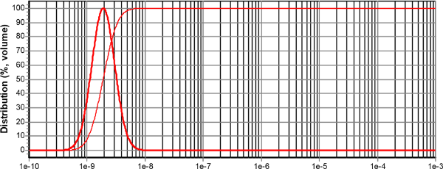 | b)  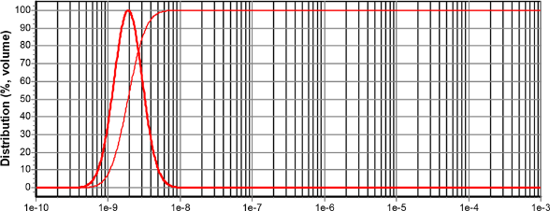
c)  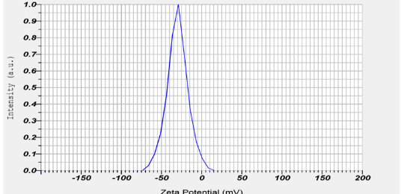 | d)  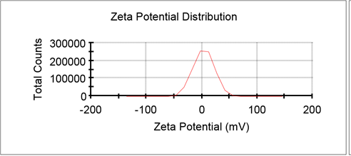
e)  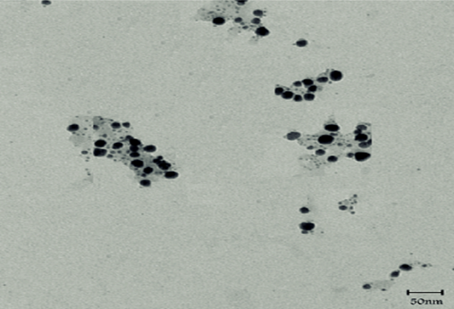 | f)  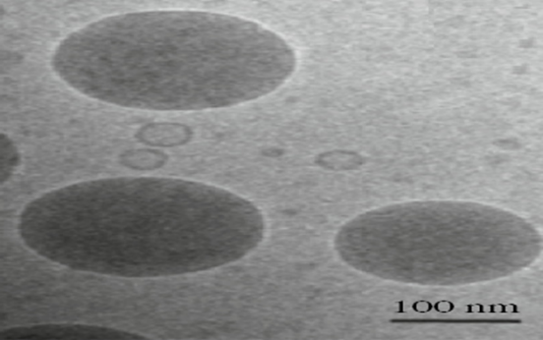
Figure 1: a) DLS of aqueous extracts of rosemary, b) DLS of alcoholic aqueous extracts of rosemary, c) Zeta potential of aqueous extracts of rosemary, d) Zeta potential of alcoholic aqueous extracts of rosemary, e) TEM of aqueous extracts of rosemary and f) TEM of alcoholic aqueous extracts of rosemary.
a)  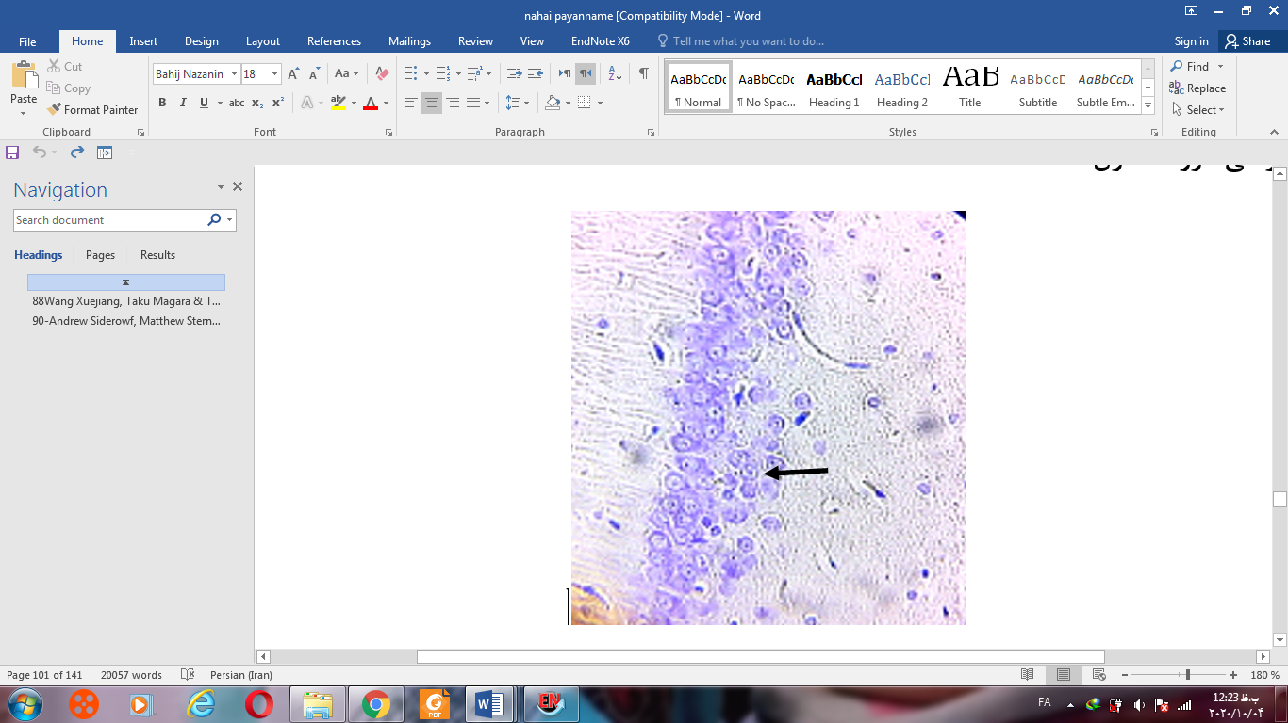 | b)  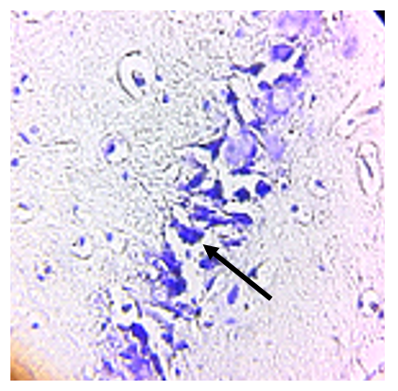 | c)  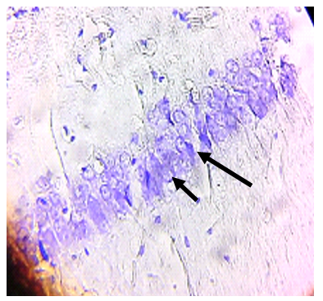
d)  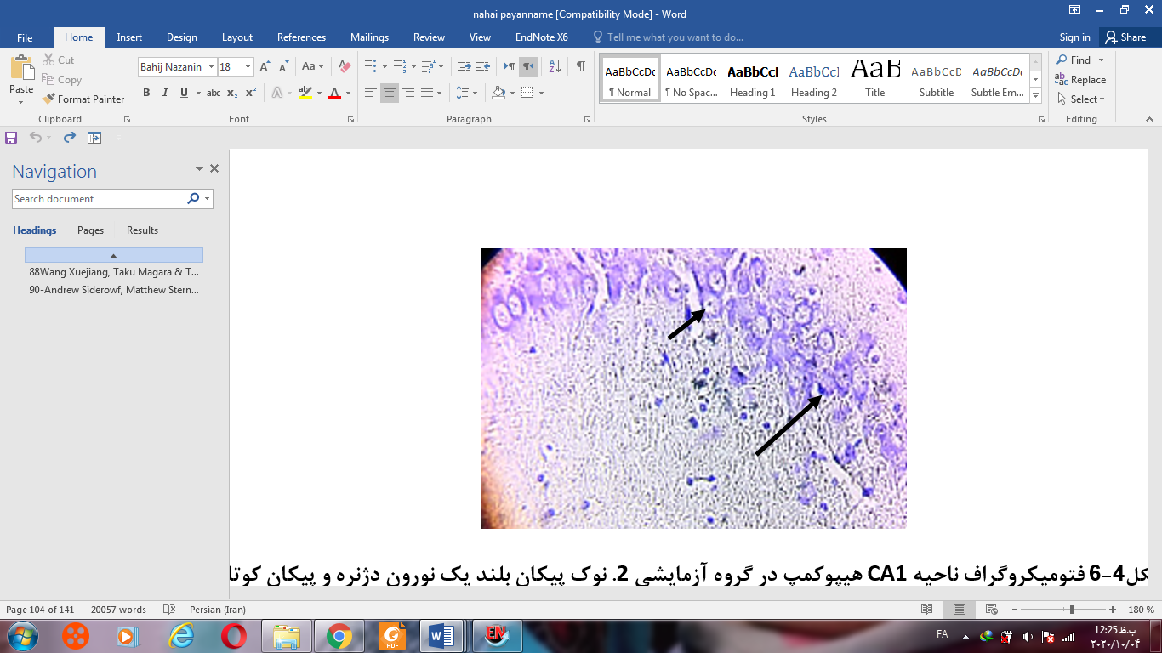 | e)  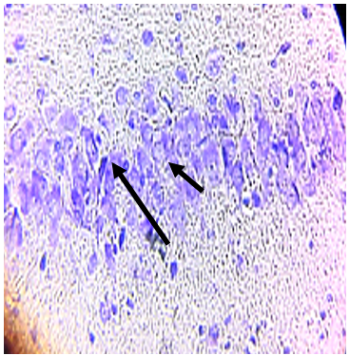 | f)  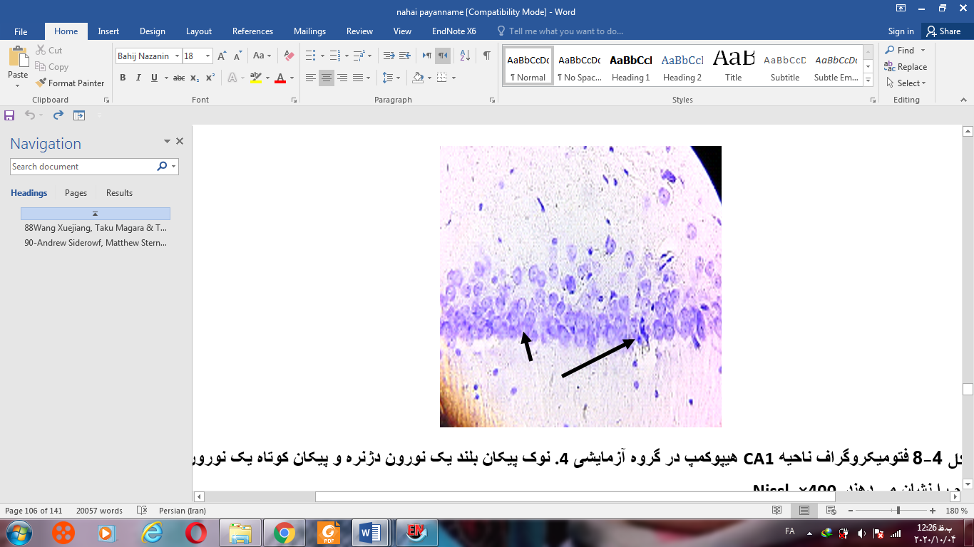
g)  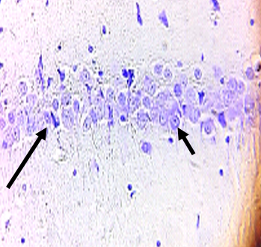 | h)  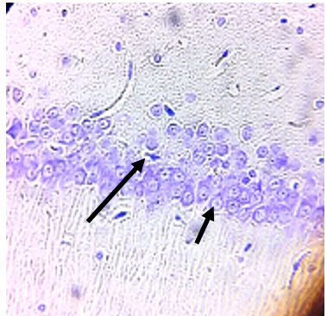 | i)  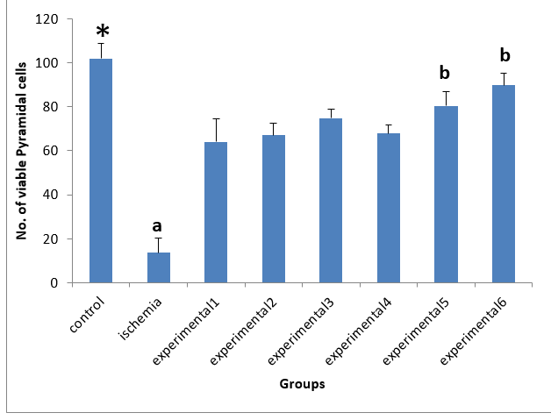
Figure 2. Nissl body staining, a) Control group, b) Ischemia group, c) Experimental group 1: injection of 50 mg/kg aqueous extract of rosemary, d) Experimental group 2: injection of 100 mg /kg aqueous extract of rosemary, e) Experimental group 3: injection of 200 mg/kg aqueous extract of rosemary, f) Experimental group 4: injection of 50 mg/kg alcoholic aqueous extracts of rosemary, g) Experimental group 5: injection of 100 mg/kg alcoholic aqueous extracts of rosemary, h) Experimental group 6: 200 mg/kg alcoholic aqueous extracts of rosemary. The long arrow shows degenerate neurons and the short arrow shows healthy neurons. i) show the number of normal neurons in different groups.

a)
Name | Absorbance 570nm |  | viability%
control | 1.421 | 1.5 | 100%
1 | 0.57 | 0.525 | 37.48716
2 | 0.637 | 0.585 | 41.83499
3 | 0.731 | 0.77 | 51.38651
4 | 1.4 | 1.409 | 96.1657
5 | 1.45 | 1.486 | 100.5135
6 | 1.452 | 1.441 | 99.04143

b)  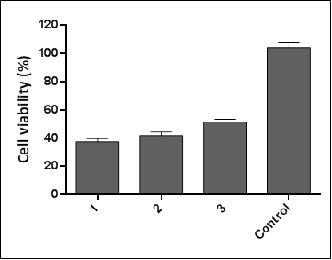 | c)  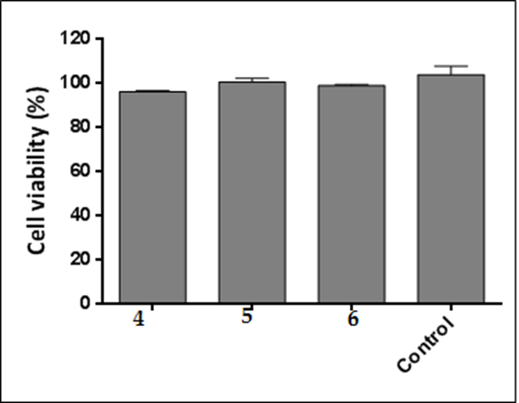
Figure 3: a) The diagram of neurons viability assayed by MTT, b) The graph of neurons viability in aqueous extracts of rosemary assayed by MTT, c) The graph of neurons viability in alcoholic extracts of rosemary assayed by MTT.

a)

b)

Figure 4: a) The graph of neurons viability in aqueous extracts of rosemary assayed by flow cytometry, b) The graph of neurons viability in alcoholic aqueous extracts of rosemary assayed by flow cytometry.

a)

b)

c)

Figure 5: Gene expression. a) The expression of BCL2gene (* indicates p<0.05), b) The expression of BAX gene (* indicates p<0.05), c) The expression of Caspase 3 gene (* indicates p<0.05).

