Cerebral venous dynamics change as potential indication of cerebral aneurysmal rupture
Kwo-Whei Lee^{1,2}, Fong Y Tsai^{1,2,3}, Wei-Liang Chen¹, Chun-Jen Hsueh¹, Julia May Huang^{1,4}
1)Department of Medical Imaging Chang-Hua Christian Hospital, Chang-Hua City, Taiwan.
2)Translational Imaging Research Center, Taipei Medical University, Taipei, Taiwan.
3)University California Irvine, Irvine, California, USA.
4)University California Los Angel, Los Angel, California, USA.

*presenter and correspondence:
Fong Y Tsai, MD, FACR
Translational Imaging Research Center, Taipei Medical University
250 Wu-Hsing Street, Taipei 11031, Taiwan
Telephone:+886-2-2736-1661-2059
FAX: +886-2-2739-0694
E-mail:ftsai@uci.edu or ftsai@tmu.edu.tw

Introduction:
Many inconsistent etiologies of cerebral aneurysmal rupture including a wide spectrum of factors have been reported. Our recent observation discloses the potential new factor of cerebral aneurysm rupture with cerebral venous pressure gradient.
Materials and Methods:
We retrospectively reviewed 25 cases treated with coil embolization with or without cerebral aneurysmal rupture. Seven males and 18 females were recruited in this study. The age ranging from 49 to 71 and average being 59.Quantitative color-coded cerebral angiography was performed during coil therapeutic procedures to measure cerebral venous circulation.
Result and Conclusion:
Cerebral venous circulation time among rupture and non-rupture patients:
Non-rupture: Right ΔCCT:11.32+/-88 Left ΔCCT:12.49+/-42
Rupture: Right ΔCCT:11.12+/-1.87 Left ΔCCT:11.54+/-2.22
Ruptured cases had shorter and symmetrical cerebral venous circulation time (P <0.05). In addition, an asymmetrical venous outflow pattern was critical for aneurysmal rupture as seen in case 1. Non-ruptured cases tended to have slower and asymmetrical cerebral venous circulation compared with rupture cases as seen case 2.
Symmetrical and shorter cerebral venous circulation in the epislateral dysplasia venous outlet may be a potential new factor for cerebral aneurysm rupture. An asymmetrical venous outflow pattern was critical for managing cerebral aneurysm and determine aneurysmal rupture.
Illustrative Case:
Case 1: A 50 year old male presented with acute anterior communicating saccular aneurysm ruptured and treated by endovascular coiling immediately post Dyna CT study. He discharged without any sequelae but still just mild headache.
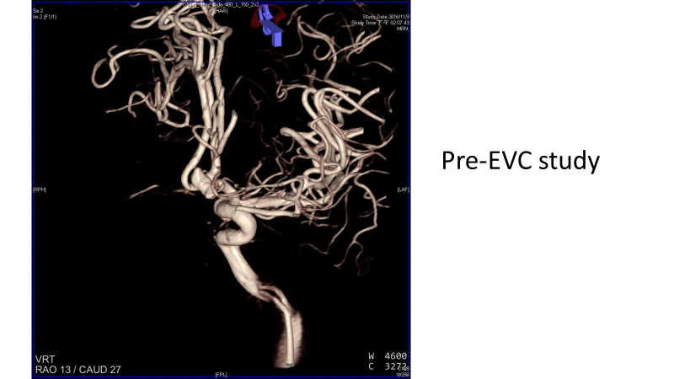

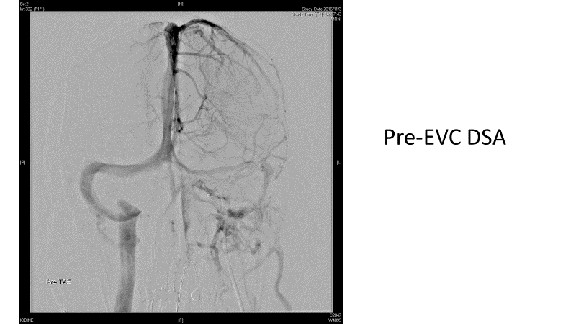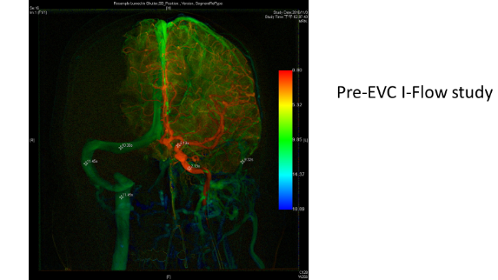
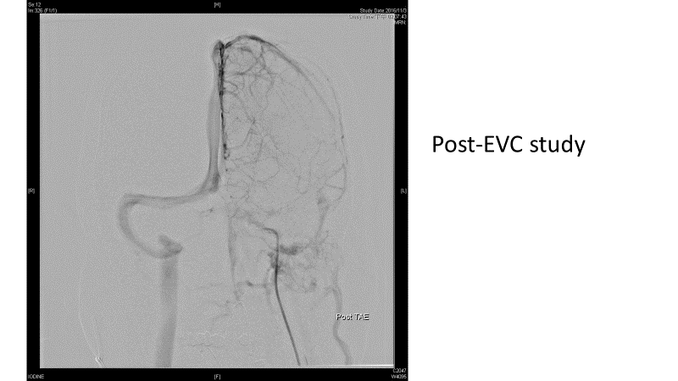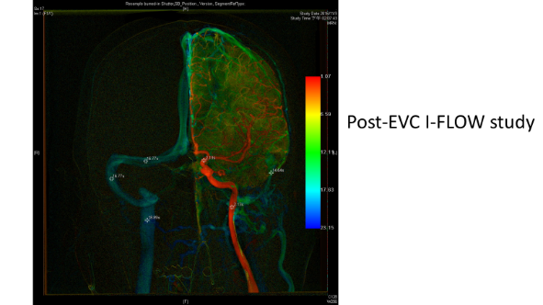

Pre-coiling: Arterial circulation: proximal Lt ICA Lt distal ICA
2.13 2.13
Venous circulation Rt S/S Lt S/S
11.45 11.45
Post-coiling: Arterial circulation: ICA proximal:2.13 distal: 2.13
Venous circulation: right sinus: 16.77 left sinus: 18.89
The venous phase showed atresia of left dural venous sinus, right dural venous sinus is dominated venous drainage but there is symmetrical venous flow. Post-Postcoiling showed the arterial flow had no change but delayed venous flow. This symmetrical venous flow might indicate increasing venous pressure gradient.
Case2: A 64 year old female had asymptomatic non-ruptured Rt distal internal carotid small wide neck saccular aneurysm
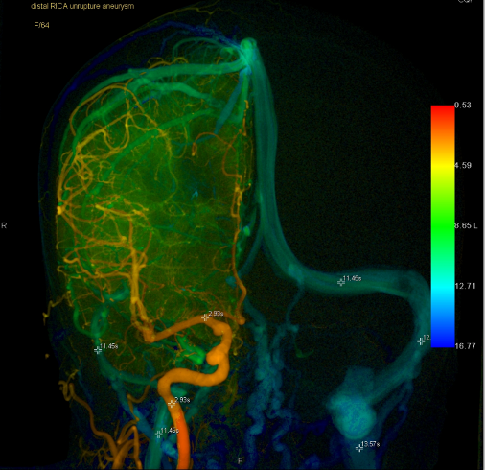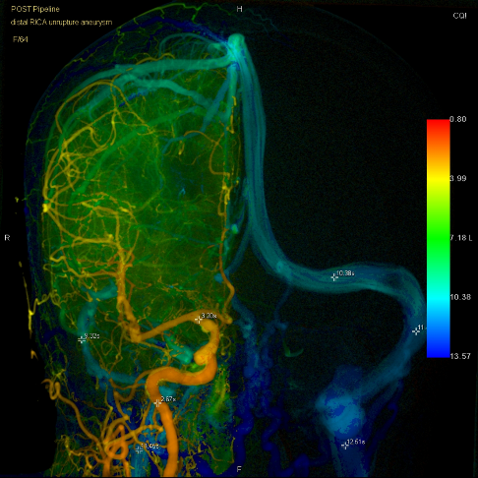
Pre-embolization iFlow Post embolization iFlow
Pre-embolization iFlow study:
Arterial site: proximal ICA 2.93sec, bifurcation 2.93sec
Venous sites : Rt Lt
middle third transverse sinus 11.14 11.45
middle third sigmoid sinus 11.45 12.51
proximal Jugular vein 11.45 13.57
The Rt cerebrum Δ CCT: 11.45 - 2.93= 8.52 sec
The Lt cerebrum ΔCCT: 13.57 – 2.93=10.64 sec
Post-embolization iFlow:
Arterial site: proximal ICA 2.67 sec, bifurcation 3.20 sec
Venous sites : Rt Lt
middle third transverse sinus 9.32 10.38
middle third sigmoid sinus 9.32 11.45
proximal Jugular vein 11.45 12.51
The Rt cerebrum ΔCCT: 11.45 - 2.67 = 8.78 sec
The Lt cerebrum ΔCCT: 12.51 - 2.67 = 9.84 sec
Result and Conclusion:
Cerebral venous circulation time among rupture and non-rupture patients:
Non-rupture: Right ΔCCT:11.32+/-88 Left ΔCCT:12.49+/-42
Rupture: Right ΔCCT:11.12+/-1.87 Left ΔCCT:11.54+/-2.22
Ruptured cases had shorter and symmetrical cerebral venous circulation time (P <0.05). In addition, an asymmetrical venous outflow pattern was critical for aneurysmal rupture as seen in case 1. Non-ruptured cases tended to have slower and asymmetrical cerebral venous circulation compared with rupture cases as seen case 2.
Symmetrical and shorter cerebral venous circulation in the epislateral dysplasia venous outlet may be a potential new factor for cerebral aneurysm rupture. An asymmetrical venous outflow pattern was critical for managing cerebral aneurysm and determine aneurysmal rupture.
References:
Lee KW, Tsai FY, Cheng CY. Venous hypertension may be a factor in aneurysmal rupture. A case report. Neuroradiol J. 2013 Jun;26(3):311-4.
Lee KW, Tsai FY, Chen WL. Intracranial venous hemodynamics and rupture of cerebral aneurysm. Neuroradiol J. 2014;27(6):703-9.

