Title:
Blood transfusion related posterior reversible encephalopathy syndrome - A case report
Author Names:
Mukesh Dube DNB (Medicine), DM (Neurology)¹
Fahad Bin Hamid D.Ortho, DNB (Orthopaedics)²
Rashi Rathore MD (Radiodiagnosis)³

Affiliation:
¹ Department of Medicine
² Department of Orthopaedics
³Department of Radiology
¹Rajshree Medical Research Institute & Hospital Bareilly
Bareilly, UP, India, 243501
^{2,3}Clara Swain Mission Hospital JV
Bareilly, UP
India, 243001

Address for correspondence:
Dr. Mukesh Dube
208A, Kings Court Apartment
Jail Road, Civil Lines
Bareilly, U.P, India
Phone- +91-9893189467
Email: dube_mukesh@yahoo.com

ABSTRACT

Introduction: Posterior reversible encephalopathy syndrome (PRES) is a neurological syndrome associated with by headache, altered mental status, seizures and visual disturbances and characterized by white matter vasogenic edema affecting predominantly the posterior occipital and parietal lobes of the brain. Neurological complications of blood transfusion are uncommon and blood transfusion related PRES is seldom reported. We report here one such case of PRES.
Description: A 61-year-old Asian woman with chronic anemia presented with history of fall causing fracture of left femur neck. As her haemoglobin was 5gms she was transfused with 4 units of packed cells in 3 consecutive days. She was alert, normotensive and afebrile. She later developed mild headache and had a generalized tonic clonic seizure. Her MRI brain showed oedema in bilateral frontal lobes and parieto -occipital lobes with normal MR venogram, consistent with PRES. We described her disorder as blood transfusion related PRES.
Conclusions: Immunologic as well as non immunologic complications of blood transfusion are known but, PRES is rare. Cumulative effects of blood transfusion on blood flow, blood viscosity, endothelial dysfunction leads to blood brain barrier dysfunction which culminates into vasogenic oedema and vasoconstriction despite normal systemic blood pressure, leading to blood transfusion related PRES.
Keywords: Posterior reversible encephalopathy syndrome (PRES), Blood transfusion related posterior reversible encephalopathy syndrome

ACKNOWLEDGEMENT: Not applicable
ETHICAL PUBLICATION STATEMENT: We confirm that we have read the Journal’s position on issues involved in ethical publication and affirm that this report is consistent with those guidelines.
DISCLOSURE OF CONFLICTS OF INTEREST: None of the authors has any conflict of interest to disclose.
FINANCIAL DISCLOSURE: None of the authors has relevant financial relationships to disclose. This research did not receive any grant from funding agencies in the public, commercial, or not-for-profit sectors.
CONTRIBUTORSHIP: All the authors have contributed to the conception and design of the study, analysis and interpretation of data and drafting the manuscript.
COMPLIANCE WITH EHICAL GUIDANCE
All procedures were followed in accordance with Helsinki Declaration of 1975 and subsequent revisions.

Introduction
Posterior reversible encephalopathy syndrome (PRES) is a clinico-radiological syndrome first described by Hinchey et al, characterized by headache, altered mental status, seizures and visual disturbances and characterized by white matter vasogenic edema affecting the posterior occipital and parietal lobes of the brain predominantly.¹ PRES was previously called as (reversible occipital parietal encephalopathy, reversible posterior leukoencephalopathy syndrome and reversible posterior cerebral edema syndrome. The clinical symptoms are myraid, the visual disturbance can vary from blurred vision, homonymous hemianopsia to cortical blindness. Altered consciousness varies from mild confusion, agitation to coma. Seizures, status epilepticus and non convulsive status epilepticus are common presentations. Other symptoms include nausea, vomiting and brainstem deﬁcits.^{1,2}
The conditions associated with acute hypertension may predispose to developing PRES. Peak systolic blood pressure ranging from170 mmHg and 190 mmHg is common, but 10% - 30% of patients have normal or only mildly elevated blood pressure . Acute hypertension is caused secondary to acute kidney injury, eclampsia, autonomic disturbance, for example Guillain-Barré syndrome, and after illicit drug use. Autoimmune diseases— including thrombotic thrombocytopenic purpura and systemic lupus erythematosus, exposure to immunosuppressive drugs such as cyclosporine, tacrolimus, or chemotherapy agents , transplantation including bone marrow or stem cell transplantation, chronic kidney disease, chronic hypertension also cause PRES. Rare causes include blood transfusion, peritoneal and haemodialysis.^{1,3, 4}

Case
61 years old female was referred to us with history of fall at home consequence of which she had difficulty in weight bearing from the left lower limb. Her evaluation with X ray of left femur showed fracture of left femur neck. She was found be anemic with Hb 5 gms. In view of her anemia she was transfused 4 units of packed cells in 3 consecutive days. She was then referred to our orthopaedics department for surgical management. At the time of admission in our hospital she was alert, normotensive (BP 120/70 mm of Hg) and afebrile. She complained of mild headache. Later in the ward she had a generalized tonic clonic seizure. She upon recovery developed confusional state and complained of parieto occipital distribution headache. Her MRI brain showed oedema in bilateral frontal lobes and parieto -occipital lobes with normal MR venogram, consistent with PRES (Fig. 1). Her repeat laboratory investigations showed Hb 15.1 gms, PCV 48.2%, RBC count 5.17 mill/mm³ with normal blood biochemistry. Her lumbar puncture was performed, showing opening pressure of 13 cms H₂O, colourless, Proteins 51.7mg/dl, Glucose 76mg/dl, Total cells 3/mm³ with 100% lymphocytes. Her blood pressure was normal throughout the hospital course. Her old records showed her Hb 8.8gms. Her confusional state as well as headache gradually improved and repeat MRI Brain showed disappearance of brain lesions (Fig. 2). There was no other episode of seizure.
Discussion
Our patient had hallmarks of PRES by having typical clinical features including seizures, benign clinical course and rapidly changing MRI features of vasogenic oedema.
Our patient was a middle aged asian female with chronic anemia with superadded acute insult. She was normotensive throughtout her hospital course and blood transfusion was the inciting cause after extensive search for other causes. Previous reports on transfusion related PRES show similar patient profiles who received blood transfusions and their haemoglobin level increased by at least 5g/dl.^{3,4}
There are few reports in the literature about blood transfusion related posterior reversible encephalopathy syndrome.^{2,3,4} Immunologic as well as non immunologic complications of blood transfusion are known but PRES is rare.²
The etiopathogenesis leading to transfusion related PRES in chronically anemic patients is that chronic anemia may result in a compensatory cerebral vasodilatation. The blood transfusion leads to increased blood flow as well as blood viscosity which results in impaired hypoxic vasodilation, thus an increase in vascular resistance, and ultimately, generalised cerebral vessel constriction.^{3,5} Rapid increase in haematocrit levels with increased blood viscosity and release of prostaglandins, calcium, serotonin, nitric oxide, and endothelin-1 exacerbates endothelial dysfunction which leads to blood brain barrier dysfunction and culminating into vasogenic oedema and vasoconstriction despite normal systemic blood pressure.^{3,4,5} Abrupt or acute cerebral hyperperfusion overwhewlming the autoregulation of cerebral capillary perfusion pressure may result in vasogenic oedema.¹ Release of catecholamines, is also suggested as possible mechanism of vasoconstriction.
Literature review suggests that cerebral vasoconstriction was seen in all reported cases.^{2,3,4,5} Cerebral vasoconstriction de novo can be considered the inciting event of PRES rather than endothelial dysfunction leading to cerebral vasoconstriction and subsequently PRES. The patients’ comorbidities, blood transfusion amount, and duration lead to the variable time frames in the cycle of auto regulation break- through to symptom onset and overt vasoconstriction of major cerebral arteries.³ The temporal course of centripetal progression of the vasoconstrictions as explained by the hypothesis that deranged cerebral vasomotor control might ﬁrst involve small distal arteries that are beyond the resolution of imaging studies, might also explain for the delayed onset of vasoconstrictions.³
We suggest that chronically anemic patients should be transfused blood components with caution as transfusion mediated autoimmunity may predispose to PRES.
Bibliography
- Sudulagunta SR, Sodalagunta MB, Kumbhat M, Settikere Nataraju A. Posterior reversible encephalopathy syndrome (PRES). Oxford medical case reports. 2017 Apr 3;2017(4):omx011.
- Ito Y, Niwa H, Iida T, Nagamatsu M, Yasuda T, Yanagi T, Sobue G. Post-transfusion reversible posterior leukoencephalopathy syndrome with cerebral vasoconstriction. Neurology. 1997 Oct 1;49(4):1174-5.
- Dou YH, Fuh JL, Chen SP, Wang SJ. Reversible cerebral vasoconstriction syndrome after blood transfusion. Headache: The Journal of Head and Face Pain. 2014 Apr;54(4):736-44.
- Zhao ZY, He F, Gao PH, Bi JZ. Blood transfusion-related posterior reversible encephalopathy syndrome. Journal of the neurological sciences. 2014 Jul 15;342(1-2):124-6.
- Liang H, Xu Z, Zheng Z, Lou H, Yue W. Reversible cerebral vasoconstriction syndrome following red blood cells transfusion: a case series of 7 patients. Orphanet journal of rare diseases. 2015 Dec;10(1):47.

Figure 1
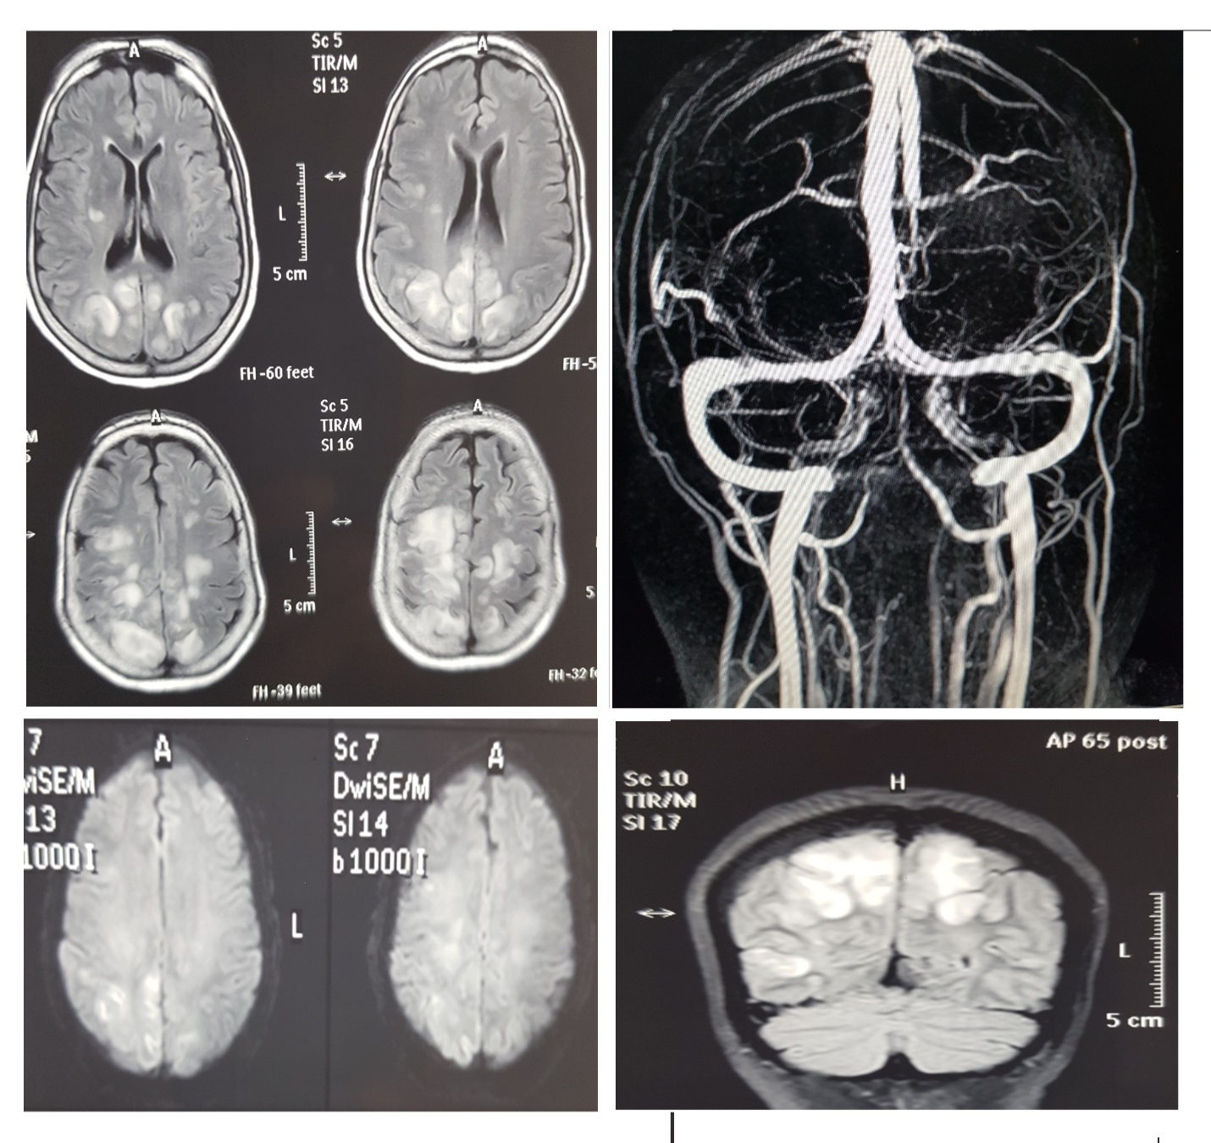

Figure 2

