CHANGES IN THE GABAERGIC SIGNALLING IN THE PREFRONTAL CORTEX OF MICE MODEL OF POST-TRAMAUTIC STRESS DISORDER

Arina Serbina¹, Alexander Bogdanov¹ and Yuriy Pankratov^{1, 2}

¹ Immanuel Kant Baltic Federal University, School of Life Sciences, Kaliningrad, Russian Federation
² The University of Warwick, School of Life Sciences, United Kingdom, Coventry
It has been suggested that the neurons of prefrontal cortex, along with the hippocampus and amygdala, can undergo morphological and molecular remodeling during the development of stress-related disorders, such as PTSD [1]. Pathological remodeling of the GABAergic inhibitory signalling during stress disorders might bring significant contribution to impairment of synaptic plasticity [2] and cognition [3]. In this work we have used an experimental model of PTSD in mice, based on a single prolonged stress protocol [4] and studied alterations in the synaptic transmission and long-term synaptic plasticity in the pyramidal neurons of prefrontal cortex.
The stress state in the animals was evaluated with the aid of Open field and Elevated cross-maze behavioral tests. We have found an increase in the quantal amplitude of GABAergic spontaneous inhibitory synaptic currents (mIPSCs) in the neurons of prefrontal cortex of stressed animals. There was also elevation in the frequency of mIPSCs in neurons of the stress-group vs control group. These results demonstrate that that exposure to stress can cause an up-regulation of the GABAergic inhibitory system in the prefrontal cortex. In the experiments on long-term potentiation (LTP) of field postsynaptic potentials (fEPSP), we have observed that the amplitude of LTP induced by the theta-burst stimulation in the prefrontal cortex synapses of stressed mice was much lower than in the control group. The data obtained suggest that stress-induced up-regulation of inhibitory signalling can affect long-term synaptic plasticity in the prefrontal cortex and thereby contribute to cognitive impairment.
Biography
Arina Serbina is a 4th year graduate student, School of Life Sciences, Immanuel Kant Baltic Federal University, specialty bioengineering and bioinformatics; Alexander Bogdanov is a researcher at School of Life Sciences, Immanuel Kant Baltic Federal University (Russia, Kaliningrad). Dr. Yuriy Pankratov - PhD, Associate professor at School of Life Sciences at the University of Warwick, UK.
Presenting author details
Serbina Arina Valentinovna  Contact number: +7 (900) 570-63-10  serbina_elena@bk.ru  Neurophysiology  Poster presentation | 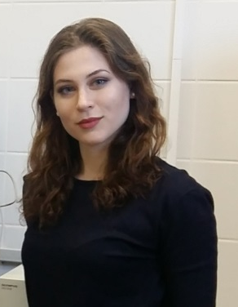

Alexander Bogdanov  Contact number: +7 (931) 603-46-77  AxeBogdanov@gmail.com  Neurophysiology  Category: Poster presentation | 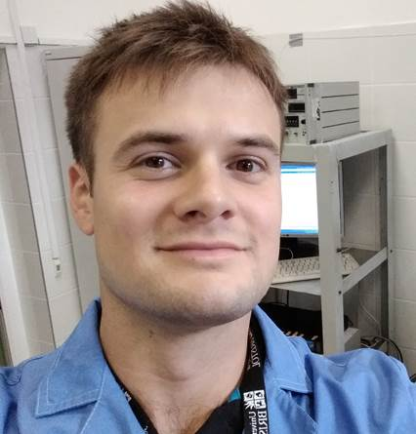

References:
1. Neuroimaging in Posttraumatic Stress Disorder and Other Stress-related Disorders / Bremner J.D. // Neuroimaging Clin. N. Am. 2007.Vol. 17. No. 4. P. 523.
2. McEwen B. S., Morrison J. H. The brain on stress: vulnerability and plasticity of the prefrontal cortex over the life course // Neuron. - 2013. - T. 79. - No. 1 .-- S. 16-29.
3. Yuen E. Y. et al. Repeated stress causes cognitive impairment by suppressing glutamate receptor expression and function in prefrontal cortex // Neuron. - 2012. - T. 73. - No. 5. - S. 962-977.
4. Single prolonged stress: toward an animal model of posttraumatic stress disorder / Yamamoto S. et al. // Depress. Anxiety. 2009.Vol. 26. No. 12. P. 1110–1117.

