Cerebelar Glioblastoma Multiforme: Case Report and Literature Review.
Astrocytomas are brain neoplasms derived from astrocytes. Among the histological subtypes of this neoplasm, degree IV is also known as glioblastoma multiforme (GBM) and the most common primary brain tumor. Cerebellar location for this neoplasm is extremely rare, and since 1975 to 2011 less than 180 cases were registered in the world.
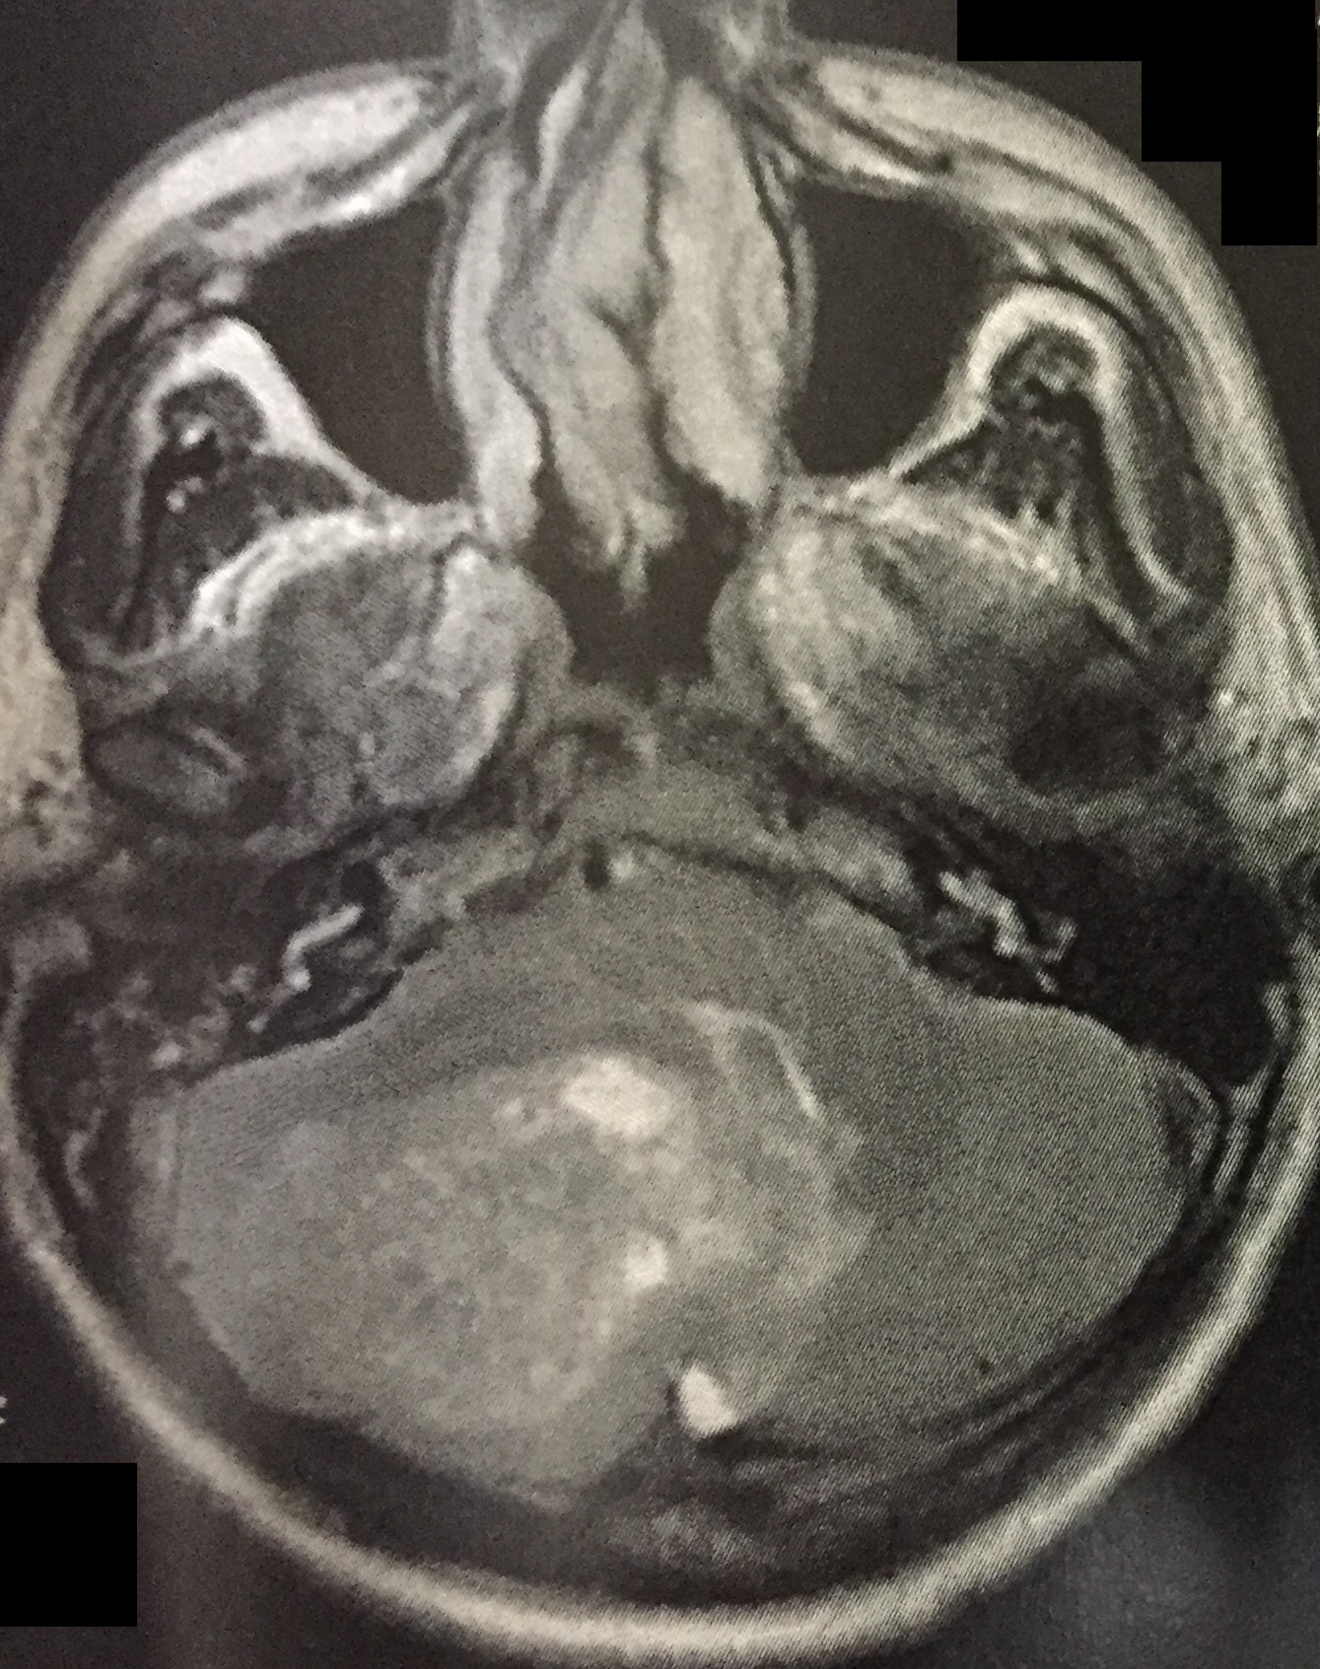
The present report describes a 45-year-old male patient started in May 2017 complaining of a lack of balance. He sought medical care in June, after vertigo worsening associated with intense bilateral throbbing headache. Physical examination showed axial and appendicular ataxia, dysarthria, altered heel-knee test, dysdiadochokinesia and dysmetria worse on the right. It was submitted to magnetic resonance imaging (MRI) of the brain. The examination revealed a neoplastic process in the right posterior fossa, of a heterogeneous character, infiltrating the cerebellar parenchyma and displacing contralaterally the IV ventricle, but without signs of hydrocephalus. In July 2017, a total resection of the heterogeneous lesion was performed, infiltrating adjacent and intensely bleeding cerebellar parenchyma. Histopathological examination and immunohistochemical analysis revealed to be GBM. Subsequent analysis of the IDH gene revealed no mutation.
Axial MRI

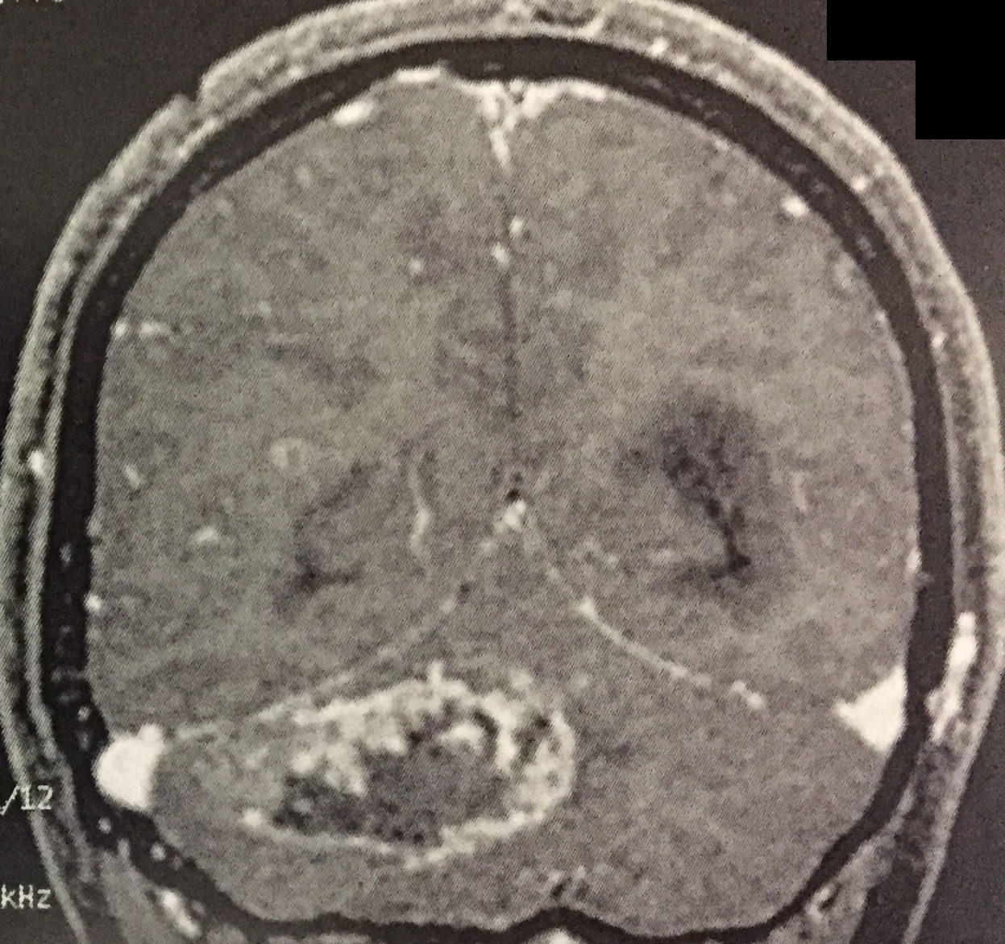
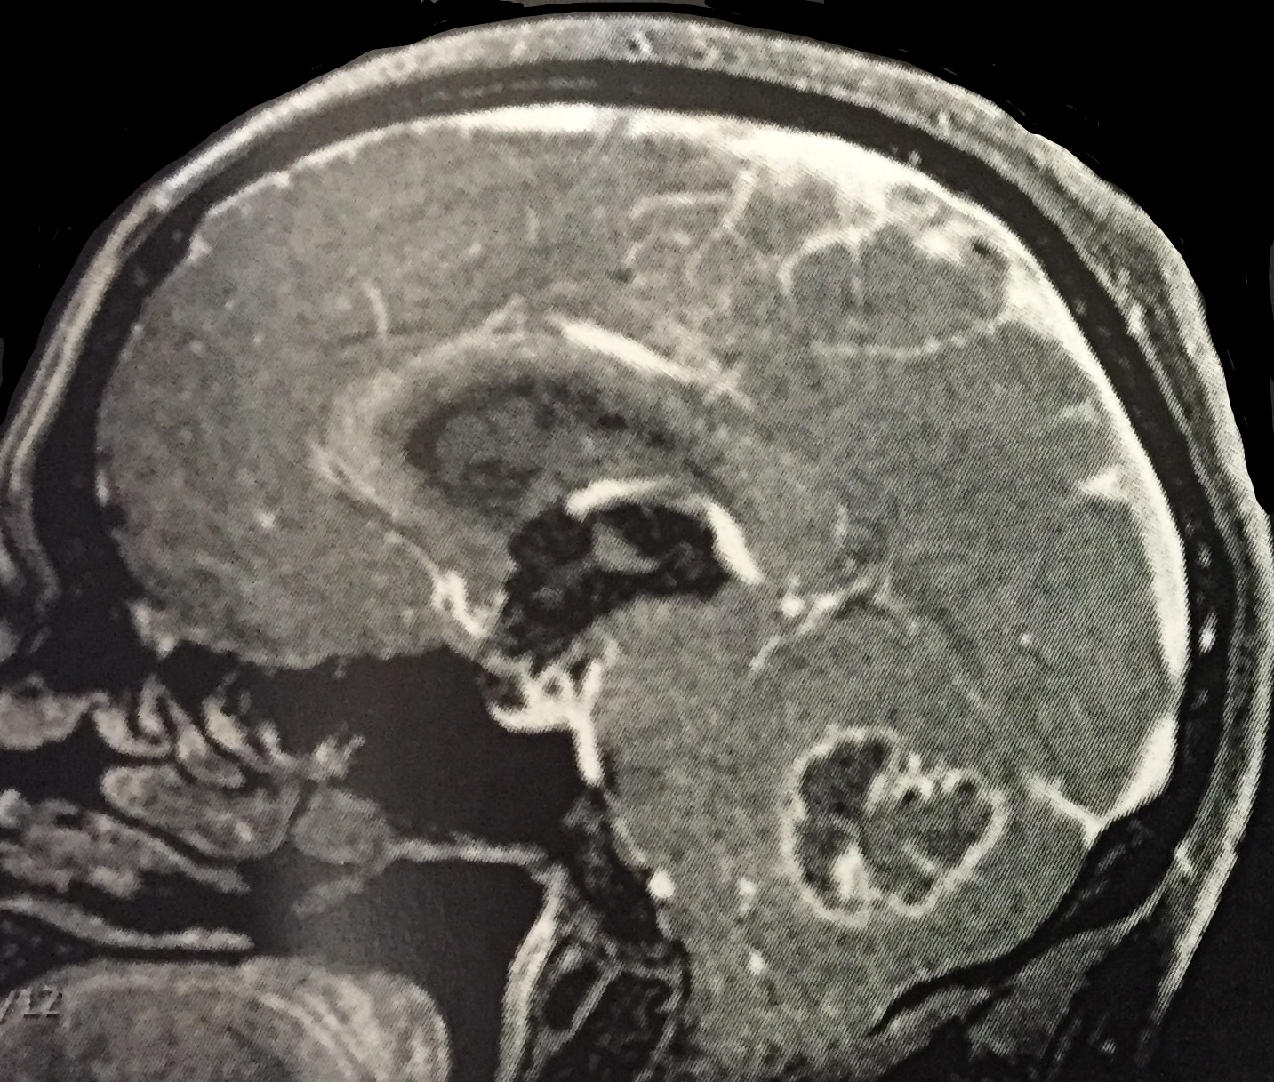
The clinical picture of cerebellar involvement is confused between the various lesions in the posterior fossa. The GBM should always be considered as a diagnostic hypothesis of aggressive tumor lesions of cerebellar hemisphere. Treatment is based on the microsurgical exeresis, radiotherapy and chemotherapy.
Coronal MRI
Sagital MRI
Bibliography
- Louis DN, Perry A, Reifenberger G, von Deimling A, Figarella-Branger D, Cavenee WK, et al. Acta Neuropathol. 2016;131(6):803-20. doi: 10.1007/s00401-016-1545-1.
- Schmidbauer M, Budka H, Bruckner R, Vorkapic P: Glioblastoma developing at the site of a cerebellar medulloblastoma treated 6 years earlier. Case report. Journal of Neurosurgery. 1987;67(6):915–918.
- Demir MK, Hakan T, Akinci O, Berkman Z. Primary cerebellar glioblastoma multiforme. Diagn Interv Radiol. 2005;11(2):83-6.
- Wang H, Cai S, Bailey BJ, Reza Saadatzadeh M, Ding J, Tonsing-Carter E, et al. Combination therapy in a xenograft model of glioblastoma: enhancement of the anti tumor activity of temozolomide by an MDM2 antagonist. J Neurosurg. 2017;126(2):446-459. doi: 10.3171/2016.1.JNS152513.
- Clark PA, Bhattacharya S, Elmayan A, Darjatmoko SR, Thuro BA, Yan MB, et al. Resveratrol targeting of AKT and p53 in glioblastoma and glioblastoma stem-like cells to suppress growth and infiltration. 2017; 126:1448-1460. doi: 10.3171/2016.1.JNS152077.
- Ohtaki S, Wanibuchi M, Kataoka-Sasaki Y, Sasaki M, Oka S, Noshiro S, et al. ACTC1 as an invasion and prognosis marker in glioma. J Neurosurg. 2017;126(2):467-475. doi: 10.3171/2016.1.JNS152075..
- El El Maaqili MR, Hossini A, El Fatemi N, Gana R, Saïdi A, Jiddane M, et al. Primary glioblastoma of the cerebellum in a 19-year-old woman: a case report. J Med Case Rep. 2012;6:329. doi: 10.1186/1752-1947-6-329.
- Grahovac G, Tomac D, Lambasa S, Zoric A, Habek M. Cerebellar glioblastomas: pathophysiology, clinical presentation and management. Acta Neurochir (Wien). 2009;151(6):653-7. doi: 10.1007/s00701-009-0286-5.
- Menon G, Nair S, Rajesh BJ, Rao BR, Radhakrishnan VV. Malignant astrocytoma following radiotherapy for craniopharyngioma. J Cancer Res Ther. 2007;3(1):50-2.
- Mattos JP, Marenco HA, Campos JM, Faria AV, Queiroz LS, Borges G, Oliveira Ed.. Cerebellar Glioblastoma Multiforme in an Adult. Arq Neuropsiquiatr. 2006;64(1):132-5. doi: /S0004- 2X2006000100028.

