Mitochondrial dysfunction and neuronal redox imbalance – the primary cause of Rett syndrome?
Karolina Can, Göttingen, Germany

Abstract

Statement of the Problem: Rett syndrome (RTT) is a neurodevelopmental disorder, which occurs almost exclusively in girls with a prevalence of 1:10.000-1:15.000 life births. The genetic causes of RTT are de novo mutations in the MECP2 gene. After a short normal development, developmental stagnation occurs with a neuronal and autonomic dysfunction, manifested as mental retardation, erratic breathing, epilepsy, loss of speech and stereotypical hand movements. Growing evidence indicates that RTT associates with mitochondrial dysfunction and oxidative stress. We previously showed that mitochondria of MeCP2-deficient (Mecp2^{-/y}) mouse hippocampus are partly uncoupled and show a higher consumption of O₂. To assess molecular events contributing to redox impairment, we intensified our analyses focusing specifically on neurons and their cytosolic and mitochondrial compartments. Methodology & Theoretical Orientation: Quantitative real-time imaging of redox dynamics was performed with the genetically-encoded redox sensor roGFP1 in cytosol and mitochondrial matrix of dissociated neurons and organotypic hippocampal slices. Optimized expression was achieved by viral transduction. Findings: Detailed excitation ratiometric fluorescence microscopy confirmed that in Mecp2^{-/y} hippocampal neurons the redox imbalance affects the cytosolic and mitochondrial compartments. These changes were especially obvious for more complex organotypic slices. Redox challenge by H₂O₂ and severe hypoxia elicited intensified oxidizing and reducing transients in Mecp2^{-/y} neurons, respectively. Inhibition of superoxide dismutase elicited only a dampened oxidation in Mecp2^{-/y} cytosol and mitochondria, suggesting a decreased efficiency of this scavenging enzyme in Rett mice. More importantly, stimulation by neurotransmitters consistently evoked intensified oxidizing shifts in the cytosol of Mecp2^{-/y} neurons. Conclusions & Significance: Redox imbalance associated with RTT clearly affects cytosol and mitochondria of central neurons. Even physiological events such as neurotransmitter stimulation are sufficient to provoke overshooting redox responses in Mecp2^{-/y} neurons. As these changes are already evident in presymptomatic mice, they may promote the progression of RTT.
Image
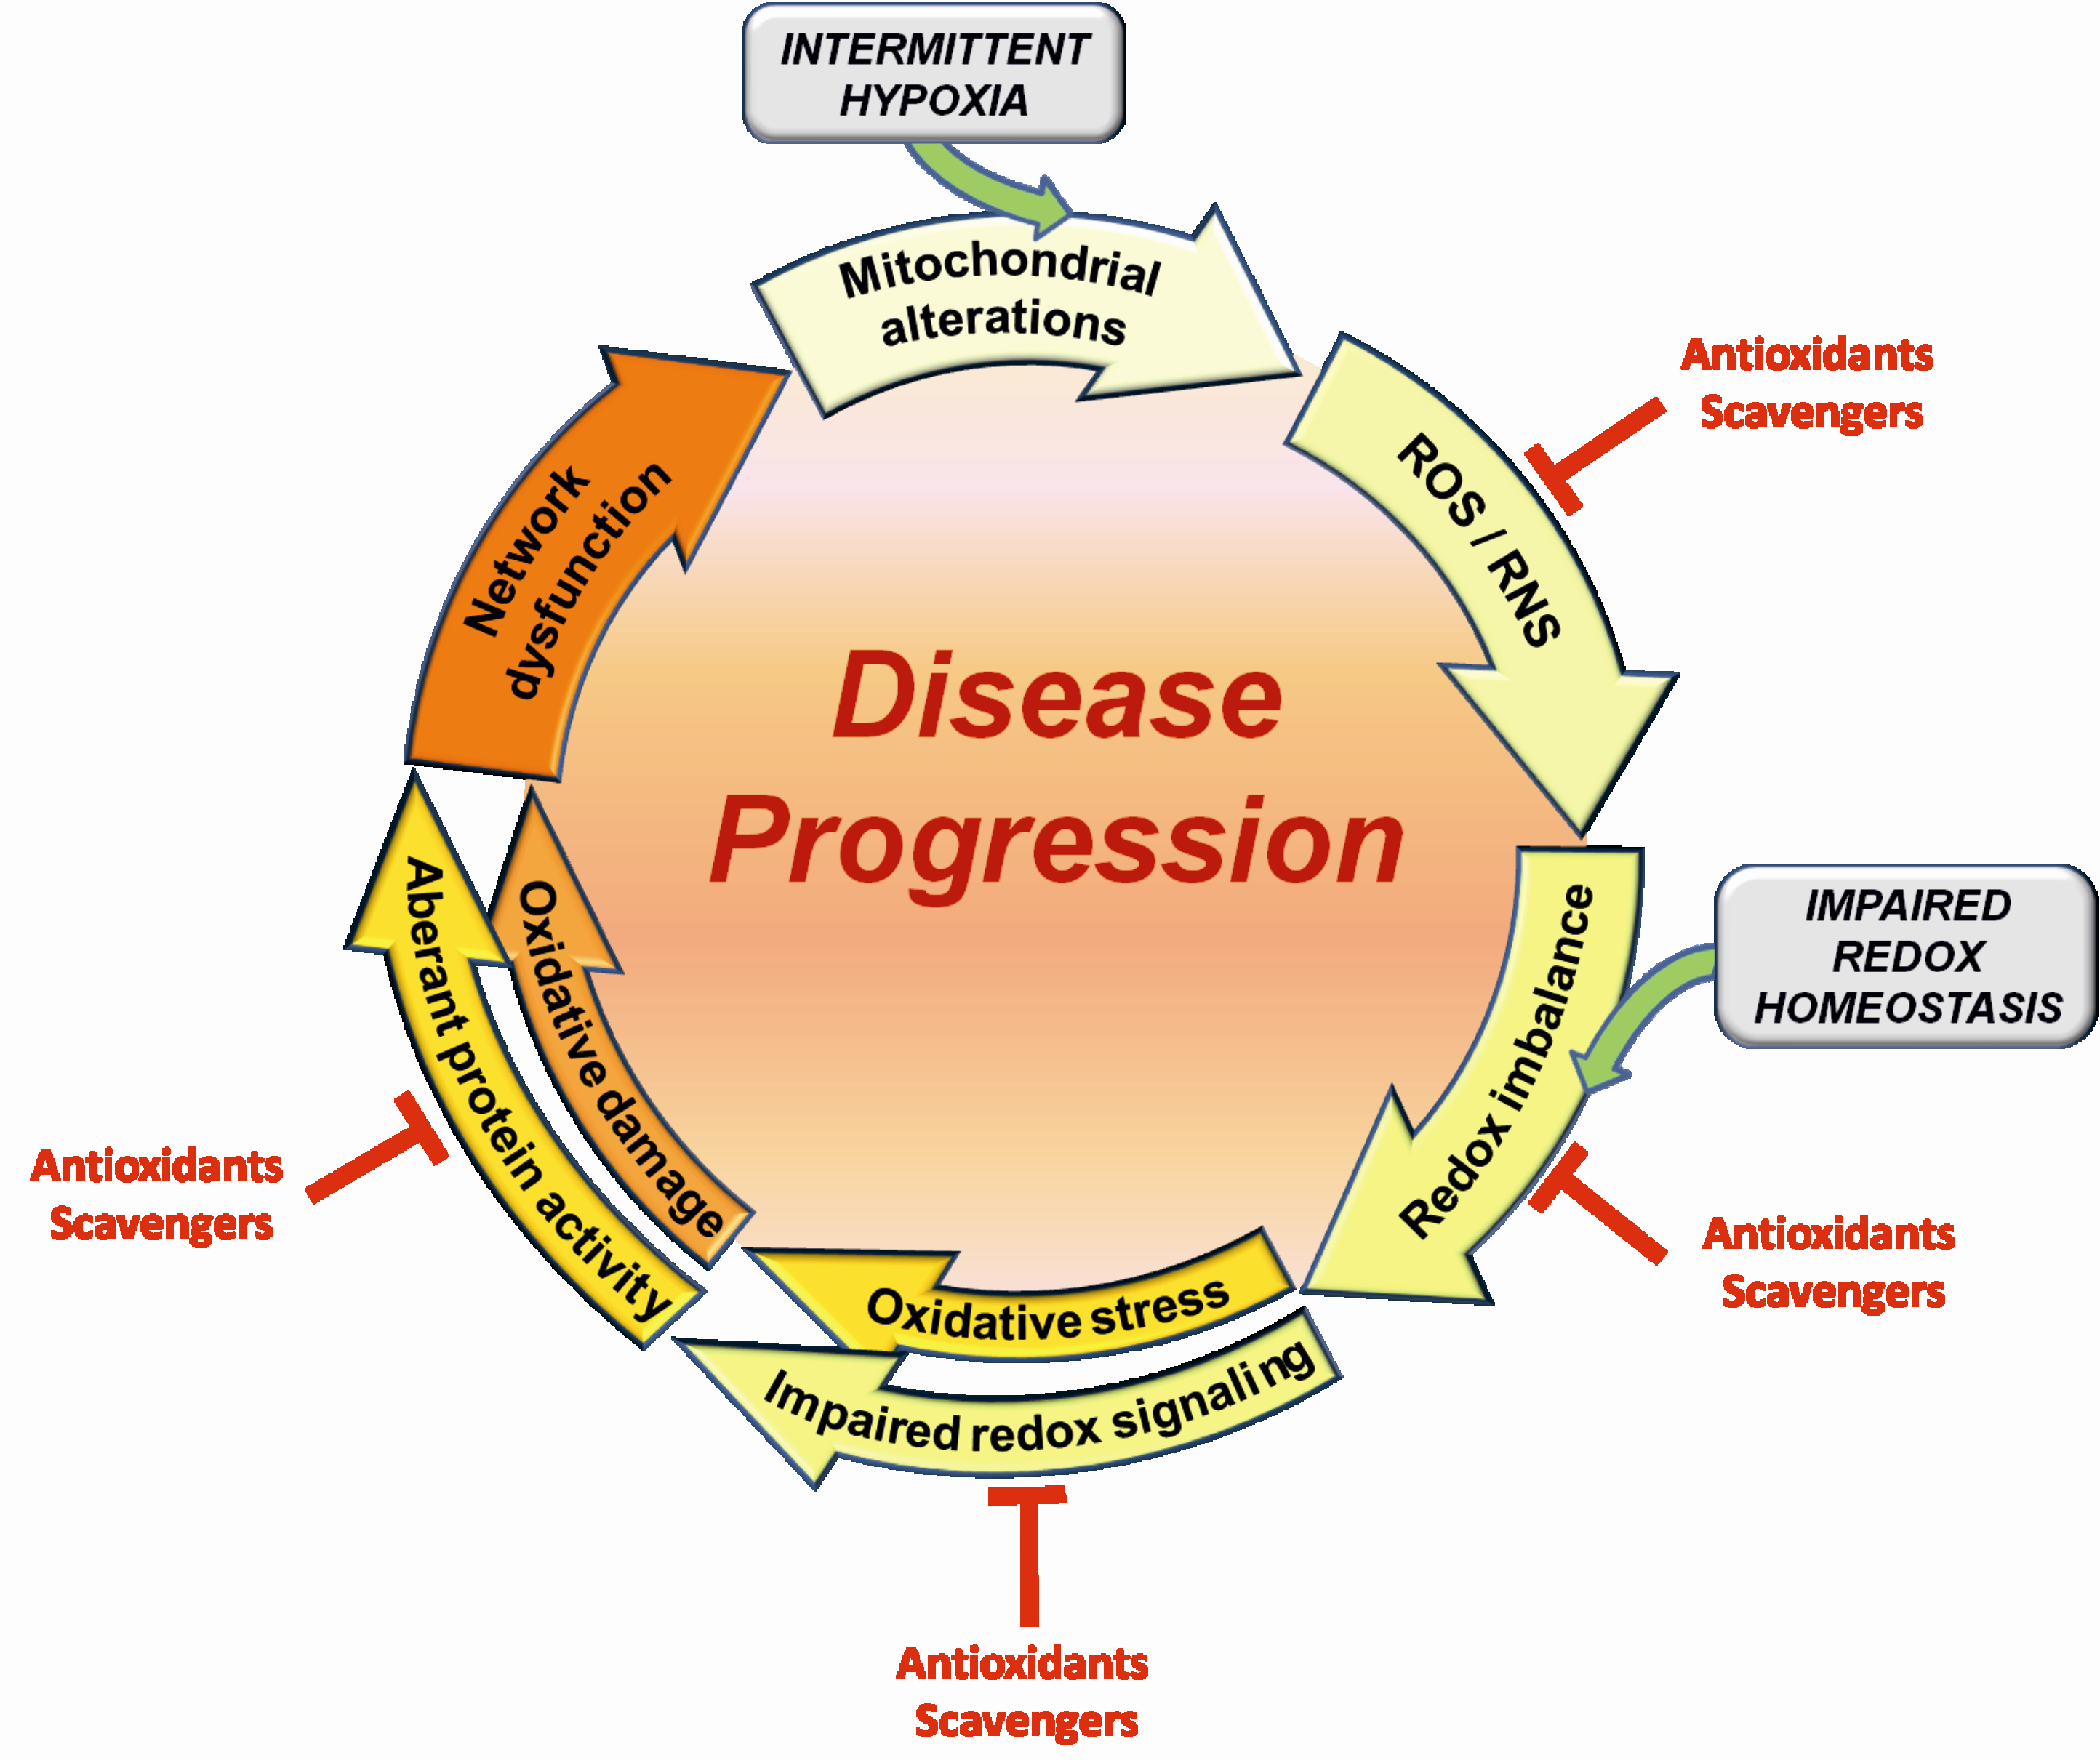
Functional damage of mitochondria results in more intensified ROS and RNS generation in Rett syndrome. This may contribute to impairment of cellular redox signalling and disturbed activity of various cellular proteins, leading further to cellular network dysfunction (This research was originally published in Portland Press Limited. Müller M, Can K. Aberrant redox homoeostasis and mitochondrial dysfunction in Rett syndrome. 2014 Aug; 42(4):959-64, Biochemical Society Transactions).
Recent Publications
1. Müller M. and Can K. (2014) Aberrant redox homoeostasis and mitochondrial dysfunction in Rett syndrome. Biochem Soc Trans 42, 959-964.
2. Großer E., Hirt U., Janc O. A., Menzfeld C., Fischer M., Kempkes B., Vogelgesang S., Manzke T. U., Opitz L., Salinas-Riester G. and Müller M. (2012) Oxidative burden and mitochondrial dysfunction in a mouse model of Rett syndrome. Neurobiol Dis 48, 102-114.
3. Funke F., Gerich F. J. and Müller M. (2011) Dynamic, semi-quantitative imaging of intracellular ROS levels and redox status in rat hippocampal neurons. Neuroimage 54, 2590-2602.

Biography

Karolina Can is a post-doctoral researcher, whose expertise focuses on Rett syndrome and oxidative stress. She performed her PhD at the Georg-August University in Göttingen in Germany, where she now continues running various projects towards mitochondrial dysfunction and potential molecular targets involved in this neurodevelopmental disorder. She strictly extended her proficiency already during her master studies (M.Sc. performed at Jagiellonian University in Krakow in Poland), when she took advantage on annual internship in the Institute of Human Genetics in Göttingen in Germany, and switched her gears from genetics towards neurophysiology and live-cell imaging.
.
Email: karolina.can@gmail.com

Notes/Comments:

