Neuroprotective effect of exogenous melatonin on apoptosis of neuroadernergic neurons in locus coeruleus of adult male rats after REM sleep deprivation

Authors: Mesgar S¹, Aghaie A¹, Jameie SB², Sadeghy Y¹

Address:
¹ Department of Anatomy, Faculty of Medicine, SbUMS, Tehran, Iran.
² Department of Medical Basic Sciences, Fac of Allied Med, IUMS, Tehran, Iran.

Abstract

Introduction: Sleep as a widespread physiological phenomenon is seen in all vertebrates. In primates as human, the sleep consists of two components REM & non-REM. One of the major centers involved in the control of REM sleep is Locus Coeruleus. REM sleep deprivation causes neural death in the LC. In the present study, we administered melatonin as an antioxidant factor and neuroprotective agent to prevent neural death.
Material & methods: In this study, the Flowerpot approach has been used to induce RSD. Melatonin was administered for 7 days, the count & the volume of the LC neurons examined due to stereology methods. The enzymatic test for GSH & measurement of Caspase-3 & C-Fos was done to assess the antioxidant property and apoptosis process and neural activity respectively. Immunohistochemistry of Anti-TH factors was done to assess the noradrenergic neurons and the Iba-1 test was also done to show the microglial migration.
Results: According to the papers the RSD cause neural apoptosis in LC. Melatonin leads to a reduction in the level of apoptotic factor Caspase-3 expression followed by RSD. According to stereology analysis, the count of adrenergic neurons & the volume of the nucleus reduces after RSD & in the administered-melatonin group the apoptotic protein Caspase-3 reduces to prevent neural death. Microglial migration to the LC occurs after neural death and the melatonin increases GSH levels in RSD group finally.
Conclusion: Melatonin with neuroprotective property can be used to treatment of adrenergic-depended sleep disorders & prevention of neural apoptosis in LC.
Keywords: Locus Ceoruleus, Melatonin, RSD, apoptosis, oxidative stress

Image

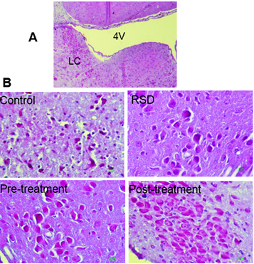

Figure 1. Nissl staining of C+REMsd+Mel/REMsd+REMsd/Mel groups in locus coeruleus(LC).
Stereology analysis includes measuring the number of LC neurons and also measure the volume of nucleus.
A: count the number of neurons in the LC following induction treatment with melatonin and sleep deprivation,
B: measure the nucleus volume in LC neurons

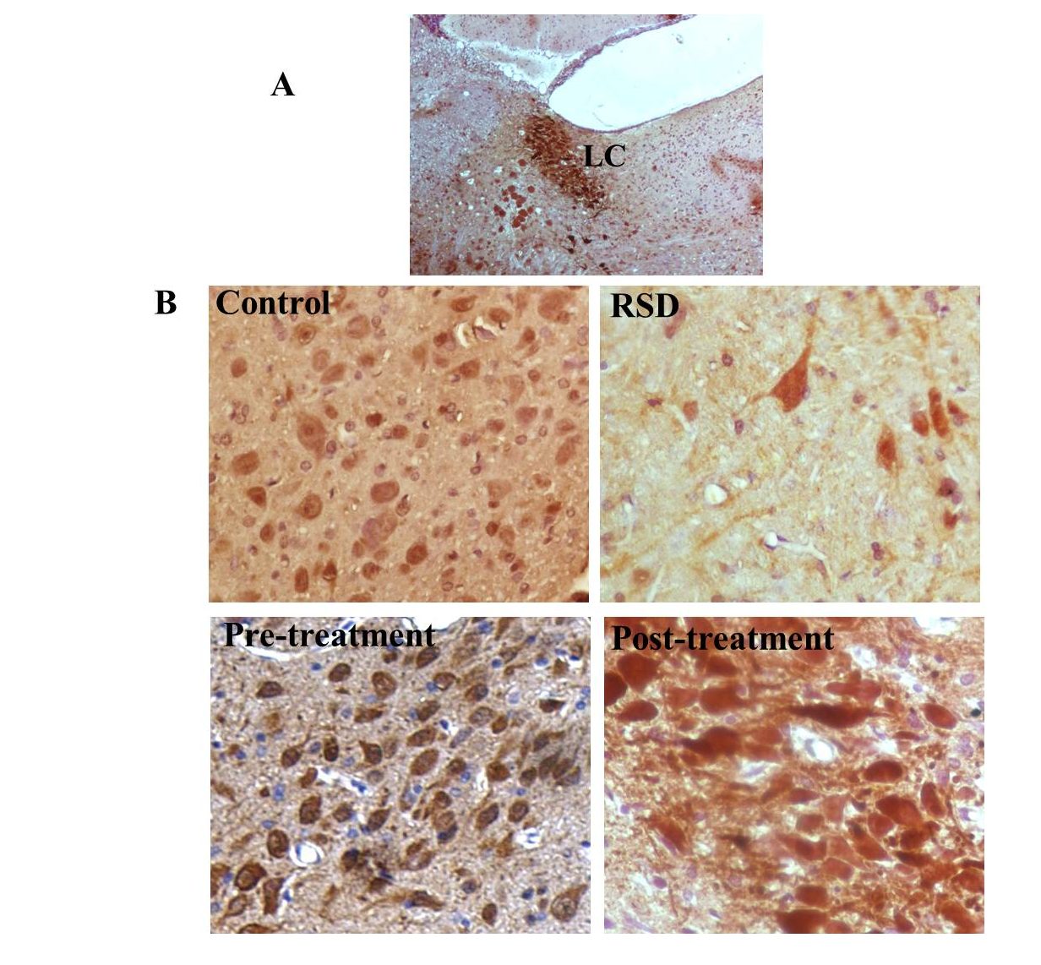
Figure 2. TH expression in neuradrenergic neurons.(brown chromoge, DAB) (A)
Magnification bars, 100 µm (A) Magnification bars, 10 µm (A) B: the number of TH expressing nueradernergic neurons

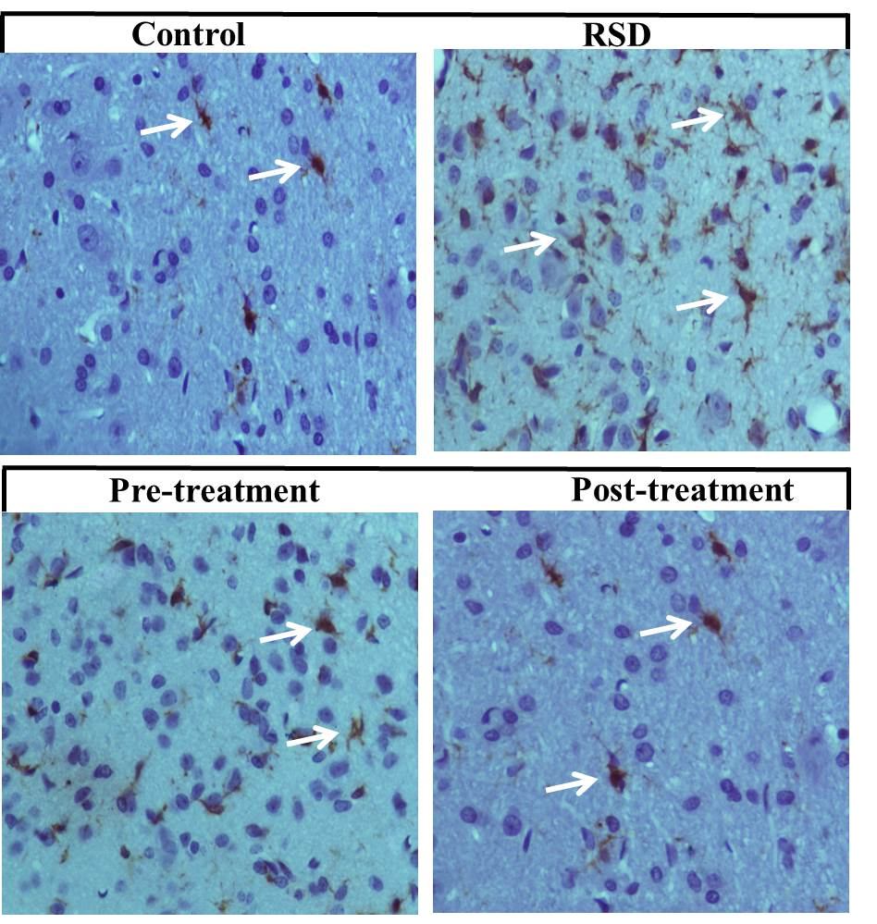

Figure 3. phtomicrographs of sections immunostaining for Iba-1 (brown chromoge, DAB)
White arrowheads indicate microglia cells. Scale, 10 µm

Recent Publications

1. Klein DC, Weller JL. Indole metabolism in the pineal gland: a circadian rhythm in N-acetyltransferase. Science. 1970;169(3950):1093-5.
2. Cao R, Li A, Cho H-y, Lee B, Obrietan K. Mammalian target of rapamycin signaling modulates photic entrainment of the suprachiasmatic circadian clock. The Journal of Neuroscience. 2010;30(18):6302-14.
3. Stephan FK, Zucker I. Circadian rhythms in drinking behavior and locomotor activity of rats are eliminated by hypothalamic lesions. Proceedings of the National Academy of Sciences. 1972;69(6):1583-6.
4. Zhdanova IV, Wurtman RJ, Lynch HJ, Ives JR, Dollins AB, Morabito C, et al. Sleep‐inducing effects of low doses of melatonin ingested in the evening. Clin Pharmacol Ther. 1995;57(5):552-8.
5. Pévet P. Melatonin and animal models. Dialogues Clin Neurosci. 2003;5:343-52.
6. Brainard GC, Hanifin JP, Rollag MD, Greeson J, Byrne B, Glickman G, et al. Human melatonin regulation is not mediated by the three cone photopic visual system. The Journal of Clinical Endocrinology & Metabolism. 2001;86(1):433-6.
7. Vaughan G, McDonald S, Jordan R, Allen J, Bohmfalk G, Abou-Samra M, et al. MELATONIN CONCENTRATION IN HUMAN BLOOD AND CEREBROSPINAL FLUID: TO STRESS. The Journal of Clinical Endocrinology & Metabolism. 1978;47(1):220-3.
8. Isobe Y, Torii T, Nishino H. Melatonin inhibits Arg–vasopressin release via MT 2 receptor in the suprachiasmatic nucleus-slice culture of rats. Brain Res. 2001;889(1):214-9.
9. Hughes RJ, Sack RL, Lewy AJ. The role of melatonin and circadian phase in age-related sleep-maintenance insomnia: assessment in a clinical trial of melatonin replacement. Sleep. 1998;21(1):52-69.
10. Cajochen C, Kräuchi K, Wirz‐Justice A. Role of melatonin in the regulation of human circadian rhythms and sleep. J Neuroendocrinol. 2003;15(4):432-7.
11. Maurizi C. The therapeutic potential for tryptophan and melatonin: possible roles in depression, sleep, Alzheimer's disease and abnormal aging. Med Hypotheses. 1990;31(3):233-42.
12. DABBENI-SALA F, DI SANTO S, FRANCESCHINI D, SKAPER SD, GIUSTI P. Melatonin protects against 6-OHDA-induced neurotoxicity in rats: a role for mitochondrial complex I activity. The FASEB Journal. 2001;15(1):164-70.
13. Garfinkel D, Laudon M, Nof D, Zisapel N. Improvement of sleep quality in elderly people by controlled-release melatonin. The Lancet. 1995;346(8974):541-4.
14. Peever J, Luppi P-H, Montplaisir J. Breakdown in REM sleep circuitry underlies REM sleep behavior disorder. Trends Neurosci. 2014;37(5):279-88.
15. Wu J, Buchsbaum MS, Gillin JC, Tang C, Cadwell S, Wiegand M, et al. Prediction of antidepressant effects of sleep deprivation by metabolic rates in the ventral anterior cingulate and medial prefrontal cortex. Am J Psychiatry. 1999.
16. Saper CB, Chou TC, Scammell TE. The sleep switch: hypothalamic control of sleep and wakefulness. Trends Neurosci. 2001;24(12):726-31.
17. Thomas M, Sing H, Belenky G, Holcomb H, Mayberg H, Dannals R, et al. Neural basis of alertness and cognitive performance impairments during sleepiness. I. Effects of 24 h of sleep deprivation on waking human regional brain activity. J Sleep Res. 2000;9(4):335-52.
18. Spoormaker VI, Schröter MS, Gleiser PM, Andrade KC, Dresler M, Wehrle R, et al. Development of a large-scale functional brain network during human non-rapid eye movement sleep. The Journal of neuroscience. 2010;30(34):11379-87.
19. Dijk D-J, Duffy JF, Czeisler CA. Contribution of circadian physiology and sleep homeostasis to age-related changes in human sleep. Chronobiol Int. 2000;17(3):285-311.
20. Dijk D-J, Hayes B, Czeisler CA. Dynamics of electroencephalographic sleep spindles and slow wave activity in men: effect of sleep deprivation. Brain Res. 1993;626(1):190-9.

