Impact of online-game playing on multitasking in a virtual environment
Yun-Hsuan Chang, PhD, Taiwan
Shulan Hsieh, DPhil, Taiwan

Abstract (300 word limit)
Evidence has suggested potential cognitive skills training of extensive video-game playing, especially in eye-hand coordination and reaction time, spatial attention, divided visual attention, selective attention and attentional capacity, but the effective in multitasking ability is unclear. As the dramatic development of computer and internet, online-game playing has become a common entertainment in the current generation. Online-game players often do several tasks at the same time; often tasks interfere with each other and might increase mistakes. This study proposed to explore the relationships between online-game playing types and multitasking ability in a virtual environment, using Edinburgh Virtual Errands Test (EVET). In this study, 79 participants with mean aged from 20-30 years old were recruited. Chen’s Internet Addiction Scale (CIAS), internet use questionnaire, EVET, working memory tests and resting fMRI were given to each participant. The results showed a positively association between multitasking ability and working memory (WM). No significant difference of spent time between MOBA and OGPs, showing both groups could be expertise in online-game playing. Three groups with varied online-game playing, multiplayer online battle arena (MOBA), other online-game players (OGPs) and no-players (NGPs) were compared with their EVET performance, WM and time spent of online-game use. The MOBA players had better performance on EVET plan follow and total score, and spatial memory than did other two groups, indicating a benefit of MOBA on planning following and increase the efficiency of multitasking. Using Cohe-ReHo analysis of resting fMRI showed significant association between both sides of temporal lobe, caudate, occipital lobe, anterior cingulate cortex and parahippocampus and EVET. In conclusions, online-game playing may provide a role in training multitasking and helps to maintain the planning. Multiplayers online game genres may benefit in participants’ spatial memory. Several brain function activities were found, indicating collaboration among multiple brain areas involving in multitasking performance.
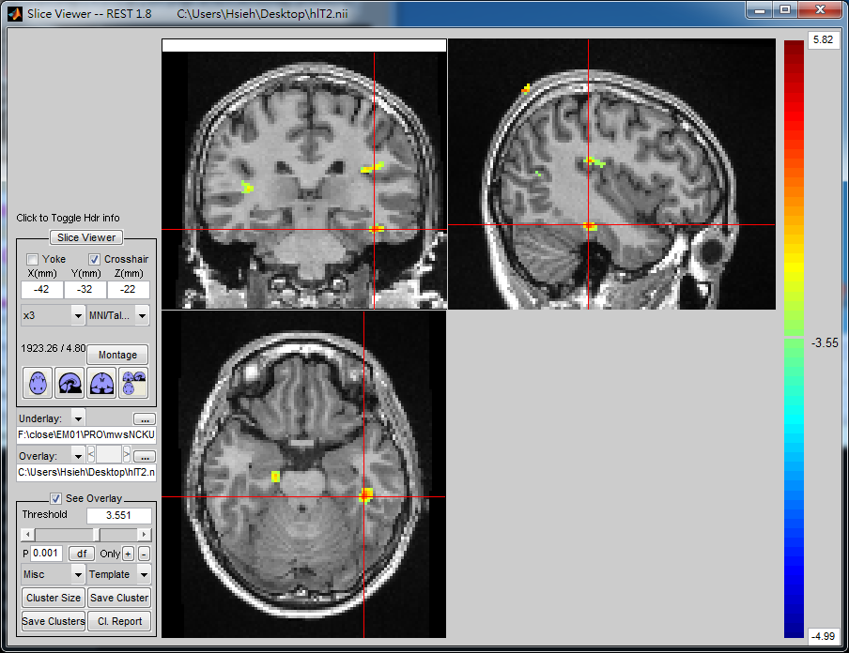
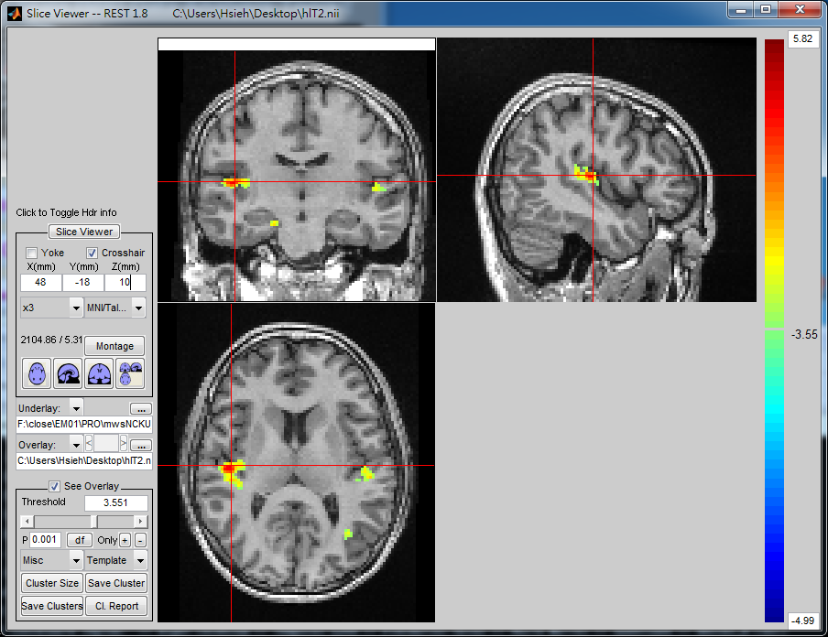
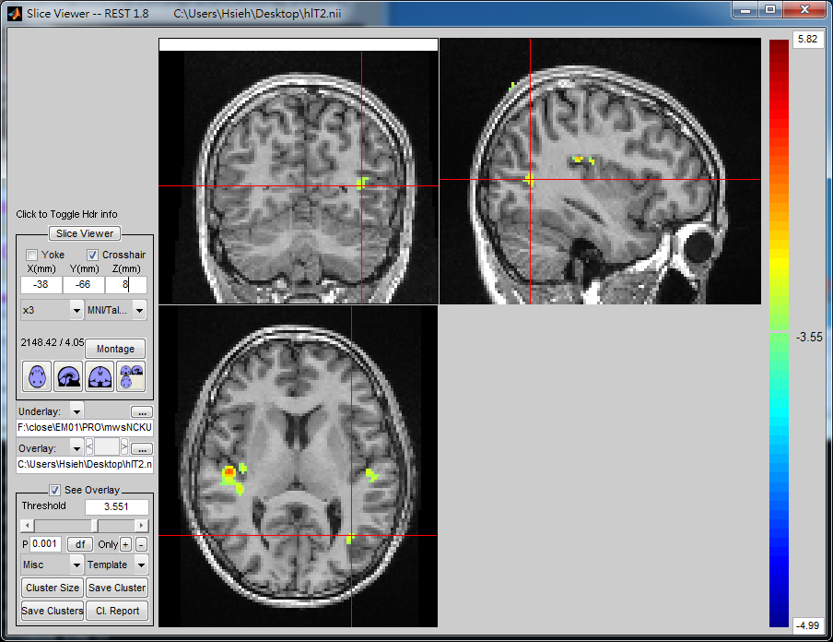
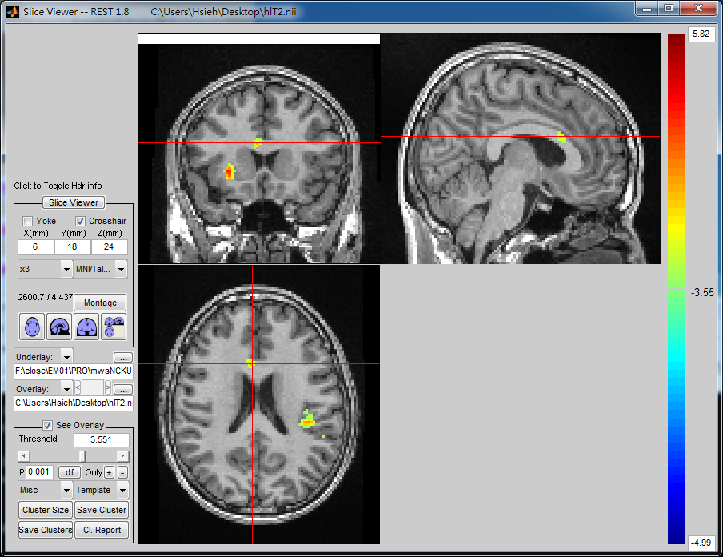
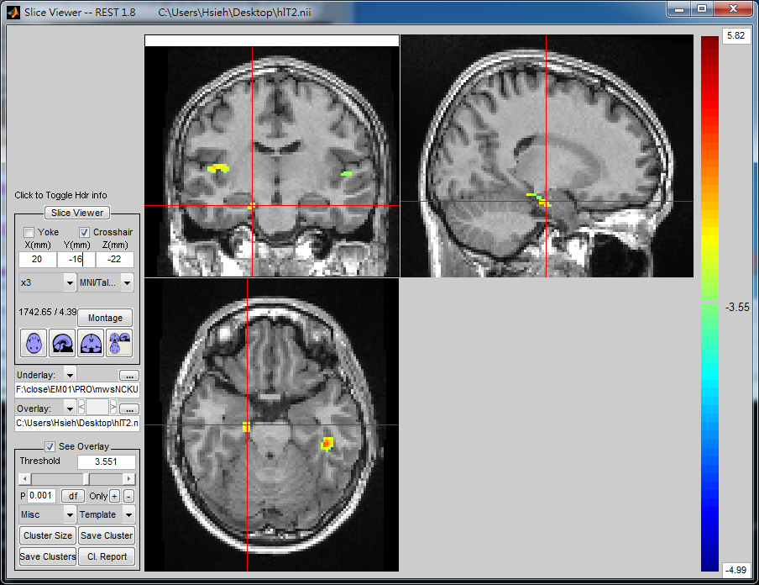
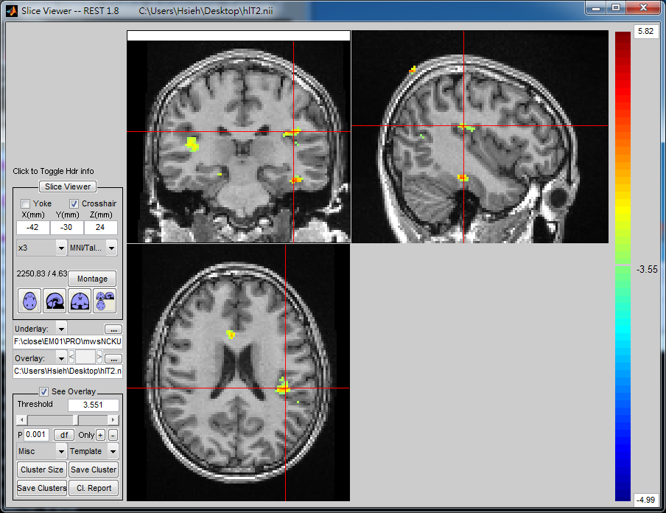

Figure 1. Resting state fMRI showed association among several brain activities and multitasking (Left: right and left temporal lobe; Right: caudate, occipital lobe, anterior cingulate cortex and parahippocampus)
Recent Publications (minimum 5)
- Colzato, L. S., van Leeuwen, P. J., van den Wildenberg, W. P., & Hommel, B. (2010). DOOM'd to Switch: Superior Cognitive Flexibility in Players of First Person Shooter Games. Front Psychol, 1, 8.
- Logie, R. H., Brockmole, J. R., & Jaswal, S. (2011). Feature binding in visual short-term memory is unaffected by task-irrelevant changes of location, shape, and color. Mem Cognit, 39(1), 24-36.
- Logie, R. H., Trawley, S., & Law, A. (2011). Multitasking: multiple, domain-specific cognitive functions in a virtual environment. Mem Cognit, 39(8), 1561-1574.
- Boot, W. R., Kramer, A. F., Simons, D. J., Fabiani, M., & Gratton, G. (2008). The effects of video game playing on attention, memory, and executive control. Acta Psychologica, 129(3), 387-398.

 Biography (150 word limit)
Shulan Hsieh completed her DPhil at University of Oxford, UK in 1993. Her research spans areas including the neural basis of the higher cognitive control functions (task switching, multi-tasking behavior, error-monitoring and inhibition), aging, sleep deprivation and emotion, and has published widely in these fields. From 1993-2009, she was appointed to the Department of Psychology at National Chung-Cheng University (CCU) in Chia-Yi, Taiwan, the Dean of the College of Social Sciences at CCU (from 2005 until taking up her present position in 2009). She has been awarded the Distinguished Research Award of the Ministry of Science and Technology, Taiwan in 2008 and several other research awards. She has been appointed as Distinguished Professor (effective from 2009) and Department Chair (effective from Aug. 2015) in the Department of Psychology at National Cheng Kung University (NCKU) in Tainan, Taiwan. She is also jointly appointed to the Institute of Allied Health Sciences and Institute of Public Health at NCKU. She was Editor-in-Chief of the Chinese Journal of Psychology (Jan. 2014 - Dec. 2016) and Advisory Board Member of the International Association for the Study of Attention and Performance (during 1996-2004 and 2011 to date). She was recently elected President of the Taiwanese Psychological Association (effective from Jan. 2017).
Email: psyhsl@mail.ncku.edu.tw
Notes/Comments:

