Clinical Separation of Herbal Drug Effects in Comparison to Valium® by Discriminant Analysis of Quantitative EEG Data in Humans (Pharmaco-EEG).

Wilfried Dimpfel, Prof. Dr., Justus-Liebig-University Giessen, Germany

Statement of the problem: Since many drugs act on the central nervous system by interference with neurochemical processes leading to changes of electric activity, measurement of the electric activity of the brain is a very promising approach to characterize the effectiveness of a neuro-active drug. The problem consists in the fact that quantitative analysis of the EEG by Fast Fourier Transformation (FFT) provides 102 parameters (17 electrode positions times 6 frequency ranges) which might change accordingly in the presence of a drug. Thus, a comparison or classification of several drugs becomes difficult. Methodology & Theoretical orientation: EEG`s were recorded on 17 channels during relaxation with open eyes before and different times after intake of herbal drugs. Data from 13 clinical studies were uniformly reanalysed with respect to drug-induced changes of spectral power in comparison to their corresponding placebo. In order to compare the obtained electrophysiological profiles with each other data were fed into a linear discriminant analysis. The results from the first three discriminant functions were projected into space (x-y-z coordinate). The result from the next three discriminant functions was processed according to so-called RGB-mode leading to different colours as six-dimensional projection. Findings: In control subjects a general increase of alpha spectral power was observed reflecting changes due to circadian rhythm. In the presence of Valium® in comparison to Calmvalera®, L-Theanine, Lasea®, Neurapas®. Neuravena®, Neurexan®, Nutrifin Relax® and Pascoflair® (calming drugs) or Sideritis Extract, memoLoges®, Menosan®, Zembrin® and Zynamite® a different pattern of changes of spectral power at all electrode positions was seen. Discriminant analysis of these data allowed direct comparison, separation and classification of the herbal drug effects. Conclusion & Significance: The analysis of herbal drug effects obtained by quantitative EEG measurement should be supplemented by discriminant analysis to allow t classification and comparison of drugs with each other.
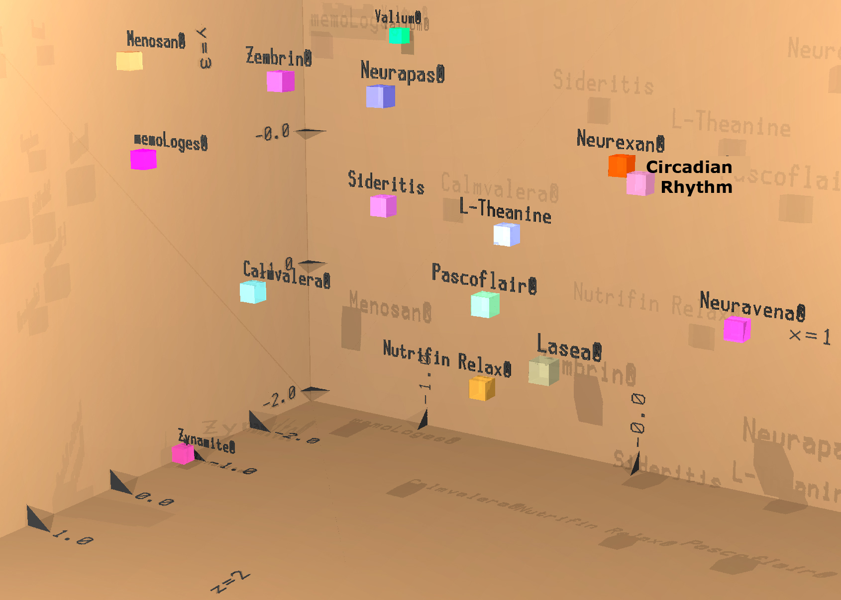

Figure 1 Discriminant analysis of quantitative EEG data from 13 herbal products in comparison to the effect of Valium®.

1. Dimpfel W, Wedekind W, Dienel A (2015) Cerebral Bioavailability of Silexan- A Quantitative EEG Study in Healthy Volunteers. Open Journal of Psychiatry 5: 285-297.

2. Dimpfel W, Schombert L, Biller A (2016) Psychophysiological Effects of Sideritis and Bacopa Extract and Three Combinations Thereof – A Quantitative EEG Study in Subjects Suffering from Mild Cognitive Impairment (MCI). Advances in Alzheimers`s Disease 5: 1-22.

3. Dimpfel W, Gericke N, Suliman S, Chiegoua Dipah, GN, Effect of Zembrin® on Brain Electrical Activity in 60 Older Subjects after 6 Weeks of Daily Intake. (2017) A Prospective, Randomized, Double-Blind, Placebo-Controlled, 3-Armed Study in a Parallel Design. World Journal of Neuroscience 7: 140-171.

4. Dimpfel W, Tausend S, Suliman S, Chiegoua Dipah, GN (2016) Psychophysiological Effectiveness of Calmvalera Hevert Tablets as measured by EnkephaloVision in Anxious Subjects during Audio-Visual Cognitive and Emotional Challenges: A double-Blind, Randomized Placebo-Controlled, 2-Armed, Phase IV Study in Parallel Design. Journal of Behavioral and Brain Science 6: 404-431.

5. Dimpfel W, Biller A, Suliman S, Chiegoua Dipah, GN (2016) Psychophysiological Effects of aCombination of Sideritis and Bacopa Extract (memoLoges®) in 32 subjects Suffering from Mild Cognitive Impairment. A Double-Blind, Randomized, Placebo-Controlled, 2-Armed Study with Parallel Design. Advances in Alzheimer`s Disease 5: 103-125.

___________________________________________________________________________________________________________
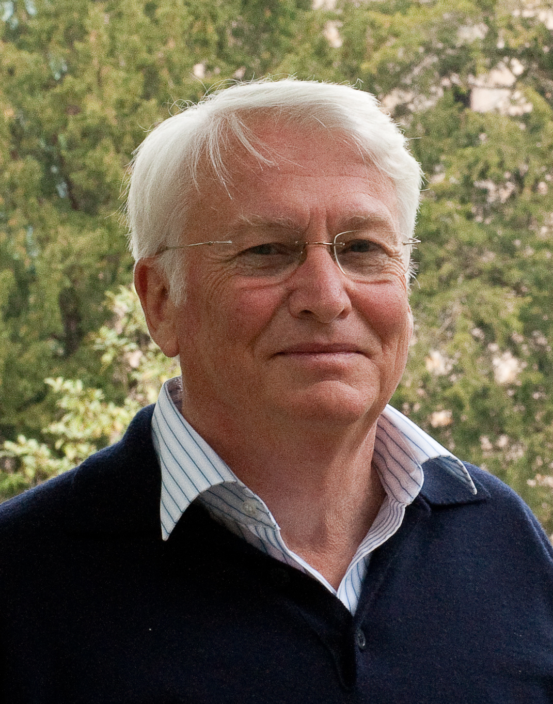
Wilfried Dimpfel is Honorary Professor at Justus-Liebig-University Giessen, Germany, since 1983. He is pharmacologist and got his neurophysiological education during 1973-1974 as Max Kade stipend (New York) at the NIH Bethesda from Phil Nelson. Together with Hans-Carlos Hofmann, a physicist and mathematician, he developed quantitative EEG software for research and practice. Wilfried Dimpfel is CEO at NeuroCode AG, Wetzlar, Germany. He published more than 150 papers in peer-reviewed journals.
Email: wilfried.dimpfel@pharma.med.uni-giessen.de

