Protein synthesis inhibitors did not interfere with long-term depression induced either electrically in juvenile rats or chemically in middle-aged rats
Abdul-Karim Abbas, Institute of Neuroscience and Physiology/University of Gothenburg, Sweden

Abstract (300 word limit)
In testing the hypothesis that long-term potentiation (LTP) maintenance depends on triggered protein synthesis, we found no effect of protein synthesis inhibitors (PSIs) on LTP stabilization. Similarly, some studies reported a lack of effect of PSIs on long-term depression (LTD); the lack of effect on LTD has been suggested to be resulting from the short time recordings. If this proposal were true, LTD might exhibit sensitivity to PSIs when the recording intervals were enough long. We firstly induced LTD by a standard protocol involving low frequency stimulation, which is suitable for eliciting NMDAR-LTD in CA1 area of hippocampal slices obtained from juvenile Sprague-Dawley rats. This LTD was persistent for intervals in range of 8–10 h. Treating slices with anisomycin, however, did not interfere with the magnitude and persistence of this form of LTD. The failure of anisomycin to block synaptic-LTD might be relied on the age of animal, the type of protein synthesis inhibitors and/or the inducing protocol. To verify whether those variables altogether were determinant, NMDA or DHPG was used to chemically elicit LTD recorded up to 10 h on hippocampal slices obtained from middle-aged rats. In either form of LTD, cycloheximide did not interfere with LTD stabilization. Furthermore, DHPG application did show an increase in the global protein synthesis as assayed by radiolabeled methodology indicating that though triggered protein synthesis can occur but not necessarily required for LTD expression. The findings confirm that stabilized LTD in either juvenile, or middle-aged rats can be independent of triggered protein synthesis. Although the processes responsible for the independence of LTD stabilization on the triggered protein synthesis are not yet defined, these findings raise the possibility that de novo protein synthesis is not universally necessary.

Image
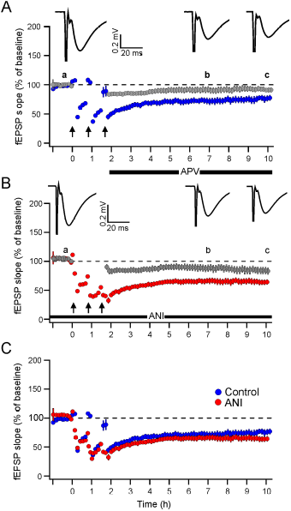
Fig 1. Effect of anisomycin on LFS-LTD. Successive measurements of fEPSP are shown for successive responses in two separate pathways. Each point represents the average of 13 successive responses (~5 min) of individual experiment and averaged of total number of experiment (n). (A) Three trains of LFS (arrows) were delivered to one pathway (test pathway). Stimulation of a second, independent pathway (control pathway) was interrupted during the delivery of LFS. D-APV was added to the solution immediately after the end of the last LFS trains (horizontal bar). (B) The same condition as with (A) but 40 μM of anisomycin (ANI)

Recent Publications (minimum 5)
- Abbas A-K (2017) The Evidence-Based Medicine Condition: A Report on Uses and Abuses. INMJ 3(1):8-16.
- Shabana H, O’Boyle CJ, Abbas A-K, Murphy O (2017) The Surgical antimicrobial prophylaxis; an Irish experience. INMJ 3(2):71-77.
- Abbas A-K (2016) Protein Synthesis Inhibitors Did Not Interfere with Long-Term Depression Induced either Electrically in Juvenile Rats or Chemically in Middle-Aged Rats. PLOS ONE | DOI:10.1371/journal.pone.0161270.
- Abbas A-K (2015) Kainic Acid, NMDA and Bicuculline Induce Elevation in Concentrations of Glutathione and Amino Acids in Vivo: Biomarkers for Seizure Predisposition? Journal of Behavioral and Brain Science 5:163-172.
- Abbas A-K, Villers A, Ris L (2015) Temporal phases of long-term potentiation (LTP): myth or fact? Rev Neurosci. 26(5):507-46.
- Abbas A-K (2013) Evidence for constitutive protein synthesis in hippocampal LTP stabilization. Neuroscience 246:301–311.
- Abbas A-K et al. (2011) Emetine treatment masks initial LTP without affecting long-term stability. Brain Res. 1426:18–29.
- Abbas A-K et al. (2009) Persistent LTP without triggered protein synthesis. Neurosci Res 63:59–65.

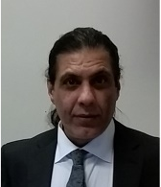 Biography (150 word limit)
Abbas has his expertise in evaluation and passion in improving the health and wellbeing via his research on mechanisms of physiological memory and memory dysfunctions. He also work on clinical research with special attention on surgical interventions. His open and contextual evaluation model based on responsive constructivists creates new pathways for understanding of memory mechanisms. His multidisciplinary approaches coupled to philosophical orientation try to uncover conceptual errors that guided research programs of memory and synaptic plasticity relevance.
Email: karim.abbas@gu.se

