Benign Epilepsy of Childhood with Central-Temporal Spikes (BECTS)
Hastuti Sri¹, Choong Yi Fong²
¹ Departement of Neurology, Faculty of Medicine, University of Syiah Kuala, Banda Aceh, Indonesia
² Devision of Paediatric Neurology, Departement of Paediatric, Faculty of Medicine, University of Malaya, Kuala Lumpur, Malaysia

Abstract

Background : Benign Epilepsy of Childhood with Central-Temporal Spikes (BECTS) is the most common focal epilepsy. It is more common in males and the onset between the ages of 3 and 13 years. Onset of the seizure is during sleep, the incident reaches until 80% of time. The clinical manifestation that mostly appear is secondary generalized seizure with a facial/perioral focal onset. The focal, perioral seizure will be reflected either in the aura or in the form of temporary post-ictal signs or symptoms. The typical features of this seizure include unilateral paraesthesia of the tongue, lips, gums or cheek; speech arrest, hypersalivation, poor swallowing post-ictally; involuntary movement of the tongue or jaw; or clonus affecting one side of the face. The feature of EEG is diphasic sharp waves in the central-midtemporal area and usually activated by sleep and unilaterally appear in any given EEG recording. The treatment is required if the seizures are frequent or long, and typically respond well to Carbamazepine, Gabapentine, Levetiracetam, Sultiame or Sodium Valproate. Objective : Identify clinical features of signs, symptoms and characteristic of EEG pictures. Method : Observational descriptive study of patient’s medical records. Case Report : 11 years old girl who has got epilepsy from 9 years old. Seizures occur with facial twitching and eye blinking. Patient came in for breakthrough seizure which occurs upon sleeping during bedtime, sometimes upon awakening. No preceding aura, but her mother noticed the automatism (lip smacking) prior to seizure attack. Semiology shows generalized tonic clonic seizure with lip smacking , head version to right. No frank sterotyped eye movement (sometimes uprolling of eyeballs /eye deviation). Finding : EEG examination found during sleep showed occasional low voltage stereotyped sharp wave discharge were seen independently over the right and left central-temporal region. These discharges activated in sleep and become bisynchronous. The EEG indicate that the child has a liability to benign rolandic epilepsy (Benign epilepsy with centro-temporal spikes /BECTS). No clinical events seen throughout recording. Conclusion : The secondary generalized seizures that happen in childhood especially with perioral and facial signs and symptoms should be suspected as BECTS and should be confirmed by EEG examination. This seizures only need to be treated if its happen frequently. But 90% of this symptoms achieve remission within several years and most by the age of 16 years. Key Words : BECTS, childhood, sleep, secondary generalized seizure, EEG

Images
Figure 1
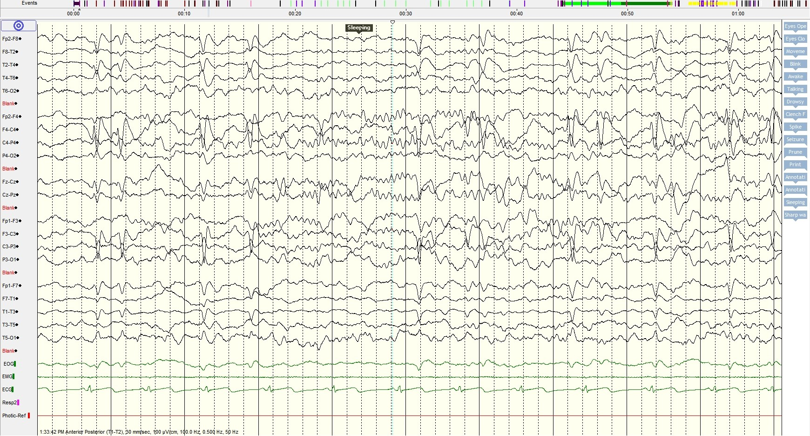

Figure 2
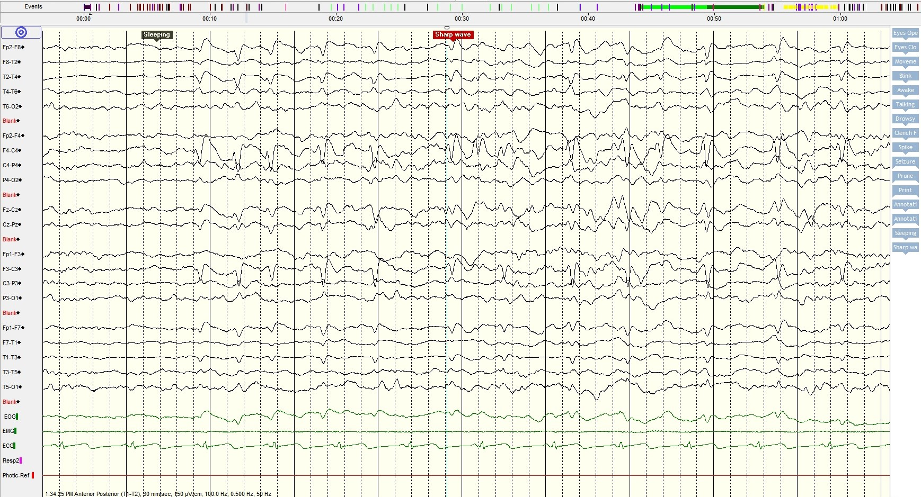

Figure 1 and 2 : During sleep EEG showed stereotyped bisynchronous burst wave discharge over the right and left central temporal-region (C3/C5/T3/T4)

Figure 3
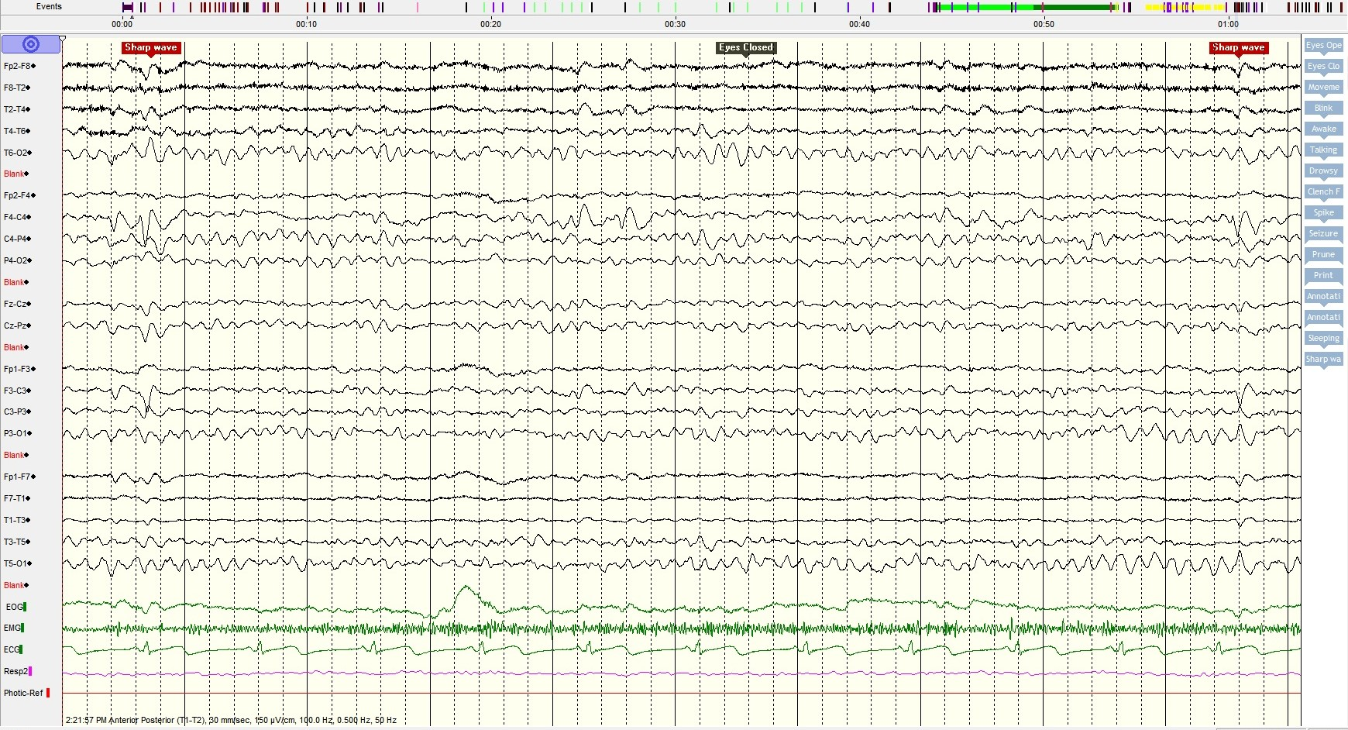

Figure 4
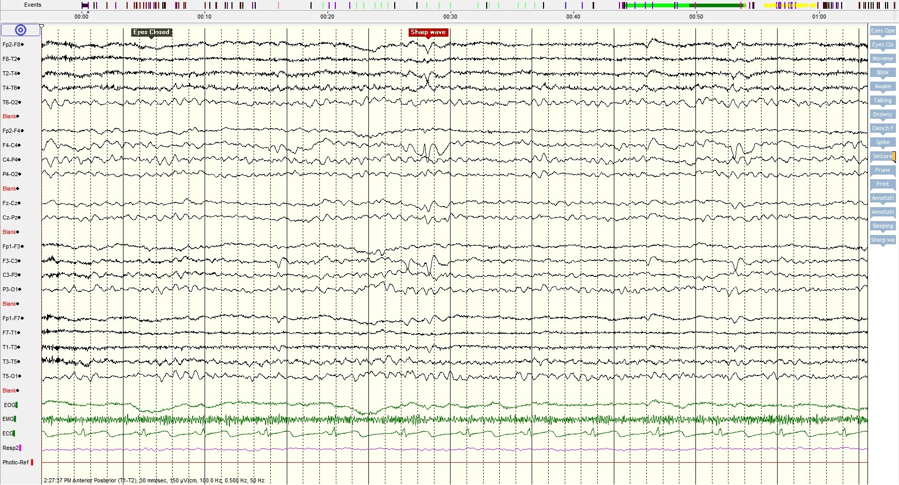

Figure 3 and 4 : During awake EEG showed stereotyped sharp wave discharge over the right and left central temporal-region (C3 /T3 /T5, C4 /T4 /T6)

Recent Publications
- Forsyth, Rob. Richard Newton (2012) Pediatric Neurology Second Edition. Childhood onset Epilepsy Syndromes 4:268.
- Singhi, Pratibha (2016) Seizures and Epilepsy in Children : a Practical Guide. Childhood Electroclinical Syndromes 7:68-92.
- Rowan, James A. Eugene T (2005) Primer of EEG with a Mini Atlas. The EEG and Epilepsy 4:51-66
- Grespel, Arielle. Philippe Gesisse. Michelle Bureau. Pierre Genton (2006). Atlas of Electroencephalography Volume 2. The Epilepsies : EEG and Epileptic Syndromes. 1:1-6
- Ebersole, John S. Pedley. Timothy A. Current Practice of Clinical Electroencephalography Third Edition (2003). Seizures and Epilepsy 17:506-588.

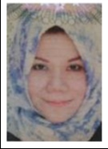 Biography
Sri Hastuti a lecturer and neurologist in aceh province, indonesia country. Because of care and passion in improving the health of the world, I went to the faculty of medicine at Syiah kuala university in aceh in 1996-2002. I dedicate myself in urban area for 3 years. The number of epilepsy cases in the area motivated me to continue my education. In 2006, I continued my specialist education at the university of Indonesia until 2010. My thesis title "Factor Influencing Audotoric P300 Wave In Children With Epilepsy" during being neurologist, I followed "EEG training at PKU Muhammadiyah Hospital, Yogyakarta, Indonesia 2015", "EEG beginner Indonesia Neurological Association, in Manado, Indonesia 2011 ". "EEG advanced Indonesia Neurological Association, Manado, Indonesia 2011". Hands of recording, reading and reporting EEG Indonesia Neurological Association, Surakarta, Indonesia 2011 ". In June 2017 to June 2018, I became a neuropediatric fellow at University Malaya Medical Center, Kuala Lumpur. Now I am Staff of Neurology Department, Zainoel Abidin Hospital, Banda Aceh, Indonesia, Staff of NeuroPediatric Division in Neurology Department, Zainoel Abidin Hospital, Banda Aceh Indonesia and Lecturer of Medical Faculty, Syiah Kuala Unvercity, Banda Aceh, Indonesia. I really hope my abstract can be accepted and participate in 3rd world congress on pediatric neurology
Email: wiwid.srihastuti@gmail.com
Phone : +62 8116898786

