Lateral Extracavitary Approach to Spinal Tumors

Basem I. Awad¹, Amen Sabry¹, Samer Serag¹, Mohamed State¹, Michael P. Steinmetz², and Edward Benzel²

¹Department of Neurological Surgery, Mansoura University School of Medicine, Mansoura, Egypt
²Department of Neurological Surgery, Cleveland Clinic, Cleveland, OH, USA

Abstract

The surgical management of pathology involving the ventral aspect of the thoracic and upper lumbar spine is typically challenging. Thoracotomy provides direct ventral exposure of the spine and spinal cord, however the approach related morbidities could be markedly significant while a separate dorsal approach may be required for instrumentation. The lateral extracavitary approach (LECA) is a dorsolateral approach that provides lateral and ventral access to thoracic and upper lumbar spine without entrance into the pleural cavity. By remaining extrapleural, the LECA avoids the complications noticed previously with thoracotomy. Neural decompression, tumor removal, and fixation can all be accomplished via LECA, which make it an invaluable tool in spinal surgery. This technical advantage has led to excellent neurological outcomes with nearly 75% of patients described in the literature revealing neurological improvement.
In the present study, we reviewed fifteen patients with spinal tumors treated with anterior and posterior resection and reconstruction from a single posterior approach. Pre- and postoperative neurological condition, mean blood loss, length of hospital stay after surgery, and complications related directly to surgery were analyzed. Pre- and postoperative computed tomography (CT) scans and magnetic resonance imaging (MRI) scans were evaluated. Our results showed neurological improvement in 69.2%, 29.2% experienced no change, and 1.5% reported worse condition. Mean blood loss was 2134 mL and hospital stay was 7.2 days. Total complication rate were 15.5%. In conclusion: Adequate neural decompression combined with anterior and posterior column reconstruction is feasible through lateral extracavitary approach using a single posterior skin incision. Minimally invasive (MIS) approaches are now being applied in all areas of the spine surgeries including LECA. MIS LECA approach is purported to have decreased operative time, reduced blood loss, less tissue dissection, less perioperative pain, and earlier mobility.

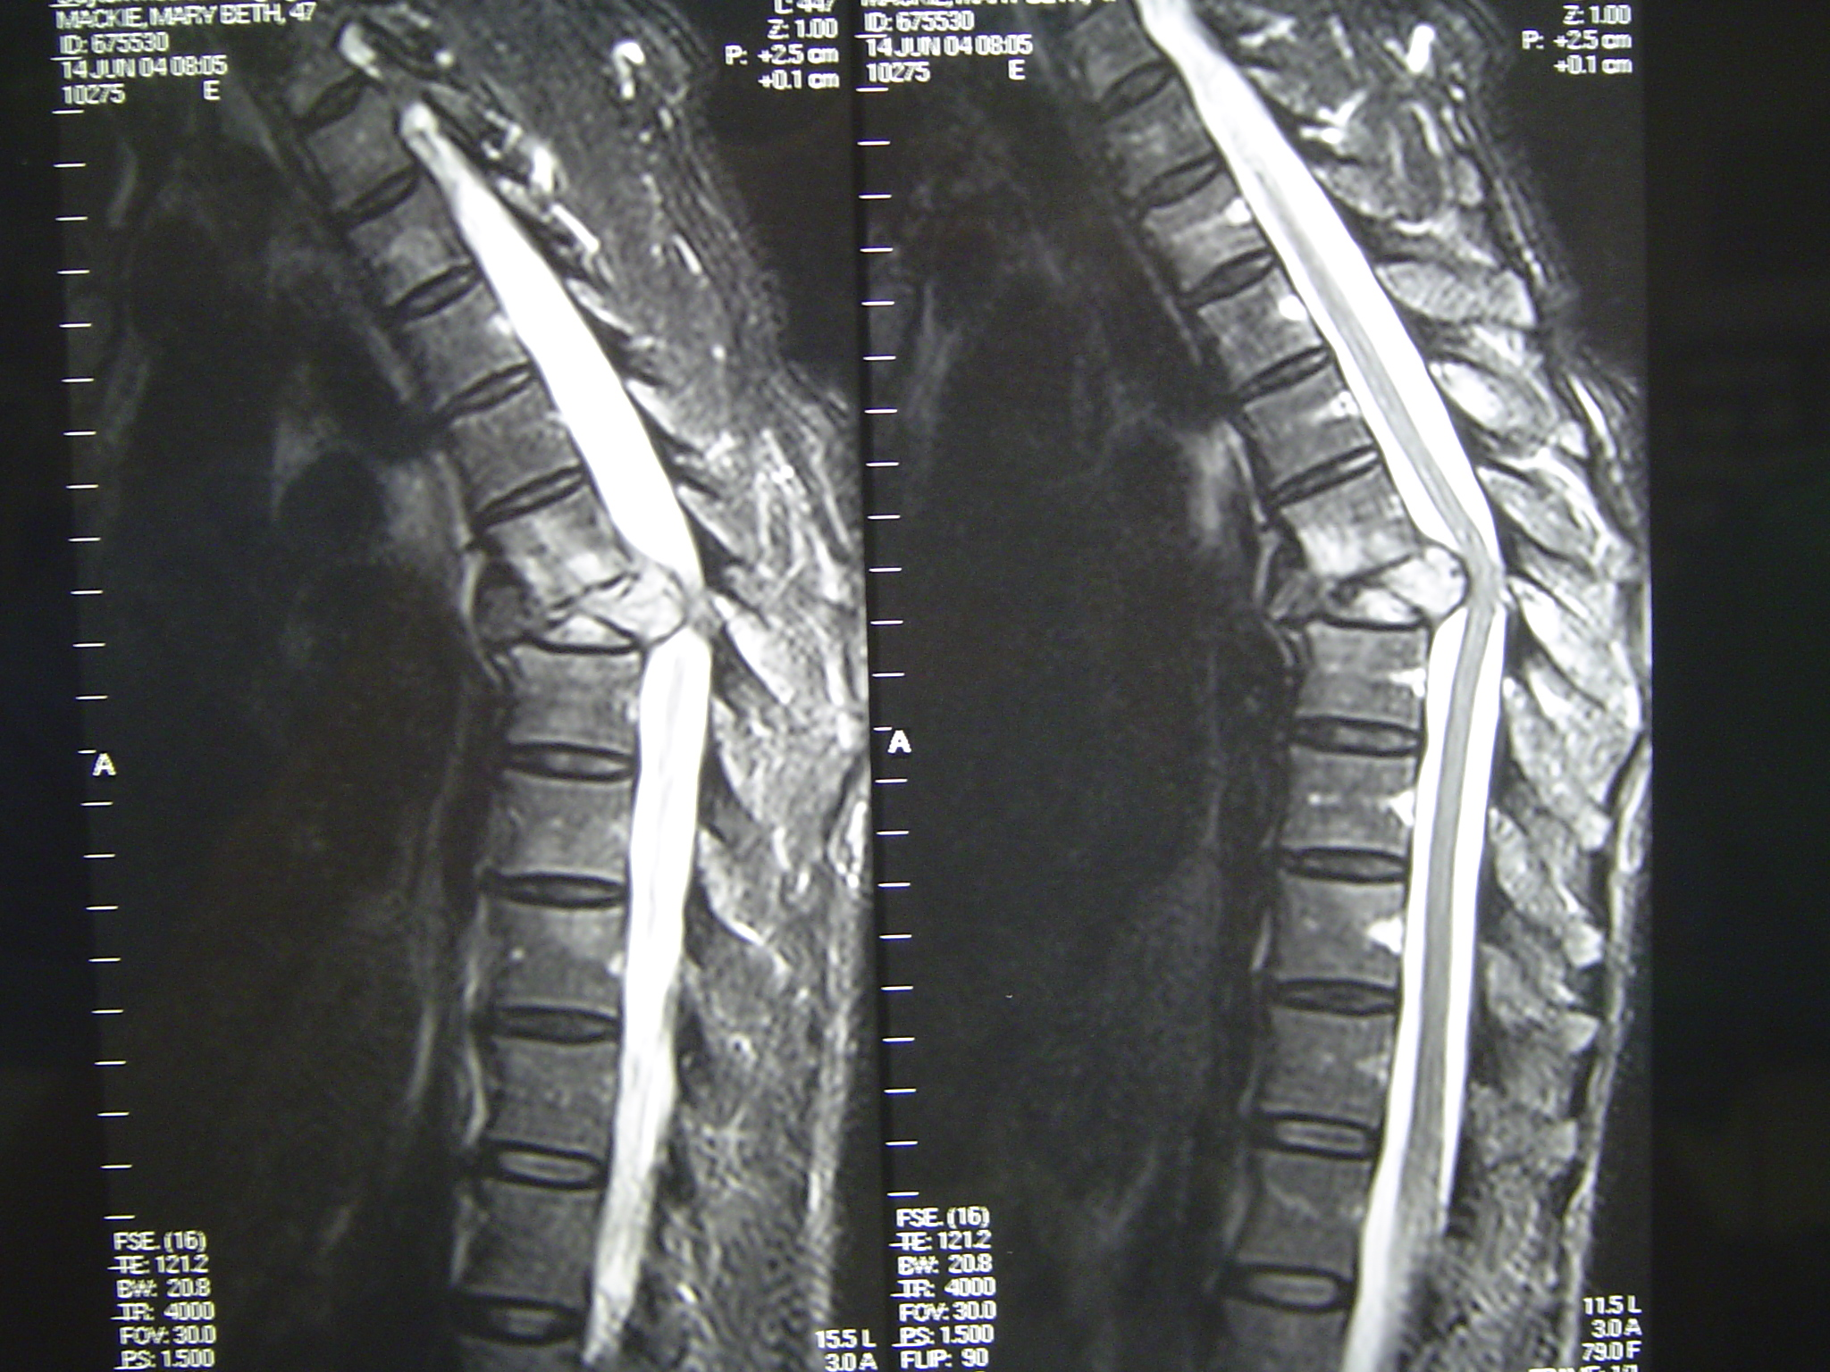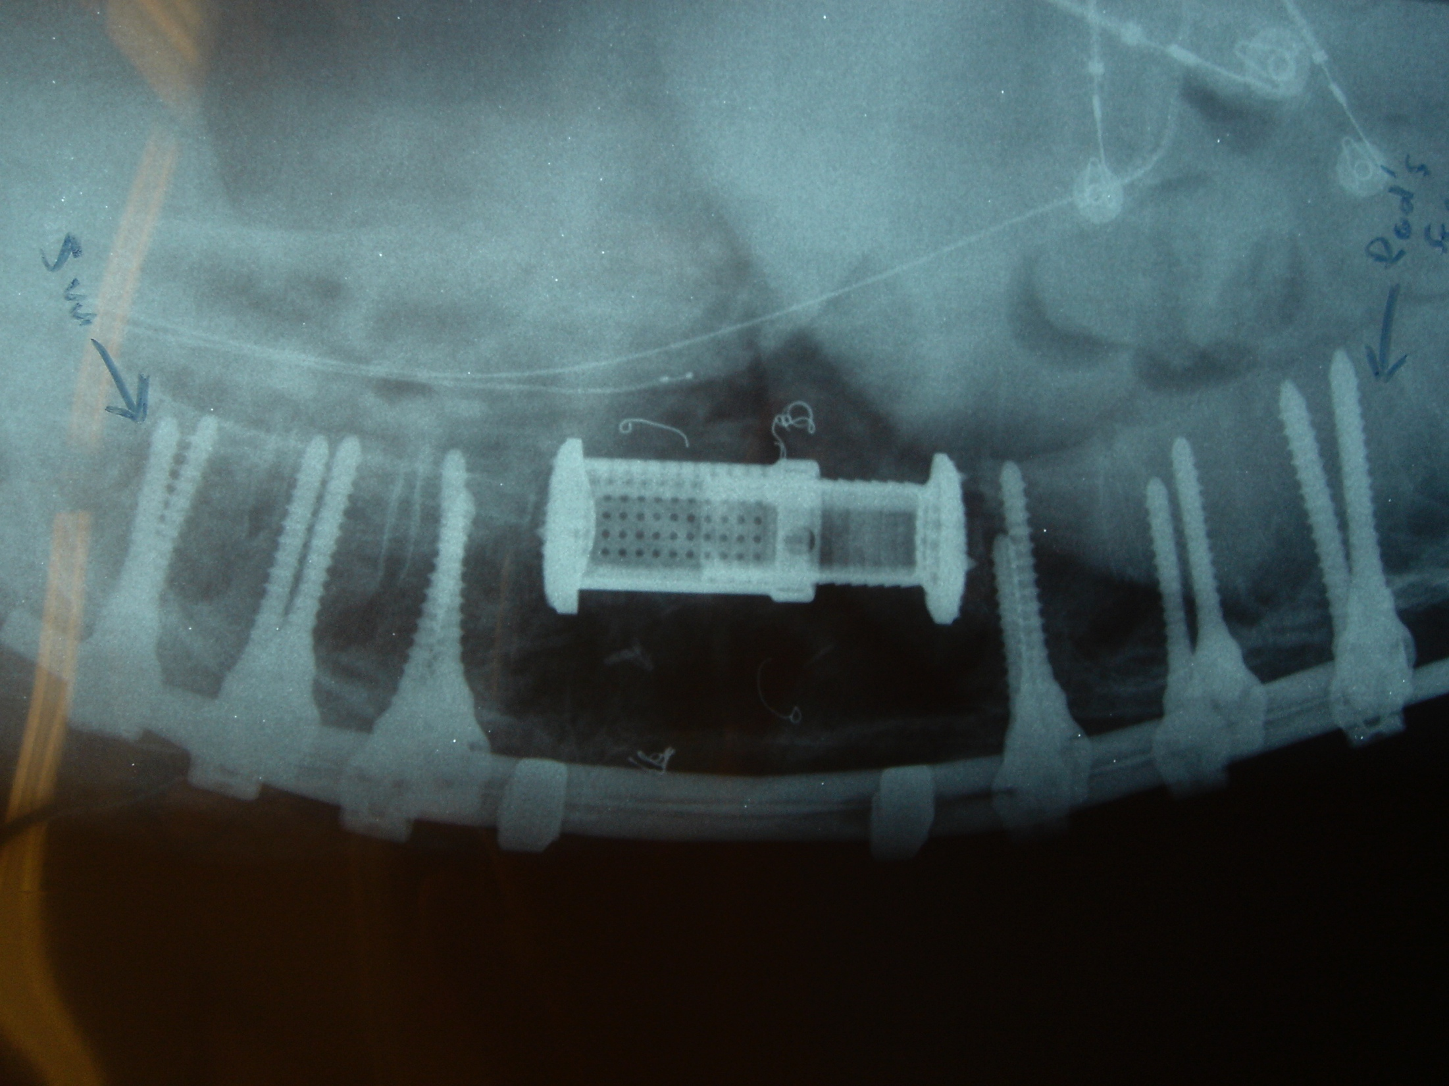

Recent Publications

- Steinmetz MP, Claybrooks R, Krishnaney A, Prayson RA, Benzel EC. Surgical management of osseous hemangioblastoma of the thoracic spine: technical case report. Neurosurgery. 2005; 57:E405.
- Khoo LT, Smith ZA, Asgarzadie F, Barlas Y, Armin SS, Tashjian V, Zarate B. Minimally invasive extracavitary approach for thoracic discectomy and interbody fusion: 1-year clinical and radiographic outcomes in 13 patients compared with a cohort of traditional anterior transthoracic approaches. J Neurosurg Spine. 2011 Feb;14(2):250-60.
- Lubelski D, Abdullah KG, Mroz TE, Shin JH, Alvin MD, Benzel EC, Steinmetz MP. Lateral extracavitary vs. costotransversectomy approaches to the thoracic spine: reflections on lessons learned.Neurosurgery. 2012 ;71(6):1096-102.
- Benzel EC. The lateral extracavitary approach to the spine using the three-quarter prone position. J Neurosurg. 1989; 71:837– 841.
- Smith ZA, Li Z, Chen NF, Raphael D, Khoo LT. Minimally invasive lateral extracavitary corpectomy: cadaveric evaluation model and report of 3 clinical cases. J Neurosurg Spine. 2012;16(5):463-70.



