Herpes simplex encephalitis during chemoradiation therapy in nasopharyngeal cancer patient

Aisha AlDowihi ⁽¹⁾ Manar Alotaibi ⁽¹⁾ Farah AlEissa ⁽¹⁾

(1)King Fahad specialist hospital – Neuroscience center
Dammam Saudi Arabia

Herpes simplex encephalitis (HSE) is a catastrophic disease with high mortality and serious neurological disabilities. Immunosuppressive state may increase the risk of developing HSE. HSE might exhibits atypical manifestations in immunocompromised patients. Brain radiotherapy (RT) have been reported to increase susceptibility to HSE, since brain RT disturb the blood-brain barrier. Here, we report a case of atypical HSE presentation in a 52 years old male with nasopharyngeal squamous cell carcinoma who was treated with concurrent chemoradiation. During his treatment period, he has pancytopenia, fever, altered level of consciousness and focal seizure, his MRI showed abnormal signal intensity in the left temporal lobe, EEG revealed left lateralized periodic discharges. Cerebrospinal fluid examination showed few neutrophilic predominant cells and positive polymerase chain reaction for herpes simplex virus-1. Acyclovir was initiated for 3 weeks and the patient had a good clinical course with few neurologic sequelae. HSE is a rare but potentially fatal possible finding in patient with NPC during or after local radiation and chemotherapy.

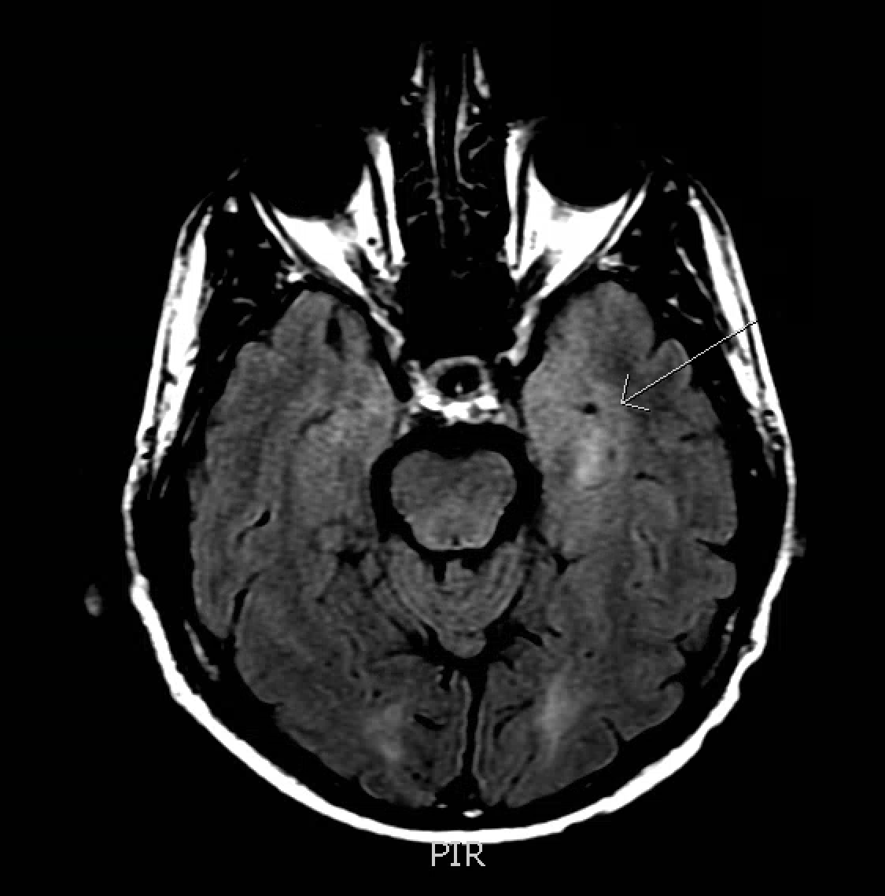
Image 1: High FLAIR signal intensity within the medial aspect of the left temporal lobe.

 Aisha AlDowihi
Adult neurology resident training at king fahad specialist hospital in Dammam, has an interest in translational neuroscience as well as neurophysiology based research.

Email: Aishaaldowihi@gmail.com
Phone: +966543095949

