Title: Curcumin-loaded Dual-targets Nanoparticles with Enhanced Magnetic Resonance Imaging Therapy of Alzheimer's Disease in Transgenic Mice

Yuting Ruan, MD, Department of Neurology, Sun Yat-Sen Memorial Hospital, Sun Yat-Sen University, China
Jun Liu, MD PhD, Department of Neurology, Sun Yat-Sen Memorial Hospital, Sun Yat-Sen University, China

Abstract

Alzheimer's Disease (AD) is a common neurodegenerative disease with no curative treatment. Curcumin (cur) has been proved to be effective in treatment of AD. However, the low bioavailability and hydrophobicity of cur which distributed non-targeted after administration and hindered by the blood-brain barrier limit its application. We designed a novel diagnostic and therapeutic nanoparticle, 1,2-dio- leoyl-sn-glycero-3-phosphoethanolamine (DSPE)-n-[poly(ethylene glycol) (PEG)] loaded with cur and superparamagnetic iron oxide (SPION) conjugated with two targets ligands to the surface of the nanoparticles, CRT and QSH, abbreviated as SPIO@DSPE-PEG/Cur-CRT/QSH. CRT specifically targets ligands at the blood-brain barrier (BBB), and QSH has an fine ability to bind with Aβ₁₋₄₂ which is the culprit of AD pathology. The in vitro parameters of nanoparticle included dynamic light scattering (DLS), transmission electron microscope, saturation of magnetization, flow cytometry analysis. In vivo image of amyloid plaques were detected by MRI scanning, and the spatial learning and memory capability of transgenic APP/PS1 mice were conducted by Morris water maze (MWM). Bielschowsky silver staining, western blotting, immunostaining were among the ex vivo assays to determine the expression of amyloid protein, tau hyperphosphorylation, glial fibrillary acidic protein (GFAP), β-III tubulin (Tuj1). The in vitro assay determined the nanoparticles that possess fine size, zeta potential, r₂ relaxivity, increased its cellular uptake. In vivo 7 Tesla MRI images of mice brains which were treated with SPIO@DSPE-PEG/Cur-CRT/QSH showed less amyloid plaques accumulation compared to native cur. The MWM results indicated the SPIO@DSPE-PEG/Cur-CRT/QSH brilliant improved the learning and memory capability of APP/PS1 mice compared with the bald cur. Moreover, SPIO@DSPE-PEG/Cur-CRT/QSH reduce hippocampal tau hyperphosphorylation and β-amyloid deposit, while increase the expression of Tuj1. This nanoparticle would be a potential diagnosis and treatment for AD.

Image
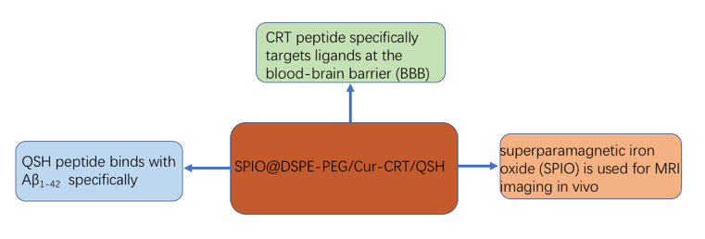
Recent Publications
- Shengnuo Fan, Xuan Liu, Wengli Fang,Xiaoyou Chen, Wang Liao, Xiuna Jing, Enxiang Tao, Qiulan Ma, Xingmei Zhang, Rui Guo* & Jun Liu* (2018) Curcumin loaded PLGA PEG nanoparticles counjugated with B6 peptide for potential use in Alzheimer's Disease. Drug Delivery,25(1):12.
- Xiao SH，Zhou DY，Luan P，Gu BB，Feng LB，Fan SN，Liao W，Fang WL，Yang LH，Tao EZ，Guo R*，Liu J*(2016) Graphene quantum dots conjugated neuroprotective peptide improve learning and memory capability，Biomaterials,106：98~110.
- Fan SN, Zhang B, Gu BB, Wan Q, Huang XY, Liao W, Liu J*(2015) PI3K/AKT/mTOR/p70S6K pathway is involved in Aß25-35-induced autophagy. BioMed Research International, 2015: p. 1-9.
- Yang LH, Cai X, Jiang L, Liang YR, Xiao SH, Liu S, Tao EX, Luan P, Liu J*(2014). Inhibitory effect of Bcl-xL gene on toxicity induced by sodium nitroprusside in SH-SY5Y cells. CNS Neurosci The, 20(4):379-81.
- Zhao Z, Lan Y, Bai S, Shen J, Xiao S, Lv R, Tao E, Liu J*(2013). Late-onset radiation-induced optic neuropathy after radiotherapy for nasopharyngeal carcinoma. J Clin Neurosci,20(5):702-6.

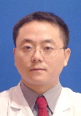  Biography
Jun Liu has completed his PhD and MD at the age of 25 years from Sun Yat-Sen University and postdoctoral studies from Kansas University School of Medicine. He is an doctorial supervisor and serves as the vice-director of Department of Neurology, Sun Yat-Sen Memorial Hospital, Sun Yat-Sen University. He has published more than 40 papers in reputed journals (Biomatiers, JBC, CNS Neurosci The) and has been serving as an editorial board member of BioMed Research International, World Journal of Neurology, J Nasopharyngeal Carcinoma , BMC Ophthalmology.
Yuting Ruan is a second-year PhD candidate majoring in Neurology at Sun Yat-Sen Memorial Hospital, Sun Yat-Sen University. He mainly focused on the diagnosis and new theraputic targets for Alzheimer’s disease.
Email: docliujun@hotmail.com
ruan_yuting15@126.com
Notes/Comments:

