Investigating the molecular mechanism of Bipolar Disorder
Qiuwen Wang, Tsinghua University, China

Abstract (300 word limit)

Bipolar disorder (BD) is a complex neuropsychiatric disorder that is characterized by intermittent episodes of mania and depression. BD affects more than 1% population worldwide and has been ranked by the World Health Organization as a top disorder of morbidity and lost productivity. However, the pathogenesis of BD has remained enigmatic. This is mainly because genetic animal models based on identified susceptible genes have often failed to show core symptoms of BD, especially spontaneous mood cycling. The introduction of induced pluripotent stem cell (iPSC) technology has provided a new approach for research of BD pathogenesis. We have developed an iPSC model for human BD and investigated the cellular and molecular deficits of patient iPSC-derived hippocampal dentate gyrus-like neurons. Guided by patch-clamp recording analysis, we have observed hyperactive action-potential firing, which could be selectively reversed by lithium treatment. Both our iPSC-based RNA analysis and past pedigree research have implicated that dysfunction in some key signaling cascades might be crucial for the disease pathogenesis in a subpopulation of BD patients. We hypothesized that the behavioral abnormalities of patients and the comorbid metabolic abnormalities might share some identical molecular mechanism. Hence, we investigated the expression of insulin/synapse dually functioning genes in patient iPSC-derived neurons and their phenotypes in the behaviors of mice with these genes silenced in the hippocampus. By this means, we identified synaptotagmin-7 (Syt7) as a candidate risk factor for behavioral abnormalities. We then investigated Syt7 knockout (KO) mice and observed nocturnal manic-like and diurnal depressive-like behavioral fluctuations in a majority of these animals, which are analogous to the mood cycling symptoms of BD and could be treated by clinical drugs. Finally, we observed that the patient plasma samples showed a significantly reduced Syt7 expression compared to the healthy control subjects. We therefore concluded that Syt7 is likely a key factor for the bipolar-like behavioral abnormalities.

Image

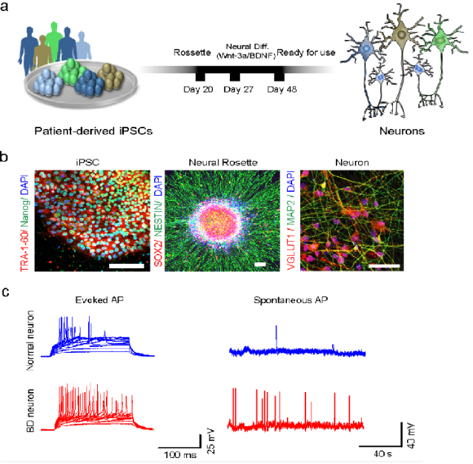
Figure 1: Hippocampal DG granule cell-like neurons derived
From patients with BD show hyperexcitability
Recent Publications (minimum 5)
- Mertens J*, Wang QW*, Kim, Y., Yu, D.X., Pham, S., Yang, B., Zheng, Y., Diffenderfer, K.E., Zhang, J., Soltani, S., et al. (2015). Differential responses to lithium in hyperexcitable neurons from patients with bipolar disorder. Nature 527, 95-99.
- Stern, S., Santos, R., Marchetto, M.C., Mendes, A.P.D., Rouleau, G.A., Biesmans, S., Wang, QW., Yao, J., Charnay, P., Bang, A.G., et al. (2018). Neurons derived from patients with bipolar disorder divide into intrinsically different sub-populations of neurons, predicting the patients' responsiveness to lithium. Molecular psychiatry 23, 1453-1465.
- Wei Shen*, Wang QW* et al. Synaptotagmin-7 is a key factor for bipolar-like behavioral abnormalities in mice. PNAS, Accepted.

 Biography (150 word limit)
Dr. Qiuwen Wang has been studying the molecular mechanisms involved in the pathogenesis of bipolar disorder. She has her expertise in stem cell biology, eletrophysiology and fluorescence imaging. She is passionate on developing new therapies and drugs aimed at clinical treatment for bipolar disorder.
Email: wang_qiuwen@163.com
Phone: +86-18811328759

Notes/Comments:

