Melatonin: the its role in the development of epileptic seizures
Voitiuk A.1, Litovchenko T.1,
1Kharkiv Medical Academy of Postgraduate Education, Department of Neurology and Child Neurology, Kharkiv, Ukraine;

Abstract

Melatonin (N-acetyl-5-methoxytryptamine) is a multifunctional hormone that is a neuroprotective agent and an antioxidant, plays a key role in the coordination and synchronization of the nervous system. It has a high permeability through the blood-brain barrier, therefore fluctuations in its concentration in the peripheral blood have a significant effect on the functional state of the brain neurons.

The purpose of this research is to study the level of melatonin in patients with epilepsy, depending on the severity of the disease, the type and frequency of seizures.

The studies were carried out on the basis of clinical symptoms and instrumental data analysis. The detection of melatonin in the blood serum was carried out by applying a modified Cole and Crank fluorometric method with orthophthalic aldehyde. Taken into account the circadian rhythms of melatonin production, the studies were conducted from 7:00 to 8:00 am, during the period of maximum secretion. The EEG and EEG-video monitoring were used as screening methods. The clinical material was analyzed on the basis of the survey of 256 patients with epilepsy, whose average age was 32-37 years. Based on multivariate analysis of clinical data, three groups of patients were identified depending on the severity of the disease. The control group is 52 practically healthy people. In all patients, a significant decrease in morning melatonin secretion was found on average by 25.6% in comparison with the control group indicators. A low level of melatonin was characteristic of patients with primary and secondary generalized convulsive seizures, as well as with prolonged complex partial seizures. The deterioration of the EEG pattern in 89.3% of cases was accompanied by the appearance of new epileptiform phenomena: spikes, "spike-slow wave" complexes, high-amplitude sharp waves. In 57.1% of patients, a significant focal "slowing down" of the EEG was registered.

Thus, melatonin deficiency can be one of the reasons for increasing the activity of excitatory systems. The correlation between epileptiform changes in the EEG and certain decrease in melatonin level has also been detected. The higher the melatonin level in patients, the lower is the convulsive readiness of the organism and the more favorable course of epilepsy.
Image

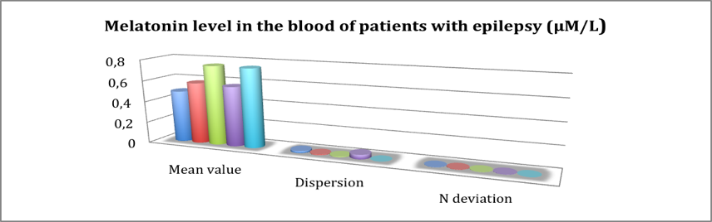

Figure 1. Melatonin level of the blood of patients with
epilepsy (μM/L)

Recent Publications (minimum 5)
- Gunata M, Parlakpinar H, Acet HA (2019) Melatonin: A review of its potential functions and effects on neurological diseases. Revue Neurologique 19:35-45.
- Sanchez-Barcello EJ, Rueda N (2017) Clinical uses of melatonin in neurological diseases and mental and behavioural disorders. Current Medicinal Chemistry 24(35):3851-3878.
- Ganie SA, Dar TA, Bhat AH (2016) Melatonin: a potential anti-oxidant therapeutic agent for mitochondrial dysfunctions and related disorders. Rejuvenation Research 19(1):21-40.
- Pandi-Perumal SR, BaHammam AS, Brown GM (2013) Melatonin antioxidative defense: therapeutical implications for aging and neurodegenerative processes. Neurotoxicity Research 23: 263-300.
5. Srinivasan V (2012) Melatonin oxidative stress and neurodegenerative diseases. Indian J Exp Biol. 40(6):668-679.

 Biography
Anna Voitiuk studied as a Postgraduate student in Neurology at Kharkiv Medical Academy of Postgraduate Education. During her residency she has shown interest and enthusiasm in treating patients with epilepsy, disorders of cerebral circulation, spinal diseases. Currently she is a highly qualified neurologist. Anna Voitiuk is an active member of Ukrainian League Against Epilepsy (ULAE). She has published the 5 articles and 3 articles in collaboration with colleagues..
Email: a_vojtyuk@yahoo.com
Phone: +380509081085

