Systemic review in venous sinus thrombosis on clinical picture of patient diagnosis and treatment

Abstract

Background
The Purpose of this systematic review is to provide a clinical picture of patient diagnosis and treatment of cerebral venous sinus thrombosis. The intended audiences are physicians and other healthcare providers who are specialized in the diagnosis and treatment of patients with cerebral venous sinus thrombosis.

Methods
All published studies from PubMed, Medline, the Cochrane Controlled Trials Register, and Cochrane Database of Systematic Reviews up to April 2017 were reviewed.

Study Selection
Randomized, controlled trials; systematic reviews of trials; and observational studies; all restricted to English-language articles.

Conclusions
Clinical picture of patient is provided for the diagnosis and treatment of venous sinus thrombosis is described. Considerations for the diagnosis and treatment of venous sinus thrombosis during pregnancy and in the pediatric population are provided.

Keywords
Venous Sinus Thrombosis, CVST, VST, intracranial thrombosis, sinus thrombosis, systematic review.

Introduction
Venous sinus thrombosis is a well-recognized form of stroke. Despite advances in the recognition of venous sinus thrombosis in recent years, diagnosis and treatment can be challenging due to the diversity of underlying risk factors and the absence of a uniform treatment approach. Venous sinus thrombosis represents ≈0.5% to 1% of all strokes and affects approximately 5 patients per million every year. Its clinical manifestations vary, and thus can delay the diagnosis. The most common symptom is headache which occurs in up to 90% of patients, abnormal vision, followed by focal lobar syndrome, seizures, encephalopathy and cranial nerve palsies. There are multiple factors contributing to venous sinus thrombosis, but not all of them are reversible. Prior medical conditions such as thrombophilias or inflammatory bowel disease, transient situations such as, pregnancy, dehydration or infection, selected medications including oral contraceptives or substance abuse, and unpredictable events for example head trauma are some predisposing conditions. Recently, computed tomography (CT), magnetic resonance imaging (MRI) and advanced modalities such as MRV (MR Venography) are increasingly being used, which has helped physicians to diagnose venous sinous thrombosis more frequently even in patients with atypical presentation.

Methods
With this systematic review we seek to address the current state of literature with particular emphasis to the recent interest in endovascular treatment options and remedy some of the misunderstandings in daily clinical practice as to the optimal way to diagnose and manage venous sinus thrombosis using the currently available modalities.

Search Strategy
Using a PubMed search, three primary investigators (SK, CS, YD) reviewed relevant published articles independently within the last 5 and until, 2019 with search phrases including, “ CVST” , VST” “Venous Sinus Thrombosis”; “Dural Venous Sinus Thrombosis”; “Cerebral Venous Sinus Thrombosis”; “Venous Sinus Thrombosis Management”; “Venous Sinus Treatment,” and “Thrombolysis AND venous sinus thrombosis,” These terms and keywords were incorporated into a Medical Subject Headings (MeSH) search to yield articles indexed in Medline. All RCTs, observational cohort studies, and administrative registries comparing or reporting venous sinus thrombosis were included.

Eligibility Criteria
Titles and abstracts of the articles resulted from the keyword searches were read and articles were selected by most relevance. The articles were regarded relevant based on the certain data provided. Articles assisting our purpose of relaying general information, clinical workup, diagnosis and treatment of venous sinus thrombosis were included. Referenced articles in a similar fashion were reviewed and used to supplement our search. Papers that were just outside of the 5-year inclusion criteria were critically analyzed and included only if contained relevant information, otherwise excluded, was provided. All scientific researches and studies publishing multiple reports on the same patient population were included only once. Editorials and comments were not included.
A data abstraction tool was designed to systematically review the recent papers related to venous sinus thrombosis diagnosis, treatment, or both. Authors, type of study, date of publication, years of data collected, patient demographics, risk factors, thrombus location, neurologic decline, intracerebral hemorrhage (ICH), venous thromboembolisms (VTE), medical management, type of intervention, , statistical analysis, 30-day mortality rate, outcome measures (mRS), and follow up periods were extracted and reported. Papers that did not meet the above criteria for relevance and papers that did not discuss diagnostic or treatment options were excluded from the systematic review. Data gathered prior to the 5-year inclusion criteria, but reported in subsequent reviews that were published within 5 years were included.

Statistical Analysis
The primary endpoint was the combined 30-day together with in-hospital death rate. If not reported, the 30-day or in-hospital death rate was used instead. A secondary endpoint was diagnosis of new or incidence of elevated ICH after endovascular intervention.

RESULTS
A total result of 4315 published papers was yielded from search methods. Sixty six studies considered relevant for the purpose of relaying convenient information in the desired timeframe. Among these articles, 35 articles investigating treatment options of a summation of 10,285 patients were eligible for data extraction and included in the systematic review of treatment modalities.
Eight from the thirty five articles, representing (22.8%), were systematic reviews of case reports and case series. Thirteen out of the 35 articles were individual case reports (37.1%), Five of the 35 were case series (14.2%), six of the 35 were retrospective reviews (17.1%), and three out of the 35 were observational studies (8.5%) that were not otherwise mentioned or included in selected systematic reviews were included. Of the retrospective reviews, two (0.5%) were multi-institutional. Ten articles were excluded from the study as they did not meet pre-defined eligibility criteria. An article distribution bar chart is shown in Figure 1.

Figure 1 - A bar chart illustrating the distribution of the selected 35 articles

A total number of 312 patients from the 25 articles were subjected for statistical analysis. All patients included and all received endovascular intervention with direct thrombolysis, mechanical thrombectomy or both. One hundred and thirty three (133,42.6%) patients reported in 21 articles were documented to have neurologic decline that prompted endovascular intervention.
Regardless of systemic anticoagulation, patients were still reported to have complications of venous sinus thrombosis. Primary outcome of 30-day-mortality rate in individual articles ranged between 0% and 30%, with average of 3.8%. Follow up appointments ranged from 2 weeks to 5 years with most articles stating 3-6month follow ups. Outcome at 3-6 month follow up indicated mRS<1 in 224 patients (Fig. 2). Secondary outcome of 44 patients (14%) at a rate of 13.2%, were documented to have intracranial hemorrhages, new or enlarging, after receiving endovascular thrombolysis or mechanical thrombectomy. Three articles did not specifically address intracranial hemorrhages post operatively (Fig.3)

Figure 2- A bar chart illustrating the outcome after Endovascular Intervention

Figure 3- A bar chart illustrating the reported ICH after Endovascular Intervention

DISCUSSION

Clinical Picture of patient
Clinical picture of patient is represented by impaired venous drainage with an elevated intracranial pressure that account for varying degrees of clinical presentations. The incomplete thrombosis or the presence of adequate collateral venous circulation permits venous drainage to continue to some extent. Presentations may range from absence of clinical signs and symptoms, to severe signs and symptoms related to acute high intracranial pressure. Headache is the most common significant symptom accounting for approximately 90% of patients diagnosed with Venous Sinus Thrombosis, followed by seizures.
Local cerebral injury accompanied by focal ischemic changes or intracerebral hemorrhage also result in pertinent clinical presentations and continued clinical disease progression. Nearly 50% of patients with cortical cerebral venous thrombosis develop venous infarcts. Thus, focal neurologic deficit should raise suspicion for local venous infarct with the diagnosis of venous sinus thrombosis. Depending on to the adequacy of venous drainage, associated local injury, and timing, symptoms such as headaches, nausea, vomiting, dizziness, decreased visual acuity, papilledema, altered mental status, depressed mental status, paralysis, seizures, coma, death may occur.
The number of reported cases of patients presenting with a subarachnoid hemorrhage (SAH) due to a cerebral venous sinus thrombosis is rising and must be recognized as a possible etiology during workup. Thus, as arterial etiologies are ruled out, venous imaging should be considered to further investigate the possibility of cerebral venous sinus thrombosis. One theory states that elevated pressures within weak cortical veins could lead to focal venous rupture within the subarachnoid spaces. 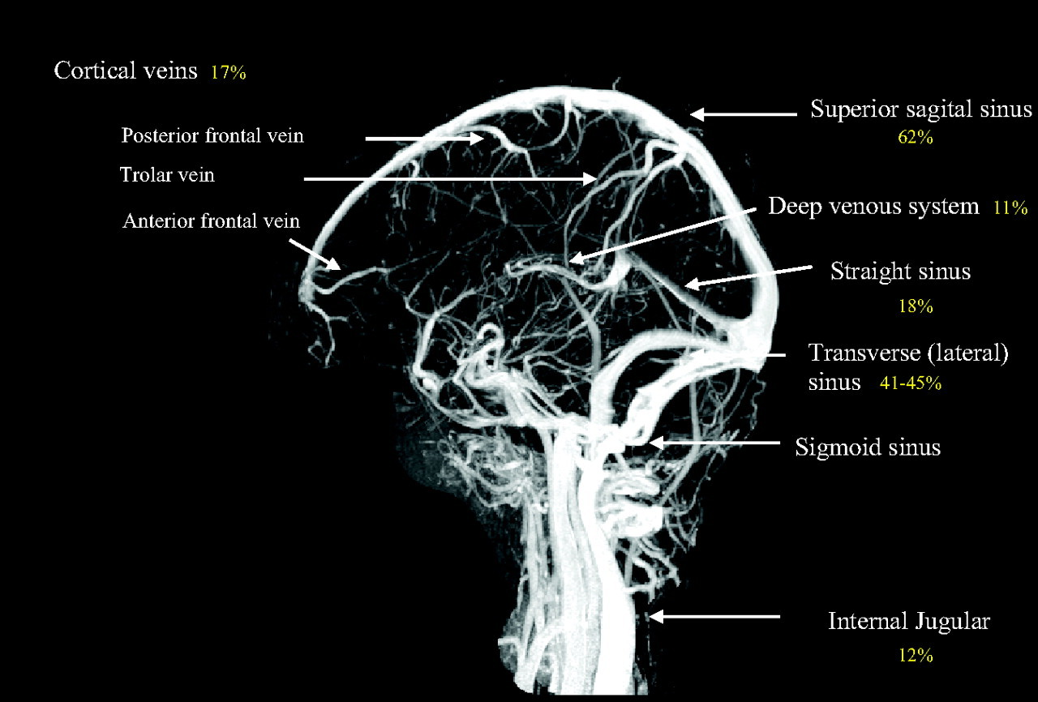
Figure 4- Magnetic resonance venogram showing the cerebral venous system and most frequent (%) location of cerebral venous and sinus thrombosis, as reported in the International Study on Cerebral Venous and Dural Sinuses Thrombosi

Making the Diagnosis
The undistinguished presentation of patients with VST complicates the diagnostic workup, therefore requires a highly educated clinical suspicion. Various diagnostic measures of venous sinus thrombosis include the serum laboratory investigation, MRI/MRV, CT/CTV, cerebral angiography.

Laboratory Investigation
D-dimer has been identified to be significantly high in patients suffering from extensive acute VST. It is a marker of fibrin degradation and has been reported to be elevated to levels more than 500ug/L. H owever, a low D-dimer does not rule out the presence of a VST or a subacute to chronic VST. A high clinical suspicion warrants further investigation even with low to normal D-dimer levels as it can also be falsely negative in patients with a high clot burden.
During clinical episode numerous abnormalities of the coagulation system can occur. While a thorough evaluation should be undertaken, a delay of 3 months after recovery from the acute phase is beneficial before evaluating predisposing conditions such as CBC, Factor II level,etc. Some tests investigating an underlying thrombophilia can be taken any time, such as protein C and S levels as well as antiphospholipid and anticardiolipin antibodies.

Computerized Tomography and Computerized Tomographic Venography (CT and CTV)
A venous sinus thrombosis on a non-contrasted CT scan is shown as a hyperdensity along the vein of interest, known at the “cord sign” which may be present for up to 2 weeks. Secondary effects such as intracerebral hemorrhage or cerebral edema, and not representative of an arterial territory might suggest a CVST. A triangular hyperdensity noted in the posterior third of the sagittal sinus or proximal transverse sinus known as the “delta sign,” represents a thrombosis in this area. A CTV with 3-D reconstructions may help in revealing a thrombus in a major draining vein.
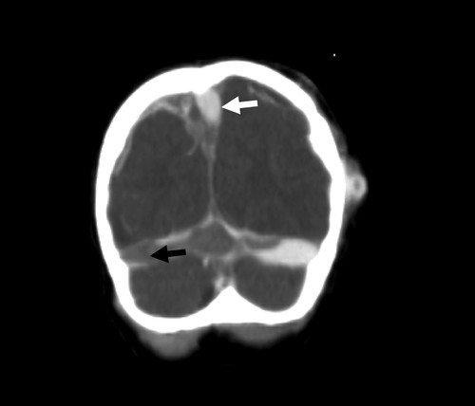
Figure 5- Computed tomographic venogram showing mixed density within venous sinuses (high-density contrast in patent segments (white arrow) and low density (black arrow) in nonperfusing thrombosed segments)

Magnetic Resonance Imaging and Magnetic Resonance Venogram (MRI and MRV)
The MRI is more sensitive than the CT and is the preferred non-invasive method of identifying a cortical or a deep venous sinus thrombus. The appearance of a thrombus on an MRI, is based upon the age of the clot. Within the first few days, the clot appears iso-intense of T1 weighted imaging and hypo-intense on T2 weighted imaging, due to the presence of de-oxyhemoglobin. After 1 week, the presence of methemoglobin gives the clot a hyper-intense appearance. Contrast enhanced MRV is more sensitive than time- of-flight (TOF) MRV and can identify thrombus in vein of much smaller caliber.
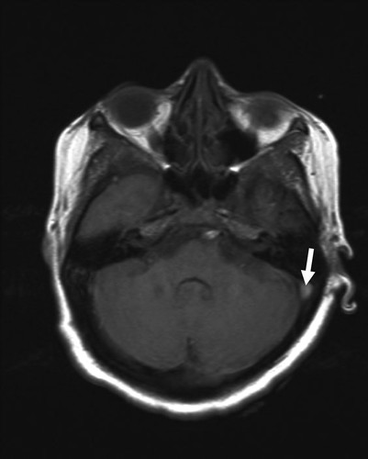
Figure 6- Flair magnetic resonance image showing hypersensitivity signal at left sigmoid sinus.

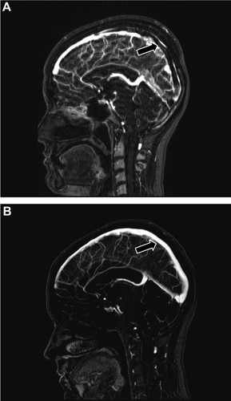

Figure 7- Magnetic resonance venogram showing thrombosis (black arrows) of the superior sagittal sinus and sigmoid sinuses. A, 2 days after symptom onset. B, 1 year follow-up after oral anticoagulation therapy (OAC).
Cerebral Angiography
Cerebral angiography can be safely executed when the diagnosis by MRI/MRV is uncertain, if the patient is not capable to have MRI, or if appropriate technologies are not available.
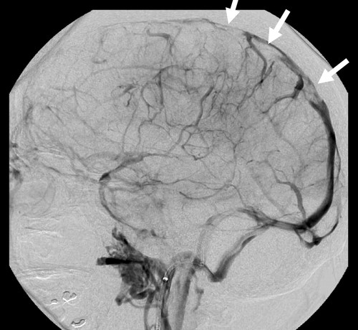
Figure 8- Venous phase of direct carotid angiogram and catheter venogram showed extensive thrombosed superior sagittal sinus (white arrows) and cortical veins. The direct venogram also showed collateral cortical veins.

Treatment

General Management
Acute management of VST, requires a precise balance between three goals: 1) recanalization of thrombosed vessels 2) preventing medical complications of therapy and 3) prevention and treatment of secondary effects.
The current literature on VST urges a quick diagnosis and treatment with fluids and anticoagulant therapy shortly after. The goals of anticoagulation are to recanalize the vessel, prevent thrombus growth and other thrombotic events. Vessel re-canalization re-establishes venous drainage and can help with acquired hydrocephalus. Many studies reported using heparin as anticoagulation to be safe with better outcome. Infection and endocarditis may result in infected thrombophlebitis and must be treated with antibiotics.

Anticoagulation
Intravenous heparin or low molecular weight heparin (LMWH), are options for acute VST treatment. Complex clinical events may prevent the immediate treatment with anticoagulants. For instance, patients following operative intervention, trauma, or those who have intracerebral hemorrhages all raise concerns about early anticoagulation therapy. However, Heparin has been shown to be beneficial rather than harmful for patients with VST in the setting of ICH. Anticoagulation therapy provides a favorable outcome when started four days after initial onset with imaging studies showing regression of subarachnoid hemorrhage.

Thrombolysis and Endovascular Intervention
In a metaanalysis of 25 studies that shows significant improvement in results following endovascular intervention, which included 312 patients, 133 (42.6%) patients, who started and failed on systemic anticoagulation, were subjected to endovascular intervention following neurologic decline. A total 44 patients acquired new or increasing intracranial hemorrhages following intervention. However, the primary outcome at 3 to 6 month follow-up yielded a good outcome of mRS < 1 in 224 patients.
Veigas and colleagues reported a significant beneficial role of systemic thrombolysis in a systematic review of 16 reports and 26 patients, examining the use of systemic thrombolysis in managing CVST. There were no randomized clinical trial found. Thrombolytic therapy differed in studies with a range of 1-120 days following the symptom onset. Most of the patients, 92.3%, regained independency (mRS<3) at last follow up. Three of the patients had ICH, 2 deaths occurred who were associated with ICH. Current reports are insufficient to ensure an obvious benefit from systemic thrombolysis versus systemic heparin.
In a retrospective review of 63 non-randomized patients, Siddiqui and colleagues compared the mortality, morbidity, angiographic recanalization, and periprocedural complications among patients recieving mechanical thrombectomy (MT) +/- intrasinus thrombolysis (IST) vs IST alone. Patients who received MT were in poor clinical status before and after intervention and were reserved after failed anticoagulation treatment. The exact definition of failed anticoagulation therapy is missing and clinical presentation must be taken into consideration.
Despite the presence of studies that describes the definitive role of interventional therapies are yet to surface, endovascular options can be explored in patients with progressive neurologic decline even with aggressive medical management. Thrombolysis and mechanical thrombectomy serve as potential treatment options for those who are not adequately treated with systemic anticoagulation. Therefore, certain indications, patient selection and safety must be investigated with large randomized trials before stating recommendations for these interventions.

Open Surgical Management
None of published literature analyzed contained recommendations for direct surgical management.

Seizure Management
Treatment of secondary effects of VST plays a large role in the care of the VST patient. Current guidelines recommend early seizure management in patients who have already had at least one seizure. They can occur in up to 40% of patient with VST and can sometimes lead to status epilepticus.

Intracranial pressure Monitoring
Intracranial pressure monitoring and treatment of hydrocephalus may be warranted in a patient with a poor, unreliable neurologic status, especially those with other observable intracranial abnormalities. Conversely, too much CSF drainage has been described to accelerate the sinus thrombosis and aggravate the patient’s symptoms, particularly with superior sagittal sinus thrombosis. Aggressive CSF drainage leads to decreased venous blood flow, thus worsening the sinus thrombosis. Medications like acetazolamide, which decrease CSF production may also be an option. Ophthalmological consultation to follow vision changes related to papilledema is generally recommended. In the setting of progressive intracranial pressure, not controlled with aggressive medical management and external cerebrospinal fluid drainage, decompressive craniectomy can be considered as the next surgical step. Though the data on decompressive craniectomies for patients with DVST in the setting of uncontrolled ICPs is lacking, the current data published suggest poor outcome for patients who were comatose before and after surgery and those with bilateral lesions.

Outcome
According to the International Study on Cerebral Vein and Dural Sinus Thrombosis (ISCVT), outcomes are generally favorable with approximately 81% of women with complete recovery and 71% of men with complete recovery. Without continued anticoagulation, patients are at greater risk of developing other thromboembolic events in the future. It was noted to be up to 6.5% per year.
In the same study, risk factors for poor outcome were reported as male sex, age over 37 years old, mental status disorder, intracranial hemorrhage on admission, a deep venous thrombosis, CNS infection, and cancer. The rate of death and dependence was 13% compared other earlier studies that reported a death and dependence rate of 9%-44%. Seizures and new thrombotic events were the most frequent complications. Recurrence of DVST and visual loss were also noted, however noted to be preventable events.
Recommendations on the duration of treatment are noted to be individualized. This decision is based on risk of recurrence, patient preference, and patient risk of hemorrhage. Generally, 3-6 months of warfarin is recommended for patients with transient risk factors. Patients with initial events with mild chronic conditions may be treated for up to a year.
Most CVT patients have a good prognosis. Approximately 80% of patients have mRS of 0–1, but they usually have residual symptoms and are often unable to return to their previous work. National Institutes of Health Stroke Scale (NIHSS) scores at admission are ≥2, and a low educational level has an impact on both functional recovery and unemployment. In CVT, a prognosis was not associated with a hypercoagulable state, the number of involved venous sinuses, or intracranial hemorrhage and seizures .

Conclusion
Venous sinus thrombosis is a recognized cause of stroke, more common in women, and presents with many diagnostic and therapeutic challenges. Identifying predisposing risk factors is critical for timely therapeutic intervention and appropriate long term follow up. The diagnosis of CVST is based on clinical presentation and confirmed by neuroimaging. Presence of direct and indirect radiological signs on CT scan can help make a diagnosis of CVST in emergency settings. Anticoagulation is the mainstay of treatment. Early anticoagulant therapy with heparin or LMWH is indicated acutely, and the utility of invasive interventions such as local thrombolysis and mechanical thrombectomy is not fully understood. Moreover, the rapid and recent advancements in perfecting endovascular techniques may render previously published data against intervention obsolete.

References

Botta, R., Donirpathi, S., Yadav, R., Kulkarni, G. B., Kumar, M. V., & Nagaraja, D. (2017). Headache Patterns in Cerebral Venous Sinus Thrombosis. Journal of neurosciences in rural practice, 8(Suppl 1), S72–S77. doi:10.4103/jnrp.jnrp_339_16
Ahmed I.Kashkoush, Henry Ma, Nitin Agarwal, David Panczy kowski, Daniel Tonetti, Gregory M.Weiner, William Ares, Cynthia Kenmuir, Ashutosh Jadhav, Tudor Jovin, Brian T.Jankowitz, Bradley A.Gross. Cerebral venous sinus thrombosis in pregnancy and puerperium: A pooled, systematic review. Journal of Clinical Neuroscience. Volume 39, May 2017, Pages 9-15. https://doi.org/10.1016/j.jocn.2017.02.046
Jernej Avsenik, Janja Pretnar Oblak, Katarina Surlan Popovic. Non-contrast computed tomography in the diagnosis of cerebral venous sinus thrombosis. Radiology and Oncology. 2016; 50(3): 263-268.
Dr. Abdulla Al-Sulaiman. Clinical aspects, diagnosis and management of cerebral vein and dural sinus thrombosis: A literature review. Saudi Journal of Medicine & Medical Sciences. 2019 . Volume 7 , Issue 3, Pages 137-145 DOI: 10.4103/sjmms.sjmms_22_19
Suzanne M. Silvis, Saskia Middeldorp, Susanna M. Zuurbier, Suzanne C. Cannegieter, Jonathan M. Coutinho. Risk Factors for Cerebral Venous Thrombosis. Seminars in Thrombosis Hemostasis 2016; 42(06): 622-631 DOI: 10.1055/s-0036-1584132
Pratibha Issar, Sirasapalli Chinna, Sanjeev Kumar Issar. Evaluation of Cerebral Venous Thrombosis by CT, MRI and MR Venography. Journal of The Association of Physicians of India. Vol. 65. November 2017.
An acute cerebral venous sinus thrombosis: successful treatment by combining mechanical thrombolysis with continuous urokinase infusion.Pan SY, Tsai TH, Chen WH, Shen CC, Tsuei YSClin Neuroradiol. 2015 Sep; 25(3):305-8.
Mechanical thrombectomy combined with recombinant tissue plasminogen activator thrombolysis in the venous sinus for the treatment of severe cerebral venous sinus thrombosis. Zhen Y, Zhang N, He L, Shen L, Yan K Exp Ther Med. 2015 Mar; 9(3):1080-1084.
An acute cerebral venous sinus thrombosis: successful treatment by combining mechanical thrombolysis with continuous urokinase infusion.Pan SY, Tsai TH, Chen WH, Shen CC, Tsuei YS Clin Neuroradiol. 2015 Sep; 25(3):305-8.
Successful treatment of extensive cerebral venous sinus thrombosis using a combined approach with Penumbra aspiration system and Solitaire FR retrieval device. Raychev R, Tateshima S, Rastogi S, Balgude A, Yafeh B, Saver JL, Vespa PM, Buitrago M, Duckwiler G J Neurointerv Surg. 2014 Jun; 6(5):e32.
Venessa L. Pinto; Prasanna Tadi; Adebayo Adeyinka. Increased Intracranial Pressure. NCBI.2019
Sunil Jee Bhat, Priyanka Vikas Kashyap. Spectrum of Cerebral Venous Thrombosis in Uttarakhand.Journal of the Association of Physicians of India. 2018
Suzanne M. Silvis, Diana Aguiar Ferrode de Sousa, José M.Ferro & Jonathan M Coutinho. Cerebral venous thrombosis. Nature Reviews Neurology. https://doi.org/10.1038/nrneurol.2017.104
Dragoș Cătălin Jianu, Silviana Nina Jianu, Georgiana Munteanu, Flavius Traian Dan and Claudia Bârsan. Cerebral Vein and Dural Sinus Thrombosis. 2018.DOI: 10.5772/intechopen.76918
Sun, J., He, Z., & Nan, G. (2018). Cerebral venous sinus thrombosis presenting with multifocal intracerebral hemorrhage and subarachnoid hemorrhage: A case report. Medicine, 97(50), e13476. doi:10.1097/MD.0000000000013476
Al-Khalaf, A. H., & Khatri, I. A. (2016). Cerebral venous sinus thrombosis in a patient with Cushings syndrome due to topical steroid. Neurosciences (Riyadh, Saudi Arabia), 21(1), 75–76. doi:10.17712/nsj.2016.1.20150534
Xian, Z., Chen, Y., Chen, L., Lu, Q., Huang, G., Qin, Q., … Liang, Z. (2019). A clinical research on the potential pathogenesis of somatic cancer related cerebral venous sinus thrombosis. Medicine, 98(19), e15134. doi:10.1097/MD.0000000000015134
Ata, B., & Urman, B. (2016). Thrombophilia and assisted reproduction technology-any detrimental impact or unnecessary overuse?. Journal of assisted reproduction and genetics, 33(10), 1305–1310. doi:10.1007/s10815-016-0771-8
Zhou, L. X., Yao, M., Cui, L. Y., Li, M. L., Zhu, Y. C., Ni, J., & Peng, B. (2017). The Structural Imaging Characteristics and Its Clinical Relevance in Patients with Cerebral Venous Thrombosis-A Retrospective Analysis from One Single Center in China. Frontiers in neurology, 8, 648. doi:10.3389/fneur.2017.00648
Aaron L. Berkowitz. Vascular Diseases of the Brain and Spinal Cord. Clinical Neurology and Neuroanatomy: A Localization-Based Approach book.Chapter 19.2016.
Smith, M., Wakam, G., Wakefield, T., & Obi, A. (2018). New Trends in Anticoagulation Therapy. The Surgical clinics of North America, 98(2), 219–238. doi:10.1016/j.suc.2017.11.003
Xu, W., Gao, L., Li, T., Shao, A., & Zhang, J. (2018). Efficacy and risks of anticoagulation for cerebral venous thrombosis. Medicine, 97(20), e10506. doi:10.1097/MD.0000000000010506
AbuRahma A. F. (2018). When Are Endovascular and Open Bypass Treatments Preferred for Femoropopliteal Occlusive Disease?. Annals of vascular diseases, 11(1), 25–40. doi:10.3400/avd.ra.18-00001
Konakondla, S., Schirmer, C. M., Li, F., Geng, X., & Ding, Y. (2017). New Developments in the Pathophysiology, Workup, and Diagnosis of Dural Venous Sinus Thrombosis (DVST) and a Systematic Review of Endovascular Treatments. Aging and disease, 8(2), 136–148. doi:10.14336/AD.2016.0915
Mark R. Etherton. The Complex Relationship Between Statins and Intracerebral Hemorrhage Outcomes. American Stroke Association. Stroke. 2017
Farge, D., & Frere, C. (2019). Recent advances in the treatment and prevention of venous thromboembolism in cancer patients: role of the direct oral anticoagulants and their unique challenges. F1000Research, 8, F1000 Faculty Rev-974. doi:10.12688/f1000research.18673.1
Wilson M. H. (2016). Monro-Kellie 2.0: The dynamic vascular and venous pathophysiological components of intracranial pressure. Journal of cerebral blood flow and metabolism : official journal of the International Society of Cerebral Blood Flow and Metabolism, 36(8), 1338–1350. doi:10.1177/0271678X16648711
Harary, M., Dolmans, R., & Gormley, W. B. (2018). Intracranial Pressure Monitoring-Review and Avenues for Development. Sensors (Basel, Switzerland), 18(2), 465. doi:10.3390/s18020465
Bahall, M., & Santlal, M. (2017). Norethisterone enanthate-induced cerebral venous sinus thrombosis (CVST). BMJ case reports, 2017, bcr2017222418. doi:10.1136/bcr-2017-222418
Dean A, Zyck S, Gould G, Schmidt E, Latorre JG. Good Outcome Following Catastrophic Cerebral Sinus Thrombosis due to Heparin-Induced Thrombocytopenia: Case Report and Review of Literature. Ann Clin Case Rep. 2018; 3: 1517.
Wasay, M., Khan, M., Rajput, H. M., Farooq, S., Memon, M. I., AlRukn, S. A., … Awan, S. (2019). New Oral Anticoagulants versus Warfarin for Cerebral Venous Thrombosis: A Multi-Center, Observational Study. Journal of stroke, 21(2), 220–223. doi:10.5853/jos.2019.00150
Hiltunen, S., Putaala, J., Haapaniemi, E., and Tatlisumak, T. (2016). Long-term outcome after cerebral venous thrombosis: analysis of functional and vocational outcome, residual symptoms, and adverse events in 161 patients. J. Neurol. 263, 477–484. doi: 10.1007/s00415-015-7996-9
Lee, D. J., Ahmadpour, A., Binyamin, T., Dahlin, B. C., Shahlaie, K., and Waldau, B. (2017). Management and outcome of spontaneous cerebral venous sinus thrombosis in a 5-year consecutive single-institution cohort. J. Neurointerv. Surg. 9, 34–38. doi: 10.1136/neurintsurg-2017-012237

