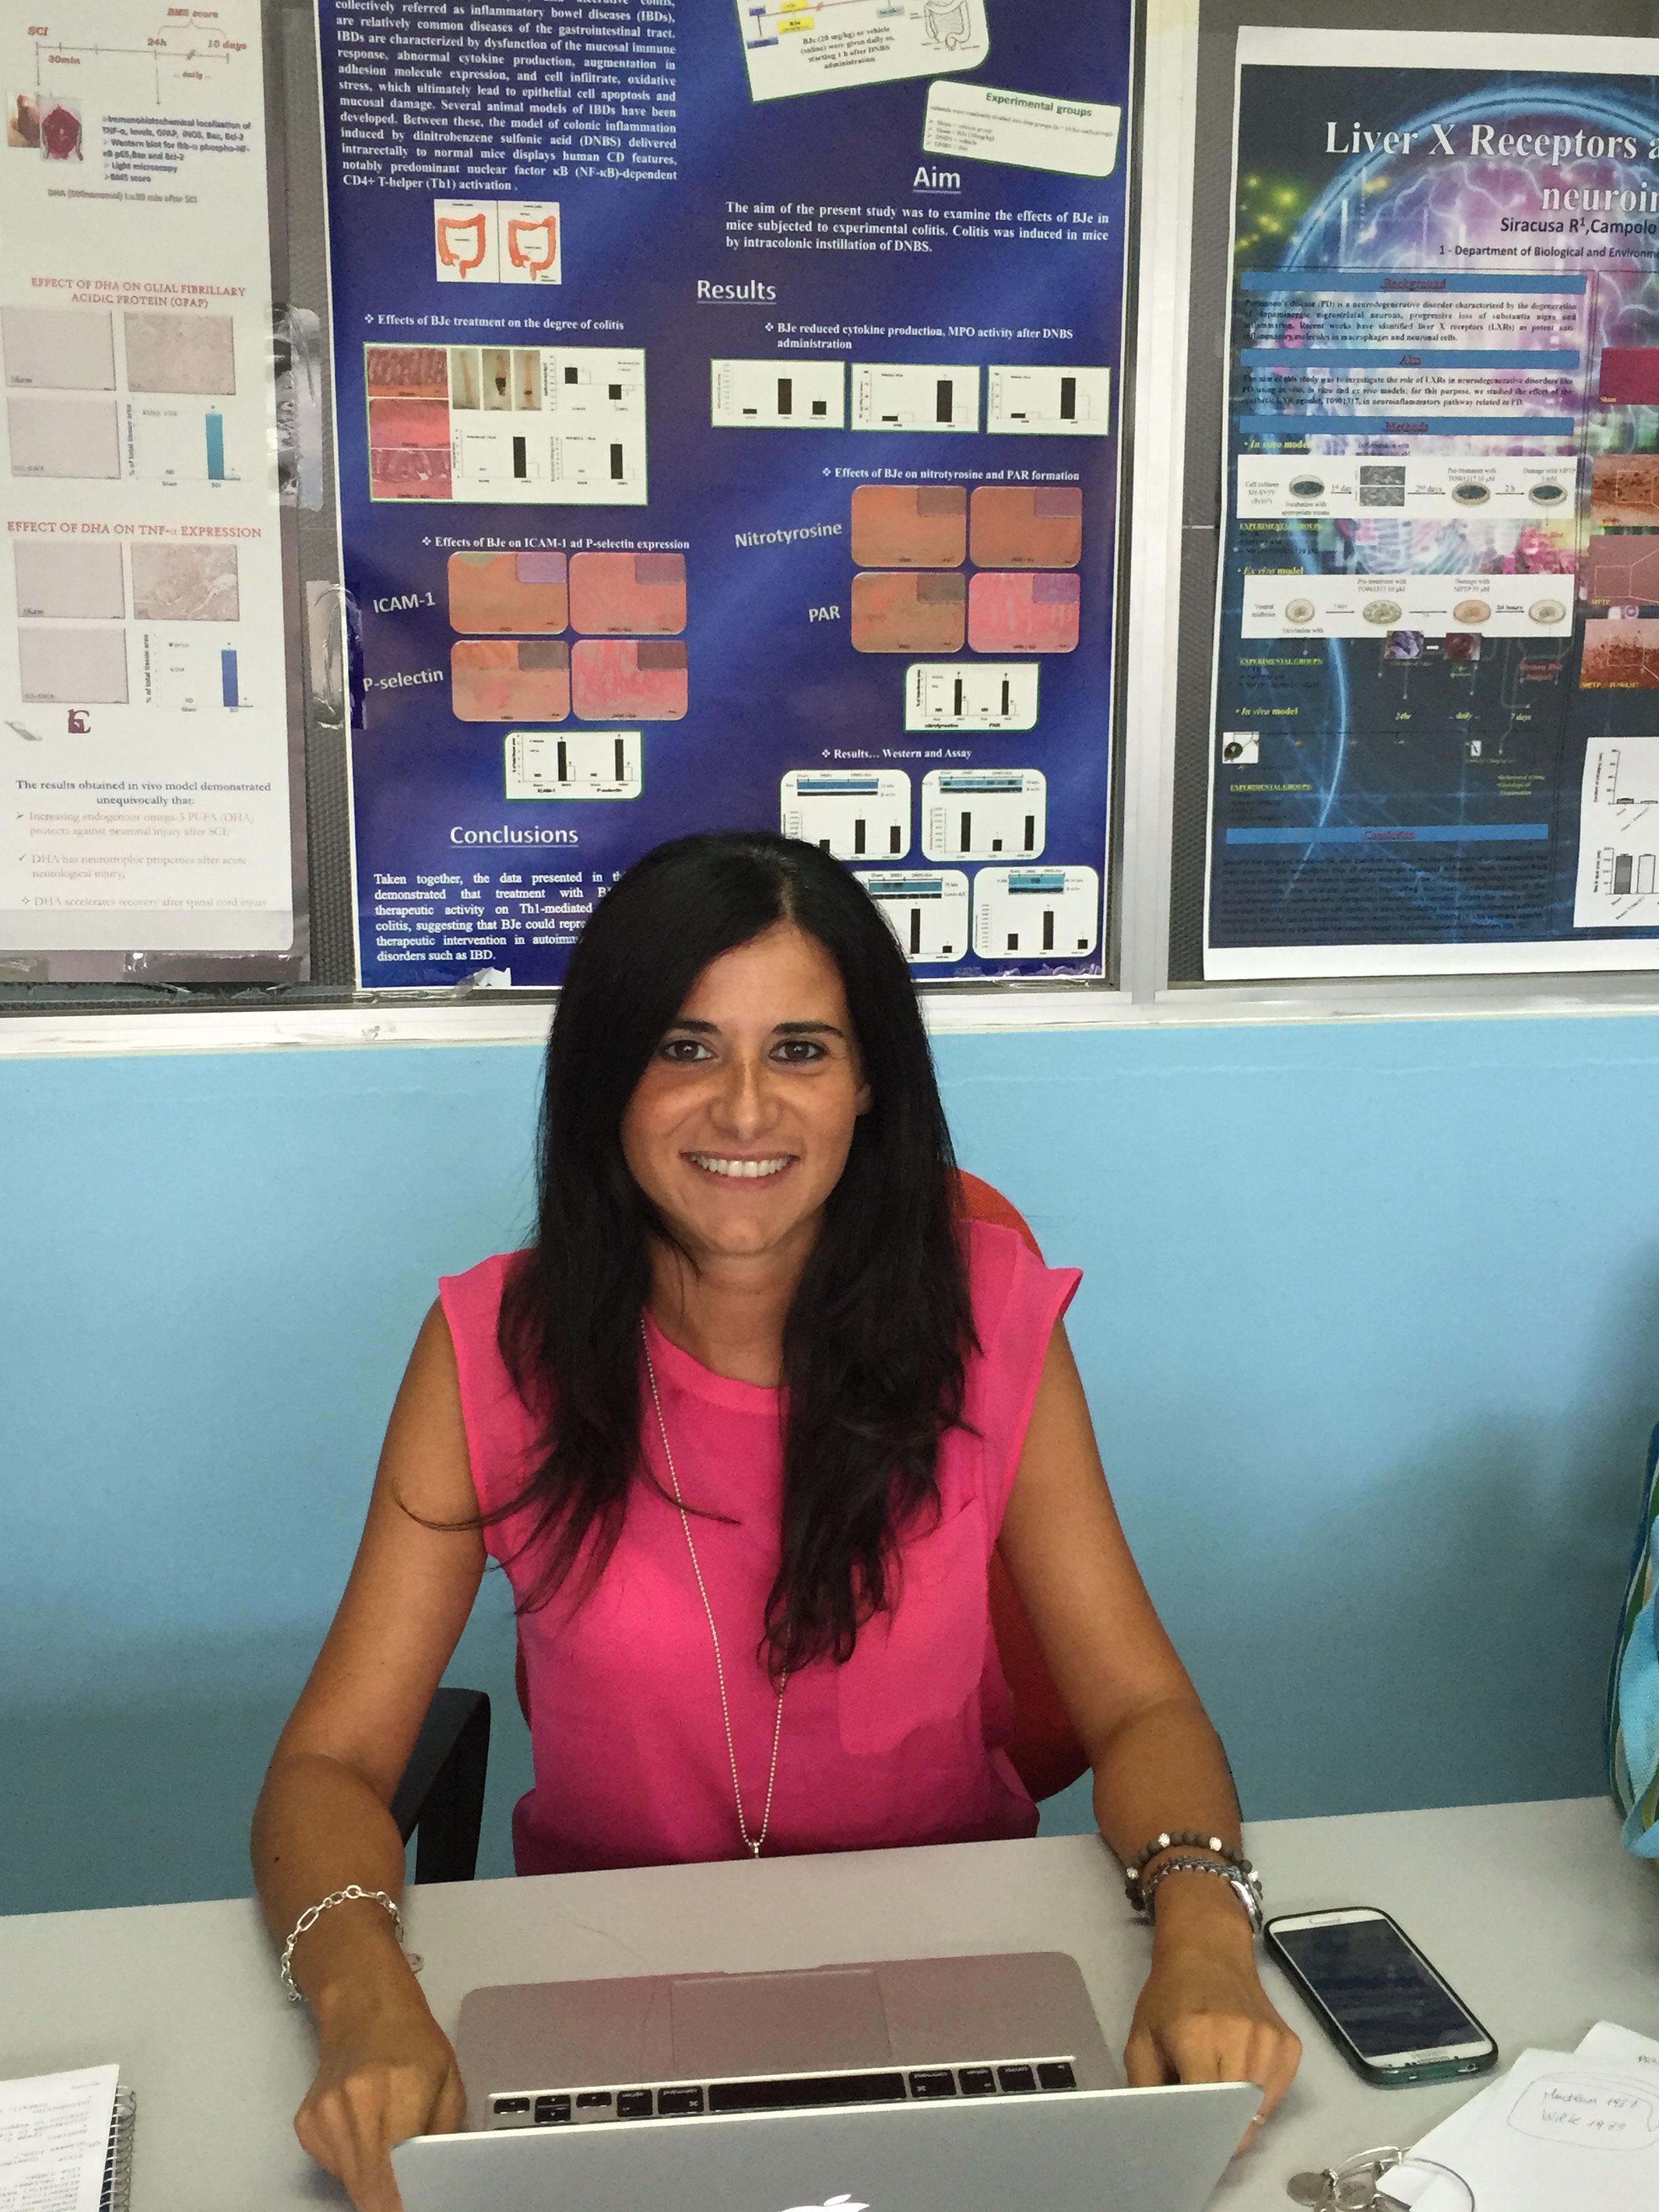

ku0063794, a dual mtorc1 and mtorc2 inhibitor, reduces neural tissue damage and locomotor impairment after spinal cord injury in mice.

Paterniti I¹, Impellizzeri D¹, Cordaro M¹, Siracusa R¹, Esposito E¹ and Cuzzocrea S ^{1,2}

1Department of Biological and Environmental Sciences, University of Messina, Messina
2Manchester Biomedical Research Centre, Manchester Royal Infirmary, School of Medicine, University of Manchester, UK

Mammalian target of rapamycin (mTOR) pathway signaling governs different cellular responses, including induction of autophagy and cell survival. Spinal cord injury (SCI) is a serious and debilitating health problem that usually causes lifelong disability and leads to neurological dysfunction. We hypothesized that mTOR pathway inhibition would diminish neuroinflammation and prevent neuronal death in a mouse model of SCI. SCI was induced in mice by the application of an aneurysm clip at T6-T7 level. mTOR pathway inhibition was achieved with rapamycin (a mTOR inhibitor), or temsirolimus (rapamycin analogues), or KU0063794 (a dual mTORC1and mTORC2 inhibitor) following spinal cord trauma (1 and 6 hours), and then for 3 subsequent days. Phospho-activation of the mTOR effectors p70S6kinase and ribosomal S6 protein and expression of infammatory parameters in perilesional area were assayed at 24 hrs, 48 and 72 hrs. Neuronal cell death was evaluated, autophagy was measured using Beclin-1 and LC3II expression. Iba-1 labeled, activated microglia were quantified. Neuronal death, and numerous Iba-1 labeled, activated microglia were evident at 24 and 48h following SCI. Rapamycin or KU0063794 treatment significantly reduced mTOR signaling, neuronal death, and microglial activation, coincident with enhanced expression of Beclin-1 and LC3II, markers of autophagy induction. KU0063794 was able to blunt the neuroinflammation better than rapamycin and temsirolimus. Persistent mTOR signaling following SCI suggests a failure of autophagy induction, which may contribute to neuronal death. These results suggest that mTOR signaling may be a novel therapeutic target to reduce neuronal cell death in SCI

Biography

Irene Paterniti has a graduated in Biology curriculum Biosanitario at the University of Messina; she has complited her PhD in Experimental Medicine at the Department of Biological and Enviromental Sciences at University of Messina.
Today she has Post Doc position at the Department of Chemical, Biological, Pharmaceutical and Environmental Science University of Messina, Italy Supervisor: Prof Salvatore Cuzzocrea.
She has published more than 180 papers in International journals. She attended 89 talks in many national and internationl meetings.
She has published 73 scientific research papers in International journals and her area of interest is the role of neuroinflammation and oxidative stress in pathology associated to Central nervous system disorders and in the neurodegenerative diseases, all aimed at protecting the health of the community. Moreover, she attended talks in many national and internationl meetings.

Presenting author details
Full name: Irene Paterniti
Contact number: +390906765208
Twitter account:
Linked In account:
Session name/ number:
Category: Poster presentation

