ARTERIAL BLOOD SUPPLY OF INTERNAL CAPSUL
Pelin Kuzucu, Göktuğ Ülkü, Pınar Çeltikçi, Emrah Çeltikçi, Ahmet Memduh Kaymaz, , Ö.Hakan Emmez, Murat Şakir Ekşi, M. Necmettin Pamir, Abuzer Güngör
Başkent University,Department of Radiology
Gazi University Faculty of Medicine，Department of Neurosurgery
Bakirkoy Research & Training Hospital for Psychiatry， Neurology， and Neurosurgery，Department of Neurosurgery
Acıbadem Mehmet Ali Aydınlar University School of Medicine，Department of Neurosurgery

Abstract
INTRODUCTION: The insular cortex is a located deep to the frontal, parietal, and temporal opercula in the floor of the sylvian fissure. The internal capsule is the projection fibre bundle which is created by the afferent and efferent ways in the deep part of insula. As the motor and sensorial ways are the connection way between the brain branch and the cerebral cortex, knowing of its supply is very important for preventing the post-operative mortality and morbidity in the operations of this area.
METHODS: 12 human hemispheres (6 brains) obtained from routine autopsies and the fresh brain specimens were prepared according to Klingler’s protocol.
The dissections were performed from lateral to medial, with klingler method.

RESULTS: The internal capsule is a thick layer of white matter consisting of projection fibres passing to and from the cerebral cortex. The internal capsule consists of 5 parts: the anterior limb, genu, posterior limb, and the retro and sublenticular parts. It is a deep subcortical structure projection fibers which important of the motor and sensory area. It has been observed in our study that the lateral lenticulostriate artery supplies the most part of putamen, the internal capsule genu and posterior limb, the globus pallidus and the caudate nucleus. We also have observed that the medial lenticulostriate artery has the extension to the anterior part of internal capsule and the genus and also the globus pallidus. We have also seen that the anterior choroidal artery enables the globus pallidus to be supplied deeply with especially the part of posterior limb and renticular limb of internal capsule by passing through more posterior part but it doesn’t attend to the putamen and caudate nucleus supply.
CONCLUSIONS: Understanding the arterial blood supply of internal capsule can help to insular tumors surgery for to reduce postoperative mortality and morbidity.

Image
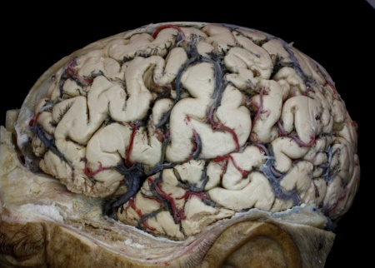
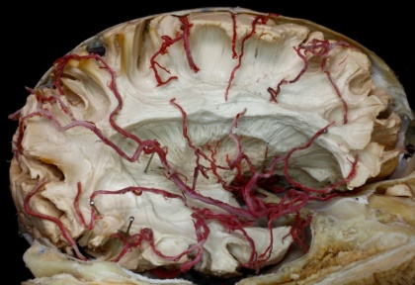
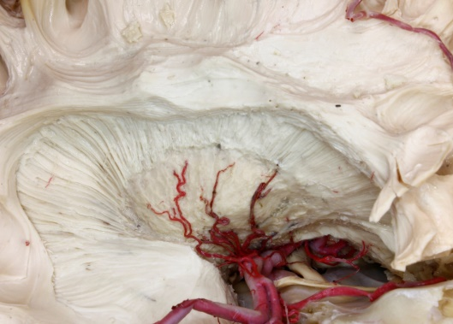
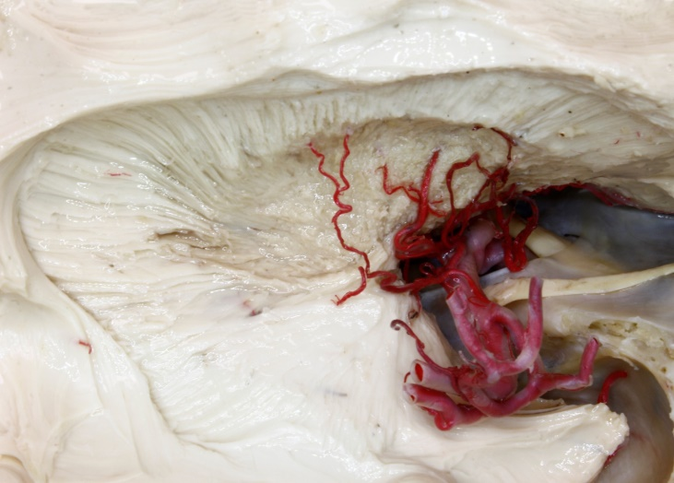
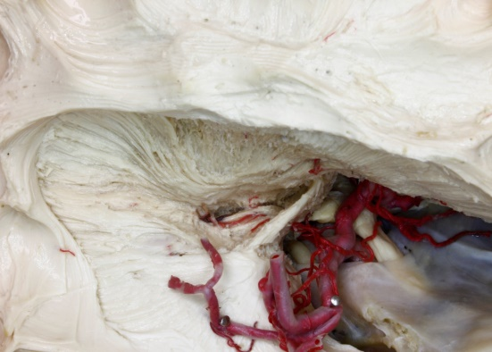
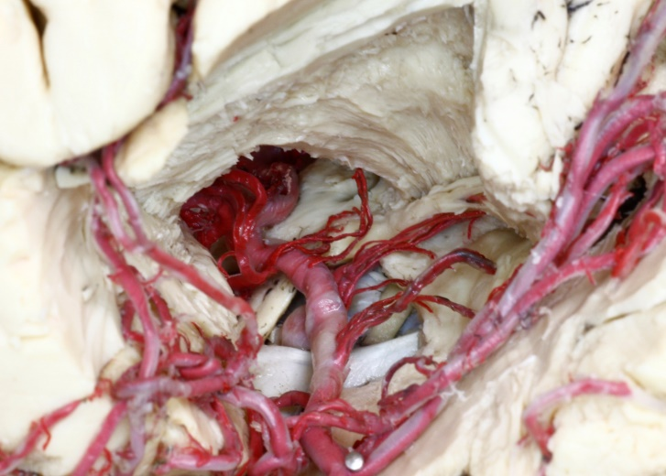
Süperior temporal gyrus
Opercül
Mid.frontal gyrus
Angüler
gyrus
Presantral gyrus
Postsantral gyrus
Supramargınal gyrus
Post. Temp.a.
Ang. a.
Post.par.a
Ant.temp.a.
Ant.par.a.
Rolandıc a.
Prerolandıc .a.
Lat.orbfro.a
Tempol.a.
Lat.lentıc.a
ACA
MCA M2
Optic
nerve
Cr.I
Med .lentıc.a
İnternal
capsüle
Heubner.a
Ant.chor.a.
İnternal capsüle
post.limb
Ant.comm.
Lat. Lentic.a.
Ant.chor.a.
Heubner.a
ACA
MCA
ICA

Recent Publications
- Factorization of polynomial x^n-1 over finite fields
- Lasjaunias P, Berenstein A, Ter Brugge KG (2001) Surgical neuroangiography, vol 1: clinical vascular anatomy and variations, 2nd edn. Springer, New York
- . Mercier P, Fournier HD, Brassier G, Papon X, Cronier P, Velut S, Pillet J (1994) The perforating arteries of the anterior part of the circle of Willis; Micro-anatomical study. Rivista di Neuroradiologica 7(Suppl 4):79–83
- Rosner SS, Rhoton AL Jr, Ono M, Barry M (1984) Microsurgical anatomy of the anterior perforating arteries. J Neurosurg 61(3):468–485
- Loukas, R.G. Louis, R.S. childsanatomical examination of the recurrent artery of Heubner Clin. Anat., 19 (2006), pp. 25-31

Biography
She was born in Ankara in 1990. She is married and has 1 child. In the 2019 Turkish Neurosurgical Society written proficiency exam, she was third. He is engaged in pediatric neurosurgery and Surgical neuroanatomy. She received her white matter dissection education at Acıbadem University Microsurgical Anatomy laboratory. She has articles in international and national refereed journals, book chapters and translations, international journal refereeing, especially on these topics, and has also taken part in various courses as an educator.
Email: drpelinkuzucu@gmail.com

Notes/Comments: I request that it be accepted as an oral presentation

Presenting author details
Full name: PELİN KUZUCU
Category: Oral presentation

