Identification of a pathologically Confirmed Vascular Parkinsonism disease in a Patient diagnosed as idiopathic PD and PDD
Shouzi Zhang, li Zhang, China

Abstract (300 word limit)
Statement of the Problem: Vascular Parkinsonism(VaP) is defined as parkinsonism resulting from cerebral vascular disease(CVD),based on the presence with variable motor and non-motor signs that are corroborated by clinical, anatomic or imaging findings of cerebrovascular disease.It is difficult to distinguish from primary neurodegenerative parkinsonism and identify overlapping syndromes with mixed pathologies. Vascular parkinsonism(VaP) are very cormmon and has been found to be present in about 3–5% in a post-mortem study of patients with parkinsonism. The frequency of post-stroke movement disorders is likely to be underestimated.Methodology & Theoretical Orientation: We report a case of a 84-year-old man presented progressive parkinsonism with prominent postural instability, gait impairment, pseudobulbar, cognitive and urinary symptoms and poor responsiveness to dopaminergic drugs.He has been diagnosed as Parkinson disease(PD) at the baseline and Parkinson Disease Dementia(PDD)at last.The patient’s post-mortem study did not conform to PD manifestation with cerebral small vessel disease (CSVD) of multiple lacunar infarction,cerebral microhemorrhage and subcortical white matter lesions.While immunohistochemical staining for α-synuclein showed no antibody accumulation.Conclusion & Significance: Insidious onset VaP subtype is more frequent, presenting with progressive parkinsonism with prominent postural instability, gait impairment,corticospinal, pseudobulbar, cerebellar, cognitive and urinary symptoms and tending to be poor responsive to dopaminergic drugs.Misdiagnosis may accur because of asymptomatic CSVD as a pathogenic factor.

Image
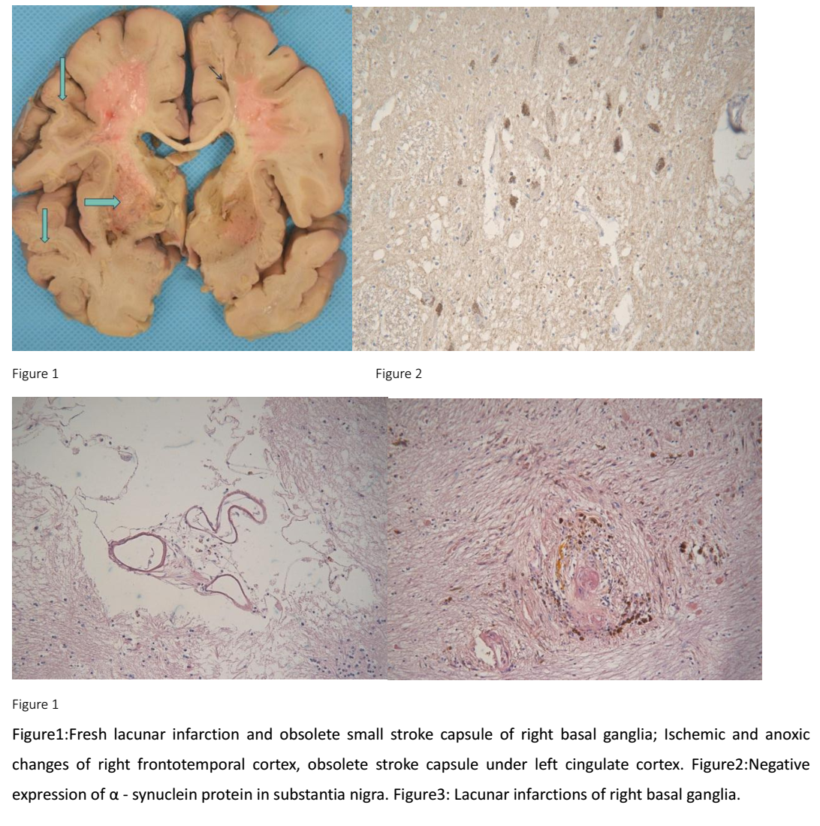
Recent Publications (minimum 5)
- Van der Holst HM, van Uden IW, Tuladhar AM (2015) Cerebral small vessel disease and incident parkinsonism:The RUN DMC study.Neurology.85:1569–77.
- Ivan Rektor,Nicolaas I. Bohnen (2018). An Updated Diagnostic Approach to Subtype Definition of Vascular Parkinsonism Recommendations from an expert working group. Parkinsonism Relat Disord. 49: 9–16.
- Korczyn AD (2015). Vascular parkinsonism characteristics, pathogenesis and treatment. Nat Rev Neurol.11:319–26.
- Ding J, Sigurosson S, J onsson PV(2017). Space and location of cerebral microbleeds,cognitive decline, and dementia in the community. Neurology 88:2089–97.
- Vizcarra JA, Lang AE, Sethi KD(2015). Vascular Parkinsonism: deconstructing a syndrome.Mov Disord. 30:886–94.

 Biography (150 word limit)
Dr zhang is a neurologist engaged in neurology and gerontology for more than 20 years. He specializes in the diagnosis and treatment of various types of dementia(Alzheimer's disease, vascular dementia, frontotemporal dementia, Parkinson's disease dementia, etc). He and His team have done many study works of pathogenesis and treatment of Alzheimer's disease, and completed many cases of autopsies to make definite diagnosis for AD.He has passion in improving the health and wellbeing of elders, especially in awakening the social concerns of wellbeing and health care for dementia old people by participating in TV programs and so on.
Email: LANCZSZ@126.com
Phone: +086-010-83183805
Notes/Commen

