Tau in the Retina

Introduction:
Alzheimer’s Disease (AD) is a chronic neurodegenerative disease characterized by loss of memory and cognitive decline and is neuropathologically associated with an increase in B-amyloid (BA) plaque deposition, neurofibrillary tangle formation (NFT), neuronal loss and inflammation. ( 1 ) Recent studies suggest that BA induced Tau pathology is responsible for the severe outcome of the disease process. Data from different models support the thesis in which BA accumulation acts as a triggering event in the pathogenetic process by accelerating antecedent Tau. ( 1 )
For many years, AD research has largely been dominated by the theory that the formation of BA plaques in the brain plays a main role in dementia. However, studies have repeatedly revealed that BA plaques are poorly correlated with dementia and results from many clinical trials based on this approach have been disappointing.( 2 )
According to the tau hypothesis, abnormal aggregation of tau protein ultimately leads to the formation of tangles within nerve cells. Once initiated, the tau aggregation process continues and spreads into previously healthy cells. ( 3 ) Tau tangles may appear many years before the clinical symptoms of the disease becomes apparent.

OCT and FAF for the Diagnosis of AD
Fundus Autofluorescein (FAF) detects lipofuscin in the retina. The autofluoresence signal from retinal pigment epithelial (RPE) cells is very much correlated with lipofuscin content and accumulation. FAF is increased with RPE dysfunction due to the accumulation, impaired processing and clearing of lipofuscin. Conversely, the FAF signal may be decreased in the setting of RPE or photoreceptor loss — if there are no photoreceptor outer segments, the source for lipofuscin formation may be lost. ( 1 )
During the evaluation of patients ,both hyperfluorescent (regions with excessive lipofuscin) or hypofluorescent (atrophic retina) areas are of concern. To better understand the layer and shape of the lesion, optical scanning tomography (OCT ) can be performed through the abnormal areas on FAF. In order to understand the nature of the lesion, curcumin may be orally or intravenously administered. Curcumin binds to AB plaques in the retina which are most likely related to AD. ( 1 )
OCT and FAF examinations provide us with important information about neurodegenerative diseases. Since the optic nerve and retina share similar structures with the brain, any defect detected by OCT and/or FAF may be related to a disease in the nervous system.
Methods:
We examined 50 patients ( 36 Women, 14 Men ) with dementia due to AD . The age range was between 59 and 84. AD was diagnosed at other centers by neurological examination, neuropsychiatric testing, cranial PET- scans and the patients were referred to our unit for retinal examination. All the patients had positive cranial PET- CT findings for AD. ( Fig. 1 ) FAF examinations were performed after which OCT was done through the abnormal (hyperfluorescent or hypofluorescent ) spots or regions. We gave curcumin capsules to all the patients to make sure BA lesions could be seen, too. The lesions on OCT that were identical with the histopathological images of Tau tangles were detected by two experts in a masked fashion. Different types of Tau in the retina were investigated. Also , 20 age- matched healthy controls underwent the same retinal tests.
Results:
In all the patients , shining dots and spots were mostly seen in the outer plexiform, ganglion and nerve fiber layers on OCT ; these were most likely curcumin stained BA plaques. ( Fig. 2 ) The shapes that were exactly identical with different types of neurofilaments and Tau tangles could be found in different retinal layers again in all patients. Filaments, comma shapes and curvy reverse – E – letter like lesions were recognized as Tau of different stages by the two investigators. ( Fig. 3,4,5,6,7 ) In the control group, similar lesions were very rare and much less identical with the real pathological accumulations. 2 patients had autopsy and retinal lesions were confirmed to be Tau tangles ; the other patients are alive.
Discussion :
Some investigators found BA plaques in AD patients using different retinal examination techniques.( 4 ) Others have shown retinal nerve fiber layer thinning by OCT due to AD.(1) But, tau tangles were not shown in the retinas of live AD patients before, to the best of our knowledge. Our retinal tests easily disclosed both kind of accumulations which seemed to be consistent with AB and Tau tangle deposits. We also believe that exactly the same kind of toxic proteins aggregate both in the retina and brain. Since the retina is a direct extension of the brain, any lesion detected in the retina may be the reflection of a central nervous system disease. Maya Koronyo and her colleagues stated that retinal lesions started either earlier than or at the same time ( but, not later ) with the brain lesions and this would be many years before the clinical symptoms of AD arose. ( 4 ) Another unproven hypothesis was the migration of the toxic proteins from the retina to the brain via the optic nerve or vice versa. ( 4 )
Recent research revealed the importance of Tau aggregation in the disease process. The spread of tau protein aggregates in the brain correlated with clinically observed cognitive deficit and progression of functional brain scan deficit. The basis for this neuroanatomical spread was established in mouse models where abnormal tau could be exchanged between neurons. The early stage aggregates of tau (oligomers) acted as infectious particles, spreading the pathology from one region to the next. ( 6 )
After initiating inside a neuron, the tau aggregation cascade is self-replicating and it consumes the normal tau pool in the cell, converting it to toxic aggregates which continue to accumulate to the point of destruction of the neuron. The end-stage results with almost complete conversion of normal tau protein into the aggregated form.
Our impression was that the frequency of the toxic aggregations increased as the cognitive functions deteriorated. ( Table 1 ) A new study is being prepared to correlate the stage of dementia with Quantitative OCT.
By examining more than 3,600 postmortem brains, researchers at Mayo Clinic found that the progression of dysfunctional tau protein drived the cognitive decline and memory loss seen in AD. BA was not the primary culprit according to their results. ( 7 )
Scoring systems were used to examine the evolution of BA and tau in dissected brain tissue. It was found that the severity of tau, but not amyloid, predicted age onset of cognitive decline, disease duration and mental deterioration. ( 7 )
The second part of the study examined amyloid brain scans taken of AD patients prior to death and compared the scans to measures of tau and amyloid brain pathology. The important outcome was that BA could be found in brains of older individuals who had not experienced cognitive problems so that BA accumulation could be the result of the aging process. ( 7 )
Tau targeted therapies show promise in the early phases of the disease. LMTX is such a drug being tried in clinical studies. As monotherapy, it demonstrated significant reductions in disease progression in mild and moderate AD. ( 8 )
Considering the fact that tau targeted and combination therapies are emerging rapidly, the importance of detecting Tau as early as possible has become the main goal. Retinal examination is the easiest and cheapest non-invasive method for this purpose.

Conclusion:
This is the first study which reveals the image of Tau in the retinas of live patients with AD. Retinal examination with FAF and OCT may be considered as a trustable tool and this approach may be used as a biomarker both for diagnosing and monitoring AD.

References:
- Kayabasi U, Sergott CR, Rispoli M. Retinal Examination for the Diagnosis of Alzheimer’s Disease. Int J Ophthalmol Clin Res 2014, 1:1.
- Harrington CR, Storey JMD, Clunas S, et al. (2015) Cellular models of aggregation-dependent template-directed proteolysis to characterize tau aggregation inhibitors for treatment of Alzheimer disease. J Biochem Pharmacol 290(17):10862-10875.
- Gong, C X., Liu F, Grundke–Iqbal I, Iqbal K. (2005). Post-translational modifications of tau protein in Alzheimer’s disease. J. Neural Transm. 112, 813–838.
- Koronyo-Hamaoui M, Koronyo Y, Ljubimov AV, Miller CA, Ko MK, et al. (2011) Identification of Amyloid Plaques in Retinas from Alzheimer’s Patients and Noninvasive In Vivo Optical Imaging of Retinal Plaques in a Mouse Model . Neuroimage 54: S204-S217.
- Harrington CR, Storey JMD, Clunas S, et al. (2015) Cellular models of aggregation-dependent template-directed proteolysis to characterize tau aggregation inhibitors for treatment of Alzheimer disease. J Biochem Pharmacol 290(17):10862-10875.
- Jones TD, Knopman SD, Gunter LJ, et al. Cascading network failure across the Alzheimer’s disease spectrum .Brain 2016 Feb; 139(2): 547–562.
- Panza F, Solfrizzi V, Seripa D, et al. Tau-Centric Targets and Drugs in Clinical Development for the Treatment of Alzheimer's Disease. Biomed Res Int.. 2016;2016:3245935.

Figures:
- Brain PET-CT disclosing bilateral temporo- parietal hypometabolism
- OCT image of BA plaques
- OCT image of Tau in the retina
- Histopathological image of Tau
- OCT image of a neurofibrillary tangle
- Histopathological view of neurofibrillary tangles
- OCT image of Tau
Table 1 : Lesions and Mini- Mental State Examination Scores

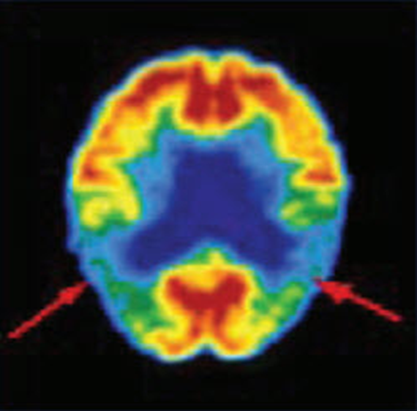
Figure 1
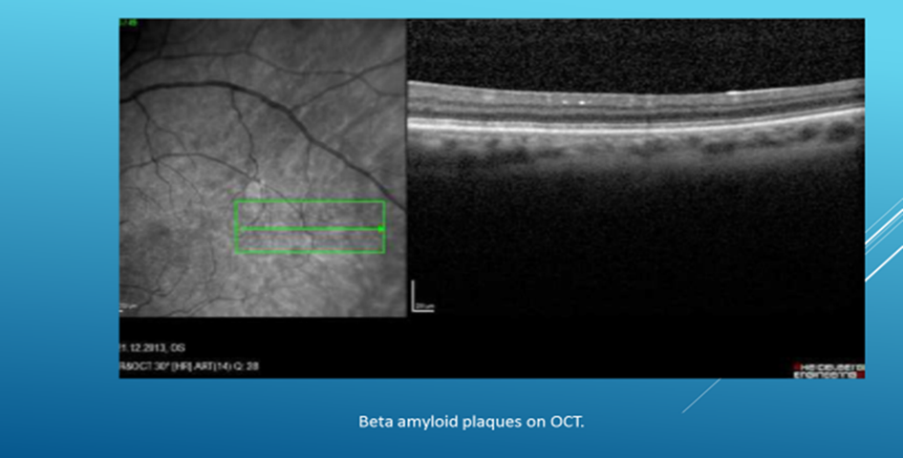
Figure 2
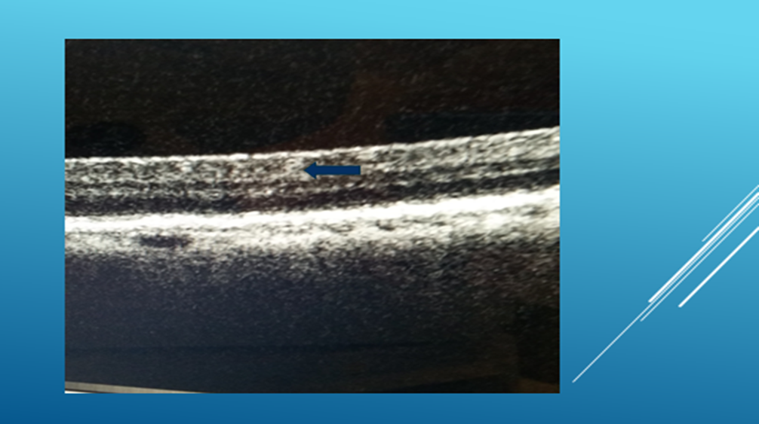
Figure 3
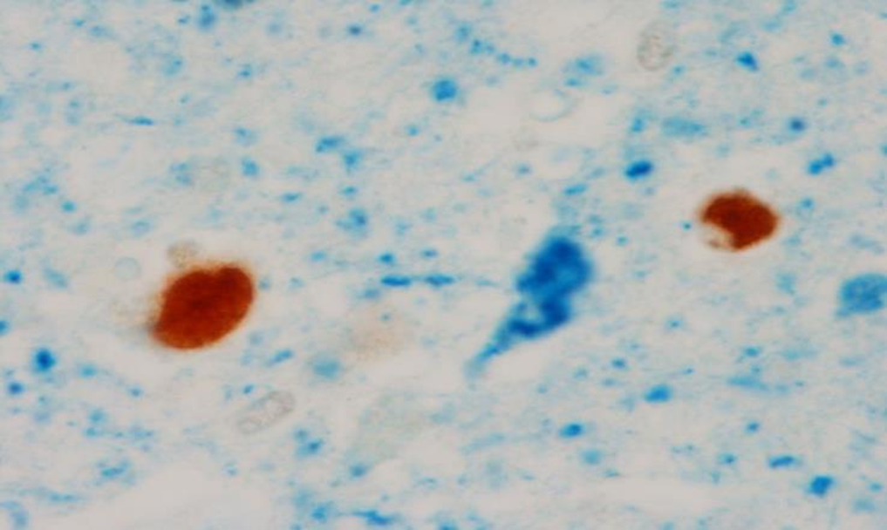
Figure 4
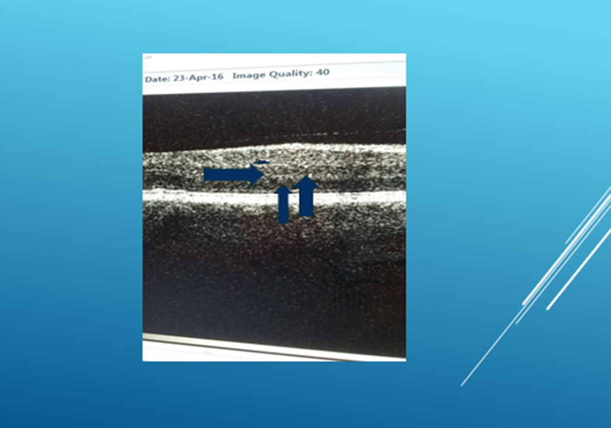
Figure 5
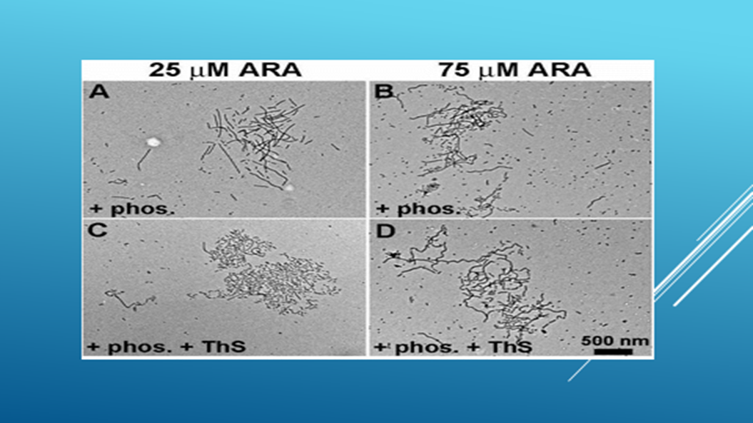
Figure 6
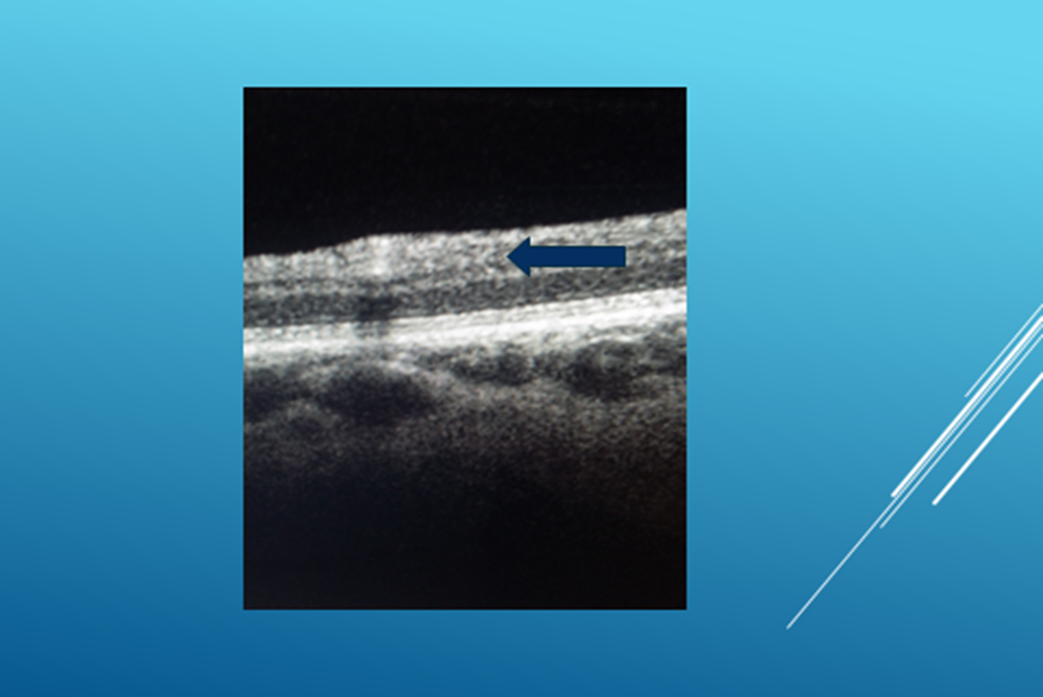
Figure 7

Table 1
 |  |  | Number of patients |  |  | Lesions in the Retina
Mini- Mental State Exam.
Score
 | 25-30 |  |  | 14 |  | Scattered, rare lesions and plaques
 | 20-25 |  |  | 26 |  | More frequent, detectable lesions
 | 10-20 |  |  | 10 |  | Generalized retinal plaques.
 |  |  | Total | 50
MMSE Score: Folstein MF, Folstein SE, McHugh PR: “Mini-mental state: A practical method for grading the cognitive state of patients for the clinician.” J Psychiatr Res 1975;12:189-198.
25- 30 : Mild Cognitive Insufficiency
20- 25 : Mild Disease
10- 20 : Moderate Disease
0- 10: Severe Disease

