Paste your Photograph Here
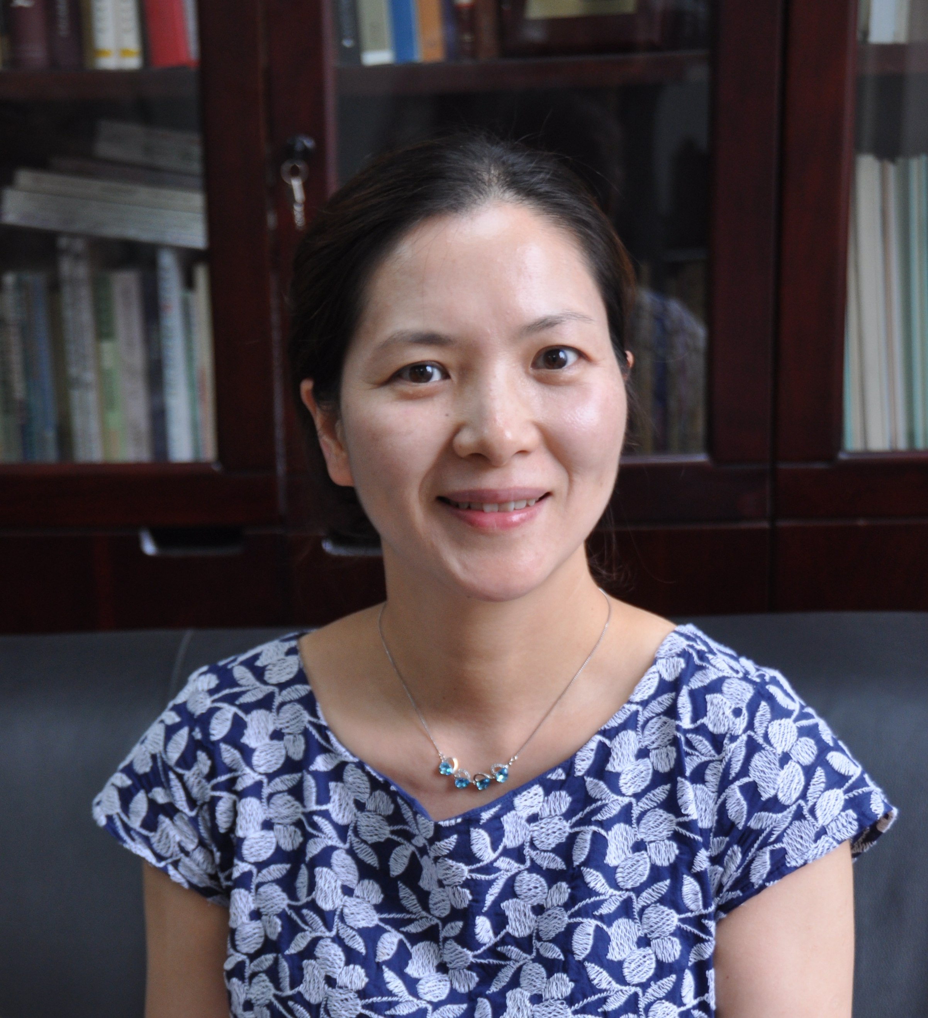

Title: XXXXX

Name: Xinyan Gao

China Academy of Chinese Medical Sciences, Beijing 100700, China

Mast cell-microglia crosstalk in dorsal horn and dorsal root ganglion (DRG) and peripheral and central ATP participate pain modulation. Mast cell tryptase cleavage of proteinase receptor 2 (PAR2) is activated in microglial cells during neuorpathic pain, which induces microglia P2X4 receptor up-regulation and BDNF releasing. Increasing recent evidence has revealed that spinal dorsal horn microglia has an intimate relationship with electroacupuncture (EA) analgesia. One of our objective is to explore whether EA has a neuroprotective effect on microglial activation and microglia-mast cell crosstalk induced by neuropathic pain in the dorsal horn and DRG in chronic constriction injury（CCI）rats. In addition, there were also reports on local increase of adenosine in human subjects and mice during EA analgesia, and adenosine subtype A1 receptor antagonist reduced this effect. The other objective is to check caffeine intake, a non selective antagonist of adenosine may reduce the EA analgesia effect. CCI neuropathic pain model were made on adult male Sprague-Dawley. was made. Paw withdrawal threshold (PWT) was detected pre-EA and post EA. The expression of microglia recepors in spinal dorsal horn and in the DRG were measured by immunofluorescence. C fiber reflex, a nociceptive stimulus evoked myoelectricity was performed. PWTs in CCI rats were significantly reduced in ipsilateral paws compared to contralateral paws and were increased significantly after EA. Microglia-mast cell crosstalk related receptor expresssions were up-regulated after peripheral nerve injury. The expressions of above receptors are decreased after EA intervention. Coffeine intake hinders decrease of C fiber reflex EMG induced by EA. (Up to 250 words)

Biography

Prof. Gao Xinyan in China has completed her PhD in at the age of 30 from China Academy of Chinese Medical Sciences (CACMS), and postdoctoral studies from Baptist University of Hongkong, 2009. She is the director of Department of Physiology, Institute of Acupuncture. She has published more than30 papers in reputed journals and has been serving as an editorial board for several peer reviewed journals.
(Up to 100 words)

