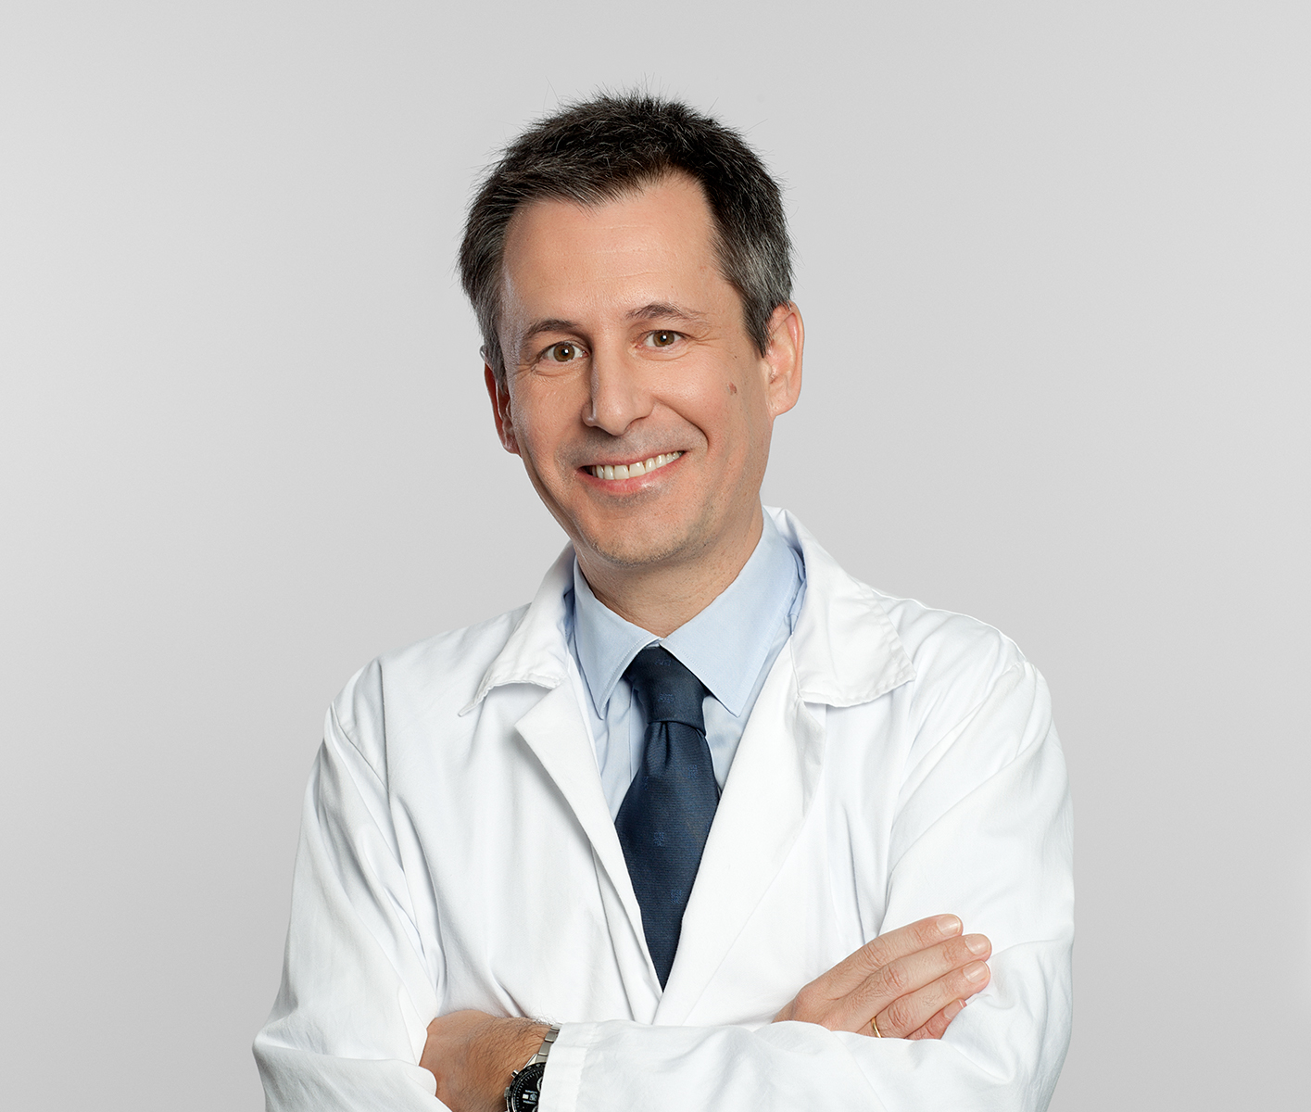


Title: STROKE ENDOVASCULAR TREATMENT: EFFICACY AND SECURITY ANALYSIS WITH THE TIME OF DEVELOPMENT.

Name: Joaquin Carneado-Ruiz. MD.
Institution: Stroke Center. Neurology Department. Hospital Universitario Puerta de Hierro, Majadahonda, Madrid.

ABSTRACT:
Objective:
To analyse the ischemic stroke endovascular treatment efficacy and security with its time of development.
Patients/ Methods:
It is an observational study with a transversal design. The endovascular treatment for the embolic ischemic stroke in Madrid Community is coordinated by six Stroke Centers.
These results are related to the University Hospital Puerta de Hierro (HUPH) treated patients. Inclusion and exclusion criteria are those recommended in international clinical guides, approved too by the Madrid`s Stroke working group. We describe results of patients treated between October 2013 and February 2016. We analyse the efficacy and security variables along different periods of time during the treatment development.
Results:
Patients number 90, we divided the study population in three similar groups (tertiles) according to the treatment date. Age (mean): 64.78 Standar deviation (SD): 14.48. Female gender: 35 (38.90%). NIHSS median (IQ 1-3): 18(16-22); Time from onset to angiography (arterial puncture): 270 min (200-330 min); Arterial Recanalization TICI 2b/3 63(70%) Rankin 0-2 7 day: 41(45.60%) Mortality 7 day: 13(14.44%) Hemorrhagic transformation: PH2 5 (5.6%). We found significant statistically difference for the recanalization grade (TICI), considering five grades (p=0.003), or between two categories (2b/3) (p=0.041).
Conclusions:
We demonstrate efficacy and security for the endovascular ischemic stroke treatment.
We demonstrate an improvement in the arterial recanalization grade with the time of treatment development.

Biography

ACTUAL POSITION: Hospital Universitario Puerta de Hierro Madrid. : Neurologist Medical Doctor, (Spain) Stroke Unit Director
Coordinator of Neurosonology Laboratory Coordinator of Acute Stroke treatment EDUCATION AND TRAINING: Neurologist Medical Doctor HU Puerta de Hierro. . Fellowship in Cerebrovascular Disease and Neurosonology., (Spain) Stroke Unit. HU Clínico San Carlos. Madrid. 1999-2000. University of California Los Angeles Medical Center. Neurology Department. Stroke Unit. , (United States) visiting Stroke Fellowship. Feb-2000 to Jun-2000. Doctoral Thesis. 2002-2004Universidad Autonoma de Madrid. He has published more than 25 papers in reputed journals and has been serving as an editorial board member of repute.

