Synthesis of benzimidazole and benzoxazole derivatives as Epigenetic regulators of PRC2 protein complex as dual anticancer and nerve regenerator

Hoda Azmy,undergraduate researcher,4th level ,faculty of pharmacy,Mansoura university,Egypt

Abstract (300 word limit)

Polycomb repressive complex 2 (PRC2) has been shown to play a major role in transcriptional silencing in part by installing methylation marks on lysine 27 of histone 3. Dysregulation of PRC2 function correlates with both certain malignancies and also correlates with the nerve regeneration process. EZH2 is the catalytic engine of the PRC2 complex responsible for the methylation process and is overexpressed in many malignancies thus represents a key candidate oncology target. In an attempt to shade more light on EZH2 inhibition as target against cancer, we synthesize and apply molecular docking of some benzimidazole and benzoxazole derivatives into EZH2 active site to help in treatment of many malignancies specially the B-cell lymphoma and as nerve regenerators in case of nerve injury.

Image

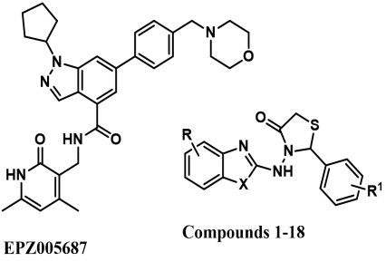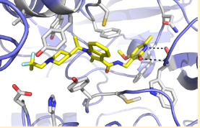
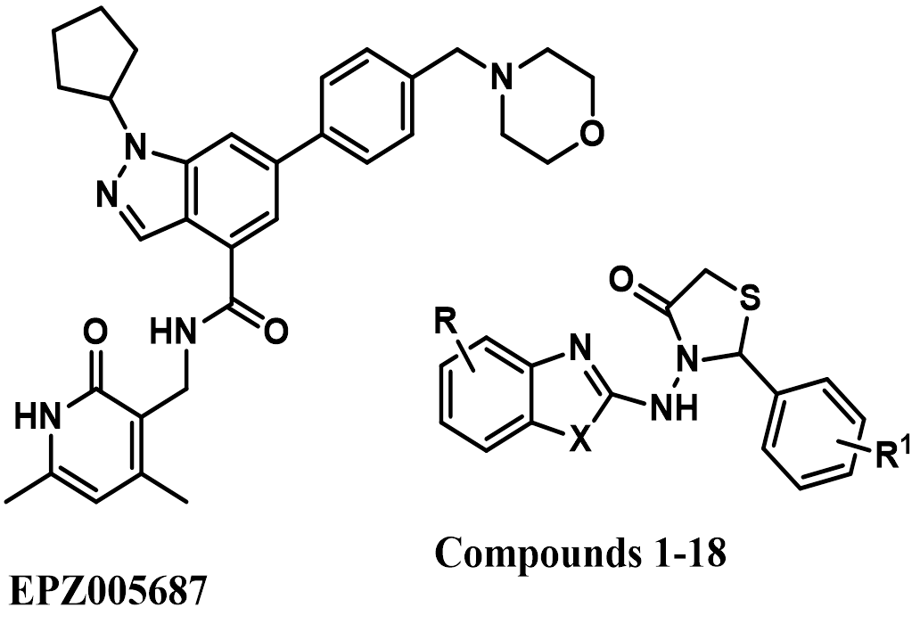

Email: hodaazmy95@yahoo.com

Notes/Comments:

