Risk assessment of thrombophilic mutations in young women

Riedlova, P. Mgr, PhD¹, Jirik, V., RNDr., PhD¹ Ostrizkova, S, Mgr¹ Kramna, D, Mgr.¹
1. Centre of Epidemiological Research, Faculty of Medicine, University of Ostrava, Ostrava, Czech Republic

Abstract
Background: Venous thromboembolic disease (TEN) is a serious disease in which genetic factors play an important role (trombophilic mutations in genes FV Leiden and FII Prothrombin). In the Czech population, 5–10 % of carriers of the FV Leiden mutation and 1–2 % of carriers of the FII mutation prothrombin. Finding a sequence variant increases the risk of clotting and clogging of blood vessels many times over, which in combination with hormonal contraception (HAK) and smoking is further multiplied. This can result in an increased risk of stroke, myocardial infarction, pregnancy problems, thrombosis or embolism. Young women are also at risk. With the gradual improvement of laboratory methods, it would be possible to improve the prevention of TEN by introducing an available screening test, which would point out a significantly increased risk of the disease. The aim of the study was to determine the frequency of two thrombophilic mutations, risk factors (HAK, smoking), which are associated with the risk of developing TEN. Methods: The study was designed as a cross-sectional epidemiological study and 148 women were enrolled. In these women, the presence of TEN risk factors was determined and DNA analysis was performed with a digital PCR (ddPCR) instrument. Results: Six women were confirmed to have a mutation in the Factor V Leiden gene (4 % of women) and three women had a mutation in the Factor II Protrombin gene (2 % of women). Two of these women took HAK before the diagnosis and one from nine women smoked. Conclusion: The applicability of ddPCR analyzes and the determination of the frequency of occurrence of TEN risk factors in a population of young women may serve to better detect the possible future occurrence of TEN in women. Thus, the prevention of this serious disease can be significantly improved.
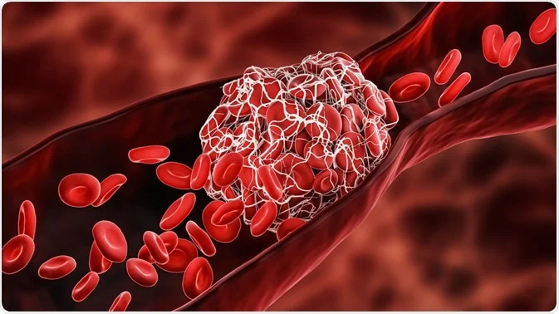

Figure 1: Formation of thrombosis

Images

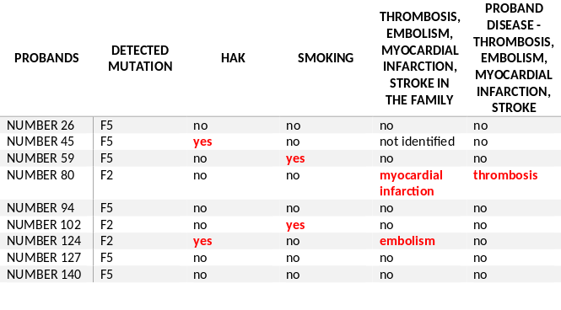
Figure 2: Positive probands

Recent Publications
- RENNER, Wilfried, KÖPPEL, Herwig, HOFFMANN, Christine et al. Prothrombin G20210A, Factor V Leiden, and Factor XIII Val34Leu. Thrombosis Research [online]. 2000, 99(1), 35-39 [cit. 2021-6-23]. ISSN 00493848. Available from: doi:10.1016/S0049-3848(00)00219-X
- MARIK, Paul E., PLANTE, Lauren A., HOFFMANN, Christine, et al. Venous Thromboembolic Disease and Pregnancy. New England Journal of Medicine [online]. 2008, 359(19), 2025-2033 [cit. 2021-6-23]. ISSN 0028-4793. Available from: doi:10.1056/NEJMra0707993
- STREIFF, Michael B., BOCKENSTEDT, Paula L., CATALAND, Spero R. et al. Venous Thromboembolic Disease. Journal of the National Comprehensive Cancer Network [online]. 2011, 9(7), 714-777 [cit. 2021-6-23]. ISSN 1540-1405. Available from: doi:10.6004/jnccn.2011.0062
- VAVRINKOVA, Blanka, BINDER, Tomas, HADACOVA, Ivana et al. Does asymptomatic carriage of FV Leiden and FII prothrombin mutations in heterozygous configuration pose an increased risk of thrombembolic complications in the course of pregnancy, labor and puerperium? Biomedical Papers [online]. 2014, 158(2), 238-241 [cit. 2021-6-23]. ISSN 12138118. Available from: doi:10.5507/bp.2012.070
- LUCOTTE, Gérard, MERCIER, Géraldine, HADACOVA, Ivana, et al. Population Genetics of Factor V Leiden in Europe. Blood Cells, Molecules, and Diseases [online]. 2001, 27(2), 362-367 [cit. 2021-6-23]. ISSN 10799796. Dostupné z: doi:10.1006/bcmd.2001.0388

 Biography

Mgr. Petra Riedlová, Ph.D. is a graduate of doctoral studies in Public Health at the Department of Epidemiology and Public Health, Faculty of Medicine in the Czech Republic. She deals with the prevention of individual non-infectious diseases, as well as the early diagnosis of cancer, she is a co-founder of the non-profit organization Czech Center of Signal Animal. She worked in the Laboratory of Molecular Biology, Department of Medical Genetics and is now a member of the team at the Center for Epidemiological Research, Faculty of Medicine, Ostrava. She is finding that genetics is playing an increasingly important role in the development and emergence of various diseases. That is why she also deals with this issue.
Email: petra.riedlovav@osu.cz

Presenting author details
Full name: Petra Riedlova
Contact number: 00420730169978
Mail id: petra.riedlova@osu.cz
Category: Poster presentation

Presenting author details
Full name: Petra Riedlova
Contact number: 00420730169978
Mail id: petra.riedlova@osu.cz
Category: Poster presentation

