BRAIN ARTERIOVENOUS MALFORMATIONS
What's new in light of current knowledge?

Robinson Trujillo MD Central Military Hospital from Bogotá

Introduction: Brain arteriovenous malformations (bAVMs) are congenital anomalies of dysplastic blood vessels with direct connections between arteries and veins without intervening capillaries called a nidus. Recent findings from novel animal models and genetic studies suggest that arteriovenous malformations, which were long considered congenital, arise from aberrant vasculogenesis, genetic mutations and/or angiogenesis after injury.
Most of these lesions are discovered incidentally during imaging for other indications; symptomatic bAVMs most commonly present with hemorrhage and seizures.
Epidemiology: The crude annual detection rate or incidence is estimated at 1.3 per 100,000 patient years with relatively stable detection rates across populations. Morbidity and mortality from AVM hemorrhage varies widely. An estimate is 10% mortality, 30–50% morbidity (neurological deficit)

Pathophysiology: This is unclear, but the possible causes might be miscues or miscommunications during embryogenesis at the time that arteries and veins are in direct contact without intervening capillaries.
Methodology: A systematic review of the most recent literature was carried out in the main databases including Cochrane Library, EMBASE, EBSCO, PubMed in search of the main updates on arteriovenous malformations during the last 10 years, including articles in English and Spanish.
Discussion: The use of the Spetzler – Martin grade scale continues to be used with great frequency to define the surgical behavior and the prognosis of patients with this diagnosis, which has opened the field for the realization of new diagnostic approaches within which it is included to perform diagnostic approaches according to the characteristics of each patient since the definitive treatment also depends on this.
Conclusion: In the light of the most recent knowledge, the diagnostic suspicion based on the symptoms and the characteristics of each

patient stands out as a tool for a diagnostic approach in order to use the most appropriate diagnostic aids and propose minimally invasive management.
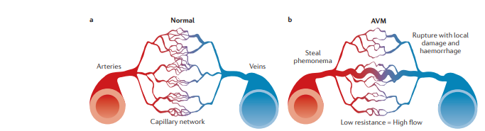

Figure 1 | Schematic representation of normal vasculature and an arteriovenous malformation

Recent Publications

1. Lawton MT, Rutledge WC, Kim H, et al.: Brain arteriovenous malformations. Nat Rev Dis Primers. 2015, 1:15008. 10.1038/nrdp.2015.8

2. Solomon RA, Connolly ES Jr: Arteriovenous malformations of the brain . N Engl J Med. 2017, 376:1859-1866. 10.1056/NEJMra1607407

3. Aboukaïs R, Vinchon M, Quidet M, Bourgeois P, Leclerc X, Lejeune JP: Reappearance of arteriovenous malformations after complete resection of ruptured arteriovenous malformations: true recurrence or falsenegative early postoperative imaging result?. J Neurosurg. 2017, 126:1088-1093. 10.3171/2016.3.JNS152846

4. van Beijnum, J. et al. Prevalence of brain arteriovenous malformations in first-degree relatives of patients with a brain arteriovenous malformation. Stroke 45, 3231–3235 (2014)

5. Multimodality treatment of cerebral arteriovenous malformations.
Nataraj A, Mohamed MB, Gholkar A, Vivar R, Watkins L, Aspoas R, Gregson B, Mitchell P, Mendelow AD.World Neurosurg. 2014 Jul-Aug;82(1-2):149-59. doi: 10.1016/j.wneu.2013.02.064. Epub 2013 Feb 20.PMID: 23454686



I am Robinson Trujillo Cabanilla, a physician passionate about neurosciences since the beginning of my professional training and with a great passion for research mainly in this area, I have participated in several projects at the Hospital Central Militar with additional training in different disciplines of neuroscience within which includes pain management. Currently, I continue developing research work in neurosurgery.
Email: robinsontrujillocabanilla@gmail.com

Notes/Comments:

Presenting author details
Full name: Robinson Fabian Trujillo Cabanilla
Contact number: + 57 3012637775
Linked In account: robtrujillo@uan.edu.co
Session name/ number:
Category: (Oral presentation/ Poster presentation)

