PRIMARY DIFFUSE LEPTOMENINGEAL GLIOMATOSIS WITH PARENHYCMAL INFILTRATION: A Clinico- radio-pathological Correlation

ABSTRACT

Primary Diffuse Leptomeningeal Gliomatosis (PDLG), as first described by Moore (1954), is a very rare form of cancer resulting from the meningeal heterotopic astrocytes that convert into malignancies and possibly causing obstruction on the Virchow spaces leading to cystic parenchymal infiltration. This case, 91st in literature, is a 45 -year old male with gradually progressive headache, difficulty sleeping and profound anxiety, left-sided numbness and seizures. Cranial CT- Scan showed right thalamic lesion without hydrocephalus. A possible thalamic infarct or cavernoma was considered. Subsequent MRI showed the same thalamic lesion but now with focal leptomeningeal enhancement probably secondary to glioma versus tuberculosis. He was given anti-Koch’s medications and steroids. Leptomeningeal biopsy confirmed this malignancy. Post- mortem autopsy revealed thickened leptomeninges, right thalamic mass involving the centromedial and posterolateral portion and small cystic lesions all over the surface. Histopathology showed Virchow -robin space infiltration proving the parenchymal involvement through the pial vessels. This case highlighted the possibility of parenchymal involvement which challenged the traditional diagnostic criteria. In this case, imaging also showed an underestimation of the extent of atypical brain parenchymal infiltration. Hence, headache coupled by leptomeningeal enhancement should always warrant close imaging surveillance and biopsy to rule out this exceptional condition.

INTRODUCTION
Primary diffuse leptomeningeal gliomatosis( PDLG) ,an exceptionally rare condition, is associated with rapid progression and mortality with only 90 reported cases worldwide ^{(1,2,3)} of which less than 5 involves parenchymal infiltration^{(7,8,10).}This condition originates from the heterotrophic glial cells that convert to malignancies^{(1,2,3,4,5)}. This report has reviewed the clinic-radio-pathological presentations of PDLG with an atypical parenchymal involvement.

CASE DISCUSION
A 45-year-old male, with unremarkable past medical history was first admitted in our institution on February 2016 , with an initial complaint of diffuse, intermittent, mild to moderate non-throbbing headache. There was no history of nausea, vomiting, fever, seizures, altered sensorium and focal weakness. General and neurologic examinations were normal. Hence, he was initially treated as a case of tension headache and anxiety disorder. Subsequently, patient developed left -sided numbness associated with the headache. Initial impression was stroke.
Increased frequency and severity of headache prompted consult at another institution. Cranial Magnetic resonance imaging (MRI) showed preferential right frontal leptomeningeal region enhancement [Figure B] with Non- enhancing homogenous lesion at the right thalamus [Figure A, B, C]. Patient was discharged with intermittent mild headache and was advised for work up for Right thalamic Glioma.

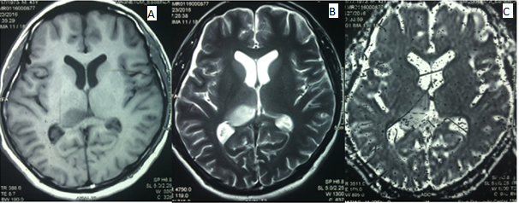

Cranial MR imaging shows prolonged T1 ( Figure A) and T2( Firure B) signal in the deep gray matter, centered at the right thalamus manifesting as hypoattenuated lesion on T1 and hyperattenuated lesion on T2. Gadolinium enhanced examination shows hyperattenuated lesion with no associated enhancing lesion( Figure C). There is also noted preferential right frontal leptomeningeal region enhancement (arrow).

On follow-up, patient was noted to have difficulty sleeping and anxiety. Hence, started on anxiolytics which afforded minimal improvement of symptoms.

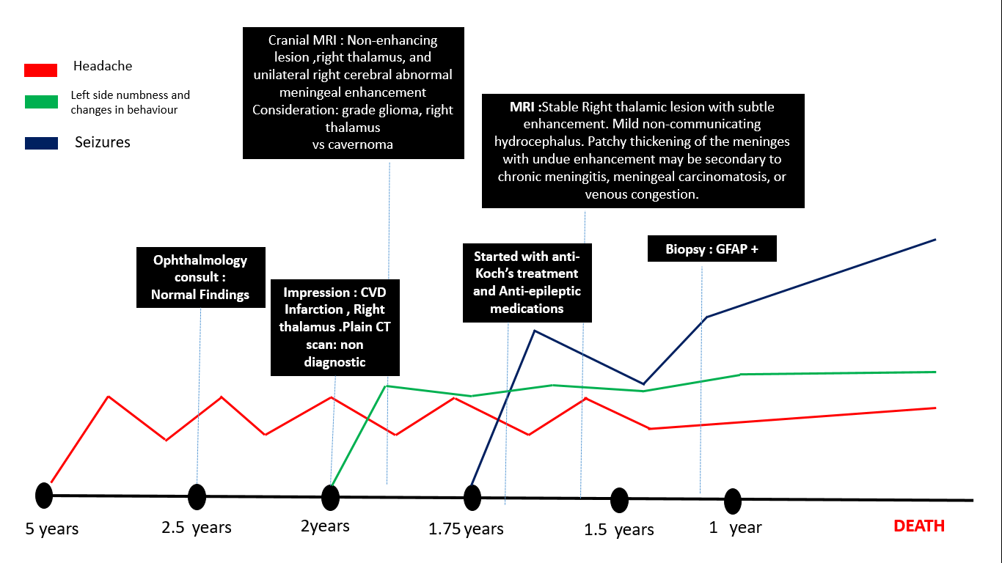 Figure 1: Temporal Profile of the Patient’s Illness

Approximately 3 years after initial symptoms, patient had his first episode of seizures, causing subsequent admission in another institution. A cranial MRI with spectroscopy showed an interval progression of in the degree of leptomeningeal thickening and no significant change in the thalamic focus (Figure A, B, and C below). Possible etiological considerations were infectious (tuberculosis) and neoplastic. A CSF analysis showed elevated protein (17,782), RBC of 7.78 cells/µL and WBC of 1.11cells/µL with lymphocytic predominance. A referral to Infectious Disease service was done. Empiric treatment with anti-tuberculous drugs and short course of steroids afforded relief. Patient was discharged with good seizure control and still able to do usual routines.
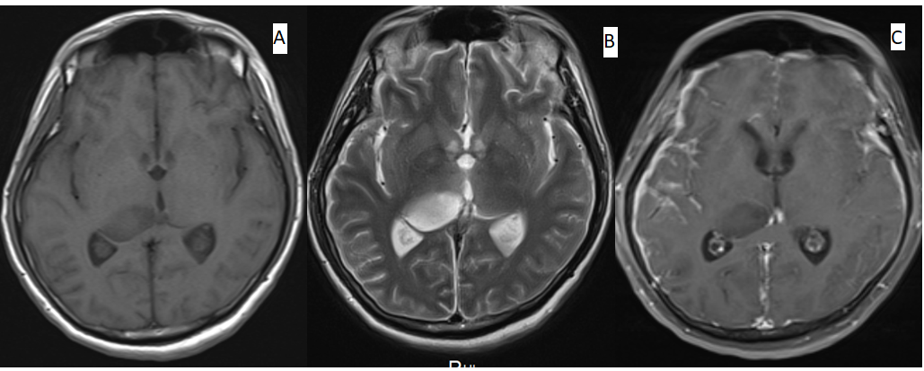
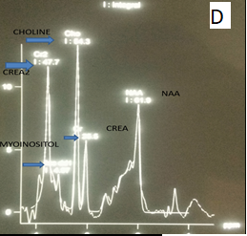

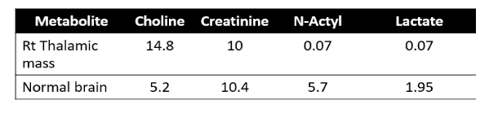

Second Cranial MR imaging again revealed the ovoid shaped non enhancing hypoattenuating focus in the right thalamus. There subtle increase in size as well as slight indentation in the third ventricle. Notice further that in the post gadolinum study there is suspicious preferential hyperattenuating focus on both lateral as well as anteroinfrior leptomeningeal spaces(ARROW).
Figure D: There is loss in normal Hunters angle with increase choline and markedly reduced N acetyl aspartate (NAA) peaks. Choline is marker of cellular membrane turnover and are elevated in condition such as neoplasm with Choline/ creatine ration of 1.5.

Due to the persistence of headaches and refractory seizures, follow up to Neurosurgery service was done.Biopsy supported the diagnosis of Glioma, probably Astrocytic . Patient was advised to undergo whole brain irradiation. However, the family opted for palliative care. Neurological deterioration thus ensued. Patient had several admissions for management of status epilepticus and eventually succumbed to infection. A whole body autopsy was carried out after obtaining consent from the wife.

Pathological findings
The brain weighted 1050 grams (unfixed).There is a diffused leptomeningeal thickening with opacities in the brain parenchyma and cerebral edema. Coronal sections showed gelatinous cystic mass lesions (Figure A, B,C -gross).A poorly demarcated margin on the right thalamus is noted. Sections from the leptomeninges and lesions from the multiple cystic parenchymal showed increased cellularity and evenly distributed glial cells with minimal pleomorphism and mitotic activity (Figure C) with strong expression of glial fibrillary acidic protein (GFAP) while negative for IDH1 staining (Figure D).
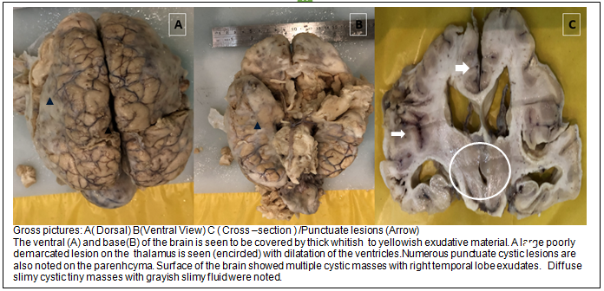
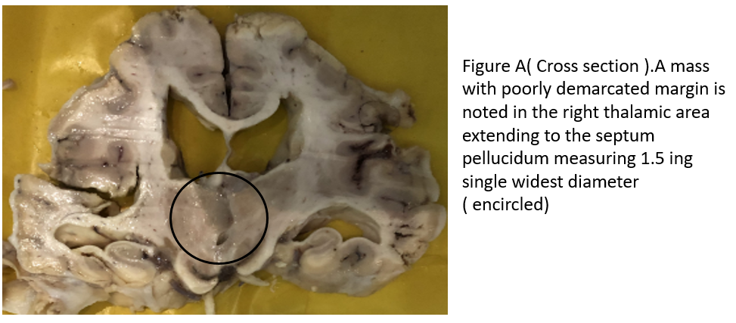
Leptomeninges
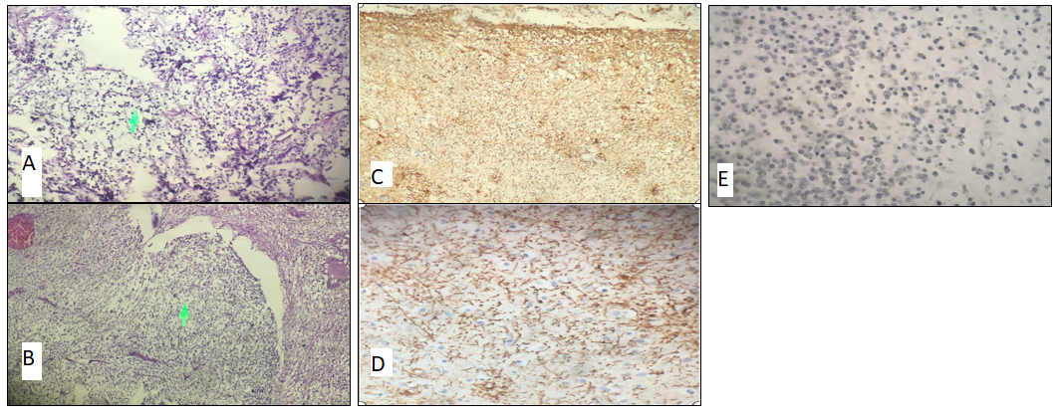
Figure C and D (LPO and HPO magnification) showing cytoplasmic positivity for glial fibrillary acidic protein (GFAP) while Figure E shows negativity on IDH1 staining.

Thalamus
Histopathological and Immunohistochemical profile of tumour. Figure A and B (H and E staining) of the tumour cell from the leptomeninges and right thalamus both showing minimal pleomorphism and mitosis with fibrillary myxoid background)

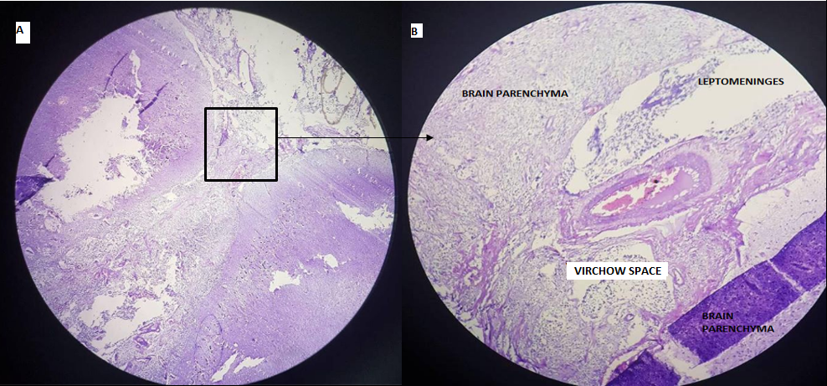
Figure A (LPO), B (HPO): Virchow space. Notice the numerous hyperpigmented (arrow) cells from the Virchow space and vessel lumen (*) .

DISCUSSION
Primary Diffuse leptomeningeal gliomatosis (PDLG) is a rare fatal malignancy , as first described by Moore(1954), with only 90 reported cases worldwide ^{(1,2,3,4,5).}PDLG is caused by the infiltrating neuroglial cells,mostly astrocytes, into the meninges ^{(7.8.9.10).} In this case, patient presents with astrocytic type which has the most aggressive behaviour. The traditional diagnostic criteria proposed by Debono includes the absence of: apparent attachment of extramedullary meningeal tumor to the parenchyma, primary neoplasia within the neuroaxis and indistinct leptomeningeal encapsulation around the mass^{(7,8,9,10).}However, three reported cases ^{(7, 8,10)} found to have brain parenchyma affectation which is similar to our case demonstrating pia arachnoid to Virchow space infiltration.

This condition may present with signs of increased intracranial pressure (89%), cranial neuropathies (35%), and seizures (29%) ^{(11, 12, 13)}. Our patient presented with chronic headache, left – sided numbness, profound anxiety and seizures. The presence of the said symptoms may be attributed to the lesion in the right thalamic centro-median and ventro-postero-lateral portions.

Cranial imaging usually shows a focal or diffuse leptomeningeal enhancement which may also be present in infectious,granulomatous, inflammatory and neoplastic processes. Increasing its diagnostic dilemma is the difficulty of obtaining a positive CSF cytology and biopsy results.
This case demonstrated multiple parenchymal involvement that was not completely evident on the imaging surveillance which only showed: focal leptomeningeal enhancement, slight interval progression of the right thalamic mass and minimal progression of hydrocephalus. Like that of case of Jiang et al(2018), initial event of leptomeningeal carcinoma infiltrating the parenchyma or the other way around that of the right thalamic mass spreading on the meninges was pondered. However, the insignificant interval change in the size of the right thalamic mass in comparison to the increasing enhancement of the leptomeninges supports this consideration. The autopsy also showed diffused leptomeningeal thickening with infiltration of neuroglial cells and with seeding on the parenchyma as evidenced by multiple cystic areas with the same histology.

The cranial imaging failed to show the extent of the parenchymal involvement which may be explained by the need for closer surveillance which was impossible due to the lack of patient’s consistent follow up to the same institution , the rapid disease progression which often has a prognosis of weeks to 3-4 months and the lack of specificity ,sensitivity and predictive value of MRI in all types of tumours ⁽ ¹⁵ ⁾ .

Although imaging may not describe the severity of this malignancy, the non-specific clinical and radiologic findings partnered with pathological studies will aid in its diagnosis. Though there is no successful definitive treatment yet, early diagnosis will possibly prolong survival time with the judicious intervention of combining cranio-spinal irradiation and Temozolomide ^{(14, 15)} and appropriate palliative management.
Author (Year) | Gender  /age  (Years) | Clinical  manifestations  (at presentation) | Imaging findings | Pathological  findings | Location of  Meningeal  alterations  on autopsy /  imaging | Time interval from initial symptoms to death  ( months) | Differential diagnoses | Treatment given
Yambao  ( current study) | M/45 | Headache, blurred vision , numbness, changes in behaviour and seizures | 1. CT: N  2.MRI:FE + mass  3. MRI with MRS : > FE, stable mass, > Cho/Crea | Gross: Diffuse leptomeningeal thickening , multiple cystic parenchymal mass, , right thalamic lesion  Histo:  increased cellularity and evenly distributed glial cells with minimal pleomorphism and mitotic activity  Immuno:  GFAP+  S100+  P53 +  K167 5% | V, ML, T | 51 | CVD infarction  Somatoform Disorder  TB meningitis | Anti-TB meds , steroids, AED’s
Jiang Y et al  (2017) | F/31 | Headache, nausea, vomiting , blurred vision, seizures | 1.MRI: V+FE  2.MRI: > GE+ CL+ > SS  3. MRI WITH MRS: >>GE+ CL, > Cho/Crea | Histo:  Spindle-shaped tumor cells with pleomorphic hyper chromatic nuclei  Immuno:  GFAP+  S100+  P53 +  K167 5%  IDH1 - | V, SS, CS, PV | 12 | TB meningitis | VP Shunting ;  Anti-TB meds  AED’s
Riva et al  (2005) | F/62 | expressive aphasia, vomiting restlessness , confusion, seizures | 1. CT: SE  2.MRI:FE | Gross:  Diffuse gliomatosis Proliferation of Histo:  -coagulative necrosis with pseudopalisading of neoplastic cells.  Immuno:  GFAP + | D, BS, SC,  TL | 3 | Viral encephalitis, meningoencephalitis and meningeal carcinomatosis. | Ant-viral therapy
Ashworth (1997) | F/69 | Disorientation, agitation , urinary incontinence , LR palsy | 1. CT : V | Gross :  Generally thickened and semi translucent.  mass in the cisterna ambiens surrounding the internal cerebral veins and pineal gland,  Histo:  fusiform and polyhedral cells with Nuclear pleomorphism, necrosis and vascular endothelial proliferation and mitosis  Immuno: GFAP + | SS, CA, P,G | 1 | Encephalitis | *Not mentioned
Table 1: A comparison of the Clinico-radio-pathologic profiles of the patients diagnosed with PDLG published reports
Legend: CT -cranial CT scan ; MR-cranial MRI ; MRS- spectroscopy ; >> - increasing ;> -high ; FE- focal enhancement ; cho/crea: choline to creatinine ration at MRS ; V- ventriculomegaly; GE- diffused enhancement of the leptomeninges ;
Location: V – ventricles , ML – leptomeninges , T-thalamus , SS- subarachnoid space, CS – cisterns , PV – periventricular white matter , D – dura amter ; BS- basal cisterns , SC- spinal cord , TL- temporal lobe
Treatment: AED- anti-epilep
CONCLUSION
PDLG is a rare malignancy characterized by increased intracranial pressure , cranial nerve palsies and seizures. The typical MRI shows a focal or diffuse leptomeningeal enhancement. However, possible parenchymal involvement maybe present. Due to non –specific clinic-radio- pathological presentation and rapid progression, cases are mostly diagnosed only though autopsy. Patients are often times treated as a case of infectious meningitis or encephalitis. In this report, the histopathological changes highlighted the limitations of cranial imaging in demonstrating the extent of an atypical parenchymal involvement.

References
- Moon, Ju Hyung et al. “Primary Diffuse Leptomeningeal Gliosarcomatosis.” Brain Tumor Research and Treatment 3.1 (2015): 34–38. PMC. Web. 7 Oct. 2018.
- Jabeen, S.A., Chowdary, A.H., Kandadai, R.M., Uppin, M.S., Meena, A.K., Borgohain, R., & Sundaram, C.A. (2014). Primary diffuse leptomeningeal gliomatosis: An autopsy case report. Annals of Indian Academy of Neurology
- Cooper IS, Kernohan JW. Heterotopic glial nests in the subarachnoid space; histopathologic characteristics, mode of origin and relation to meningeal gliomas. J Neuropathol Exp Neurol (1951) 10(1):16–29. doi:10.1097/ 00005072-195110010-00002 2. Riva M, Bacigaluppi S, Galli C, Citterio A,
- Collice M. Primary leptomeningeal gliomatosis: case report and review of the literature. Neurol Sci (2005) 26(2):129–34. doi:10.1007/s10072-005-0446-1 3. Mathews MS, Pare LS, Kuo JV, Kim RC. Primary
- SH, Jun DC, Park JS, Heo JH, Kim SM, Kim J, et al. Primary diffuse leptomeningeal gliomatosis: report of a case presenting with chronic meningitis. J Clin Neurol (2006) 2(3):202–5.10.3988/jcn.2006.2.3.202 [PMC free article] [PubMed] [Cross Ref]
- Debono B., Derrey S., Rabehenoina C., Proust F., Freger P., Laquerrière A. Primary diffuse multinodular leptomeningeal gliomatosis: case report and review of the literature. Surgical Neurology. 2006;65(3):273–282. doi: 10.1016/j.surneu.2005.06.038. [PubMed] [Cross Ref]
- Jiang, Yun et al. “Parenchymal Infiltration in Primary Diffuse Leptomeningeal Gliomatosis: Dynamic Changes in Brain MRI.” Frontiers in Oncology 7 (2017): 240. PMC. Web. 7 Oct. 2018.
- Riva M, Bacigaluppi S, Galli C, Citterio A, Collice M. Primary leptomeningeal gliomatosis: case report and review of the literature. Neurol Sci (2005) 26(2):129–34.10.1007/s10072-005-0446-1
- G, Duyckaerts C, Lazareth JP, Poisson M, Delattre JY. Diffuse primary leptomeningeal gliomatosis. J Neurooncol (1993) 15(1):45–9.10.1007/BF01050262
- Ashworth B, Gordon A. Leptomeningeal gliomatosis. J Neurol Neurosurg Psychiatry (1994) 57(4):471–3.10.1136/jnnp.57.4.471
- Yamasaki K, Yokogami K, Ohta H, Yamashita S, Uehara H, Sato Y, et al. A case of primary diffuse leptomeningeal gliomatosis. Brain Tumor Pathol (2014) 31(3):177–81.10.1007/s10014-014-0176
- Lyle, Megan R. et al. “Newly Identified Characteristics and Suggestions for Diagnosis and Treatment of Diffuse Leptomeningeal Glioneuronal/Neuroepithelial Tumors: A Case Report and Review of the Literature.” Child neurology open 2.1 (2015): 2329048X14567531. PMC. Web. 21 Sept. 2018.
- Ahmad, Ehtasham, Mohamed Mohamed, and Apostolos Vrettos. “Primary Diffuse Leptomeningeal Gliomatosis: Radiological/Pathological Features.” Case Reports in Neurological Medicine 2016 (2016): 5016840. PMC. Web. 21 Sept. 2018.
- Dardis C, Milton K, Ashby L, Shapiro W. Leptomeningeal Metastases in High-Grade Adult Glioma: Development, Diagnosis, Management, and Outcomes in a Series of 34 Patients. Frontiers in Neurology. 2014;5:220. doi:10.3389/fneur.2014.00220.
- Taghipour Zahir S, Rezaei sadrabadi M, Dehghani F. Evaluation of Diagnostic Value of CT Scan and MRI in Brain Tumors and Comparison with Biopsy. Iran J Ped Hematol Oncol. 2011; 1 (4) :121-125 .URL: http://ijpho.ssu.ac.ir/article-1-46-en.html

