Neurocognitive dysfunction in Rasopathies

Ramachandran Muthiah

Morning star hospital, Marthandam,
Kanyakumari District, India

Abstract

RASopathies are resulting from germline mutations of the protooncogene HRAS. Many of these mutations affect SHP2, SOS1, RAS, RAF and MEK proteins. Dr. White says. a group of related disorders including Costello syndrome, Noonan syndrome (NS), cardiofaciocutaneous (CFC) syndrome, and neurofibromatosis 1 (NF1), caused by abnormal functioning of the Ras‐mitogen‐activated protein kinase (RAS/MapK) pathway. Ras/MAPK pathway is an essential signaling pathway that controls cell proliferation, differentiation, survival and its dysregulation causes clinically overlapping genetic disorders, called as ‘Rasopathies’. In this pathway, Ras, a GTPase, transmits extracellular signaling from receptor tyrosine kinases to two serine/threonine kinases (Raf and MEK) and, finally, to the activation of MAPKs. She has led the implementation of exome sequencing (a genomic technique for sequencing all of the protein-coding regions of genes in a genome known as the exome) at The Royal Children’s Hospital and The Murdoch Children’s Research Institute (Melbourne, Australia). Aoki et al. discovered that these germline mutations altered residues Gly12 and Gly13 in HRAS's P-loop and had been identified previously as somatic defects in various tumors.
Rasopathies are developmental disorders characterised by postnatal growth retardation with delayed skeletal maturation, psychomotor retardation, cutis laxa, and acanthosis nigricans. In 2009, gain-of-function missence mutation in SHOC2, C4a> G(Ps2g), identified in NS-like syndrome with loose anagen hair, severe intellectual disability, hypernasal voice and skin abnormalities. HRAS consists of six exons. Five exons code for a protein of 189 amino acids with a molecular weight of 21 kd. Alternative splicing, excluding residues 152–165, gives rise to a protein of 170 amino acids. The nucleotide substitution c.34G>A, resulting in p.Gly12Ser amino acid change is the most common (65/81 or 80%). The splicing efficiency of activating HRAS mutations can determine the rasopathy phenotype. Gene correction of these germline mutations to restore normal protein functions is anticipated as a new therapeutic option.
Neurocognitive involement is a common feature of rasopathies. Isoprenylation involves the enzyme farnesyl transferase(FTase) transferring a farnesyl group from farnesyl pyrophosphate (FPP) to the pre-Ras protein. Pathway modulators or small molecule inhibitors such as statins causes significant improvement in verbal and nonverbal memory, visual attention & efficacy by inhibiting the posttranscriptional lipid modification of RAS. RAF-1 inhibition by C-type Natriuretic Peptide (CNP) improved bone growth in preclinical animal models and it is a potential targeted therapeutic drug to improve the stature of patients affected with disruption of the RAS/MEK/ERK pathway.

Oxidative stress- play a role in cancer development and free radicals- determine non-neoplastic clinical features such as elastin anomalies, alteration of skin and appendages, developmental retardation and cardiac defects. PAR therapy (potassium ascorbate with ribose) a reduction in oxidative stress biomarkers in parallel with improvement of clinical features. It combines the antioxidant action of vitamin C with the stabilizing intracellular effects of potassium and causes improvement of skin and appendage lesions, better evolution of psychomotor development, no Progression of heart hypertrophy, nor tumor development. It is low cost, no side-effects, orally administered and useful for all genetic syndromes with cancer risk.

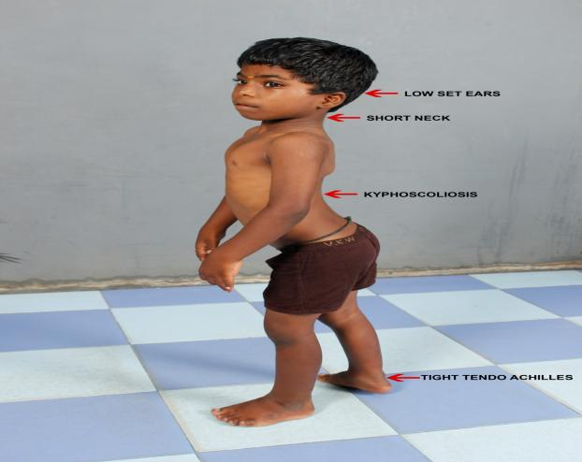o
9 years old boy
low-set ears, short neck, kyphoscoliosis, tight tendoachilles

Publications
- Muthiah, R. (2021) Isolated Acute Rheumatic Pancreatitis—A Case Report. Case Reports in Clinical Medicine, 10, 52-77
- Muthiah, R. (2019) Infective Endocarditis in Tetralogy of Fallot Complicating Brain Abscess—A Case Report. Case Reports in Clinical Medicine, 8, 105-126
- Muthiah, R. (2018) Native Aortic Valve Endocarditis—A Case Report. Case Reports in Clinical Medicine, 7, 483-504.
- Muthiah, R. (2018) Tropical Coronary Artery Disease and Arrhythmogenic Potentials—The Changing Pattern towards Endomyocardial Fibrosis—An Analysis. Case Reports in Clinical Medicine, 7, 397-429
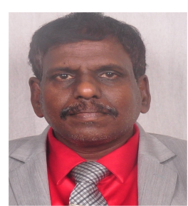
Muthiah, R. (2018) Isolated Patent Ductus Arteriosus in an Elderly Female, Aged 65 Years—A Case Report. Case Reports in Clinical Medicine, 7, 352-379

Biography
Ramachandran Muthiah, Consultant Physician & Cardiologist, Zion hospital, Azhagiamandapam and Morning star hospital, Marthandam, Kanyakumari District, India. Born on 10/5/1966.. Mother Swornam belongs to keezhkulam village and Father Muthiah belongs to Enayam thoppu and both were farmers. Published many papers in Cardiosource, American College of Cardiology Foundation, Case Reports in Clinical Medicine (SCIRP) and Journal of saudi heart assocoation.
Name/Address: Ramachandran Muthiah
Palaninta vilai, keezhkulam-629193, kanyakumari district, Tamil nadu state, India
(landline-+914651 203014,
mobile +91 7598755201)
Category: Oral
Passport No:P8925619

