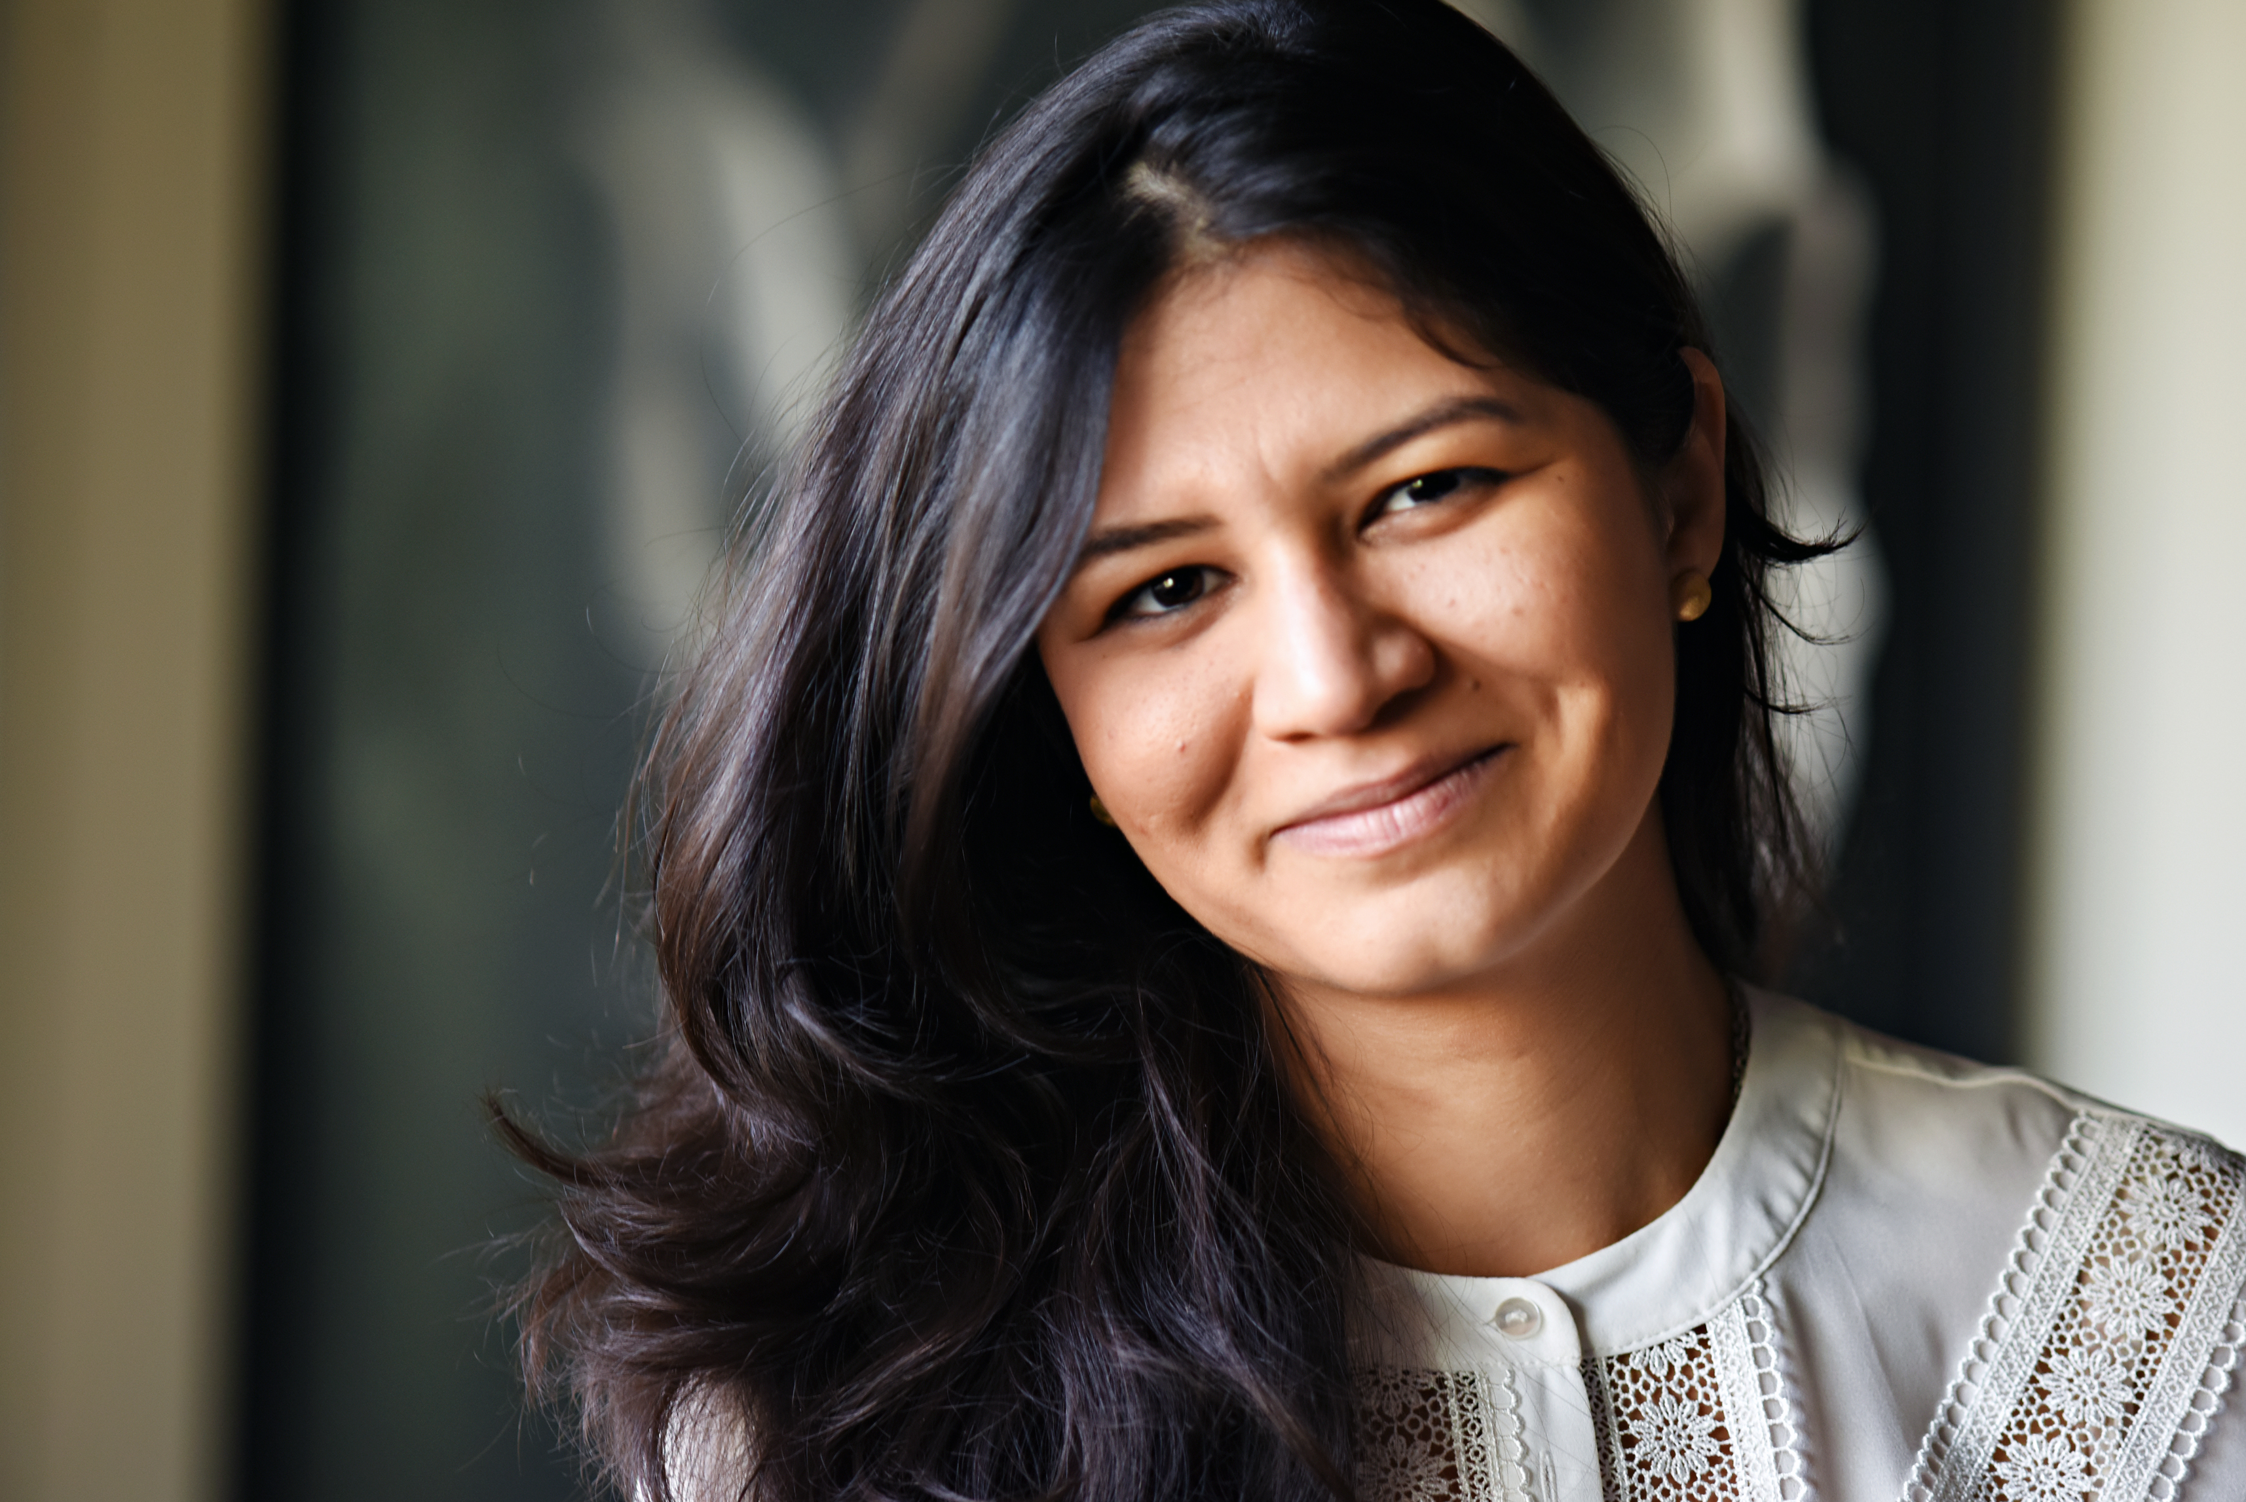

Title: Understanding the Unseen: The Impact of Complex Trauma on Cognitive Development

Name: Malak Kamel, M.A.
Zayed University College of Natural and Health Sciences, Abu Dhabi, U.A.E.

Abstract:

Complex trauma is defined as the experience of multiple, chronic, and adverse traumatic events that are of an interpersonal nature and most often occur in early development. When exposed to repeated traumatic experiences, a great amount of emotional and mental energy is expanded to deal with the event(s). The brain becomes wired for survival, altering patterns of neural connections in the limbic system or emotional brain, thus derailing normal neurocognitive development.
Research also shows that the early years of children’s lives are crucial to their development; and that exposure to chronic neglect and to maladaptive attachment styles can contribute to complex trauma. Working in parallel during this crucial period is the brain’s ability to change its own structure in response to experiences and the eniviornment (known as brain plasticity), continuing throughout childhood and well into adulthood. This makes it imperative that practitioners act swiftly in assessing trauma and providing the necessary supports at the earliest possible. Research shows that building on empowerment and resilience with a strong focus on self-concept can foster brain plasticity and thwart the effects of complex trauma.
During this brief talk Ms. Kamel will discuss the primary types of child neglect and maladaptive attachment styles, reviewing their impacts on cognitive development and touch upon various tools used to assess for complex trauma. Most importantly Ms. Kamel will discuss implications in practice and ways to foster empowerment and resilience, providing examples from her years of practice in Canada, Trinidad and Tobago, Egypt, and the U.A.E.

(Word Count: 248)

Biography:
Malak Kamel is a licensed psychotherapist, university instructor, and frequently sought after government advisor in child development and youth mental health. She served the Canadian government in child and family services, has developed international child protection trainings and welfare policies, and has collaborated in research ventures with McGill University, Columbia University, and Harvard University. Ms. Kamel is a member of the American Psychological Association, the Canadian Psychological Association, and the Middle East Psychological Association. She enjoys balancing her contributions to the field between private practice therapy, university teaching, and community engagement in psychology and social work.

(Word Count: 96)

Presenting author details:
Full name: Malak Kamel
Contact number: +971 50 528 2894
Twitter account: None
Linked In account: https://www.linkedin.com/in/malak-kamel/
Session name/number: ?
Category: Oral presentation

