Role of Adipokines in Enhanced Pain and Inflammation in a rodent model of obesity
Sharron Dolan, PhD, Glasgow Caledonian University, UK
Nasser M AlorfI, BSc, Glasgow Caledonian University, UK

Abstract (300 word limit)

Obese individuals are more likely to be affected by chronic pain, however, the biological mechanisms underpinning this comorbidity are not known. A causal link may be dysregulated secretion of inflammatory adipokines both from expanding adipose tissue and centrally. The aim of this study was to characterize altered pain processing and changes in inflammatory cytokine expression in spinal cord in rodent models of obesity.

Responses to thermal and mechanical stimulation of the hindpaw were assessed in adult male Wistar rats fed a high fat diet (HFD; 22%) or normal diet for 16 weeks (n=6/group) in absence of inflammation, and then in response to intradermal hindpaw injection of carrageenan (3%; 50μl), a model of acute inflammation. Spinal cord was collected and adipokine mRNA expression, cholesterol and triglycerides (TAGs) measured using real-time PCR and ELISA

Rats fed a HFD gained significantly more weight than controls (502 ± 12g vs. 444 ± 7g; P<0.01), and displayed plasma hyperinsulaemia and hypercholesterolaemia (both P<0.05 vs. controls) but normoglycaemia. Acute nociceptive responses were unchanged in obese rats but they displayed potentiated mechanical and thermal hyperalgesia and increased paw oedema (all P<0.05 vs. lean controls) in response to carrageenan. Significant changes in levels of resistin, C reactive protein, TGFβ and visfatin (but not IL1β or TNFα) were detected in obese rat spinal cord.

The increased pain and inflammation in obese rats fits with the hypothesis that obesity is a chronic low-grade inflammatory disorder, producing a state where responses to inflammatory challenge are potentiated. The altered adipokine profile observed suggests adipokines may be useful biomarkers for monitoring initiation and progression of pain with obesity, or even be involved in the development of co-morbid pain in obese individuals.

Image

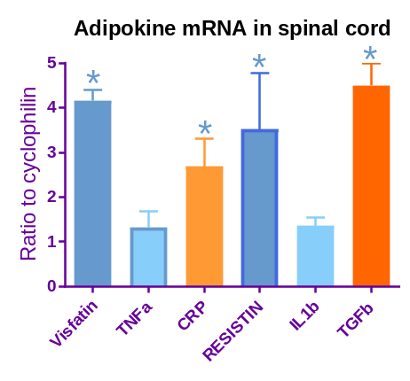
Real-time PCR analysis of adiopkine mRNA in spinal cord from HFD fed rats and control rats (n =6/group). Target mRNA are expressed relative to housekeeping gene cyclophilin. Data are expressed as mean ± SEM. * p <0.05.
Recent Publications (minimum 5)
1. Iannitti T., Graham A., Dolan S. (2015) Adiponectin mediated analgesia and anti-inflammatory effects in rat. PLoS One; 10(9): e0136819.
2. Soffientini, U., Dolan, S., Graham, A. (2015) cytosolic lipid trafficking proteins stard4 and stard5 modulate hepatic neutral lipid metabolism: implications for diabetic dyslipidaemia and steatosis. Journal of Diabetes & Metabolism 6:558.
3. Soffientini, U., Caridis, A-M., Dolan, S., Graham, A. (2014) Intracellular cholesterol transporters and modulation of hepatic lipid metabolism: implications for diabetic dyslipidaemia and steatosis. Biochimica et Biophysica Acta 1842(10):1372-82.
5. Goldie, M., Dolan, S. (2013) Bilobalide, a unique constituent of Ginkgo biloba, inhibits inflammatory pain in rat. Behavioural Pharmacology 24, 298-306.
6. Iannitti T, Graham A, Dolan S (2012) Increased central and peripheral inflammation and inflammatory hyperalgesia in Zucker rat model of leptin receptor deficiency and genetic obesity. Experimental Physiology 97 (11), 1236-45.

Biography (150 word limit)
Dr Sharron Dolan is a Senior Lecturer in Pharmacology and Assistant Head of the Department of Life Sciences at Glasgow Caledonian University. After completing her PhD in Neuropharmacology at University of Stirling with Dr Peter Cahusac, she took up a BBSRC funded post-doctoral position with Professor Andrea Nolan at Glasgow University’s Veterinary School, working to characterize the spinal mechanisms of inflammatory pain and analgesia. Dr Dolan took up a tenured post as lecturer at GCU in 2004. Her research over the past 20 years has focused on understanding the neuronal mechanisms of pain and inflammtion, and more recently focused on mechanisms underlying co-morbid pain with diabetes and obesity.

Notes/Comments:

