Silencing Neurodegeneration by Reducing Vascular Inflammatory Free Radicals and Unleashing the Capillary Cell Dance
Robert L Buckingham, MD, FACP
Ojai California

Abstract (not more than 300 words)

It is my theory, based on prevailing evidence, that neurodegeneration is initiated by vascular inflammatory free radical interstitial space impingement and a subsequent blockage of the endothelial and capillary cell dance. It is associated with:
- Vascular inflammatory free radical stealth migration through capillary cell membranes, attachment to capillary cell basement membranes and pluming an immune arsenal response towards their attachment. If not completely removed, chronic inflammation establishes a foothold.
- A chronic expansion of an immune arsenal response into the interstitial space between nerve and capillary cells of the brain becomes increasingly ineffective towards removal of the free radical impingements.
- Perpetuated endothelial and capillary cell outer membrane increases in permeability fixates their mitochondria into energy combustion to support outer membrane active transport processes. This blocks the back and forth rhythm in outer membrane permeability and mitochondrial combustion from energy to nitric oxide.
- The blocked capillary cell pivot and swing dance limits mitochondrial nitric oxide production while energy combustion goes on overdrive. With less nitric oxide combustion, superoxide free radicals increase and nitric oxide induced rejuvenation of capillary infrastructure decreases.
- As nuclear DNA coding is silenced from increasing superoxide free radical damage, effective protein synthesis diminishes and capillary cells of the blood brain barrier cannot regenerate mitochondria, outer membrane receptors or infrastructure. Mitochondrial volumes and outer membrane receptors decrease (pseudocapillarization).
- Pseudocapillarization coupled with ineffective mitochondrial energy support renders capillary cells dysfunctional. They lose control of feedback loop signaling to adjoining astrocytes, pericytes and brain cells while enabling a wayward array of different white blood cells and cytokines access into the brain’s interstitial spaces-cerebrospinal fluid.
- These wayward cells accumulate and rather than working for sanitation of the interstitial space they work against it. They do this by establishing a counter feedback loop signaling control of the brains interstitial space, utilizing cytokine signals that run counter to sanitation and in deference to the feedback loops of the fading capillary cell.
- As endothelial and capillary cells zombie, their outer membranes become easily pirated by cytokine influences from wayward white blood cells. These influences support interstitial space chronic inflammatory disease venues (also known as neurodegeneration) within the brain. As this occurs, pericytes, astrocytes and other glial elements are taken hostage into the alternative feedback loop scheme, further isolating brain cells from oxygen, nutrient and their capillary cell brethren.
- Chronic inflammation within the brains interstitial space matures in phases to include the matrix and anti-organ. With each phase, chronic inflammation masters more control over the interstitial space while utilizing vascular inflammatory free radicals as fuel to initiate disease venues, for expanding interstitial space operations and keeping the capillary cell permanently disabled.
- The interstitial space of the brain becomes ripe for different disease expressions including chronic hypoxia- ischemia (strokes, mini-strokes), infections (meningitis, encephalitis, abscess), cancer (astrocytoma, glioblastoma), and autoimmune disease (multiple sclerosis).
- As brain cells atrophy or die from different combinations of any or all of these disease venues, astrocytes and other glial elements are called upon to produce scar tissue and secrete beta amyloid and tau.
- Disease venues escalate to induce a broad array of clinical deficits including headaches, seizures, declines in mental acuity, gait disturbances as well as diffuse weakness and chronic fatigue. Many of these disease outcomes take advantage of pre -existing genetic influences built into brain cells.
- Reversal requires a comprehensive and abrupt withdrawal of vascular inflammatory free radicals into the brain’s interstitial space to enable capillary cells to begin dancing again, before disease venues have become too far advanced.

Keywords—neurodegeneration, pseudocapillarization, capillary cell dance

Professional Biography

Robert Buckingham MD, FACP, received a Master’s degree in neurochemistry of sleep from the University of Illinois in 1975, where he also received his MD degree in 1976. He went on to become a Fellow of the American College of Physicians in 2009. Over forty years, Dr. Buckingham has held multiple positions within hospital infrastructure including Chief of Staff, Medicine, Pharmacy and Therapeutics, Intensive Care and other quality assurance committees. Besides serving as Internal Medicine consultant and patient advocate for complex medical cases, he has published three books on a proposed theory on the mechanics and origins of chronic inflammation and illness. Central to this theory is how chronic inflammation within interstitial spaces, induced by vascular inflammatory free radicals, blocks the capillary cell pivot and swing dance to cascade capillary cell dysfunction and a switch in feedback loop signalling control of interstitial space dynamics to darker influences.

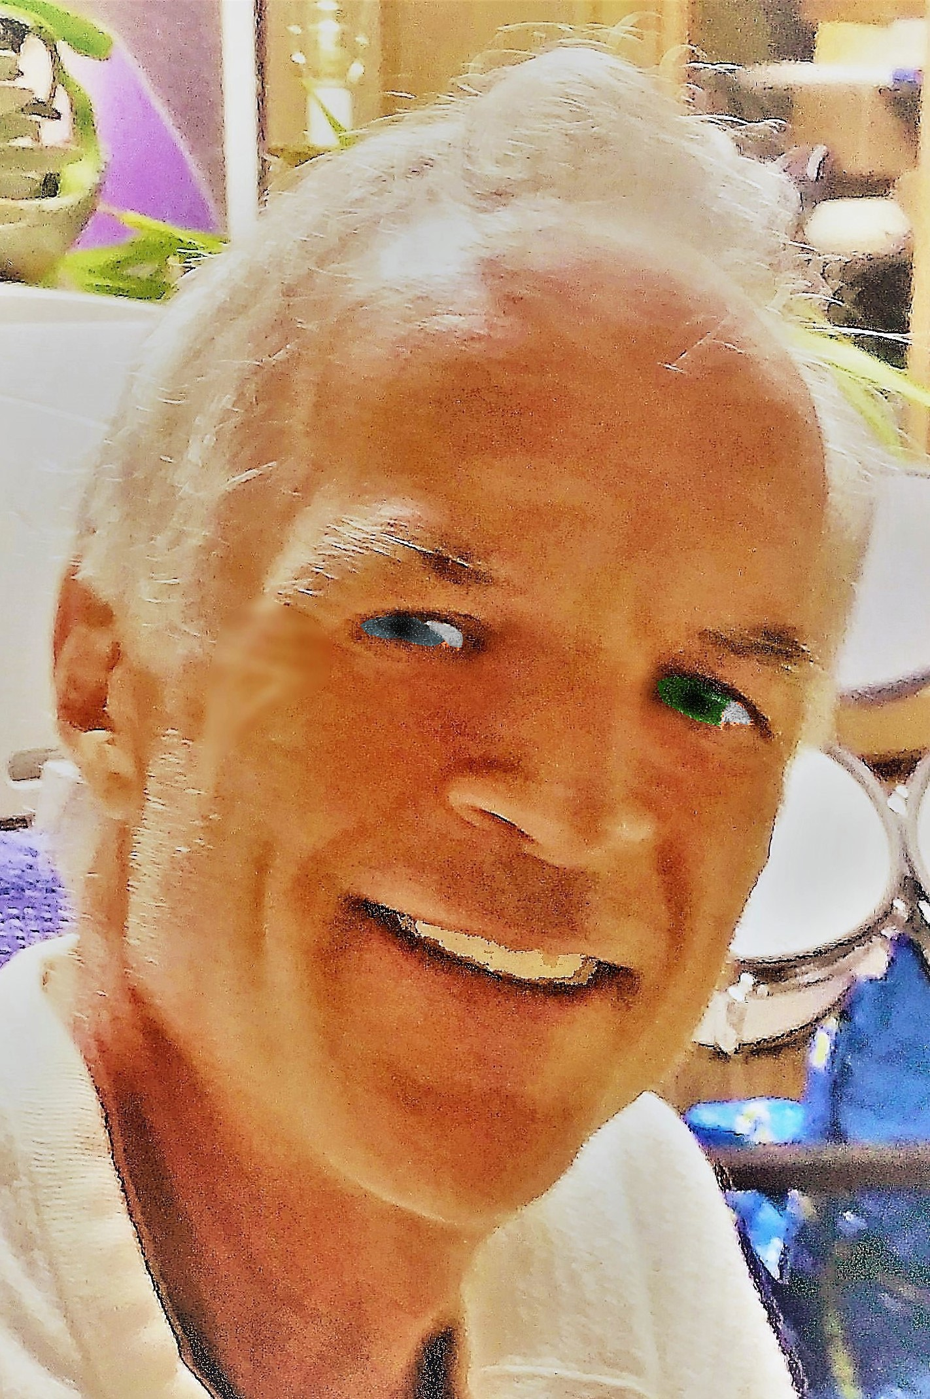
Robert Buckingham, MD, FACP
drrlbuckingham@yahoo.com
1-805-798-3481
Facebook: Dr Robert Buckingham
Linked In: Robert Buckingham, MD

