The kinase HIPK2 regulates spastin protein: implications in Hereditary Spastic Paraplegia (HSP)
Francesca Sardina¹, Davide Valente², Manuela Ferrara¹, Alessandra Pisciottani¹, Marco Crescenzi³, Silvia Soddu², Cinzia Rinaldo^{1,2}
¹Institute of Molecular Biology and Pathology-CNR, Rome, Italy; ²Regina Elena National Cancer Institute, Rome, Italy; ³Istituto Superiore Di Sanità, Rome, Italy ;

Abstract

The alteration of axonal-transport is an early and causal event in many neurodegenerative diseases (ND). Among the mechanisms contributing to axonal-transport defects, the loss of microtubules dynamism is one of the key mechanisms. Spastin is a microtubule severing protein involved in cytokinesis and in axonal-transport.
Mutations in SPG4 gene encoding spastin, are found in patients with HSP, an autosomal dominant ND. Recently, it has been shown that to increase spastin levels rescues the pathological phenotypes in HSP-patient-derived cells suggesting that intervening to modulate spastin levels may be a valid therapeutic strategy in ND characterized by spastin misregulation.
We found that spastin is regulated by the kinase HIPK2 in neural compartment. HIPK2 depletion leads to spastin downregulation in a proteasome-dependent manner and impairs axonal-transport. Wild-type-HIPK2 overexpression, but not kinase-defective-HIPK2, increases spastin levels and rescues axonal transport defects in spastin-deficient motorneurons. Mechanistically, we showed that HIPK2 phosphorylates spastin at S268. This phosphorylation stabilizes spastin and prevents its polyubiquitination and proteasome degradation. These results, in addition to expanding our understanding of the HIPK2/spastin axis in neural compartment, might provide the basis for the development of a new therapeutic approach to treat HSP.

Image

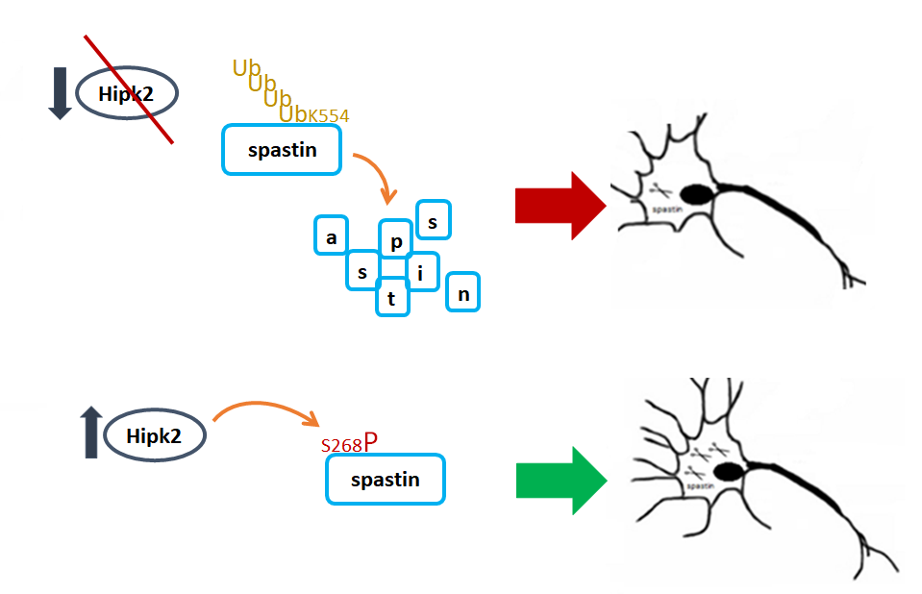
Figure1. Effects of HIPK2 modulation on spastin

Recent Publications
- V. Colicchia, M. Petroni, G. Guarguaglini, F. Sardina, M. Sahun Roncero, M. Carbonari, B. Ricci, C. Heil, C. Capalbo, F. Belardinilli, A. Coppa, G. Peruzzi, I. Screpanti, P. Lavia, A. Gulino, G. Giannini “PARP inhibitors enhance replication stress and cause mitotic catastrophe in MYCN-dependent neuroblastoma" (Oncogene, January 2017, 36, 4682-4691).
- M. Petroni, F. Sardina, C. Heil, M. Sahún-Roncero, V. Colicchia, V. Veschi , S. Albini, D. Fruci, B. Ricci , A. Soriani, L. Di Marcotullio, I. Screpanti, A. Gulino, G. Giannini “The MRN complex is transcriptionally regulated by MYCN during neural cell proliferation to control replication stress” (Cell Death Differ. February 2016, 23(2) 197-206).
- Sardina F, Petroni M, Heil C, Colicchia V, Ricci B, Soriani A, et al. The crucial role of MRN complex in suppressing the deleterious effects of replication stress in MYCN-amplified neuroblastoma identifies it as a potential therapeutic target (Submitted).
- Pisciottani A, Biancolillo L, Ferrara M, Valente D, Monteonofrio L, Sardina F, Camerini S, Crescenzi M, Soddu S, Rinaldo C, HIPK2 protects the microtubule-severing enzyme spastin from degradation promoting cytokinesis (Submitted).
- Sardina F, Valente D., Crescenzi M., Ferrara M., Piasciottani A., Soddu S. and Rinaldo C. “HIPK2-mediated phosphorylation prevents spastin degradation in neurons” (manuscript in preparation).

Biography
Francesca Sardina is interested in the study of DNA damage response during neuronal development and carcinogenesis (Petroni, Sardina et al., Cell Death Differ.,2016; Colicchia et.al, Oncogene,2017; Sardina et al., submitted). In this last years, she started to characterize the role of HIPK2, a kinase controlling DNA damage and cytokinesis, in the regulation of spastin protein closely involved in Hereditary spastic paraplegia, a neurodegenerative disease (Sardina et al., in preparation). Her studies could open the way to develop new and innovative therapeutic approaches in the field of neurodegenerative diseases.

.
Email:
francesca.sardina@uniroma1.it

