Hypothalamic Injury Following Surgery for Craniopharyngioma Causing Immediate Postoperative Death
Dr.Mohammed Musheer Ahmed M.B.B.S.,M.S.(General Surgery)

Abstract:-
Craniopharyngiomas are rare, benign sellar/parasellar tumors derived from embryonic tissue. Even though these tumors are slow-growing and benign, they cause complications as a result of the mass effect on the neighboring structures. This results in the patient presenting with symptoms, such as headaches, bitemporal hemianopia, and hypopituitarism. Radical excision of craniopharyngiomas usually leads to injury to the hypothalamus.
While autonomic disturbances resulting from a hypothalamic injury are uncommon complications following surgery for craniopharyngioma, they can lead to postoperative death. Herein, we discuss the case of a multicompartmental craniopharyngioma in a 13-year-old child who died due to unexpected hypothalamic injury, resulting in rapid deterioration in the hemodynamic and neurological status of the patient and did not respond well to treatment.

Conclusion and significance:-
GTR is considered to be the gold standard treatment for craniopharyngioma and is successful in most cases as it hinders the chances of recurrences of the tumor. It is our belief that our attempt at GTR proved to be fatal due to the damage to multiple hypothalamic nuclei. This injury to the hypothalamus may have been a result of direct trauma to it or an infarction following injury to the vessels that supply the hypothalamus The use of GTR in such circumstances led to damage of various nuclei of the hypothalamus, resulting in deterioration in the patient’s health and, finally, led to his demise. We conclude that, in cases such as ours, the idea of SR followed by RT may prove to be a better approach despite having a higher recurrence rate because the life-threatening extreme damage to the hypothalamic nuclei can be avoided.
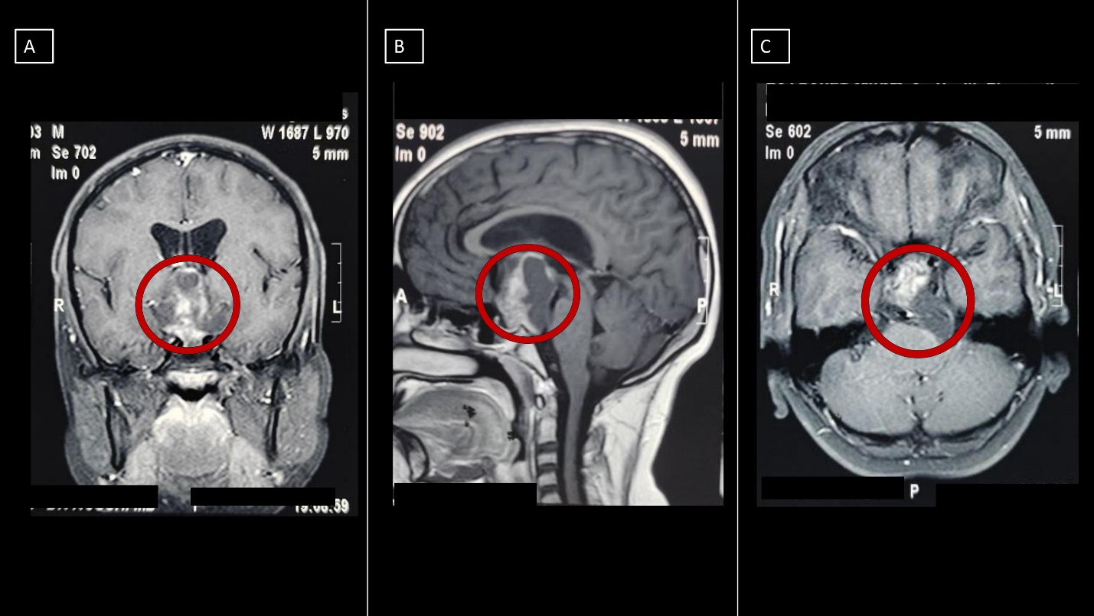A: Preoperative contrast-enhanced coronal MRI showing a heterogeneously enhancing lesion in the sellar/suprasellar region; B: preoperative contrast-enhanced sagittal MRI showing the solid cystic nature of the sellar/suprasellar lesion with enhancing solid portion and non-enhancing cystic portion; C: preoperative contrastenhanced axial MRI showing the solid cystic lesion centred in the sellar/suprasellar region with extension of the cystic component posteriorly into the left cerebellopontine (CP) angle cistern, causing effacement of it and causing mass effect on the left brainstem.
**The red circle marks the location of the lesion on the MRI

Recent Publications:-
- Bhandari P, Nagpal S, Parthasarathi A, et al. (October 16, 2021) Hypothalamic Injury Following Surgery for Craniopharyngioma Causing Immediate Postoperative Death. Cureus 13(10): e18814. doi:10.7759/cureus.18814
- Ahmed, Mohammed & Sinsodhiya, Rajpal & Gaharwar, A. & Chhangte, Ramngaihzuala. (2021). SHORT TERM OUTCOME OF DIVERSION LOOP COLOSTOMY IN CHILDREN OF ANORECTAL MALFORMATION.. GLOBAL JOURNAL FOR RESEARCH ANALYSIS. 30-33. 10.36106/gjra/4806580.
- Chhangte, Ramngaihzuala & Shukla, Pushpendra & Singh, Atul & Ahmed, Mohammed. (2021). “ASSOCIATION OF LOWER URINARY TRACT SYMPTOMS WITH METABOLIC SYNDROME IN MALE PATIENTS OF AGE MORE THAN 45 YEARS.”. GLOBAL JOURNAL FOR RESEARCH ANALYSIS. 15-19. 10.36106/gjra/6006127.
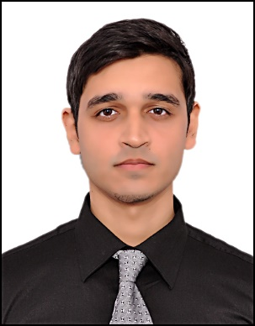
Biography:
Dr.Musheer Ahmed is currently doing his Senior residency at Shyam Shah Medical college,Rewa,M.P.,India. He completed his junior residency in General Surgery from the same institute and completed his M.B.B.S. from RIMS,Raichur,Karnataka,India. He has presented multiple posters and papers in state level and national surgical conferences in India.

Email: dr.mdmusheerahmed@gmail.com

Presenting author details:-
Full name: Dr.Mohammed Musheer Ahmed
Contact Number:- +91-8310133256
Category:-Poster Presentation

