Preclinical modeling in glioblastoma patient-derived xenografts to guide clinical development of the novel microtubule inhibitor Lisavanbulin
Danielle M Burgenske, PhD, Mayo Clinic, USA

Abstract (300 word limit)

Glioblastoma (GBM) is an incurable disease with few approved therapeutic interventions. Radiation therapy (RT) and temozolomide (TMZ) remain the standards of care. The efficacy and optimal deployment schedule of the microtubule-binding drug Lisavanbulin (LIS) alone, and in combination with, standards of care were assessed using a panel of IDH-wildtype GBM patient-derived xenografts.

Mice bearing intracranial tumors were treated with LIS +/- RT +/- TMZ and followed for survival. LIS concentrations in plasma and brain were determined by liquid chromatography with tandem mass spectrometry, while flow cytometry was used for cell cycle analysis.

LIS monotherapy showed significant benefit (p<0.01) in 9 of 14 PDXs tested (median survival extension 10-87%) and demonstrated brain-to-plasma ratios of 1.29 and 1.64 at 2- and 6-hours post-dose, respectively. Prolonged LIS dosing from RT start until moribund was required for maximal benefit (GBM6: median survival LIS/RT 90 vs. RT alone 69 days, p=0.0001; GBM150: LIS/RT 143 days vs. RT alone 73 days, p=0.06). Similar observations were seen with RT/TMZ combinations (GBM39: RT/TMZ/LIS 502 days vs. RT/TMZ 249 days, p=0.0001; GBM26: RT/TMZ/LIS 172 days vs. RT/TMZ 121 days , p=0.04). Immunohistochemical analyses showed a significant increase in phospho-histone H3 with LIS treatment (p=0.01).

LIS demonstrated excellent brain penetration, significant extension of survival when used alone or in combination with RT- or RT/TMZ and was associated with mitotic arrest. These data provide a strong clinical rationale for testing LIS in combination with RT or RT/TMZ in GBM patients.
Image
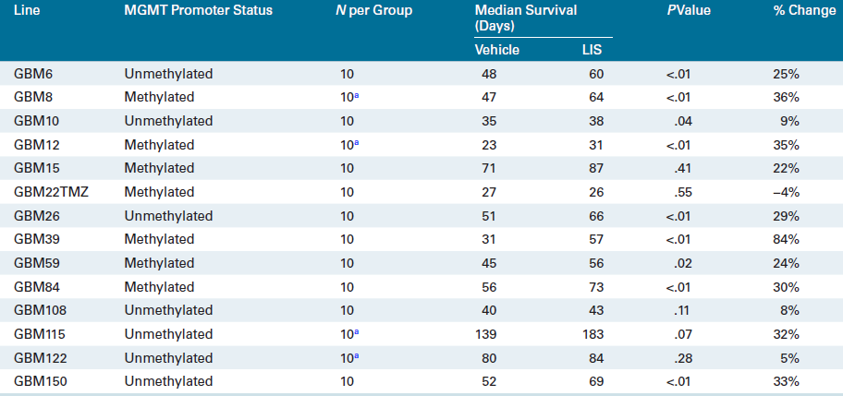
Recent Publications (minimum 5)
- GC Lopez B et al. (2021) Multimodal platform for assessing drug distribution and response in clinical trials. Neuro Oncol. PMID: 34383057.
- Kohale IN, Burgenske DM et al. (2021) Quantitative analysis of tyrosine phosphorylation from FFPE tissues reveals patient-specific signaling networks. Cancer Res 81(14):3930-3941. PMID: 34016623.
- Burgenske DM (2021) Preclinical modeling in glioblastoma patient-derived xenografts to guide clinical development of the novel microtubule inhibitor Lisavanbulin. Neuro Oncol. PMID 34232318.
- Eckel-Passow JE et al. (2021) Experimental Design of Preclinical Experiments: Number of PDX Lines versus Subsampling within PDX Lines. Neuro Oncol. PMID: 34107029.
- Marin BM et al. (2021) Heterogeneous delivery across the blood-brain barrier limits the efficacy of an EGFR-targeting antibody drug conjugate in glioblastoma. Neuro Oncol. PMID: 34050676.



Biography (150 word limit)
Danielle Burgenske received her PhD in Cellular and Molecular Genetics at the Van Andel Institute Graduate School in Grand Rapids, MI. She followed with a postdoctoral training fellowship in the lab of Dr. Jann Sarkaria at the Mayo Clinic in Rochester, MN. Currently, she is a senior program coordinator in the Sarkaria lab and actively manages all animal work for industry collaborations and grants. Their lab has over 100 fully annotated patient-derived xenograft models of GBM which they use to evaluate novel therapeutics with an emphasis on inhibitors of the DNA damage response.
Email: Burgenske.danielle@mayo.edu

Notes/Comments:

