Neurotrophic factor reduces inflammation and improve brain neuronal regeneration in inflammatory brain injury
Ling Li （liling@xinhuamed.com.cn）
Department of Pedtiatric neurology, Xinhua Affiliated to Shanghai Jiaotong University School of Medicine, Shanghai, China
The risk of suffering from serious permanent sequelae following a central nerve system (CNS) infection is high and varies in different studies from 30 to 60%, to some extent depending on the causative agent. Inflammation is emerging as a critical mechanism underlying neurological disorders of various etiologies, yet its role in altering brain function as a consequence of neuroinfectious disease remains unclear. The main limitation to advance in prevention and treatment of the disease is incomplete knowledge of its pathogenesis and pathophysiology. There is now solid evidence that intense inflammatory host response causes important damage to the brain, inducing unfavorable outcomes of meningitis.
Neurotrophic factor family (nerve growth factor, NGF, brain derived neurotrophic factor, BDNF, et al) plays an important role in the development, differentiation, and survival of neurons in the CNS. Dysfunction in the regulation of BDNF is associated with numerous disorders of CNS, including Alzheimer’s disease (AD), multiple sclerosis (MS), depression, and unacceptable outcomes of bacterial meningitis. Our previous study showed that increased expression of BDNF in the acute S. pneumonia meningitis was abviously alleviated after antibiotic treatment (Fig. 1). Similarly, increased BDNF levels were also observed in the serum and cerebrospinal fluid (CSF) of pediatric patients with CNS infections on the day of admission. Furthermore, Barichello et al. reported that decreases in BDNF levels during the long-term phase of meningitis were correlated with behavioral deficits in adult animals submitted to meningitis during the neonatal period. Interestingly, our previous study reported that administration of exogenous BDNF increased neuron survival in both the cortex (Fig.2) and hippocampus (Fig.3), and reversed brain damage, and it was recently reported that exogenous BDNF increases neurogenesis of neuron stem cells in the hippocampus after S. pneumoniae meningitis (Fig.4). These findings indicate that regulatory expression of BDNF may be a part of the host inflammatory response in S. pneumoniae meningitis, and the innate immune response could be a double-edged blade possessing both protective and damaging properties, and there could be interaction between them. However, the underlying regulatory mechanism is still not clear.
We investigated the effects of BDNF-related signaling on the inflammatory response and hippocampal apoptosis in experimental models of pneumococcal meningitis. Pretreatment with exogenous BDNF or the tropomyosin-receptor kinase B (TrkB) inhibitor k252a was performed to assess the activation or inhibition of the BDNF/TrkB-signaling axis prior to intracisternal infection with live S. pneumoniae. The results showed rats administered BDNF exhibited reduced clinical impairment, pathological severity (Fig.5), and hippocampal apoptosis (Fig.6). Furthermore, BDNF pretreatment suppressed the expression of inflammatory factors, including tumor necrosis factor α, interleukin (IL)-1β, and IL-6, and increased the expression of the anti-inflammatory factor IL-10 (Fig.7). Moreover, BDNF pretreatment increased TrkB expression, activated downstream phosphatidylinositol 3-kinase (PI3K)/protein kinase B (AKT) signaling (Fig.8), and inhibited the myeloid differentiation primary response gene 88 (MyD88)/NF-κB-signaling pathway (Fig.9 & Fig.10). These data suggested that BDNF administration exerted anti-inflammatory and anti-apoptotic effects on an experimental pneumococcal meningitis model via modulation of MyD88/NF-κB- and PI3K/AKT-signaling pathways. Our results indicated that treatment with exogenous BDNF and increase the expression of endogenous neurotrophic factor might constitute a potential therapeutic strategy for the treatment of inflammatory brain injury.
This is a case of acute necrotizing encephalopathy by inducted infection. He is a 2-year-old boy who developed acute necrotizing encephalopathy had relatively good prognosis after timely treatments. The level of the patient’s consciousness and spirit reaction improved greatly after high-dose methylprednisoloneand and intravenous immunoglobulin therapy as well as multiply vitamins and nerve growth factor administered. Neuroregeneration was seen in follow-up brain MRI after long-term use of multiply vitamins and nerve growth factor (made in China) (Fig 11). At the same time motor ability and cognitive level of the children improved slowly and he can now live a relatively normal life. Among them, multiply vitamin not only participates in cell energy metabolism, but also enhances endogenous NGF and BDNF.

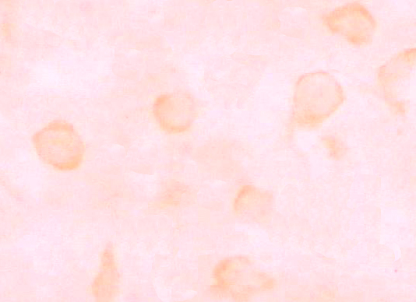
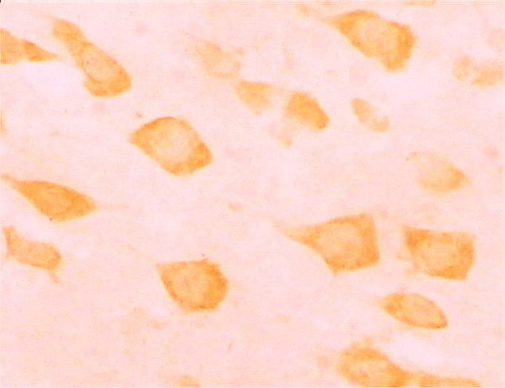

B
A


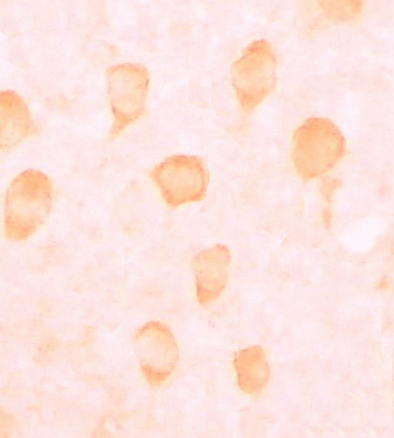
C
D

Fig.1 Higher magnification of BDNF mRNA in cerebral cortex
A. Normal contral. B. After infection 24 hour. C After infection 5 days.
D. Infection group treated with ceftriaxone 100mg/kg.
B
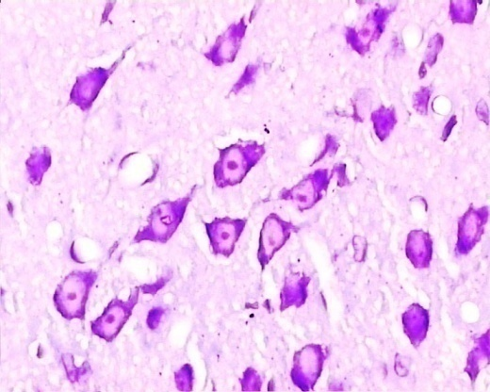
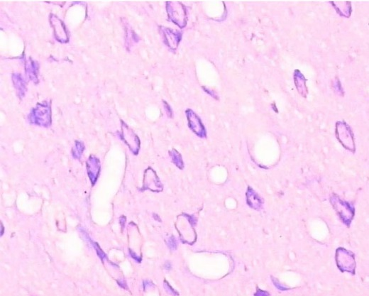
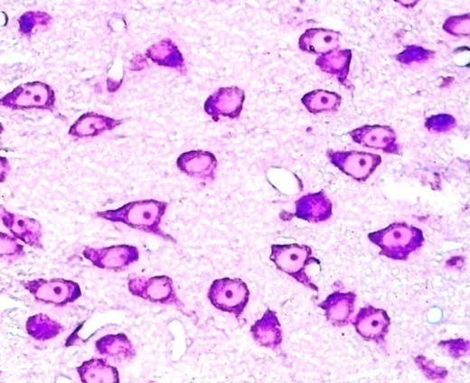

A
B
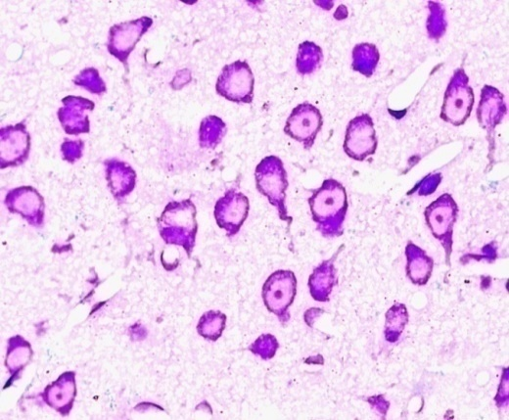
D
C

Fig.2. Micrograph of cerebral cortex by cresyl violet staining. The neurons in rat with Pneumococcal meningitis were protected by BDNF (A), as comparing with placebo (B), however, there were no significant difference between neurons in normal control rat treated with BDNF(C) and placebo(D).

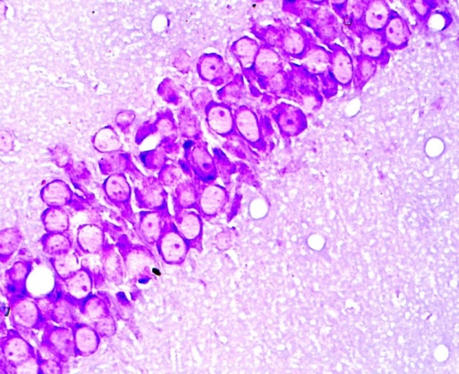
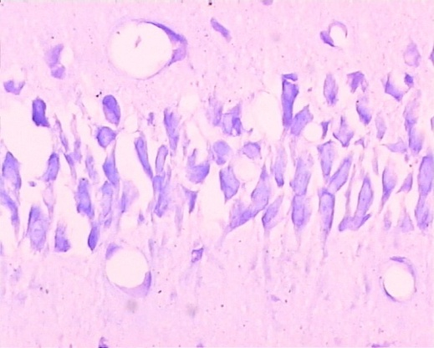
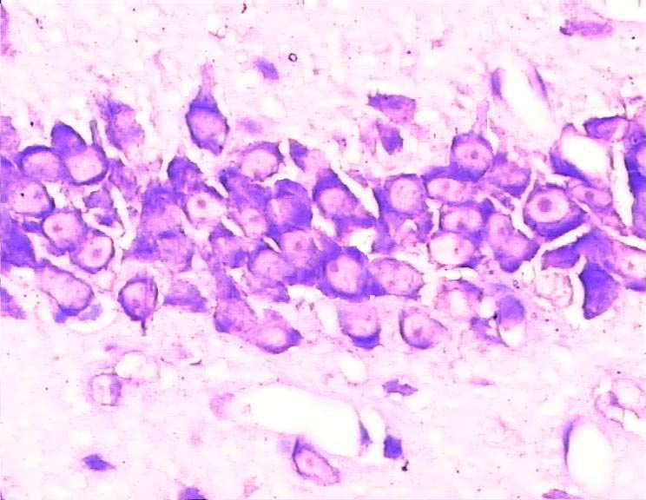
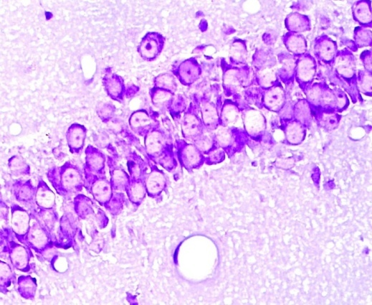
D
B
C
A

Fig.3. Micrograph of hippocampus by cresyl violet staining. The neurons in rat with Pneumococcal meningitis were protected by BDNF (A), as comparing with placebo (B), however, there were no significant difference between neurons in normal control rat treated with BDNF(C) and placebo(D).

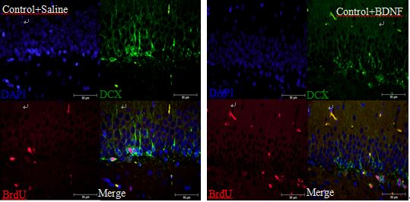
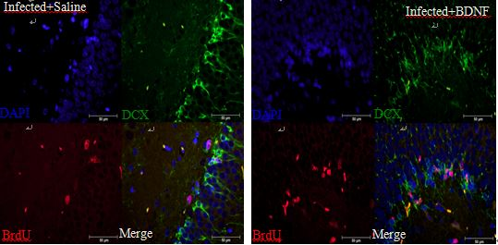

Fig.4. Double-labeling immunofluorescence of BrdU (red) and DCX (green) positive cells in the DG of hippocampus 7 days after inoculation in Saline treated control rats, BDNF treated control rats, Saline treated infected rats and BDNF treated infected rats. B. The percentage of BrdU & DCX/BrdU-positive cells in groups of Saline treated control rats, BDNF treated control rats, Saline treated infected rats and BDNF treated infected rats in the DG of hippocampus 7 days after inoculation. (*P b 0.05 vs Saline treated control rats, BDNF treated control rats and Saline treated infected rats; **P b 0.05 vs Saline treated control rats, Saline treated infected rats and BDNF treated infected rats).

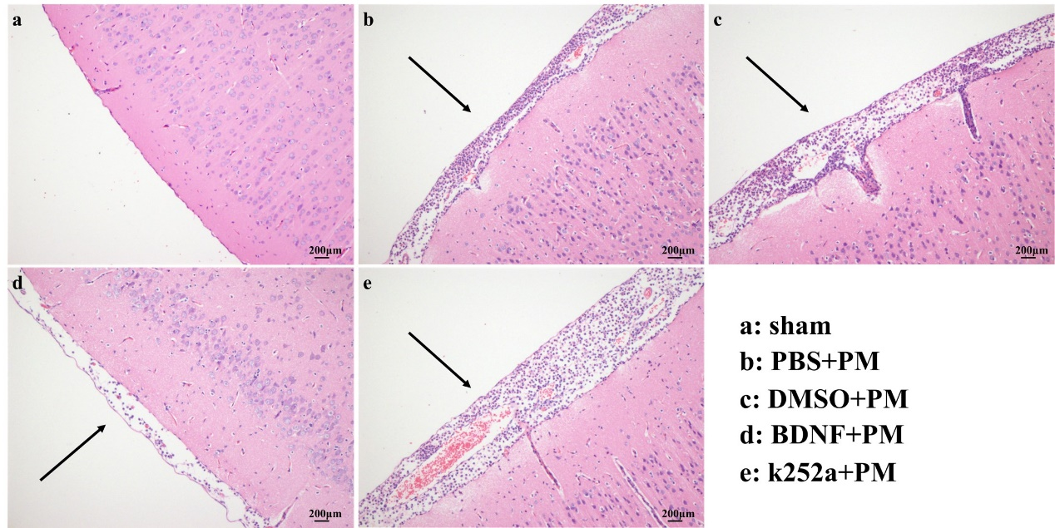
Fig.5. BDNF alleviates the pathological severity of PM. a Rats in the sham group showed no inflammatory infiltrates, whereas b–e H&E-stained sections showed infiltration of inflammatory exudate and mononuclear cells in the subarachnoid space of infected rats. The BDNF + PM group showed a mild inflammatory response as compared with that observed in the PBS + PM group.

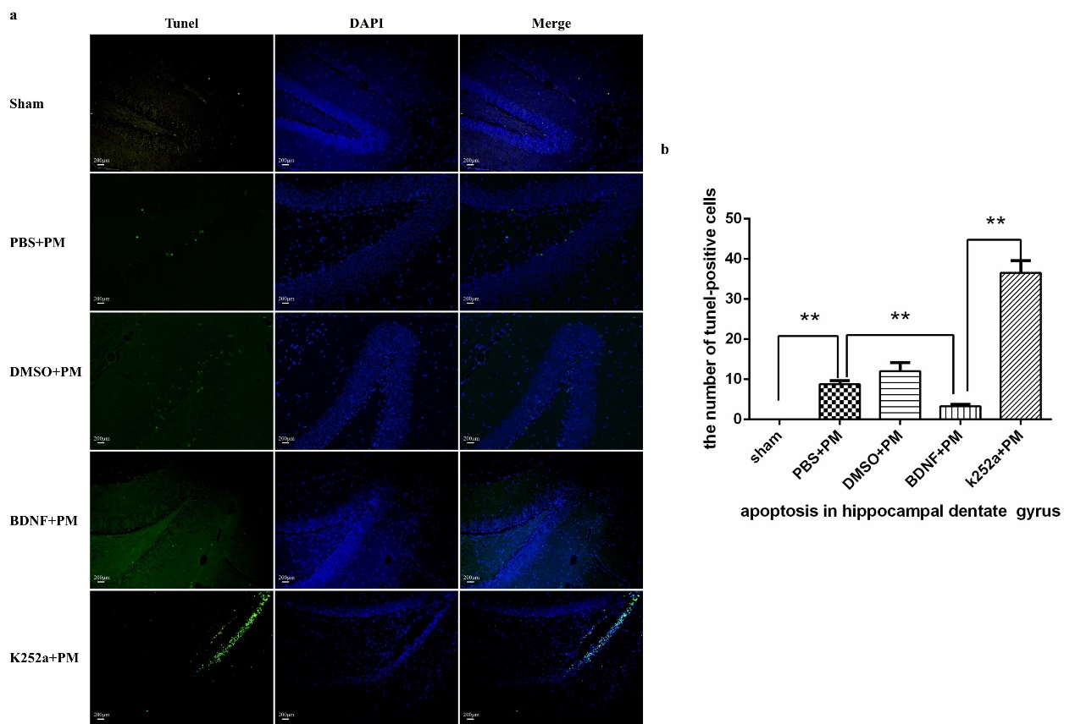
Fig.6. BDNF reduces hippocampal apoptosis in PM. Apoptotic neurons in the hippocampal dentate gyrus were assessed by TUNEL staining. a BDNF administration prevented neurons from apoptotic injury from PM-induced hippocampal apoptosis, whereas k252a-pretreatment significantly elevated levels of hippocampal apoptosis as compared with levels observed in the BDNF + PM group. b Quantitative analysis of the TUNEL results. **p < 0.01
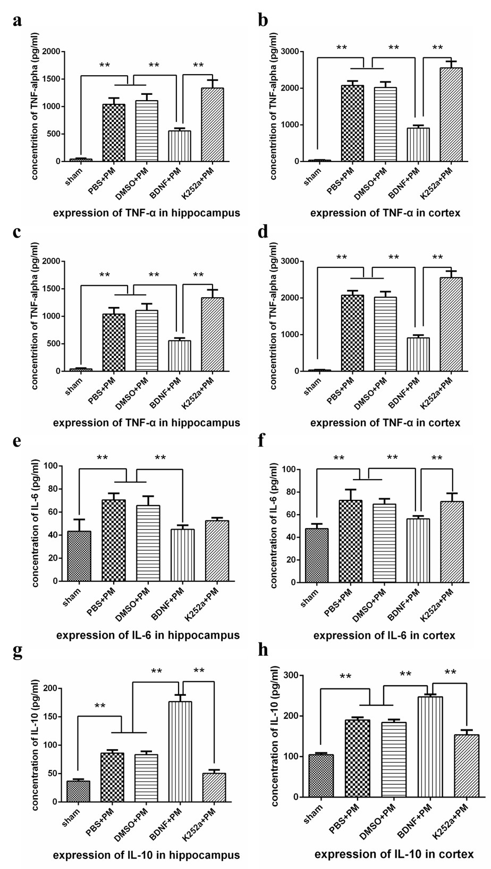
Fig.7. BDNF downregulates proinflammatory cytokine expression and upregulates anti-inflammatory cytokine expression in PM. Levels of proinflammatory cytokines (TNF-α, IL-1β, and IL-6) and anti-inflammatory cytokines (IL-10) in both the hippocampus and cortex at 24 h post-infection as measured by ELISA. Levels of both proinflammatory and anti-inflammatory cytokines were significantly increased at 24 h post-infection as compared with levels observed in the sham group. Administration of exogenous BDNF significantly decreased the levels of TNF-α, IL-1β, and IL-6 in the a, c, e hippocampus and b, d, f cortex, and g, h further elevated IL-10 levels. Rats pretreated with k252a exhibited enhanced expression of proinflammatory cytokines and attenuated expression of anti-inflammatory cytokines as compared with levels observed in the BDNF + PM group. **p < 0.01
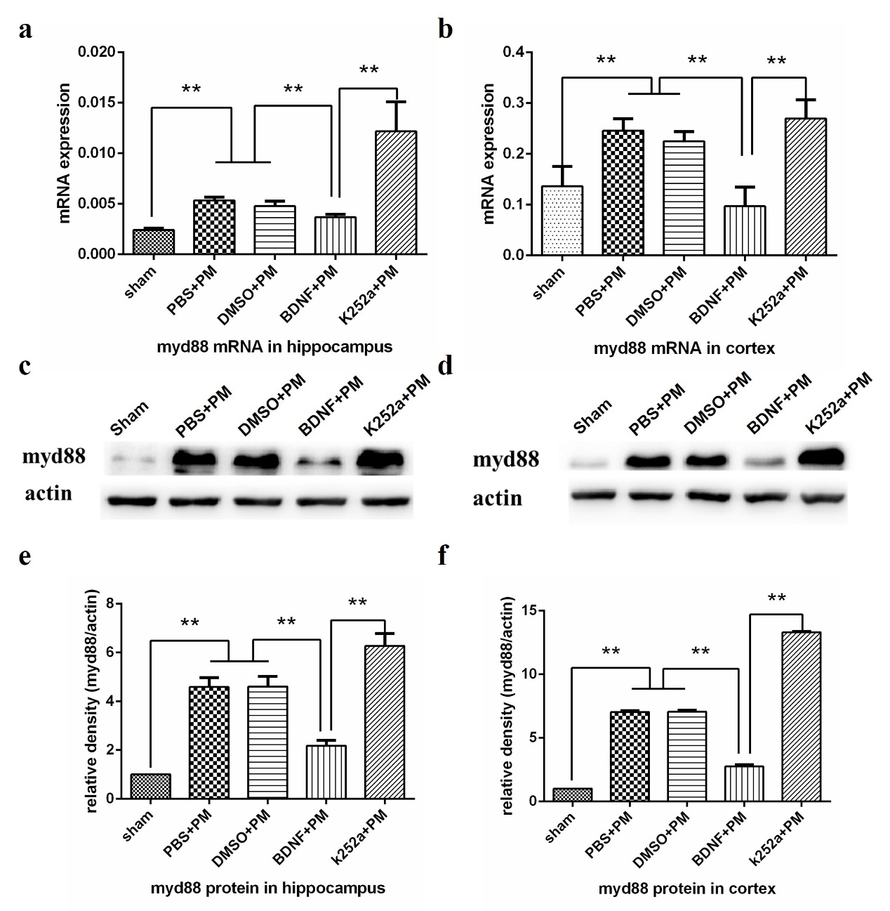
Fig.8. BDNF inhibited MyD88 expression in PM. MyD88 mRNA levels in a hippocampus and b cortex increased at 24 h post-infection. BDNF pretreatment inhibited the upregulation of MyD88 mRNA, whereas rats pretreated with k252a showed increased MyD88 expression as compared with that observed in the BDNF + PM group. Western blot analysis confirmed lower levels of MyD88 protein in the c, e hippocampus and d, f cortex following BDNF treatment, whereas these results were not observed in the k252a + PM group. **p < 0.01

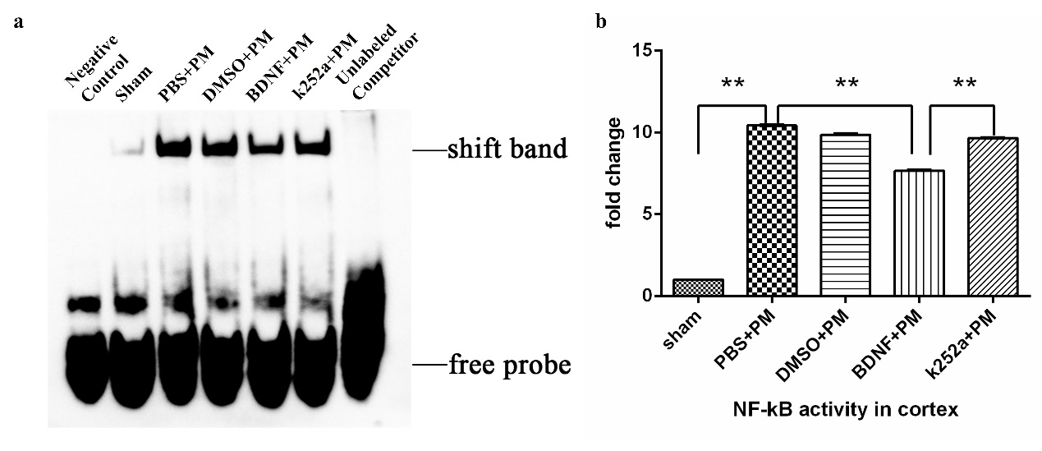
Fig.9. BDNF reduces NF-κB-binding activity in the cortex at 24 h post-infection. a NF-κB DNA-binding activity examined by EMSA revealed increased NF-κB-binding activity in all infected rats relative to levels observed in the sham group. BDNF pretreatment inhibited NF-κB-binding activity as compared with levels observed in the PBS + PM group, and pretreatment with k252a significantly increased NF-κB-binding activity as compared with activity observed in the BDNF + PM group. b Quantitative analysis of the EMSA results. **p < 0.01

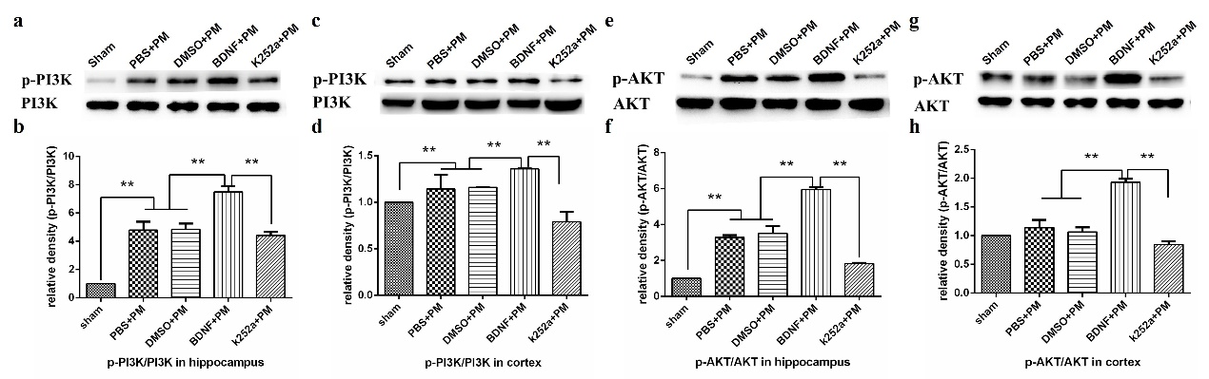
Fig.10. BDNF activates the PI3K/AKT-signaling pathway in brain tissue 24 h post-infection with PM. Levels of phosphorylated PI3K and AKT in the a, b, e, f hippocampus and c, d, g, h cortex as examined by western blot using specific antibodies. BDNF administration increased levels of phosphorylated PI3K and AKT, whereas k252a pretreatment decreased these levels. **p < 0.01

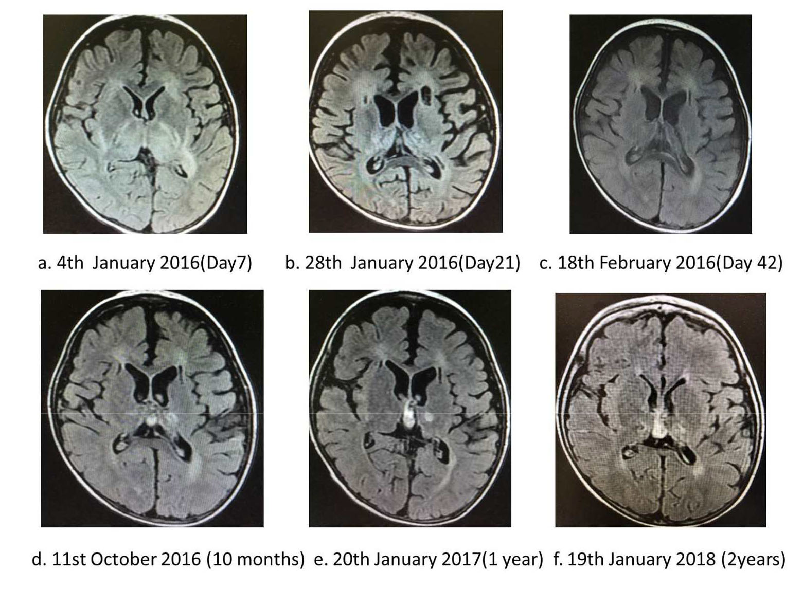
Fig. 11 Changes of cerebral MRI in the patient
