

Title: Improving Sales Forecasting Using Real-time Monitoring of Out-of-Stock Events through deep learning based Object detection technique for Ice cream brands
Rohit Agarwal, Gaurav Pawar
Mobisy Technologies Pvt Ltd, Bangalore, India

Business Problem:
Out-of-stock situations (OOS) are undesirable for brands especially in the ice cream business. Traditional prediction (forecasting) models which depend largely on historical sales data tend to fail while predicting optimal quantity of ice cream stock for various retailers. This is evident as the OOS situation is quite common especially in the summers. One of the reasons is that the models generally don’t use past OOS events to correct themselves. This is simply because gathering OOS data automatically is a challenge. Brands are dependent on the retailers to report the events as they occur who may forget to do so.

Technical Solution:
Ice-cream cabinets are mostly placed horizontally with a number of baskets containing various flavors (SKUs).The key to identify OOS in ice cream cabinet is to determine the depth up to which an ice cream basket is filled with the SKU. We have devised an automated way to determine the OOS by leveraging our state-of-art deep learning based image recognition technology 35 hawk.
- The solution requires a static camera to be placed above the ice cream cabinet which can take the top view of the ice cream cabinet.
- The images are then analysed to detect cabinet baskets and depth of basket along with SKU kept in each of the baskets using a CNN based object detector. This has custom layers that make bounding box merger class agnostic.
- The OOS events are added in a tree based demand forecasting model to predict the demand more accurately to avoid OOS events

Results:
The algorithm has been tested in retail stores across Bangalore,India with following outcomes:
80% of OOS events avoided due to better stock predictions
SKU Detection Accuracy: 95%
Depth Detection Accuracy: 90%

This approach is generic and can be extended to dairy, frozen foods which are kept in horizontal refrigerators (cabinets). In this presentation we intend to share our work and results with respect to the Indian market.

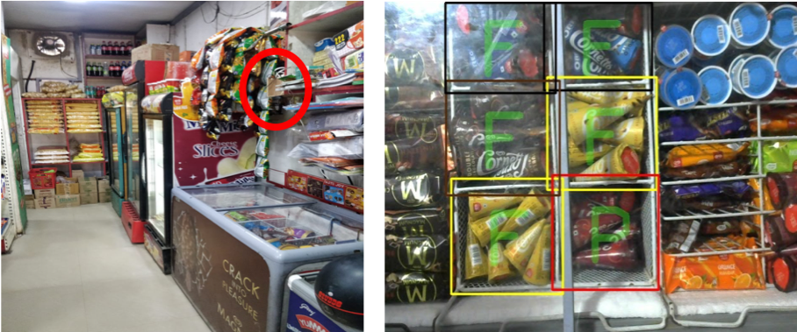

Fig: Shows the camera setup (Left) and the depth analysis of the baskets(Right) (F means basket is full
P means basket is partially full,L means basket is low in stock)

Biography

Rohit Agarwal
Works as Senior Data Scientist in Mobisy Technologies, Bangalore where he leads a team of Data Scientists & Software Engineers, focusing on salesforce automation by applying state of the art ML & Deep Learning techniques. He has 13 years of industry experience with 11 years in GE where he worked on conceptualizing, designing, prototyping a number of software & data solutions using cutting edge technologies for solving large industrial problems. As a hobby project he launched a website http://bmtcroutes.in which aims at finding bus routes in Bangalore and is currently in top google search results. He has Masters in IT from IIIT, Bangalore,India and Bachelors in Computer Science from IET, Lucknow,India.

Gaurav Pawar
Passionate about data science, he has a B.E degree in Electronics and Telecommunication with more than 3 years of practical hands-on experience in computer vision and machine learning. Specialised in building quick prototypes using python environment by leveraging GPU platform. In-depth understanding and deployment experience of state-of-art algorithms designed to solve fundamental computer vision problems such as object detection, object pose estimation and face recognition. Expertise in using popular deep learning libraries such as tensorflow, pytorch and keras. Currently interested in solving data science problems in Indian retail industry using images and other source of data.

Presenting author details
Full name: Rohit Agarwal, Gaurav Pawar
Contact number: +919886553734,+919763532288
Twitter account:@rohitagarwal,@gauravp3005
Linked In account: https://www.linkedin.com/in/rohitagarwal24/, https://www.linkedin.com/in/gaurav-pawar-a4560589/
Session name/ number:
Category: (Oral presentation/ Poster presentation):

