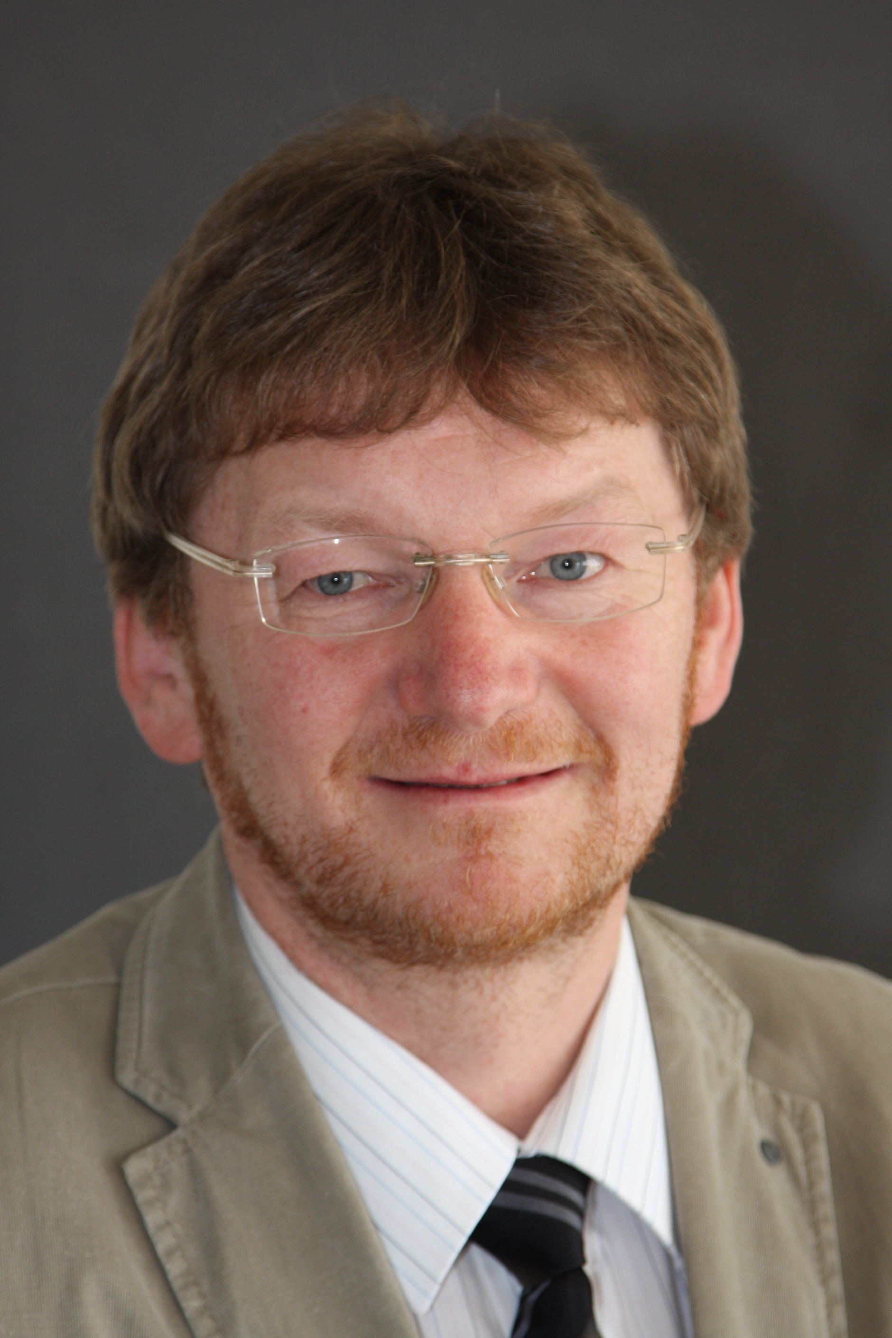

Title: Basics and examples of successful treatment of uro-nephrological diseases in the context of CAM

Dr.med. Ralf Oettmeier
Paracelsus Clinic, Comprehensive Center for Biological Medicine, CH-9062 Lustmühle, Switzerland

Additional to conventional basics, complementary and alternative medicine (CAM) also uses evidence-based aspects from environmental medicine (toxins, physical irritating fields), the vegetative nervous system (reflex zones, sympathetic-parasympathetic balance, somatotopies, odontomas), energetic medicine (acupuncture meridians of TCM, chakras from Ayurvedic medicine) as well as approved psycho-mentally and psycho-emotionally relationships. The uro-nephrological system is clearly embedded in this holistic context, which enables a clear diagnostic strategy to develop an individual therapeutic concept. With the usage of this thinking it is possible to treat the deep reasons of the diseases even more. Mostly, it is necessary to reduce the environmental toxic load, to optimize the dental situation and to diminish chronic neuro-modulative triggers (foci) with the help of neural therapy. Next, we pay attention to the intestinal health and immune system. Finally, the patient’s own healing forces were activated by using a big palette of natural remedies and organ cell therapy. The examples of chronic cystitis, nephrotic syndrome and prostate cancer illustrate the successful application of CAM in this fields.

Biography

Dr. R. Oettmeier had his medical studying at the Friedrich-Schiller-University Jena (Germany). From 1993 – 2014 he worked in his own outpatient department with the focus on reflex therapies (Chirotherapy, Acupuncture, Neural Therapy), Homeopathy and special pain treatment and as leading head physician in the Clinic „im LEBEN“ at Greiz, Germany. Since 2014 he is leading Doctor at the Paracelsus Clinic Lustmühle, Switzerland, a Comprehensive Center for Biologic-Integrative Medicine and Dentistry. He realizes considerable activities of seminars and presentations in the fields of Biological Medicine, is author of textbooks and publications in CAM, and finally of some guidebooks for patients.

Presenting author details
Full name: Dr. Ralf Oettmeier
Contact number: 0041 105 44 90
Twitter account: no
Linked In account: no
Session name/ number: clinical nephrology
Category: Oral presentation

