A Preliminary study on sodium oxalate impact on different body organs in aged male Wistar rats.
Doaa S Foda* and Noha E Ibrahim.
*Therapeutic Chemistry Departement, Pharmaceutical and Drug Industries Research Division, National Research Centre. Egypt.
Sodium oxalate was administrated to male rats for a month. PH range of rats' urine showed no difference in the oxalate injected group compared to control group. Microscopic examination of rats'urine reveals the existence of large oxalate crystals in the group administrated sodium oxalate. Different biochemical parameters were detected in urine and serum. Detectable changed serum levels of glucose, urea and total proteins were observed. Kidney histological examination revealed the existence of distortion of cells tissue and harmful changes existed besides inflammation and lymphocyte infiltration that occurred. Sections in bone marrow showed a significant changes in the number of the hematopoietic cells and hypercellularity of the bone marrow in the oxalate administrated group. Changes in bone marrow cellularity may involve all or individual blood cell types. Hypercellularity mainly occurs due to a regenerative response to compensate the decrease in blood cells numbers associated to oxalate injection. Further histological examinations and studies on the molecular levels of brain, liver and spleen tissues are under investigation.

Figures

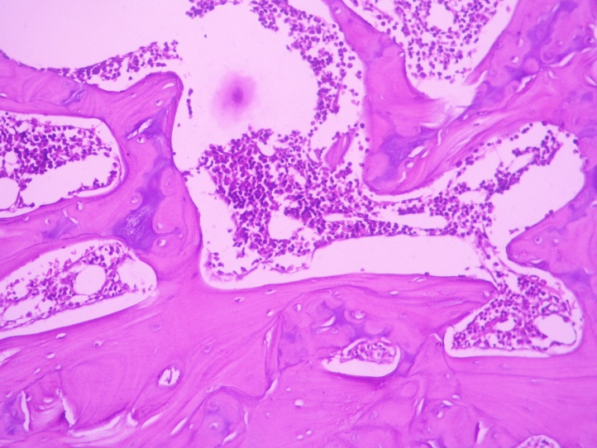
Fig 1: Microscopic section showed normal shape and normal hematopoietic cell number in bone marrow of control aged rat.

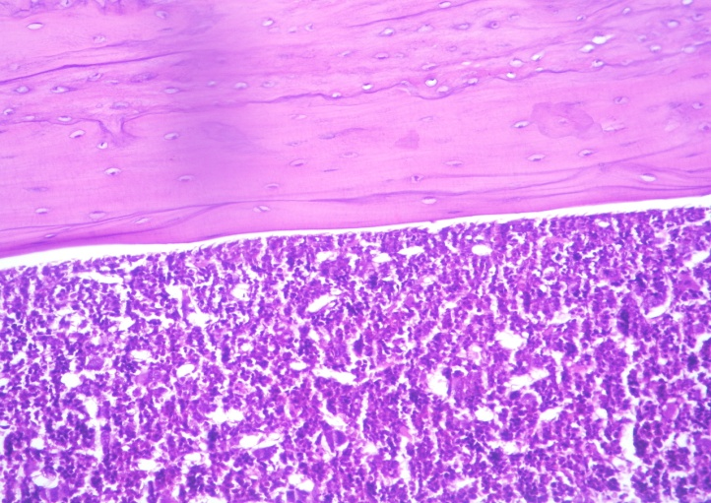
Fig 2 : A microscopic section showed abnormal hematopoietic cell number in bone marrow of oxalate administrated aged rat.

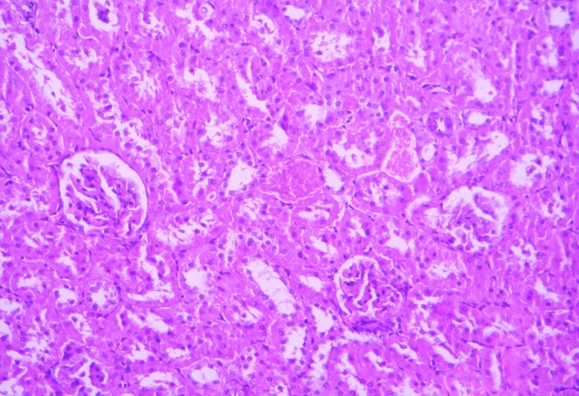
Fig 3: A microscopic section showed normal kidney tissue in control aged rats.

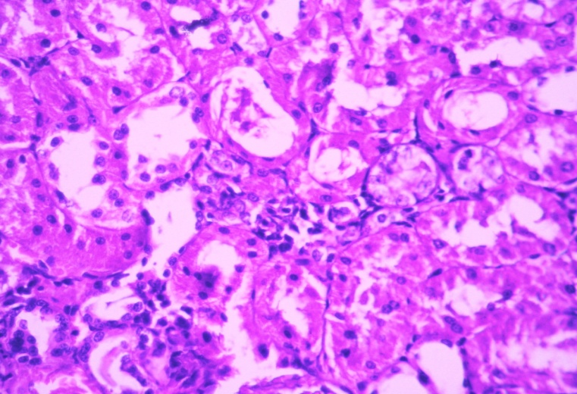
Fig 4: A microscopic section showed a distortion in kidney tissue in oxalate administrated aged rat.

