Title: END-STAGE RENAL DISEASE WITH ERYTHROCYTOSIS: A Case Report on a Rare Association of Crescentic Glomerulonephritis and JAK2-Positive Polycythemia Vera

*Gale Rizzae B. Mercado, MD, **Eratosthenes S. Polito, MD

*Internal Medicine Resident in Training Year Level-1, Perpetual Succour Hospital, Cebu City, Cebu
**Nephrology Fellow-in-Training Year Level-1, Perpetual Succour Hospital, Cebu City, Cebu

Keywords: Erythrocytosis; polycythemia vera; crescentic glomerulonephritis; end-stage renal disease

I. ABSTRACT

The occurrence of glomerulonephritis in patients with primary polycythemia vera is clinically rare. To date, there are only 23 related cases published with only 1 case of renal failure identified resulting from rapidly progressive glomerulonephritis. We present a case on simultaneous occurrence of primary polycythemia vera and rapidly progressive glomerulonephritis in a 69 year-old man who came in with gross hematuria, sterile pyuria and renal failure. The occurrence of glomerulonephritis in patients with polycythemia vera remains unclear, it may be a comorbidity or etiologically linked, either by common pathogenesis, or a complication. More clinical evidence is required to confirm the causal relationship. Since the predictor of outcome in patients with crescentic glomerulonephritis is the severity of renal failure at the time of therapy, diagnosis should be prompt and accurate to which in this case renal biopsy was done and appropriate therapy such as immunosuppressive agents were instituted and eventual renal replacement therapy.

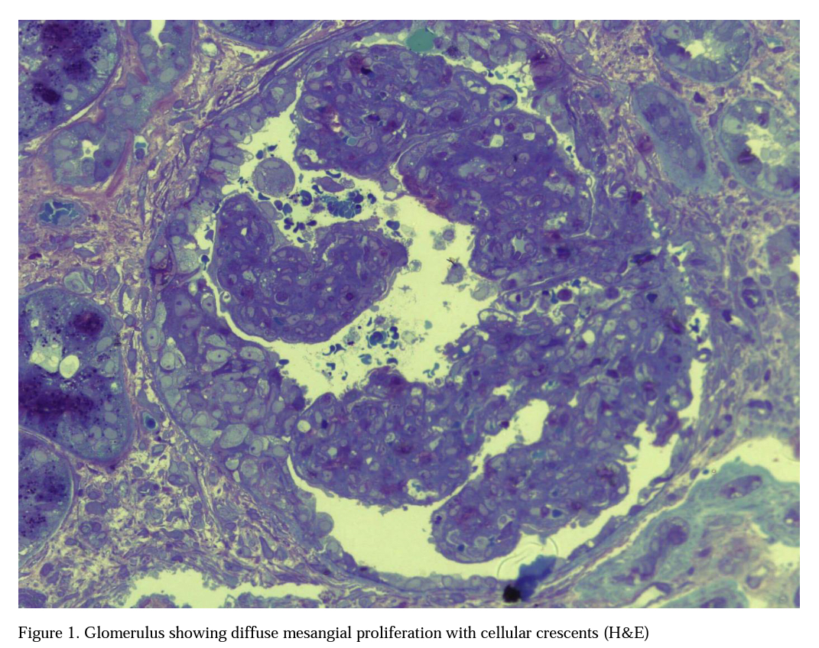
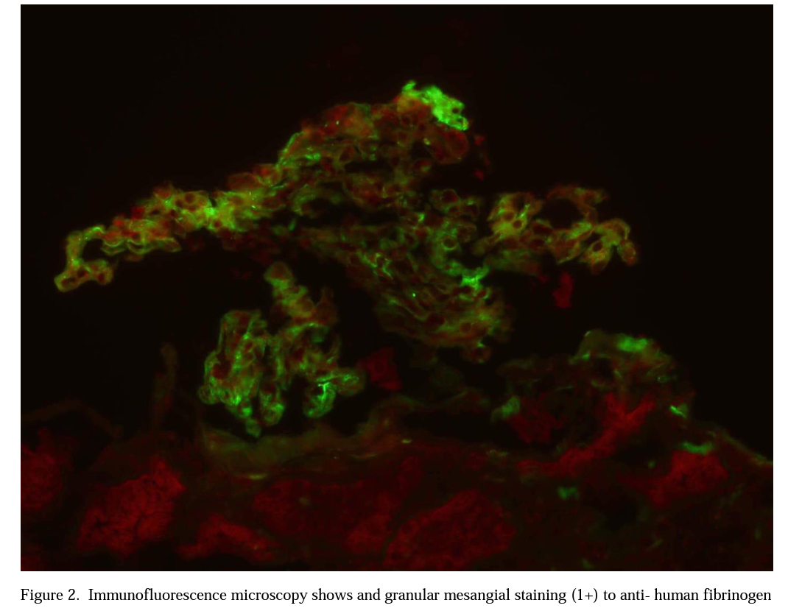
II. IMAGE

III. REFERENCES

      - Kasper, D. (2015). Harrisons Principles of Internal Medicine. New York. McGraw Hill Education.
      - Ohyashiki JH, Fujieda H, Ohyashiki K, Toyama K. Correction of anemia by recombinant human erythropoietin in a patient with polycythemia vera associated with hemodialysis‐dependent chronic renal failure. Am J Hematol 1991; 37: 141–142
      - Greenhall G., Salama A: What is new in the management of rapidly progressive glomerulonephritis. Clinical Kidney Journal. 2015 Apr; 8(2): 143-150.

IV. AUTHOR DETAILS
Gale Rizzae B. Mercado, MD; Internal Medicine Resident in Training Year Level-1, Perpetual Succour Hospital, Cebu City, Cebu


Co- Author Eratosthenes S. Polito, MD; Nephrology Fellow-in-Training Year Level-1, Perpetual Succour Hospital, Cebu City, Cebu

Full name: Gale Rizzae B. Mercado
Contact number: 09175823285
Twitter account: galerizzae
Category: Poster presentation

