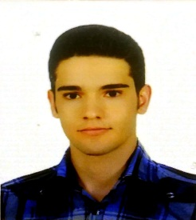
Title: Mutational dysostosis ,review of the literature and a case report
Name: Amirreza Monsef Esfehani

Hamadan university of medical sciencese, IRAN

Mutational dysostosis also called Cleidocranial dysplasia or Cleidocranial dysostosis is a rare congenital bone disease inherited as autosomal dominant trait. The incidence is 1/200000 to 1/1000000 in alive newborn. Delay in skull ossification is a major symptom. It manifest as large fontanels ,hypoplasia or aplasia of clavicle leeding to droped scholders beyond the chest, delay in thooth eruption, high arch palate and symphysis pubis widening may be present.
Our case is a one day boy hospitalized for respiratory distress in newborn ward. Both anterior and posterior fontanels were opened and joined each other. The scholders also were mildly droped. On X-ray we notice that both clavicles and vertex bone had not foremed.
Biography
Amirreza Monsef Esfehani has studied medicine at the Hamadan university of medical sciencese and now he is in internship course. He has published 6 papers in reputed journals and he is an active member of research center of medical students.
Presenting author details :
Full name: Amirreza Monsef Esfehani
Contact number: +989379216178
Email: amonar2009@gmail.com
Session name/ number: Neonatology
Category: Oral presentation

