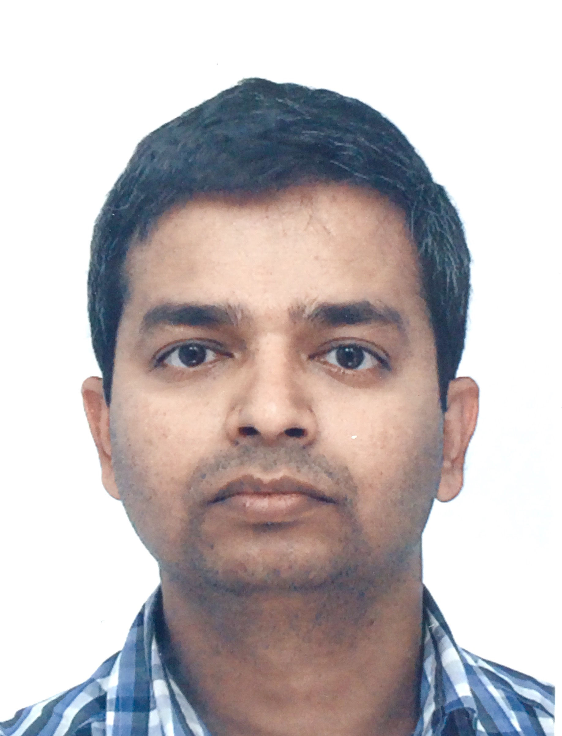

Title: Outcome of prolonged jaundice screen in a District Hospital: A 3-year retrospective study
Name: Prasad Adavappa Parvathamma
Specialty Registrar, Royal Gwent Hospital, Newport United Kingdom

Co-Authors: Emily Brockbank, Royal Gwent Hospital, Newport United Kingdom

Background: Although Prolonged jaundice can be a sign of serious underlying pathology and warrants further evaluation, there is not yet agreement as to the appropriate screening investigations, especially in otherwise well children. Prolonged jaundice screen vary in complexity and the additional diagnostic yield from screening has not been assessed.

AIM: The aim of this retrospective study was to ascertain the causes of PJ in well infants and to analyze the extent and consistency of investigations performed.
Methods: We performed a retrospective study of all PJ screening in our Children’s assessment unit in a District General Hospital during 2013-15. Nurse-led PJ screening , included history and examination with investigations including urine culture as per the proforma. All the clinical notes and results were analyzed.

Results: A total 115 infants aged 14-73 days were referred for screening by midwives, GP and A&E. All the infants were examined by a doctor and had all essential documentations including stool color. Neutropenia was common finding on blood-film persisting for 3-4 weeks. All had unconjugated hyperbilirubinemia and most common cause was breast milk jaundice. Two infants were treated as UTI and no other pathological causes of PJ were identified. Additional tests (TFTs, LFTs and G6PD in high-risk population) did not identify any pathological causes.

Conclusion: Our study demonstrated still delay in referrals and varied practice of requesting the additional investigations. Additional blood tests did not identify any pathological causes. Hence the PJ screening investigations may safely be reduced to: a FBC and split bilirubin in addition to clinical evaluation.

Biography

Prasad has completed his M.D (Paediatrics) from Baba Farid University of Health Science,India in 2008 and MRCPCH (UK) IN 2014 . He is currently working as a Specialty Trainee (Yr 5) at Wales Deanery . He has worked in Paedaitrcs for more than a decade and presented numerous papers in international conferences. His clinical interest is Neonatology and very keen on advocating evidence based neonatology and providing child and family centred care.
Presenting author details
Full name: Prasad Adavappa Parvathamma
Contact number:0044-7411910226
Twitter account:@IamAPPrasad
Session name/ number:
Category: Poster presentation

