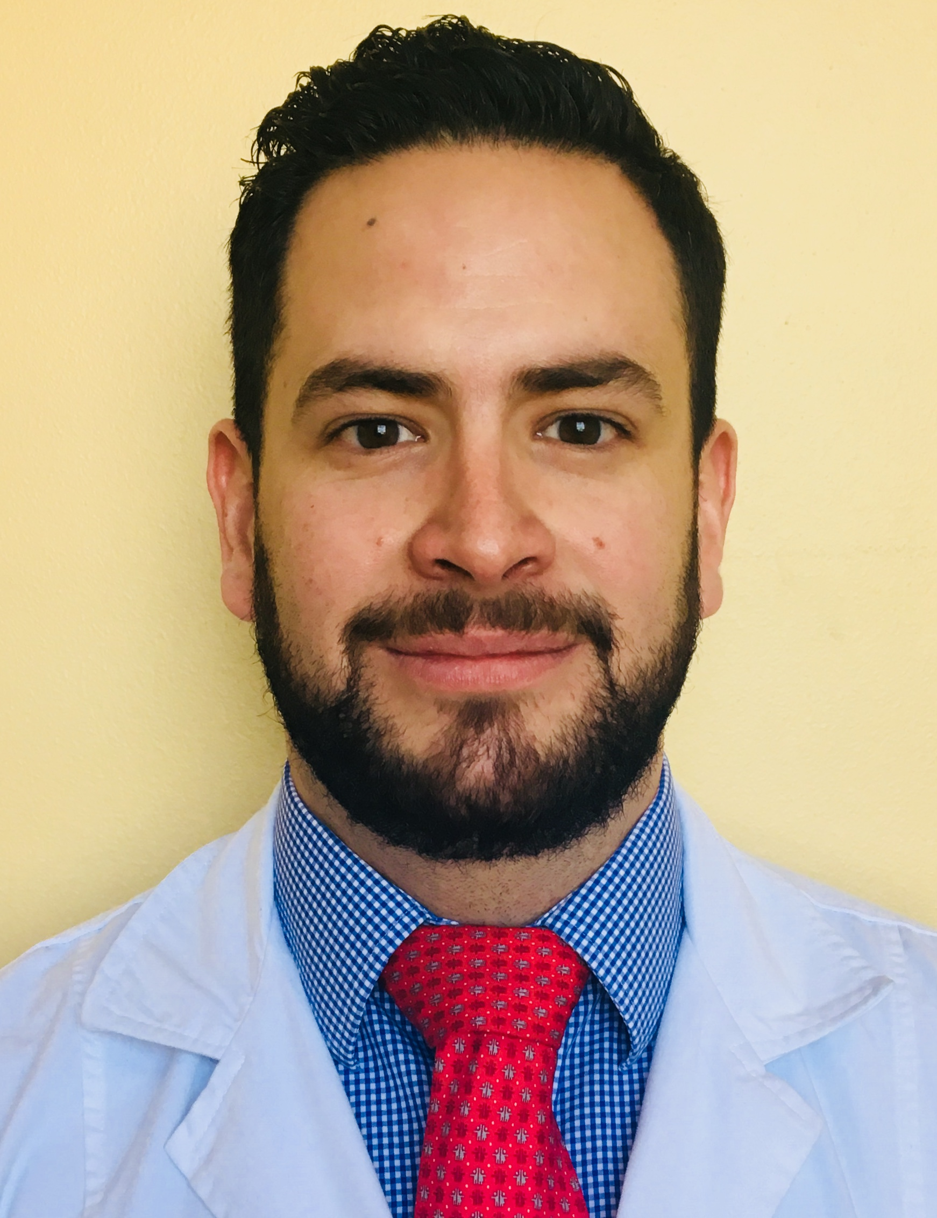

Title: GRADE III INTRAMEDULLARY ASTROCYTOMA IN A 21-MONTH-OLD PATIENT: CASE REPORT

F. Medrano Muñoza, A. Garza Peñab

aPediatric Pulmonology Resident. Instituto Nacional de Pediatria, México • b Pediatric Neurology. San José Medical Center. Nuevo León. México.
Central nervous system tumors represent 15-20% of all childhood tumors. Primary spinal cord tumors are rare entities that only for 4-10% of all primary tumors of the CNS. Intramedullary tumors are the least common, representing only 35% of spinal tumors. The most common intramedullary tumor is astrocytoma in 75% of the cases, being grade III the least common with a frequency of 25%.
We present the clinical manifestations and diagnostic approach of a grade III intramedullary astrocytoma in a 21-month-old female with no prior history of illnesses. Symptoms started 11 days prior to admission, as limping, weakness, diminished movements and inability to handle objects with the right arm. The neurological evaluation was normal except for diminished strength 3/5 (distal), 4/5 (proximal), muscle deep reflexes 2/4 of left extremities.
Column and hip radiographies, as well as a head CT were reported normal. Head and spinal MRI, reported an heterogenic intramedullary lesion that went from C3 to T3 with hypo-intense areas in T1 and hyper-intense areas in T2, 7.6 cms long which obliterated sub-arachnoid space

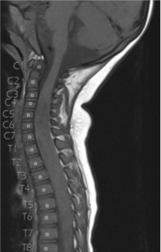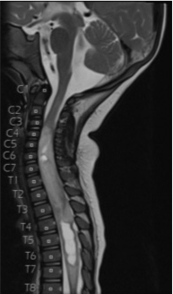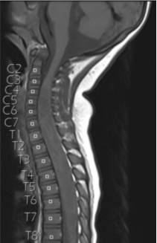

A biopsy reported a fibrilar hyper cellular, astrocytic neoplastic lesion with hemorrhagic areas and 2 active mitosis without necrosis. Grade III intramedullary astrocytoma was diagnosed following WHO criteria.

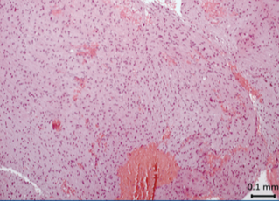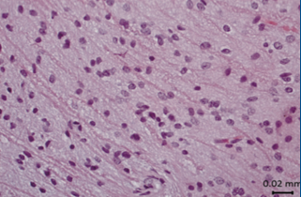

Clinical features classify our patient in stage II according to McCormick’s scale. The most widely accepted classification is the WHO’s, which is based in biopsy findings, and because of the mitosis found, it would correspond to a stage III neoplastic lesion.

Biography

Francisco Medrano finished his MD at the Universidad Autonoma de Guadalajara in 2005, later on he did his pediatric residency at the Instituto de estudios superiores del Tecnologico de Monterrey, and is currently a second year fellow in pediatric pulmonology at the Instituto Nacional de Pediatria.
He has published in a high impact European medical journal and is currently enrolled in two ongoing studies, regarding neonatal and pediatric pulmonology topics.
He was a speaker at the world Zummit on pediatrics in Sophia, Bulgary.

