Development of ginseng seedling storage technology for stable production of ginseng sprouts

Dong Hyeon Cho, Ho Seob Soh, Young Nam An, Jeong A Han, Eun Seob Yi, Chang Hui Cho, Jin Young Kim

Gyeonggi-do Agricultural Research & Extension Services

Abstract

Although consumer demand for sprout ginseng is increasing, research on sprout ginseng has just begun. Therefore, continuous researches on sprout ginseng production technology is still needed. The objective of this study was to investigate the storage temperature, storage period, and fillers suitable for storage of ginseng seedlings for stable year-round production of ginseng sprouts. The test materials used in the study consisted of 2 types: ginseng seedlings harvested in fall(fall samples) and ginseng seedlings harvested in spring(spring samples). For the storage test using the fall samples, ginseng seedlings were packed in antimicrobial film and plastic bag filled with vermiculite, which were then placed in Styrofoam boxes for storage at -5℃ and -1℃. Samples stored at -1℃ with antimicrobial film treatment showed the highest percentage of healthy seedlings of 88% up to 9 months of storage. Ginseng sprouts grown for two months using fall samples which were treated with antibacterial film and stored at -1℃ showed highest appearance rate of 96.2% and excellent marketable product rate of 80.4%. For the storage test using spring samples, ginseng seedlings were packed in a Styrofoam boxes filled with vermiculite and porous artificial soil for storage at 5℃ and -1℃. Samples treated with porous artificial soil showed the highest percentage of healthy seedlings of 91.8% and 91.2% when stored at -5℃ and -1℃, respectively. Ginseng sprouts grown for two months using spring samples which were treated with porous artificial soil and stored at 5℃ showed excellent marketable product rate of 83.5%. In conclusion, samples treated with antimicrobial film and stored at -1℃ showed high percentage of healthy seedlings in the storage test using fall samples, while samples treated with porous artificial soil and stored at -1℃ and -5℃ showed high percentage of healthy seedlings in the storage test using spring samples.

Image

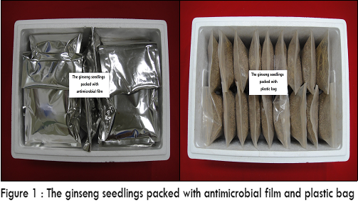
Recent Publications
- Kim JY (2015). Quality Characteristics of Ginseng Seedling During Storage and Growth inhibition of Botrytis cinerea Treated by Gaseous Chlorine Dioxide. Master’s thesis of Mokpo National University.
- Lee JH, Choi JW, Hong YP, Kim GS (2015). Effects of Storage Temperature on Quality of Fresh Ginseng during Distribution. The Korean Society of Medicinal Crop Science 23(6):431-438.
- Hyun DH, Kim YC, Bang GH, Kim JU, Jang IB, Park HU, Kim OT, Kim DH, Kim KH (2015). Long-term storage method of ginseng seedlings. Patent registration-number : 10-1494428.
- Lee EH, Lee DY, Park JS (2015). Development of Functional Cosmetics using Saponin and Bioactive compounds from the Hydroponic Ginseng. Final Report of National Institute of Horticultural and Herbal Science.
- Choi SY, Kim YH, Han DH, Song IK (2012). Investigation on the Growth of Ginseng by the Storage Period of ginseng seedlings. Final Report of Chungcheongbuk-do Agricultural Research and Extension.

Biography
Dong-hyeon Jo is a researcher at Gyeonggi-do Agricultural Research and Extension Services. He graduated from horticulture department. He is studying on development of the technology for stable production of sprout ginseng. The contents of the research include the development of light-weight bed soil for the production of ginseng seedlings and the development of technology for reuse of light-weight bed soil for cultivation of ginseng seedlings and sprout ginseng. He presented his research results to the society(The Korean Society of Medicinal Crop Science) under the theme of ‘Water control technology suitable for sprout ginseng cultivation’. He will continue to work on the research of stable production of sprout ginseng.
Dong-hyeon Cho
Tel: +82-31-229-6184
Plant Science Research
Category: Poster presentation
Email: jo9309@gg.go.kr

Notes/Comments

