UP NOAH’s Early Warning System through WebGIS Platform help in Timely and Responsive Philippine DRRM Efforts
Neyzielle Ronnicque Cadiz, University of the Philippines Resilience Institute, Philippines

Abstract (300 word limit)
As an archipelago, the Philippines is prone to geological and hydro-meteorological hazards due to its geographical and physical characteristics. The country is highly vulnerable to disasters resulting from extreme natural events as an average of 20 tropical cyclones per year enters the Philippine Area of Responsibility (PAR).

Statement of the Problem: Philippine disaster scientists agree that disaster risk communication is actually a perennial dilemma. In the Philippines alone, there are so many efforts to reach the grassroots level but emergency and disaster preparedness messages inevitably fall short, even with the significant availability of open-sourced data from UP NOAH and other government agencies.

UP NOAH Center works to raise Filipinos’ awareness of natural hazards through undertaking advanced disaster science research. The organization has developed an early warning system that allows user to see incoming weather disturbances through a WebGIS platform.

Methodology & Theoretical Orientation: Using analytic network process and goal programming, it is noted that the WebGIS is now conveniently used by local government units (LGUs) in the Philippines in their disaster prevention and mitigation efforts. These tools give people the ability to make informed decisions as they are able to determine the dangers and risks a hazard can bring.

Findings: Timely and responsive preparations even before a hazard hits can lead to zero casualty. Launched in 2012, one of now-UP NOAH’s initial objectives was to provide early warning systems to the communities along Philippine’s major river basins. Throughout its implementation, scientific tools, technologies, and open data codes have been developed to support the system.

Conclusion & Significance: The publicly promoted tools developed by UP NOAH include (1) Animated images from the Himawari satellite that allow users to monitor storms that may enter the Philippine Area of Responsibility; (2) Doppler Radar stations that accurately display the coverage of raincloud; (3) Water level sensors that indicate the rise and fall of a river’s water level; among other tools that significantly help in disaster mitigation. These effective open-sourced measures has helped in preventing harm to people and even in reducing significant property damages in Philippine communities.
Image
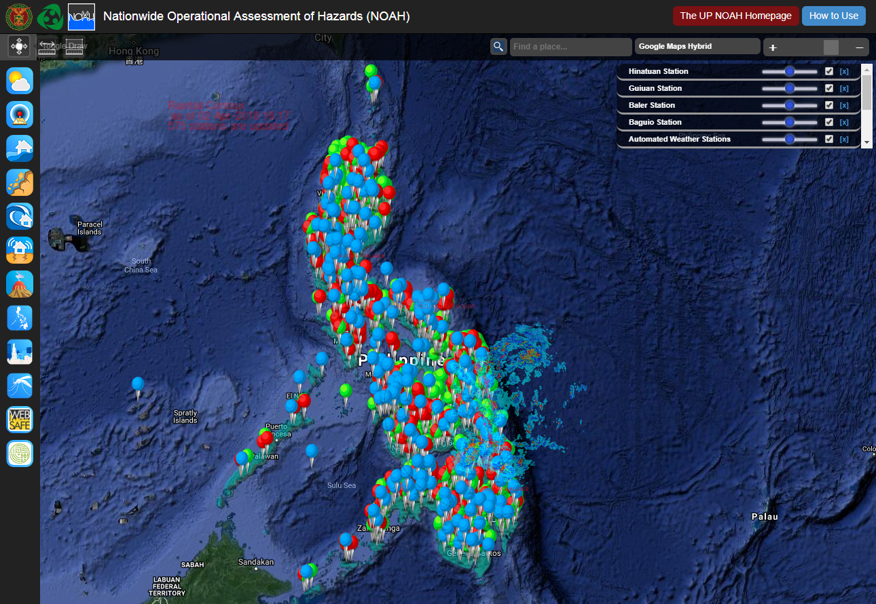
Figure 1 The latest tools, innovations, features, and all available free and open hazard and risk data created by UP NOAH are directly integrated to its disaster risk reduction and management online platform.
Recent Publications (minimum 5)
- Cadiz, N.R.R. (2018). UP NOAH in Building Resilient Philippines; Multi-hazard and Risk Mapping for the Future. Procedia Engineering. Volume 212, 2018, pp. 1018-1025. doi:10.1016/j.proeng.2018.01.131
- Lagmay, A. M. F. A., Racoma, B., Aracan, K., Alconis-Ayco, J., & Saddi, I. (2017). Disseminating near-real-time hazards information and flood maps in the Philippines through Web-GIS. Journal of Environmental Sciences. doi:10.1016/j.jes.2017.03.014
- Escape, C.M., Alemania, M.K., Luzon, P.K., Felix, R., Salvosa, S., Aquino, D., Eco, R.N. (2015). Comparison of various remote sensing classification methods for landslide detection using ArcGIS. Journal of the Philippine Geoscience and Remote Sensing Society, 1:1.
- A.M.F. Lagmay. (2014). Lessons from Disasters in the Philippines: The Project NOAH experience. South East Asian Regional Center for Graduate Study and Research in Agriculture (SEARCA). 4 pp, ISSN 2225-9694
- Lee, J.W., Kim S.H. (2000). Using analytic network process and goal programming for interdependent information system project selection. Journal of Computers & Operations Research. 10.1016/S0305-0548(99)00057-X

Biography (150 word limit)
Neyzielle Ronnicque Cadiz is one of the science research specialists/ information officers of the University of the Philippine’s Resilience Institute with the integration of UP NOAH Center. She is taking Master of Arts in Journalism at the University of the Philippines Diliman and is currently writing her thesis related to mobilizing hazards communication. She designs and creates publication materials for the organization using different technologies; and also attends conferences, lectures, and seminars relevant to the institute. She is a a service-oriented woman in perpetual quest of social relevance who is always armed with a notebook and a pen with her cameras to compensate for her short-term memory.
Email: nrcadiz1@up.edu.ph

Notes/Comments

