Establishing Crises Decision and Early Warning System

For Crises Management In Kuwait.
Abdullah Alenezi, Kuwait Institute for scientific research, Kuwait.
Ali Aldousari, Kuwait Institute for scientific research, Kuwait.
Mohammed Yassin, Kuwait Institute for scientific research, Kuwait.
Mohammed Alkhamis, Kuwait Institute for scientific research, Kuwait.

Abstract (300 word limit)
Kuwait is currently facing a possible potentially extensive and harmful scope of both natural and anthropogenic hazards. This can range from dust storms, floods, fires, nuclear accidents, earthquakes, oil spills, tsunamis and other hazards. Until today Kuwait's Government had no disaster support system, written code of practice or a communication and command system for coordinating environmental crises with other national stakeholders in the country and frequently ill-prepared for responses to environmental crises. For that purpose the Kuwait Institute for Scientific Research (KISR), establishing a Decision Support system for crieses management in Kuwait. It will support policy makers, stakeholders and national committees with technical information that they need to efficiently and effectively assess, monitor and finally manage environmental disasters using the necessary decision support tools. Examples include, but are not limited to, remote sensing information, Geographical Information Systems (GIS), simulation and prediction models and early warning systems (developing and early warning system and forecasting model for an epidemic disease, dust and harsh meteorological event). This
will improve forecasting, early warning and response mechanisms to the major physical threats to the environment. An online information for the center will be provided, drawing together relevant information from KISR and other organizations and clear communication procedures to provide these data to support decision makers during environmental crises. The decision support package will be based on three technical pillars:
- Monitoring and information management tools, such as meteorological data and statistics (hydrological conditions and water quality, etc.), updated information on environmental conditions etc…
- Modeling tools and analytics performed from the collected information, allowing for prospective analysis, including forecasting and prediction, such as land planning and management (to ensure sustainable soil quality and vegetation cover for e.g.), integrated water resource management, etc.
- Visualization tools for either information management or modeling, such as updated remote sensing images, GIS, analytical heat maps, clustering and pattern identification, etc.

Image
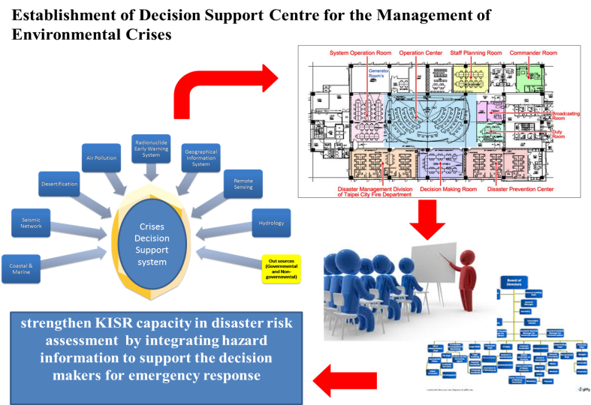
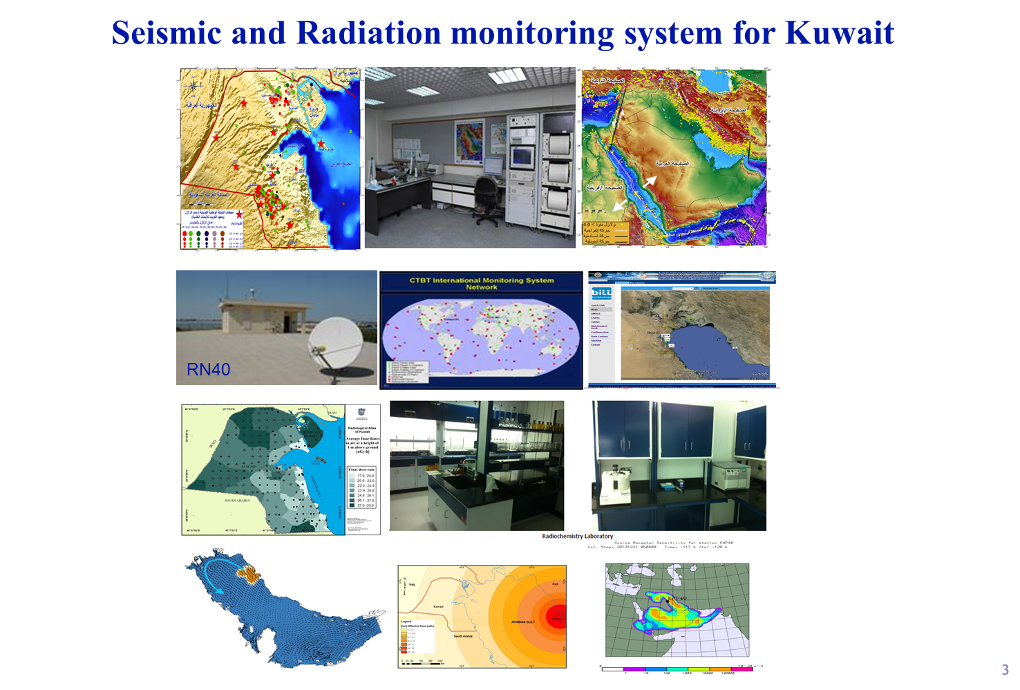
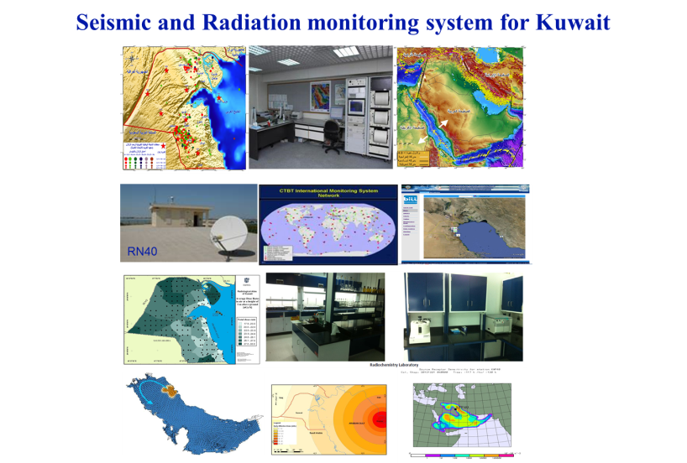

Biography (150 word limit)
Dr. Abdullah Alenezi is researcher at Kuwait Institute for scientific Research expert in the field of seismology and geology of arid land. Dr. Enezi is the Program Manager for the Crises Decision Support program. He is also the operation manager of Kuwait National Seismic Network (KNSN) . He is currently leading projects related to hazard assessment of Kuwait and Establishment of Decision Support Centre for the Management of Environmental Crises
Email: aenezi@kisr.edu.kw

